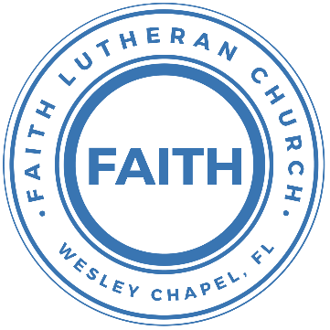

**Leading our community into a deep connection in Christ**

**Worship Service for June 16, 2024 at 11 AM**

**Welcome**

**Opening Song:** Mighty To Save

Everyone needs compassion, a Love that's never failing.

Let mercy fall on me.

Everyone needs forgiveness, the kindness of a savior.

The hope of nations

Chorus:

Savior, He can move the mountains.

My God is mighty to save. He is mighty to save.

Forever, author of salvation,

He rose and conquered the grave. Jesus conquered the grave.

So take me as you find me, all my fears and failures,  
And fill my life again.  
I give my life to follow everything I believe in.  
Now I surrender. (I surrender)

Chorus:

Savior, He can move the mountains.

My God is mighty to save. He is mighty to save.

Forever, author of salvation,

He rose and conquered the grave. Jesus conquered the grave.

Bridge:

Shine your light and let the whole world see singing,

For the glory of the risen king, Jesus.

Shine your light and let the whole world see singing,

For the glory of the risen king

*(Chorus 2x)* © 2006 Hillsong Publishing

**Invocation**

**Responsive Psalm - Psalm 19:7-11**

**P:** The law of the Lord is perfect, reviving the soul;

**C:** The testimony of the Lord is sure, making wise the simple;

**P:** The precepts of the Lord are right, rejoicing the heart;

**C:** The commandment of the Lord is pure, enlightening the eyes;

**P:** The fear of the Lord is clean, enduring forever;

**C:** The rules of the Lord are true, and righteous altogether.

**P:** More to be desired are they than gold, even much fine gold;

**C:** Sweeter also than honey and drippings of the honeycomb.

**P:** Moreover, by them is your servant warned;

**C:** In keeping them there is great reward.

**Confession and Forgiveness:** *(stand)*

**P:** As we gather, today, let us cleanse our hearts and our consciences by confessing our sin to God.

*(Time of silence for reflection and confession)*

**C:** Heavenly Father, we confess that we are sinful and unclean. We have sinned against you and against our neighbor in our thoughts, words, and actions.  We are truly sorry for our sins and sincerely repent of them. We ask for Your mercy. For the sake of Jesus Christ's bitter suffering and death, please forgive us and renew us that we may walk in Your Spirit to the glory of Your holy name. Amen

**P:** The Lord has heard your confession. Therefore, as a called and ordained servant of the Lord, in the stead and by the command of my Lord, Jesus Christ, I forgive you all your sins in the name of the Father and of the Son and of the Holy Spirit.  
**C:** Amen

**Song of Praise and Thanksgiving:** Praise To The Lord The Almighty

Praise to the Lord the Almighty, the King of creation.

O my soul, praise Him for He is your health and salvation.

Let all who hear, now to His temple draw near,

Joining in glad adoration.

Praise to the Lord who o’er all things is wondrously reigning,

And as on wings of an eagle, uplifting, sustaining.

Have you not seen, all that is needful has been,

Sent by His gracious ordaining?

Praise to the Lord! O let all that is in me adore Him.

All that has life and breath come now with praises before Him.

Let the “Amen” sound from His people again.  
Gladly forever adore Him. © Public Domain

**Old Testament Reading** - Isaiah 55:8-11For my thoughts are not your thoughts, neither are your ways my ways, declares the Lord. For as the heavens are higher than the earth, so are my ways higher than your ways and my thoughts than your thoughts. “For as the rain and the snow come down from heaven and do not return there but water the earth, making it bring forth and sprout, giving seed to the sower and bread to the eater, so shall my word be that goes out from my mouth; it shall not return to me empty, but it shall accomplish that which I purpose, and shall succeed in the thing for which I sent it.

**Reader:** This is the Word of the Lord.  
**C:** Thanks be to God.

**Epistle Reading** - Hebrews 4:12-16For the word of God is living and active, sharper than any two-edged sword, piercing to the division of soul and of spirit, of joints and of marrow, and discerning the thoughts and intentions of the heart. And no creature is hidden from his sight, but all are naked and exposed to the eyes of him to whom we must give account. Since then we have a great high priest who has passed through the heavens, Jesus, the Son of God, let us hold fast our confession. For we do not have a high priest who is unable to sympathize with our weaknesses, but one who in every respect has been tempted as we are, yet without sin. Let us then with confidence draw near to the throne of grace, that we may receive mercy and find grace to help in time of need.

**Reader:** This is the Word of the Lord.  
**C:** Thanks be to God.

**Gospel Reading** - Matthew 7:24-29“Everyone then who hears these words of mine and does them will be like a wise man who built his house on the rock. And the rain fell, and the floods came, and the winds blew and beat on that house, but it did not fall, because it had been founded on the rock. And everyone who hears these words of mine and does not do them will be like a foolish man who built his house on the sand. And the rain fell, and the floods came, and the winds blew and beat against that house, and it fell, and great was the fall of it.” And when Jesus finished these sayings, the crowds were astonished at his teaching, for he was teaching them as one who had authority, and not as their scribes.

**P:** This is the Gospel of the Lord.  
**C:** Praise be to You, O Christ.

**Children's Message** *(Children dismissed to Children's Church)*

**Sermon Hymn***–*Thy Strong Word

Thy strong word did cleave the darkness;

At Thy speaking it was done.

For created light we thank Thee,

While Thine ordered seasons run.

Refrain:

Alleluia, alleluia! Praise to Thee who light dost send!

Alleluia, alleluia! Alleluia without end!

Lo, on those who dwelt in darkness,

Dark as night and deep as death,

Broke the light of thy salvation,

Breathed thine own life-giving breath. *(Refrain)*

Thy strong Word be- speaks us righteous;

Bright with thine own holiness,

Glorious now, we press toward glory,

And our lives our hope confess. *(Refrain)*  
 © 1969 Concordia Publishing House

**Sermon** - "Why the Bible Matters"

**Prayers:** *Text in prayer requests to (813) 326-5255*

**Nicene Creed** *(stand)*

I believe in one God, the Father Almighty, maker of heaven and earth and of all things visible and invisible.

And in one Lord Jesus Christ, the only-begotten Son of God, begotten of His Father before all worlds, God of God, Light of Light, very God of very God, begotten, not made, being of one substance with the Father, by whom all things were made; who for us men and for our salvation came down from heaven and was incarnate by the Holy Spirit of the virgin Mary and was made man; and was crucified also for us under Pontius Pilate. He suffered and was buried. And the third day He rose again according to the Scriptures and ascended into heaven and sits at the right hand of the Father. And He will come again with glory to judge both the living and the dead, whose kingdom will have no end.

And I believe in the Holy Spirit, the Lord and Giver of Life, who proceeds from the Father and the Son, who with the Father and the Son together is worshiped and glorified, who spoke by the prophets. And I believe in one holy Christian and apostolic Church, I acknowledge one Baptism for the remission of sins, and I look for the resurrection of the dead and the life of the world to come. Amen.

**The Lord's Prayer**

Our Father who art in heaven, hallowed be Thy name, Thy kingdom come, Thy will be done on earth as it is in heaven.  Give us this day our daily bread; and forgive us our trespasses as we forgive those who trespass against us; and lead us not into temptation, but deliver us from evil.  For Thine is the kingdom and the power and the glory forever and ever.  Amen

**Offering**

**Benediction Benediction** *– The online service ends. The closing hymn video is on the Livestream page bulletin at FaithWesleyChapel.com with lyrics below. See announcements below as well.*

**Closing Song:**Whom Shall I Fear

You hear me when I call. You are my morning song.

Though darkness fills the night, it cannot hide the light.

Whom shall I fear?

You crush the enemy underneath my feet.

You are my sword and shield, though troubles linger still.

Whom shall I fear?

Chorus:

I know who goes before me. I know who stands behind.

The God of angel armies is always by my side.

The One who reigns forever, He is a friend of mine.

The God of angel armies is always by my side.

My strength is in Your name for You alone can save.  
You will deliver me. Yours is the victory!  
Whom shall I fear? Whom shall I fear?

*(Chorus)*

Bridge:

And nothing formed against me shall stand.

You hold the whole world in Your hands.

I'm holding on to Your promises. You are faithful. You are faithful.

*(Repeat)*  
You are faithful

*(Chorus)* © 2012 Worship Together Music

|  |  |
| --- | --- |
| **Serving This Week** | |
|  | |
| **O.T. Reader:** Melissa Steinbrueck | **Children’s Church Teacher:** |
| **Epistle Reader:** Vanessa Frost | Halston & Ben |
| **Acolyte:** Kaylee Steinbrueck | **Children’s Church Assistant:** |
| **Com. Asst:** Larry Chmiel | N/A |
|  | |
| **Serving Next Week** | |
|  | |
| **O.T. Reader:** Richard Steinbrueck | **Children’s Church Teacher:** |
| **Epistle Reader:** Josh Strasheim | Melissa Steinbrueck |
| **Acolyte:** Thomas Horness | **Children’s Church Assistant:** |
| **Com. Asst:** Larry Chmiel | Kaylee Steinbrueck |

|  |
| --- |
|  |

**Upcoming Events**

**Today – After Service 1 PM, Loving God with Your Mind   
(Lunch and Bible Study)**  
Pastor Kurt’s Home

**June 18 – 7 PM, Council Meeting**  
Pastor Kurt’s Home

**June 23rd – After Service 1 PM, Loving God with Your Mind   
(Lunch and Bible Study)** – Pastor Kurt’s Home

**July 10 – 8 AM, Food Pantry**  
Atonement

**www.FaithWesleyChapel.com**

**Faith YouTube**

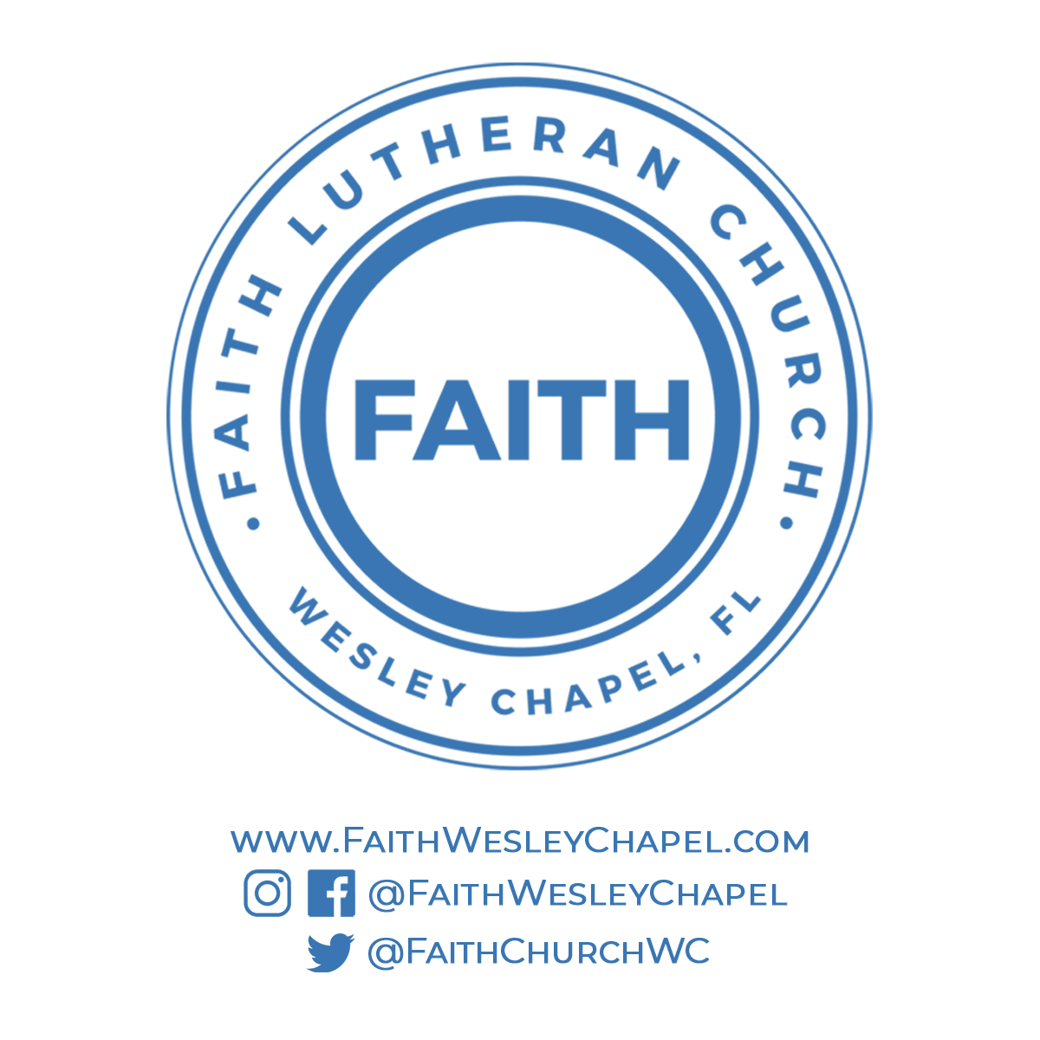**@FaithWesleyChapel**

**@FaithWesleyChapel**

**@FaithChurchWC**