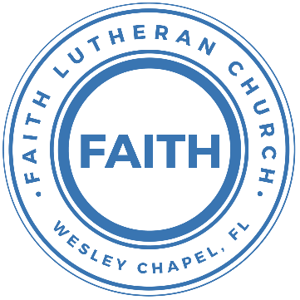

**Leading our community into a deep connection in Christ**

**Worship Service for July 14, 2024 at 11 AM**

**Welcome**

**Pray for the Food** - **People get food**

**Invocation** *(stand)*

**Confession and Forgiveness:** *(stand)*

**P:** As we gather, today, let us cleanse our hearts and our consciences by confessing our sin to God.

*(Time of silence for reflection and confession)*

**C:** Heavenly Father, we confess that we are sinful and unclean. We have sinned against you and against our neighbor in our thoughts, words, and actions.  We are truly sorry for our sins and sincerely repent of them. We ask for Your mercy. For the sake of Jesus Christ's bitter suffering and death, please forgive us and renew us that we may walk in Your Spirit to the glory of Your holy name. Amen

**P:** The Lord has heard your confession. Therefore, as a called and ordained servant of the Lord, in the stead and by the command of my Lord, Jesus Christ, I forgive you all your sins in the name of the Father and of the Son and of the Holy Spirit.  
**C:** Amen

**Apostles' Creed** *(stand)*

I believe in God, the Father almighty, maker of heaven and earth,  
And in Jesus Christ, his only Son, our Lord,  
who was conceived by the Holy Spirit,  
born of the Virgin Mary, suffered under Pontius Pilate,  
was crucified, died and was buried. He descended into hell.  
The third day he rose again from the dead.  
He ascended into heaven and sits at the right hand of God  
the Father almighty.  
From there he will come to judge the living and the dead.  
I believe in the Holy Spirit, the holy Christian Church,  
the communion of saints, the forgiveness of sins,  
the resurrection of the body, and the life everlasting. Amen.

**Offering** *(sit)*

**Prayers**

**First Reading:**Acts 2:37-41

Now when they heard this they were cut to the heart, and said to Peter and the rest of the apostles, “Brothers, what shall we do?” And Peter said to them, “Repent and be baptized every one of you in the name of Jesus Christ for the forgiveness of your sins, and you will receive the gift of the Holy Spirit. For the promise is for you and for your children and for all who are far off, everyone whom the Lord our God calls to himself.” And with many other words he bore witness and continued to exhort them, saying, “Save yourselves from this crooked generation.” So those who received his word were baptized, and there were added that day about three thousand souls.

**Reader:** This is the Word of the Lord.  
**C:** Thanks be to God.

**Gospel Reading** - Mark 6:17-20

For it was Herod who had sent and seized John and bound him in prison for the sake of Herodias, his brother Philip's wife, because he had married her. For John had been saying to Herod, “It is not lawful for you to have your brother's wife.” And Herodias had a grudge against him and wanted to put him to death. But she could not, for Herod feared John, knowing that he was a righteous and holy man, and he kept him safe. When he heard him, he was greatly perplexed, and yet he heard him gladly.

**P:** This is the Gospel of the Lord.  
**C:** Praise be to You, O Christ.

**Sermon Song –** When I Survey The Wondrous Cross

Verse 1  
When I survey the wondrous cross,  
On which the prince of glory died,  
My richest gain I count but loss,  
And pour contempt on all my pride.

Verse 2  
Forbid it, Lord, that I should boast,   
Save in the death of Christ my God.  
All the vain things that charm me most,   
I sacrifice them to His blood

Verse 3  
See from his head, His hands, His feet,  
Sorrow and love flow mingled down.  
Did e’er such love and sorrow meet,  
Or thorns compose so rich a crown

Verse 4  
Were the whole realm of nature mine,  
That were an present far too small  
Love so amazing so divine,  
Demands my soul, my life, my all. *© Public Domain*

**Sermon/Discussion** – "Go Prophesy Somewhere Else!"

Sermon/Discussion Amos 7:7-17

This is what he showed me: behold, the Lord was standing beside a wall built with a plumb line, with a plumb line in his hand. And the Lord said to me, “Amos, what do you see?” And I said, “A plumb line.” Then the Lord said,

“Behold, I am setting a plumb line  
 in the midst of my people Israel;  
 I will never again pass by them;  
the high places of Isaac shall be made desolate,  
 and the sanctuaries of Israel shall be laid waste,  
 and I will rise against the house of Jeroboam with the sword.”

Then Amaziah the priest of Bethel sent to Jeroboam king of Israel, saying, “Amos has conspired against you in the midst of the house of Israel. The land is not able to bear all his words. For thus Amos has said,

“‘Jeroboam shall die by the sword,  
 and Israel must go into exile  
 away from his land.’”

And Amaziah said to Amos, “O seer, go, flee away to the land of Judah, and eat bread there, and prophesy there, but never again prophesy at Bethel, for it is the king's sanctuary, and it is a temple of the kingdom.”

Then Amos answered and said to Amaziah, “I was no prophet, nor a prophet's son, but I was a herdsman and a dresser of sycamore figs. But the Lord took me from following the flock, and the Lord said to me, ‘Go, prophesy to my people Israel.’ Now therefore hear the word of the Lord.

“You say, ‘Do not prophesy against Israel,  
 and do not preach against the house of Isaac.’

Therefore thus says the Lord:

“‘Your wife shall be a prostitute in the city,  
 and your sons and your daughters shall fall by the sword,  
 and your land shall be divided up with a measuring line;  
you yourself shall die in an unclean land,  
 and Israel shall surely go into exile away from its land.’”

**The Lord's Prayer** *(stand)*

Our Father who art in heaven, hallowed be Thy name, Thy kingdom come, Thy will be done on earth as it is in heaven.  Give us this day our daily bread; and forgive us our trespasses as we forgive those who trespass against us; and lead us not into temptation, but deliver us from evil.  For Thine is the kingdom and the power and the glory forever and ever.  Amen

**Song –** Lord I Need You

Lord I come, I confess. Bowing here, I find my rest.  
Without You, I fall apart. You're the one that guides my heart.

Chorus:  
Lord, I need You, oh I need You. Every hour I need You.  
My one defense, my righteousness, Oh God, how I need You.

Where sin runs deep, Your grace is more.  
Where grace is found is where You are.  
And where You are Lord I am free. Holiness is Christ in me.

*(Chorus)*

So teach my song to rise to You, when temptation comes my way.  
And when I cannot stand I'll fall on You.   
Jesus, You're my hope and stay.

Chorus:Lord, I need You, oh I need You. Every hour I need You  
My one defense, my righteousness, Oh God, how I need You  
My one defense, my righteousness, Oh God, how I need You  
My one defense, my righteousness, Oh God, how I need You

© 2011 Sweater Weather Music, Valley Of Songs Music, and Thankyou Music

**Words of Institution** *(stand)*

**Distribution**

**Prayer** *(stand)*

**Benediction** *– The online service ends. The closing hymn video is on the Livestream page bulletin at FaithWesleyChapel.com with lyrics below. See announcements below as well.*

**Closing Song:** Praise God From Whom All Blessings Flow *(stand)*

Praise God from Whom all blessings flow.  
Praise Him all creatures here below.  
Praise Him above, ye heavenly hosts.  
Praise Father, Son and Holy Ghost.  
Amen

|  |  |
| --- | --- |
| **Serving This Week** | |
|  | |
| **O.T. Reader:** N/A | **Children’s Church Teacher:** |
| **Epistle Reader:** Darlene Mueller | Melissa Steinbrueck |
| **Acolyte:** Kaylee Steinbrueck | **Children’s Church Assistant:** |
| **Com. Asst:** Larry Chmiel | Kaylee Steinbrueck |
|  | |
| **Serving Next Week** | |
|  | |
| **O.T. Reader:** Vanessa Frost | **Children’s Church Teacher:** |
| **Epistle Reader:** Josh Strasheim | Halston & Ben |
| **Acolyte:** Lawrence Finnerty | **Children’s Church Assistant:** |
| **Com. Asst:** N/A | N/A |

**Upcoming Events**

**Today – After Service 1-2:30 PM, Loving God with Your Mind  
(Snacks and Bible Study)**Pastor Kurt’s Home – 4414 Crystal Downs Ct. W.C. FL, 33543

**Aug 3 – Aquatica (Open 9 AM–6 PM)**$40/adult or +$8 to add a meal. Kids and Youth are FREE!  
Order by TODAY!!!

**Aug 13 – 7pm, Growth Group**   
Renee’s home - 3436 Chapel Creek Cir, Wesley Chapel, FL 33544

**Aug 17 – 4 PM, T.B. Rays Faith Night**

**Aug 25, 5 PM Youth Game Night**  
The Frost’s Home

**www.FaithWesleyChapel.com**

**Faith YouTube**

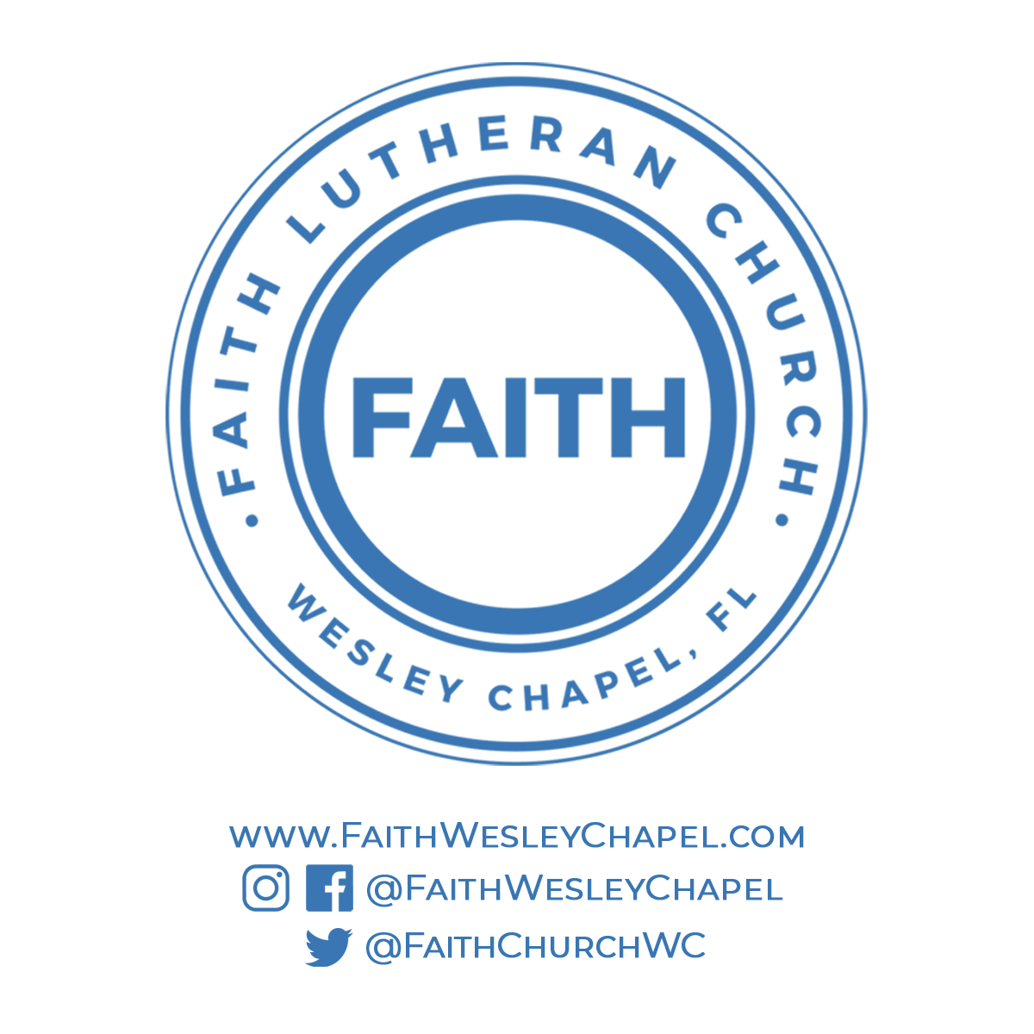**@FaithWesleyChapel**

**@FaithWesleyChapel**

**@FaithChurchWC**