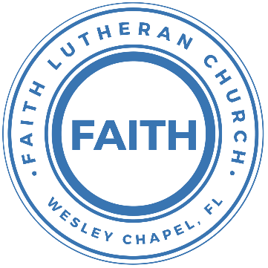

**Leading our community into a deep connection in Christ**

**Worship Service for August 4, 2024 at 11 AM**

**Welcome**

**Opening Song:**Father Abraham

Father Abraham had many sons. Many sons had Father Abraham.

I am one of them and so are you. So, let's just praise the Lord!

Right arm  
Left arm  
Right foot  
Left foot  
Chin up  
Turn around  
Sit down © Public Domain

**Invocation**

**Confession and Forgiveness:**

**P:** We have come here today to worship the Lord.  In worship we hear the Word of God, we receive God's blessings, and respond with thanks and praise.  We begin by seeking God's blessing of forgiveness.  He has promised to remove the guilt and shame of our sin through the sacrifice of Jesus Christ on the cross.

*(a time of silence to reflect and personally confess our sins)*

**P:** Let us confess our sins to the Lord.

**P:** Heavenly Father,  
**C:** Heavenly Father,

**P:** I have done things that were wrong.  
**C:** I have done things that were wrong.  
  
**P:** I have been mean to others.  
**C:** I have been mean to others.

**P:** I have not obeyed my parents.  
**C:** I have not obeyed my parents.

**P:** I have not obeyed You, God.  
**C:** I have not obeyed You, God.

**P:** But I am very sorry.  
**C:** But I am very sorry.

**P:** Please forgive me.  
**C:** Please forgive me.

**P:** I love You very much.  
**C:** I love You very much.

**P:** And I know You love me, too.  
**C:** And I know You love me, too.

**P:** Amen.  
**C:** Amen.

**P:** God has heard your apology.  He loves you very much.  God has told us that when we believe and trust in Him, He makes us His children.  As far as the east is from the west, so far does he remove our sins from us. He has told me to tell you that you are forgiven.  So, as His servant, I forgive you in the name of the Father and of the Son and of the Holy Spirit.   
**C:** Amen.

**Song:**Jesus Loves Me

Verse 1:

Jesus loves me this I know, for the Bible tells me so.

Little ones to Him belong. They are weak, but He is strong.

Chorus:

Yes, Jesus loves me. Yes, Jesus loves me.

Yes, Jesus loves me, the Bible tells me so.

Verse 2:

Jesus loves me, He who died, Heaven's gates to open wide.

He will wash away my sin, let His little child come in.

*(Chorus)* © Public Domain

**First Reading -**Exodus 16:2-3

Then the whole community of Israelites began complaining again. They complained to Moses and Aaron in the desert. They said, “It would have been better if the Lord had just killed us in the land of Egypt. At least there we had plenty to eat. We had all the food we needed. But now you have brought us out here into this desert to make us all die from hunger.”

**Reader:** This is the Word of the Lord.  
**C:** Thanks be to God.

**Children's Message**"The Complainer"

**Song:**You Are Holy (Prince Of Peace)

Verse:

You are holy. *(Women echo)* You are mighty. *(Women echo)*

You are worthy, *(Women echo)* Worthy of praise *(Women echo)*

I will follow. *(Women echo)* I will listen. *(Women echo)*

I will love You, *(Women echo)* All of my days. *(Women echo)*

*Chorus:*

*(MEN) (WOMEN)*

I will sing to He is Lord of Lords

And worship He is King of Kings

The King who He is Mighty God

Is worthy Lord of everything

I will love and He's Emmanuel

Adore Him He's the Great I Am

And I will bow down He's my Prince of Peace

before Him Who is the Lamb

I will sing to He's my Living God

And worship He's my Saving Grace

The King who He will reign forever

Is worthy He is Ancient of Days

I will love and He is Alpha, Omega

Adore Him Beginning and End

And I will bow down He's my Savior, Messiah

Before Him Redeemer and friend

All: He's my Prince of Peace, and I will live my life for Him.  
 © 1994 Imboden Music and Martha Jo Publishing

**Second Reading -**John 6:25–26

The people found Jesus on the other side of the lake. They asked him, “Teacher, when did you come here?” He answered, “Why are you looking for me? Is it because you saw miraculous signs? The truth is, you are looking for me because you ate the bread and were satisfied.

**Reader:** This is the Word of the Lord.  
**C:** Thanks be to God.

**Children's Message**"If you give me what I want."

**Gospel Reading -**John 6:25-35

When they found him on the other side of the sea, they said to him, “Rabbi, when did you come here?” Jesus answered them, “Truly, truly, I say to you, you are seeking me, not because you saw signs, but because you ate your fill of the loaves. Do not work for the food that perishes, but for the food that endures to eternal life, which the Son of Man will give to you. For on him God the Father has set his seal.” Then they said to him, “What must we do, to be doing the works of God?” Jesus answered them, “This is the work of God, that you believe in him whom he has sent.” So they said to him, “Then what sign do you do, that we may see and believe you? What work do you perform? Our fathers ate the manna in the wilderness; as it is written, ‘He gave them bread from heaven to eat.’” Jesus then said to them, “Truly, truly, I say to you, it was not Moses who gave you the bread from heaven, but my Father gives you the true bread from heaven. For the bread of God is he who comes down from heaven and gives life to the world.” They said to him, “Sir, give us this bread always.”

Jesus said to them, “I am the bread of life; whoever comes to me shall not hunger, and whoever believes in me shall never thirst.

**P:** This is the Gospel of the Lord.  
**C:** Praise be to You, O Christ.

**Sermon Hymn:**Seek Ye First

Seek ye first, the Kingdom of God and His righteousness,  
And all these things shall be added unto you. Allelu, Alleluia.

Ask and it shall be given unto you. Seek and ye shall find.  
Knock and it shall be opened unto you. Allelu, Alleluia.

Man shall not live by bread alone, but by every word,  
That proceeds out from the mouth of the Lord. Allelu, Alleluia.

© Public Domain

**Sermon –**"It Was Better Before. I Want to Go Back!"

**Prayers:** *Text in prayer requests to (813) 326-5255*

**The Lord's Prayer** *(stand)*

Our Father who art in heaven, hallowed be Thy name, Thy kingdom come, Thy will be done on earth as it is in heaven.  Give us this day our daily bread; and forgive us our trespasses as we forgive those who trespass against us; and lead us not into temptation, but deliver us from evil.  For Thine is the kingdom and the power and the glory forever and ever.  Amen

**Offering**

**Benediction** *– The online service ends. The closing hymn video is on the Livestream page bulletin at FaithWesleyChapel.com with lyrics below. See announcements below as well.*

**Closing Song:**Gratitude

All my words fall short. I got nothing new.  
How could I express all my gratitude?

I could sing these songs, as I often do

But every song must end and You never do

Chorus:

So I throw up my hands and praise You again and again

'Cause all that I have is a Hallelujah. Hallelujah!

And I know it's not much but I've nothing else fit for a King

Except for a heart singing, Hallelujah  Hallelujah

I've got one response. I've got just one move

With my arm stretched wide, I will worship You

*(Chorus)*

Bridge:

So come on, my soul, oh, don't you get shy on me. Lift up your song,

'Cause you've got a lion inside of those lungs

Get up and praise the Lord

*(Repeat 2x)*

*(Chorus)*© 2021 Bethel Worship Publishing

|  |  |
| --- | --- |
| **Serving This Week** | |
|  | |
| **1st Reader:** Eli Bingaman | **Children’s Church Teacher:** |
| **2nd Reader:** Alanna Bingaman | N/A – No Children’s Church |
| **Acolyte:** Kaylee Steinbrueck | **Children’s Church Assistant:** |
| **Com. Asst:** Larry Chmiel | N/A – No Children’s Church |
|  | |
| **Serving Next Week** | |
|  | |
| **O.T. Reader:** Darlene Muller | **Children’s Church Teacher:** |
| **Epistle Reader:** Vanessa Frost | Need Volunteer |
| **Acolyte:** Lawrence Finnerty | **Children’s Church Assistant:** |
| **Com. Asst:** Larry Chmiel | N/A |

**Hey Youth!!**Do you know any worship songs you’d like to sing as part of our youth service? Let Pastor Kurt know.

Do you want to sing or play an instrument? Let Pastor Kurt know.

We want you to be a part of the service.

**Upcoming Events**

**Aug 13 – 7pm, Growth Group**   
Renee’s Son’s home

**Aug 17 – 4 PM, T.B. Rays Faith Night**

**Aug 25, 5 PM Youth Game Night**  
The Frost’s Home

**www.FaithWesleyChapel.com**

**Faith YouTube**

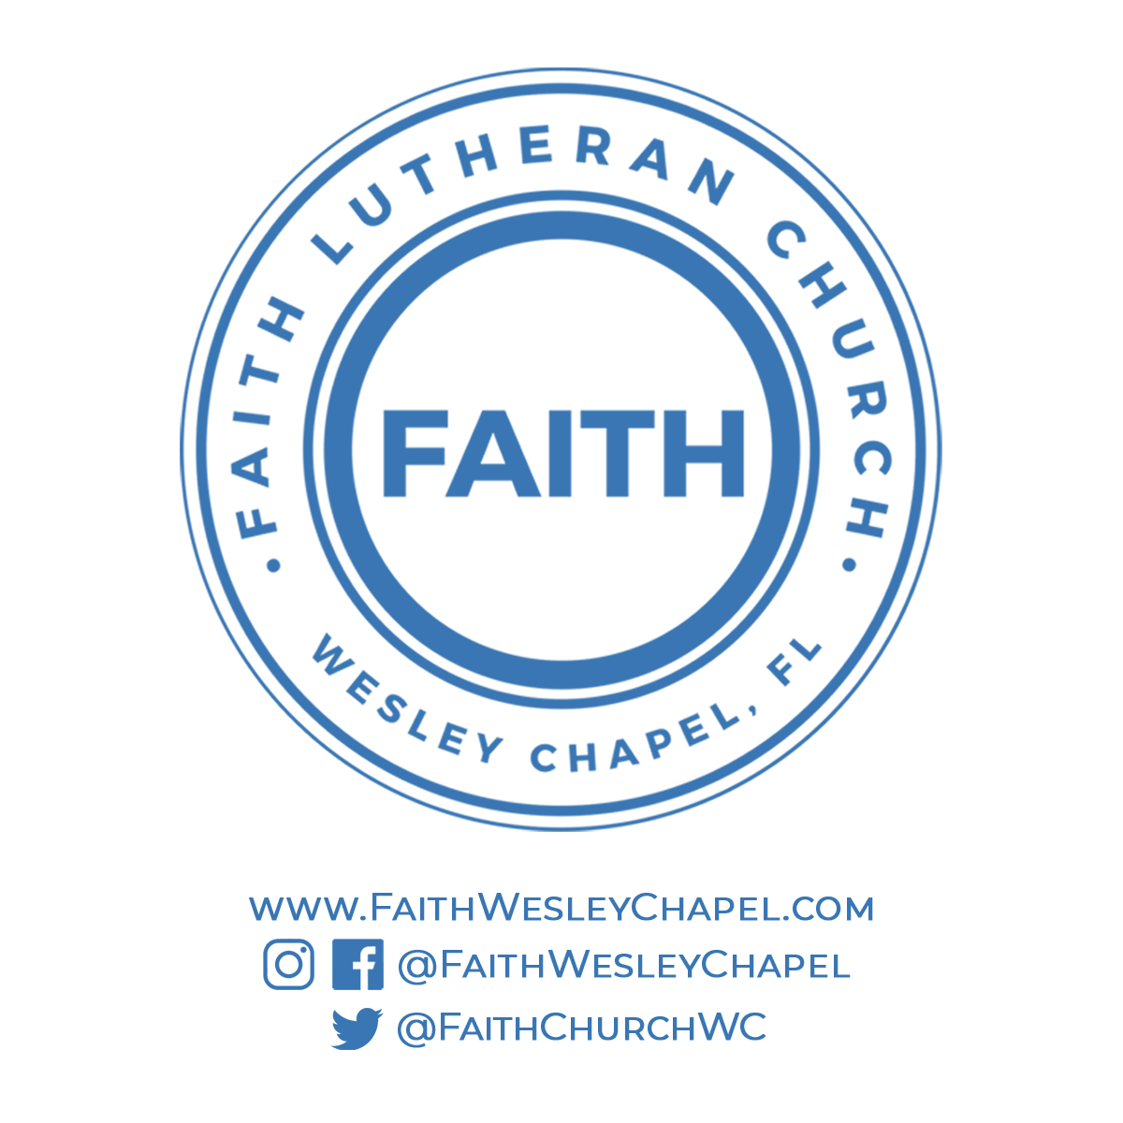**@FaithWesleyChapel**

**@FaithWesleyChapel**

**@FaithChurchWC**