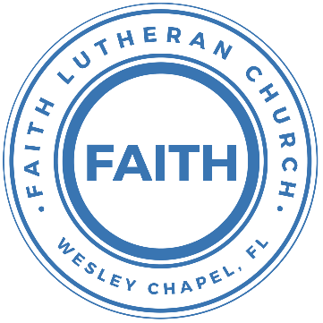

**Leading our community into a deep connection in Christ**

**___________________________________________________**

**Worship Service for August 18, 2024 at 11 AM**

**Welcome**

**Opening song:** God So Loved

Come all you weary. Come all you thirsty.

Come to the well that never runs dry.

Drink of the Water. Come and thirst no more.

Come all you sinners. Come find His mercy.

Come to the table. He Will satisfy.

Taste of His goodness. Find what you’re looking for.

Chorus 1:

For God so loved the World that He gave us,

His one and only Son to save us.

Whoever believes in Him, will live forever.

Bring all your failures. Bring your addictions.

Come lay them down at the Foot of the cross.

Jesus is waiting there with open arms.

*(Chorus 1)*

Chorus 2:

The power of Hell forever defeated.

Now, it is well. I’m Walking in freedom.

For God so loved, God so loved the world.

Bridge:

Praise God! Praise God from whom all blessings flow.

Praise Him! Praise Him for the wonders of His love.

*(Repeat)*

His amazing love!

Chorus 1 and 2:

For God so loved the World that He gave us,

His one and only Son to save us.

Whoever believes in Him, will live forever.  
The power of Hell forever defeated.

Now, it is well. I’m Walking in freedom.

For God so loved, God so loved the world.

Bring all your failures. Bring your addictions.

Come lay them down at the Foot of the cross.

Jesus is waiting there with open arms. © 2019 Andrew Bergthold Designee

**Invocation**

**Confession and Forgiveness:**

**P:** Our Heavenly Father asks us to come into His presence.  
**C:** But we are sinful and unworthy.

**P:** Yes, all have sinned and fall short of the glory of God, but Jesus Christ died on the cross that we may be forgiven and washed clean of all our sins by His blood spilled on the cross.  
**C:** Lord, if You wash us, we will certainly be clean and pure.

**P:** We take a moment to bow before the His cross and silently reflect on our lives and confess our sins.

*(Time of silence for reflection and confession)*

**P:** Let us confess, together, our sins to God our Father.  
**C:** Heavenly Father, we confess that we are sinners.  We have sinned against you and our neighbors. We have not loved you with our whole heart and we have not loved our neighbors as ourselves. We have not lived out our faith in our community. We justly deserve Your punishment.  For the sake of Your Son, Jesus Christ, have mercy on us.  Forgive us, renew us, and lead us, so that we may delight in Your will and walk in Your ways to the glory of Your holy name.  Amen.

**P:** *(Word of Forgiveness)*  
**C:** Amen

**Song of Praise and Thanksgiving:** By Grace I'm Saved

By grace I'm saved, grace free and boundless.  
My soul, believe and doubt it not.  
Why stagger at this word of promise?  
Has Scripture ever falsehood taught?  
No! Then this word must true remain;  
By grace you too will life obtain.

By grace God's Son, our only Savior,

Came down to earth to bear our sin.

Was it because of your own merit,

That Jesus died your soul to win?

No, it was grace, and grace alone,

That brought Him from His heav'nly throne.

By grace! On this I'll rest when dying.

In Jesus' promise I rejoice!

For though I know my heart's condition,

I also know my Savior's voice.

My heart is glad, all grief has flown,

Since I am saved by grace alone. © Public Domain

**Old Testament Reading** – Isaiah 43:8-13

Bring out the people who are blind, yet have eyes, who are deaf, yet have ears! All the nations gather together, and the peoples assemble. Who among them can declare this, and show us the former things? Let them bring their witnesses to prove them right, and let them hear and say, It is true. “You are my witnesses,” declares the Lord, “and my servant whom I have chosen, that you may know and believe me and understand that I am he. Before me no god was formed, nor shall there be any after me.  
I, I am the Lord, and besides me there is no savior. I declared and saved and proclaimed, when there was no strange god among you; and you are my witnesses,” declares the Lord, “and I am God. Also henceforth I am he; there is none who can deliver from my hand; I work, and who can turn it back?”

**Reader:** This is the Word of the Lord. **C:** Thanks be to God.

**Epistle Reading** - 1 Timothy 2:1-6

First of all, then, I urge that supplications, prayers, intercessions, and thanksgivings be made for all people, for kings and all who are in high positions, that we may lead a peaceful and quiet life, godly and dignified in every way. This is good, and it is pleasing in the sight of God our Savior, who desires all people to be saved and to come to the knowledge of the truth. For there is one God, and there is one mediator between God and men, the man Christ Jesus, who gave himself as a ransom for all, which is the testimony given at the proper time.

**Reader:** This is the Word of the Lord. **C:** Thanks be to God.

**Gospel Reading** - John 14:1-7

“Let not your hearts be troubled. Believe in God; believe also in me. In my Father's house are many rooms. If it were not so, would I have told you that I go to prepare a place for you? And if I go and prepare a place for you, I will come again and will take you to myself, that where I am you may be also. And you know the way to where I am going.” Thomas said to him, “Lord, we do not know where you are going. How can we know the way?” Jesus said to him, “I am the way, and the truth, and the life. No one comes to the Father except through me. If you had known me, you would have known my Father also. From now on you do know him and have seen him.”

**P:** This is the Gospel of the Lord. **C:** Praise be to You, O Christ.

**Children's Message** *(Children dismissed to Children's Church)*

**Sermon Hymn***–*In Christ Alone

In Christ alone my hope is found.   
He is my light, my strength, my song.  
This Cornerstone, this solid ground,  
Firm through the fiercest drought and storm.  
What heights of love, what depths of peace,  
When fears are stilled, when strivings cease.  
My Comforter, my All in All. Here in the love of Christ I stand.

In Christ alone, who took on flesh,   
Fullness of God in helpless babe.  
This gift of love and righteousness,   
Scorned by the ones He came to save.  
‘Til on that cross as Jesus died,   
The wrath of God was satisfied.  
For every sin on Him was laid, Here in the death of Christ I live.

There in the ground His body lay,   
Light of the world by darkness slain.  
Then bursting forth in glorious Day,   
Up from the grave He rose again.  
And as He stands in victory,   
Sin’s curse has lost its grip on me.  
For I am His and He is mine,   
Bought with the precious blood of Christ.

No guilt in life, no fear in death,   
This is the power of Christ in me.  
From life’s first cry to final breath,   
Jesus commands my destiny.  
No power of hell, no scheme of man,   
Can ever pluck me from His hand.  
‘Til He returns or calls me home,   
Here in the power of Christ I’ll stand.  
No power of hell, no scheme of man,   
Can ever pluck me from His hand.  
‘Til He returns or calls me home,   
Here in the power of Christ I’ll stand. © 2001 Thankyou Music

**Sermon** - "Are All Religions Basically the Same?"

**Prayers:** *Text in prayer requests to (813) 326-5255*

**Nicene Creed** *(stand)*

I believe in one God, the Father Almighty, maker of heaven and earth and of all things visible and invisible.

And in one Lord Jesus Christ, the only-begotten Son of God, begotten of His Father before all worlds, God of God, Light of Light, very God of very God, begotten, not made, being of one substance with the Father, by whom all things were made; who for us men and for our salvation came down from heaven and was incarnate by the Holy Spirit of the virgin Mary and was made man; and was crucified also for us under Pontius Pilate. He suffered and was buried. And the third day He rose again according to the Scriptures and ascended into heaven and sits at the right hand of the Father. And He will come again with glory to judge both the living and the dead, whose kingdom will have no end.

And I believe in the Holy Spirit, the Lord and Giver of Life, who proceeds from the Father and the Son, who with the Father and the Son together is worshiped and glorified, who spoke by the prophets. And I believe in one holy Christian and apostolic Church, I acknowledge one Baptism for the remission of sins, and I look for the resurrection of the dead and the life of the world to come. Amen.

**The Lord's Prayer** *(stand)*

Our Father who art in heaven, hallowed be Thy name, Thy kingdom come, Thy will be done on earth as it is in heaven.  Give us this day our daily bread; and forgive us our trespasses as we forgive those who trespass against us; and lead us not into temptation, but deliver us from evil.  For Thine is the kingdom and the power and the glory forever and ever.  Amen

**Offering**

**Benediction** *– The online service ends. The closing hymn video is on the Livestream page bulletin at FaithWesleyChapel.com with lyrics below. See announcements below as well.*

**Closing Song: Closing Song:**Gratitude

All my words fall short. I got nothing new.  
How could I express all my gratitude?

I could sing these songs, as I often do

But every song must end and You never do

Chorus:

So I throw up my hands and praise You again and again

'Cause all that I have is a Hallelujah. Hallelujah!

And I know it's not much but I've nothing else fit for a King

Except for a heart singing, Hallelujah  Hallelujah

I've got one response. I've got just one move

With my arm stretched wide, I will worship You

*(Chorus)*

Bridge:

So come on, my soul, oh, don't you get shy on me. Lift up your song,

'Cause you've got a lion inside of those lungs

Get up and praise the Lord

*(Repeat 2x)*

*(Chorus)*© 2021 Bethel Worship Publishing

|  |  |
| --- | --- |
| **Serving This Week** | |
|  | |
| **O.T. Reader:** Ginger Torgrimson | **Children’s Church Teacher:** |
| **Epistle Reader:** Ginger Dunn | Melissa Steinbrueck |
| **Acolyte:** Kaylee Steinbrueck | **Children’s Church Assistant:** |
| **Com. Asst:** Larry Chmiel | Kaylee Steinbrueck |
|  | |
| **Serving Next Week** | |
|  | |
| **O.T. Reader:** Josh Strasheim | **Children’s Church Teacher:** |
| **Epistle Reader:** Larry Chmiel | Halston & Ben |
| **Acolyte:** Jacob Torgrimson | **Children’s Church Assistant:** |
| **Com. Asst:** Larry Chmiel | N/A |

**Upcoming Events**

**Aug 20 – 7pm, Council Meeting**   
Larry’s home

**Aug 25, 5 PM Youth Game Night**  
The Frost’s Home

**Aug 27, 7 PM Growth Group**  
Renee’s Home

[**www.FaithWesleyChapel.com**](http://www.FaithWesleyChapel.com)

 **Faith YouTube**

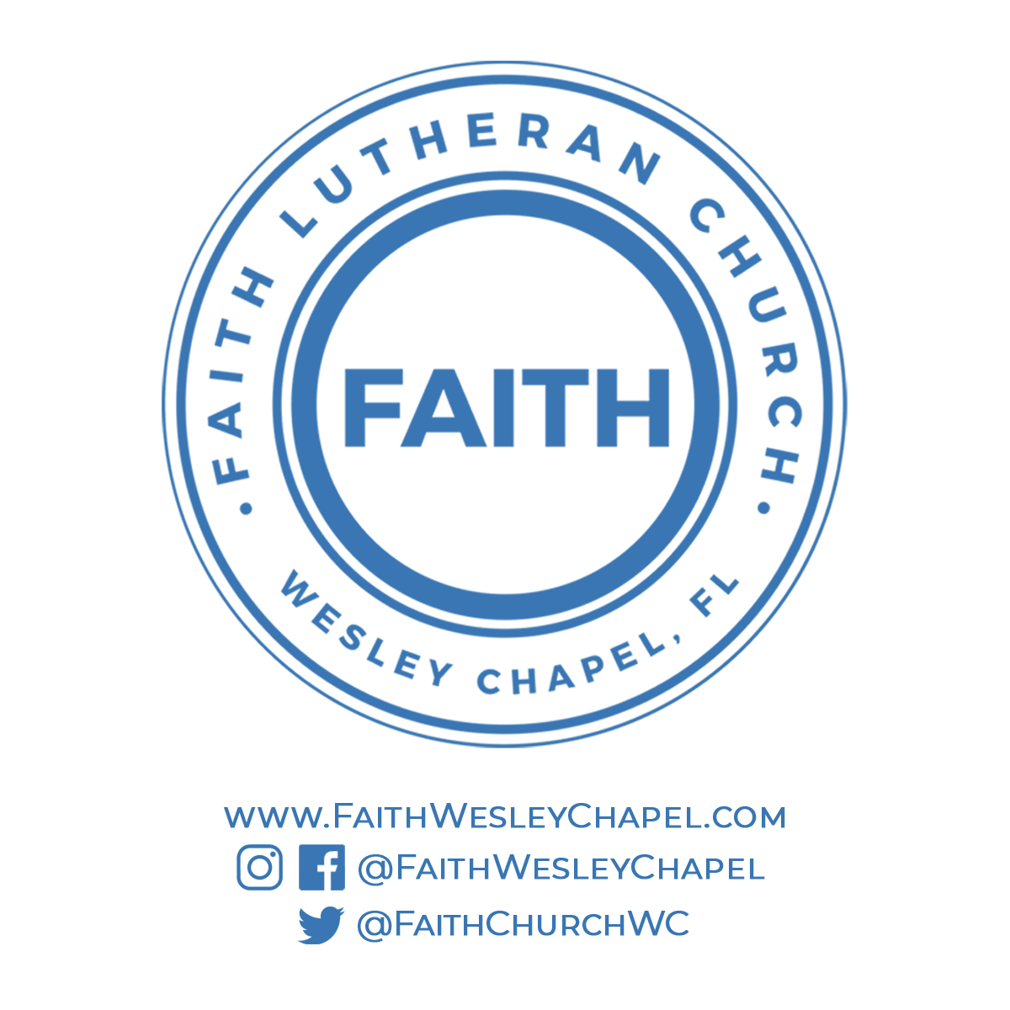**@FaithWesleyChapel**

**@FaithWesleyChapel**

**@FaithChurchWC**