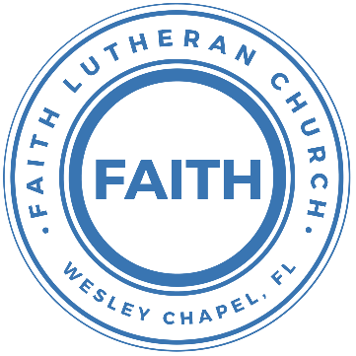

**Leading our community into a deep connection in Christ**

**Worship Service for September 1, 2024 at 11 AM**

**Welcome**

**Opening Song:**I Just Wanna Be A Sheep

Chorus:  
I just wanna be a sheep, baa baa baa baa.  
I just wanna be a sheep, baa baa baa baa.  
I pray the Lord my soul to keep,   
I just wanna be a sheep, baa baa baa baa.

Verse 1:  
Don't wanna be a goat...nope! Don't wanna be a goat...nope!  
Haven't got any hope...nope! Don't wanna be a goat...nope!

Verse 4:  
Don't wanna be a Sadducee. Don't wanna be a Sadducee.  
'Cause they're so sad you see. Don't wanna be a Sadducee.

*(Chorus)*

Verse 5:  
Just wanna be a child of God. Just wanna be a child of God.  
Walkin' the same path He trod. Just wanna be a child of God.

*(Chorus)*  © 1974 Mission Hills Music

**Invocation**

**Confession and Forgiveness:**

**P:** We have come here today to worship the Lord.  In worship we hear the Word of God, we receive God's blessings, and respond with thanks and praise.  We begin by seeking God's blessing of forgiveness.  He has promised to remove the guilt and shame of our sin through the sacrifice of Jesus Christ on the cross.

*(a time of silence to reflect and personally confess our sins)*

**P:** Let us confess our sins to the Lord.

**P:** Heavenly Father,  
**C:** Heavenly Father,

**P:** I have done things that were wrong.  
**C:** I have done things that were wrong.  
  
**P:** I have been mean to others.  
**C:** I have been mean to others.

**P:** I have not obeyed my parents.  
**C:** I have not obeyed my parents.

**P:** I have not obeyed You, God.  
**C:** I have not obeyed You, God.

**P:** But I am very sorry.  
**C:** But I am very sorry.

**P:** Please forgive me.  
**C:** Please forgive me.

**P:** I love You very much.  
**C:** I love You very much.

**P:** And I know You love me, too.  
**C:** And I know You love me, too.

**P:** Amen.  
**C:** Amen.

**P:** God has heard your apology.  He loves you very much.  God has told us that when we believe and trust in Him, He makes us His children.  As far as the east is from the west, so far does he remove our sins from us. He has told me to tell you that you are forgiven.  So, as His servant, I forgive you in the name of the Father and of the Son and of the Holy Spirit.   
**C:** Amen.

**Song:**God Is So Good

God is so good. God is so good.  
God is so good. He's so good to me.

He died for me. He died for me so.  
He died for me. He's so good to me.

He loves me so. He loves me so.  
He loves me so. He's so good to me. © Public Domain

**First Reading -**Deuteronomy 4:1a, 2

Israel's people, listen to the rules and laws that I will now teach you. If you obey them, you will live....Do not add anything to these rules. Do not remove anything from them. You must obey the commands of the Lord your God that I am giving to you.

**Reader:** This is the Word of the Lord.  
**C:** Thanks be to God.

**Children's Message**"God Is Always Right"

**Song:**Who You Say I Am

Who am I that the highest King would welcome me?

I was lost but He brought me in. Oh, His love for me.

Oh, His love for me.

Chorus 1:

Who the Son sets free, Oh is free indeed.

I'm a child of God, Yes I am.

Free at last He has ransomed me. His grace runs deep.

While I was a slave to sin Jesus died for me. Yes, He died for me.

Chorus 2:

Who the Son sets free, oh is free indeed.

I'm a child of God, Yes I am.

In my Father's house there's a place for me.

I'm a child of God, Yes I am.

I am chosen, not forsaken. I am who You say I am

You are for me, not against me. I am who You say I am  
I am chosen, not forsaken. I am who You say I am

You are for me, not against me. I am who You say I am

I am who You say I am

*(Chorus 2)*

*(Chorus 2 second half, "In my Father's house...")* © 2017 Hillsong Music Publishing (Admin. by Capitol CMG Publishing)

**Second Reading -**Deuteronomy 4:6

Obey them carefully. That will show people of other nations that you are wise. They will hear about all your laws. Then they will say, ‘The people of this great nation are very wise and clever!’

**Reader:** This is the Word of the Lord.  
**C:** Thanks be to God.

**Children's Message**"It's for Our Good"

**Gospel Reading -**Mark 7:14–23

And he called the people to him again and said to them, “Hear me, all of you, and understand: There is nothing outside a person that by going into him can defile him, but the things that come out of a person are what defile him.” And when he had entered the house and left the people, his disciples asked him about the parable. And he said to them, “Then are you also without understanding? Do you not see that whatever goes into a person from outside cannot defile him, since it enters not his heart but his stomach, and is expelled?” (Thus he declared all foods clean.) And he said, “What comes out of a person is what defiles him. For from within, out of the heart of man, come evil thoughts, sexual immorality, theft, murder, adultery, coveting, wickedness, deceit, sensuality, envy, slander, pride, foolishness. All these evil things come from within, and they defile a person.”

**P:** This is the Gospel of the Lord.  
**C:** Praise be to You, O Christ.

**Sermon Hymn:**Turn Your Eyes Upon Jesus

O soul are you weary and troubled?

No light in the darkness you see?

There's light for a look at the Savior,

And life more abundant and free.

Chorus:

Turn your eyes upon Jesus,

Look full in His wonderful face;

And the things of earth will grow strangely dim,

In the light of His glory and grace.

Through death into life everlasting,

He passed, and we follow Him there.

Over us sin no more hath dominion,

For more than conqu'rors we are.

*(Chorus)*

His word shall not fail you He promised

Believe Him and all will be well.

Then go to a world that is dying,

His perfect salvation to tell

*(Chorus)* © 1922 Public Domain, Words: New Spring, and Music: 1922 New Spring

**Sermon –**"Trust What Is from God Not from Man"

**Prayers:** *Text in prayer requests to (813) 326-5255*

**The Lord's Prayer** *(stand)*

Our Father who art in heaven, hallowed be Thy name, Thy kingdom come, Thy will be done on earth as it is in heaven.  Give us this day our daily bread; and forgive us our trespasses as we forgive those who trespass against us; and lead us not into temptation, but deliver us from evil.  For Thine is the kingdom and the power and the glory forever and ever.  Amen

**Offering**

**Benediction** *– The online service ends. The closing hymn video is on the Livestream page bulletin at FaithWesleyChapel.com with lyrics below. See announcements below as well.*

**Closing Song:**Every Move I Make

Verse:  
Every move I make, I make in You. You make me move, Jesus.  
Every breath I take, I breathe in You.

Every step I take, I take in You. You are my way, Jesus.  
Every breath I take, I breathe in You.

Chorus:  
Waves of mercy, Waves of grace,  
Everywhere I look, I see Your face.  
Your love has captured me. Oh my God, this love, how can it be?

Bridge:  
Na Na Na... *(Repeat)*

*(Verse)  
(Chorus)  
(Bridge (2x)* © 1996 Mercy/Vineyard Publishing, Vineyard Songs Canada, and ION Publishing

|  |  |
| --- | --- |
| **Serving This Week** | |
|  | |
| **1st Reader:** Kaylee Steinbrueck | **Children’s Church Teacher:** |
| **2nd Reader:** Alanna Bingaman | N/A – No Children’s Church |
| **Acolyte:** Jakob Torgrimson | **Children’s Church Assistant:** |
| **Com. Asst:** Larry Chmiel | N/A – No Children’s Church |
|  | |
| **Serving Next Week** | |
|  | |
| **O.T. Reader:** Josh Strashmeim | **Children’s Church Teacher:** |
| **Epistle Reader:** N/A | Melissa Steinbrueck |
| **Acolyte:** Kaylee Steinbrueck | **Children’s Church Assistant:** |
| **Com. Asst:** Larry Chmiel | Kaylee Steinbrueck |

**Hey Youth!!**Do you know any worship songs you’d like to sing as part of our youth service? Let Pastor Kurt know.

Do you want to sing or play an instrument? Let Pastor Kurt know.

We want you to be a part of the service.

**Upcoming Events**

**Sept 8, After Service – Voter Meeting**   
Faith Lutheran Church

**Sept 10, 7pm – Growth Group**  
Renee’s home

**Sept 29, 11am - Commitment Sunday**Faith Lutheran Church

**www.FaithWesleyChapel.com**

**Faith YouTube**

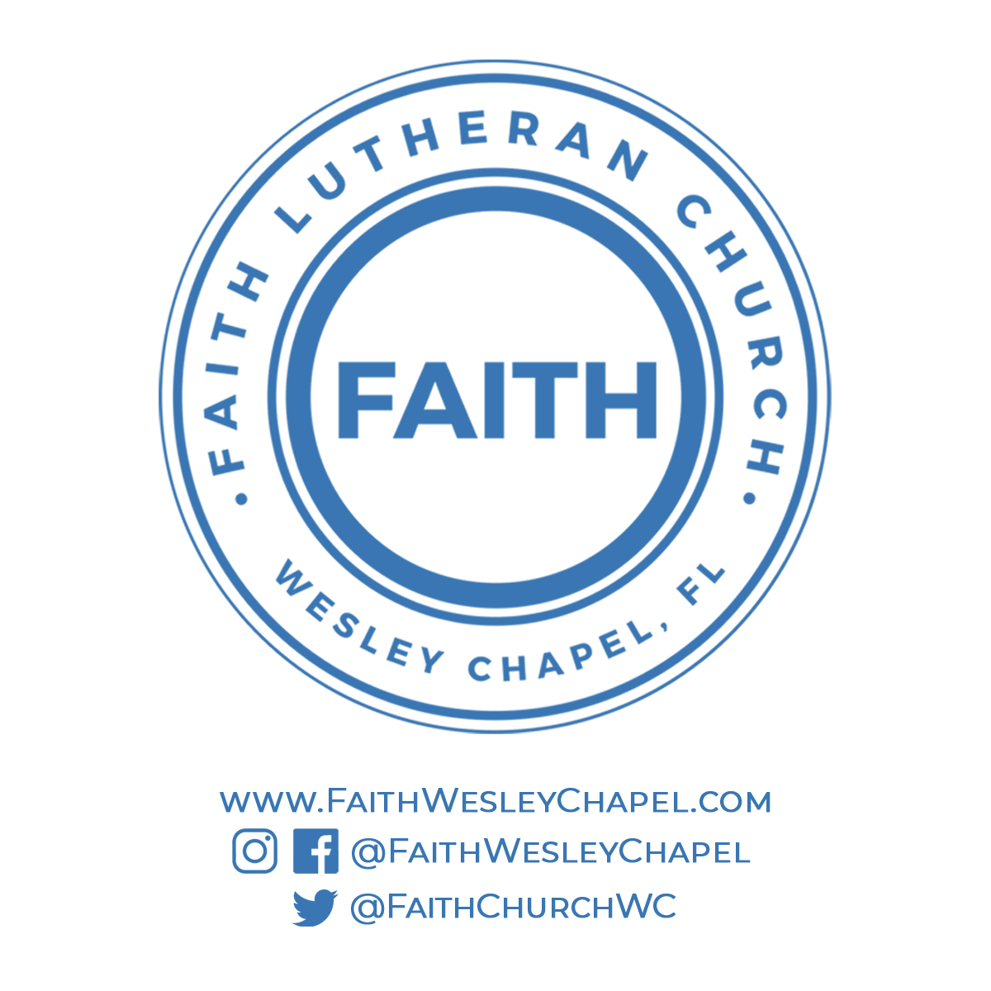**@FaithWesleyChapel**

**@FaithWesleyChapel**

**@FaithChurchWC**