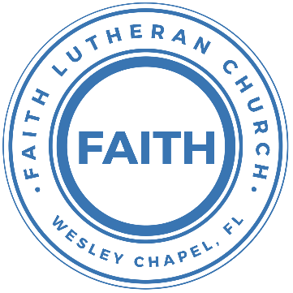

**Leading our community into a deep connection in Christ**

**___________________________________________________**

**Worship Service for September 15, 2024 at 11 AM**

**Welcome**

**Invocation**

**Confession and Forgiveness:**

**P:** Our Heavenly Father asks us to come into His presence.  
**C:** But we are sinful and unworthy.

**P:** Yes, all have sinned and fall short of the glory of God, but Jesus Christ died on the cross that we may be forgiven and washed clean of all our sins by His blood spilled on the cross.  
**C:** Lord, if You wash us, we will certainly be clean and pure.

**P:** We take a moment to bow before the His cross and silently reflect on our lives and confess our sins.

*(Time of silence for reflection and confession)*

**P:** Let us confess, together, our sins to God our Father.  
**C:** Heavenly Father, we confess that we are sinners.  We have sinned against you and our neighbors. We have not loved you with our whole heart and we have not loved our neighbors as ourselves. We have not lived out our faith in our community. We justly deserve Your punishment.  For the sake of Your Son, Jesus Christ, have mercy on us.  Forgive us, renew us, and lead us, so that we may delight in Your will and walk in Your ways to the glory of Your holy name.  Amen.

**P:** Almighty God in His mercy has given His Son to die for you and for His sake forgives you all your sins.  As a called and ordained servant of Christ, and by His authority, I, therefore, forgive you all your sins in the name of the Father and of the Son and of the Holy Spirit.  
**C:** Amen

**Song of Praise and Thanksgiving:** Amazing Grace

Amazing grace, how sweet the sound that saved a wretch like me.

I once was lost, but now am found. Was blind but now I see.

T'was grace that taught my heart to fear,

And grace my fears relieved.

How precious did that grace appear, the hour I first believed.

When we've been there ten thousand years,  
bright shining as the sun,

we've no less days to sing God’s praise,  
than when we've first begun. © Public Domain

**Old Testament Reading** - Isaiah 50:4-10

The Lord God has given me

the tongue of those who are taught,

that I may know how to sustain with a word

him who is weary.

Morning by morning he awakens;

he awakens my ear

to hear as those who are taught.

The Lord God has opened my ear,

and I was not rebellious;

I turned not backward.

I gave my back to those who strike,

and my cheeks to those who pull out the beard;

I hid not my face

from disgrace and spitting.

But the Lord God helps me;

therefore I have not been disgraced;

therefore I have set my face like a flint,

and I know that I shall not be put to shame.

He who vindicates me is near.

Who will contend with me?

Let us stand up together.

Who is my adversary?

Let him come near to me.

Behold, the Lord God helps me;

who will declare me guilty?

Behold, all of them will wear out like a garment;

the moth will eat them up.

Who among you fears the Lord

and obeys the voice of his servant?

Let him who walks in darkness

and has no light

trust in the name of the Lord

and rely on his God.

**Reader:** This is the Word of the Lord.  
**C:** Thanks be to God.

**Epistle Reading** - James 3:5-12

So also the tongue is a small member, yet it boasts of great things.

How great a forest is set ablaze by such a small fire! And the tongue is a fire, a world of unrighteousness. The tongue is set among our members, staining the whole body, setting on fire the entire course of life, and set on fire by hell. For every kind of beast and bird, of reptile and sea creature, can be tamed and has been tamed by mankind, but no human being can tame the tongue. It is a restless evil, full of deadly poison. With it we bless our Lord and Father, and with it we curse people who are made in the likeness of God. From the same mouth come blessing and cursing. My brothers, these things ought not to be so. Does a spring pour forth from the same opening both fresh and salt water? Can a fig tree, my brothers, bear olives, or a grapevine produce figs? Neither can a salt pond yield fresh water.

**Reader:** This is the Word of the Lord.  
**C:** Thanks be to God.

**Gospel Reading** - Mark 9:16-29

And he asked them, “What are you arguing about with them?” And someone from the crowd answered him, “Teacher, I brought my son to you, for he has a spirit that makes him mute. And whenever it seizes him, it throws him down, and he foams and grinds his teeth and becomes rigid. So I asked your disciples to cast it out, and they were not able.” And he answered them, “O faithless generation, how long am I to be with you? How long am I to bear with you? Bring him to me.” And they brought the boy to him. And when the spirit saw him, immediately it convulsed the boy, and he fell on the ground and rolled about, foaming at the mouth. And Jesus asked his father, “How long has this been happening to him?” And he said, “From childhood. And it has often cast him into fire and into water, to destroy him. But if you can do anything, have compassion on us and help us.” And Jesus said to him, “‘If you can’! All things are possible for one who believes.” Immediately the father of the child cried out and said, “I believe; help my unbelief!” And when Jesus saw that a crowd came running together, he rebuked the unclean spirit, saying to it, “You mute and deaf spirit, I command you, come out of him and never enter him again.” And after crying out and convulsing him terribly, it came out, and the boy was like a corpse, so that most of them said, “He is dead.” But Jesus took him by the hand and lifted him up, and he arose. And when he had entered the house, his disciples asked him privately, “Why could we not cast it out?” And he said to them, “This kind cannot be driven out by anything but prayer.”

**P:** This is the Gospel of the Lord.  
**C:** Praise be to You, O Christ.

**Children's Message** *(Children dismissed to Children's Church)*

**Sermon Hymn***–*Christ Is Risen

Let no one caught in sin remain inside the lie of inward shame.  
We fix our eyes upon the cross and run to Him who showed great love  
And bled for us. Freely You've bled for us.

Chorus:  
Christ is risen from the dead, trampling over death by death.  
Come awake, come awake, come and rise up from the grave.  
Christ is risen from the dead, we are one with Him again.  
Come awake, come awake, come and rise up from the grave.

Beneath the weight of all our sin You bowed to none but Heaven's will  
No scheme of Hell, no scoffer's crown,   
No burden great can hold You down.  
In strength You reign. Forever let Your church proclaim.

*(Chorus)*

O death, where is your sting? O hell, where is your victory?  
O church, come stand in the light.  
The glory of God has defeated the night!  
O death, where is your sting? O hell, where is your victory?  
O church, come stand in the light.  
Our God is not dead. He is alive! He is alive!

*(Chorus)* © 2009 Thankyou Music, spiritandsong.com, Unknown, and SHOUT! Publishing

**Sermon** - "Let Him Who Walks in Darkness Trust the Lord"

**Prayers:** *Text in prayer requests to (813) 326-5255*

**Nicene Creed** *(stand)*

I believe in one God, the Father Almighty, maker of heaven and earth and of all things visible and invisible.

And in one Lord Jesus Christ, the only-begotten Son of God, begotten of His Father before all worlds, God of God, Light of Light, very God of very God, begotten, not made, being of one substance with the Father, by whom all things were made; who for us men and for our salvation came down from heaven and was incarnate by the Holy Spirit of the virgin Mary and was made man; and was crucified also for us under Pontius Pilate. He suffered and was buried. And the third day He rose again according to the Scriptures and ascended into heaven and sits at the right hand of the Father. And He will come again with glory to judge both the living and the dead, whose kingdom will have no end.

And I believe in the Holy Spirit, the Lord and Giver of Life, who proceeds from the Father and the Son, who with the Father and the Son together is worshiped and glorified, who spoke by the prophets. And I believe in one holy Christian and apostolic Church, I acknowledge one Baptism for the remission of sins, and I look for the resurrection of the dead and the life of the world to come. Amen.

**The Lord's Prayer** *(stand)*

Our Father who art in heaven, hallowed be Thy name, Thy kingdom come, Thy will be done on earth as it is in heaven.  Give us this day our daily bread; and forgive us our trespasses as we forgive those who trespass against us; and lead us not into temptation, but deliver us from evil.  For Thine is the kingdom and the power and the glory forever and ever.  Amen

**Offering**

**Benediction** *– The online service ends. The closing hymn video is on the Livestream page bulletin at FaithWesleyChapel.com with lyrics below. See announcements below as well.*

**Closing Song:**Jesus Messiah

He became sin, who knew no sin,  
That we might become His Righteousness.   
He humbled Himself and carried the cross.   
Love so amazing, love so amazing!

Chorus:  
Jesus Messiah, Name above all names,  
Blessed Redeemer, Emmanuel,  
The rescue for sinners, the ransom from Heaven,  
Jesus Messiah, Lord of all.

His body the bread, His blood the wine,  
Broken and poured out all for love.  
The whole earth trembled and the veil was torn.  
Love so amazing, love so amazing!

*(Chorus)*

All our hope is in You. All our hope is in You.  
All the glory to You, God, The light of the world.

*(Chorus)*

Jesus Messiah, Lord of all. He is the Lord of all! Lord of all. © 2008 Vamos Publishing and Alletrop Music

|  |  |
| --- | --- |
| **Serving This Week** | |
|  | |
| **O.T. Reader:**  Larry Chmiel | **O.T. Reader:**  Larry Chmiel |
| **Epistle Reader:** Ginger Torgrimson | **Epistle Reader:** Ginger Torgrimson |
| **Acolyte:** Thomas Horness | **Acolyte:** Thomas Horness |
| **Com. Asst:** Larry Chmiel | **Com. Asst:** Larry Chmiel |
|  | |
| **Serving Next Week** | |
|  | |
| **O.T. Reader:** Ginger Dunn | **O.T. Reader:** Ginger Dunn |
| **Epistle Reader:** Vanessa Frost | **Epistle Reader:** Vanessa Frost |
| **Acolyte:** Lawrence Finnerty | **Acolyte:** Lawrence Finnerty |
| **Com. Asst:** Larry Chmiel | **Com. Asst:** Larry Chmiel |

**Upcoming Events**

**Sept 17, 7pm – Council Meeting**  
The Frost’s home

**Sept 29, 11am - Commitment Sunday**Faith Lutheran Church

[**www.FaithWesleyChapel.com**](http://www.FaithWesleyChapel.com)

 **Faith YouTube**

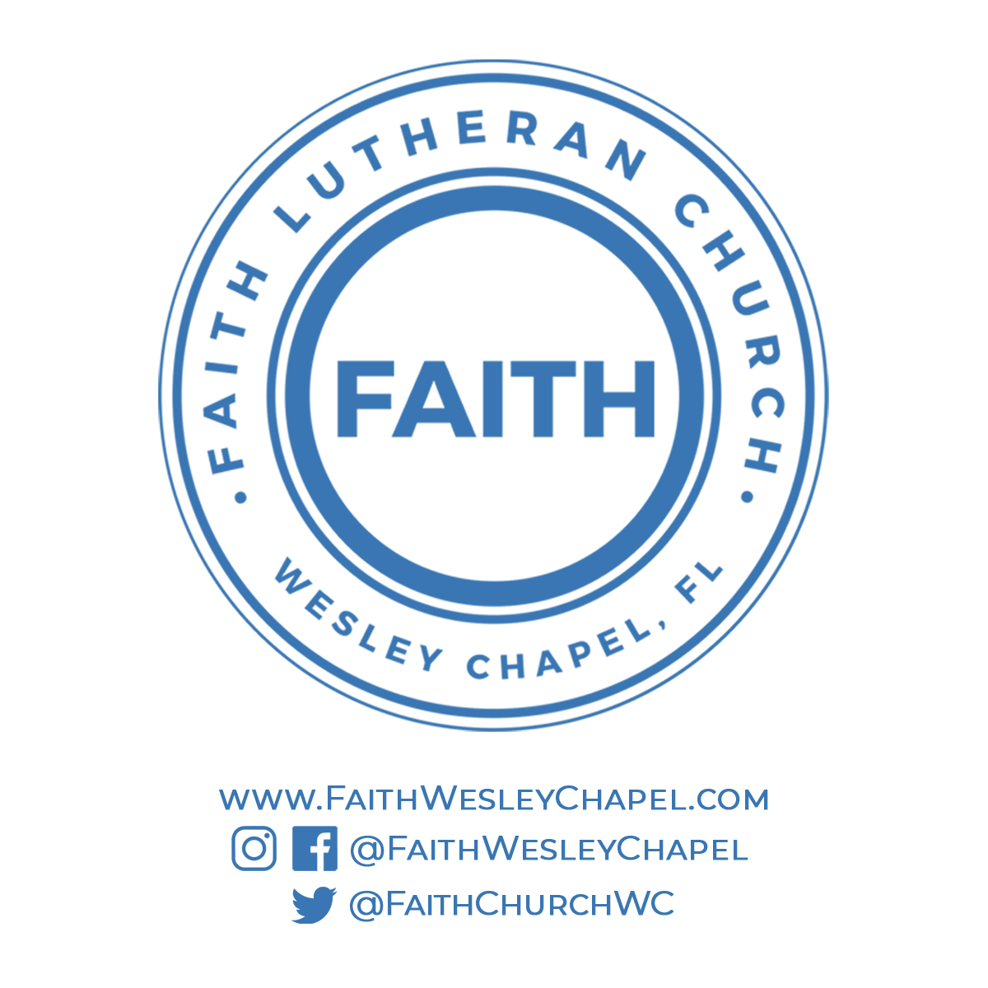**@FaithWesleyChapel**

**@FaithWesleyChapel**

**@FaithChurchWC**