

**Leading our community into a deep connection in Christ**

**Worship Service for September 22, 2024 at 11 AM**

**Welcome**

**Opening Song:**Great Is Thy Faithfulness

Great is Thy faithfulness, O God my Father.  
There is no shadow of turning with Thee  
Thou changest not, Thy compassions they fail not.  
As Thou hast been, Thou forever wilt be.

Chorus:

Great is Thy faithfulness! Great is Thy faithfulness!

Morning by morning new mercies I see

All I have needed Thy hand has provided.

Great is Thy faithfulness, Lord unto me.

Summer and winter and springtime and harvest,

Sun, moon and stars in their courses above

Join with all nature in manifold witness

To Thy great faithfulness mercy and love.

*(Chorus)*

Pardon for sin and a peace that endureth,Thine own dear presence to cheer and to guide;Strength for today and bright hope for tomorrow,Blessings all mine, with ten thousand beside.

*(Chorus)* © 1923. Renewed 1951 Hope Publishing Company

**Invocation**

**Confession and Forgiveness:**

**P:** Come into the presence of the Lord our God.  
**C:** Have mercy, O Lord. If you, Lord, kept a record of sins, Lord, who could stand; but if we confess our sins, he is faithful and just to forgive us our sins and to cleanse us from all unrighteousness.

*(A time of silence to reflect and personally confess our sins)*

**P:** I said, "I will confess my transgressions to the LORD." And you forgave the guilt of my sin. Let us confess our sin before the Lord. Let us confess together.  
**C:** Heavenly Father, we confess that we are sinners.  We have sinned against you and our neighbors. We have not loved you with our whole heart and we have not loved our neighbors as ourselves. We justly deserve Your punishment.  For the sake of Your Son, Jesus Christ, have mercy on us.  Forgive us, renew us, and lead us, so that we may delight in Your will and walk in Your ways to the glory of Your holy name.  Amen.

**P:** The Lord is gracious and merciful. He promises to forgive our sins. Therefore, upon this, your confession, as a called and ordained servant of the Lord, in the stead and by the command of my Lord, Jesus Christ, I forgive you all your sins in the name of the Father and of the Son and of the Holy Spirit.  
**C:** Amen.

**Song of Praise and Thanksgiving -** What a Friend

Everybody has trials and temptations.  
Everybody knows heartbreak, isolation.

Pre-Chorus:  
But we can lay our burdens down. Lay our burdens down.

Chorus:  
What a friend we have in Jesus. East to west my sins are gone.  
I see grace on every horizon.  
And forever and ever His heart is my home.

Everybody has fears, everybody got worries.  
Everybody knows sorrow, devastation.

*(Pre-Chorus)  
(Chorus)*

Bridge:  
No more betrayal, for He is faithful.  
He fills me up and my cup runneth over.  
No more betrayal, for He is faithful.  
How He has proven it over and over.  
(Repeat)

*(Chorus 2x)*

And forever and ever His heart is my home. © All Essential Music

**Old Testament Reading -** Psalm 104: 27–35

These all look to you, to give them their food in due season. When you give it to them, they gather it up; when you open your hand, they are filled with good things. When you hide your face, they are dismayed; when you take away their breath, they die and return to their dust. When you send forth your Spirit, they are created, and you renew the face of the ground.

May the glory of the Lord endure forever; may the Lord rejoice in his works, who looks on the earth and it trembles, who touches the mountains and they smoke! I will sing to the Lord as long as I live; I will sing praise to my God while I have being.

May my meditation be pleasing to him, for I rejoice in the Lord. Let sinners be consumed from the earth, and let the wicked be no more!

Bless the Lord, O my soul!  
Praise the Lord!

**Reader:** This is the Word of the Lord.  
**C:** Thanks be to God.

**Epistle Reading -** James 5:1–6

Come now, you rich, weep and howl for the miseries that are coming upon you. Your riches have rotted and your garments are moth-eaten. Your gold and silver have corroded, and their corrosion will be evidence against you and will eat your flesh like fire. You have laid up treasure in the last days. Behold, the wages of the laborers who mowed your fields, which you kept back by fraud, are crying out against you, and the cries of the harvesters have reached the ears of the Lord of hosts. You have lived on the earth in luxury and in self-indulgence. You have fattened your hearts in a day of slaughter. You have condemned and murdered the righteous person. He does not resist you.

**Reader:** This is the Word of the Lord.  
**C:** Thanks be to God.

**Children's Message** - "I Want More!"

**Sermon Hymn -** I Surrender All

Verse 1:

All to Jesus I surrender. All to Him I freely give.

I will ever love and trust Him. In His presence daily live.

Chorus:

I surrender all. I surrender all. All to Thee my blessed Savior, I surrender all.

Verse 2:  
All to Jesus I surrender. Humbly at His feet I bow.  
Worldly pleasures all forsaken. Take me, Jesus, take me now.

*(Chorus)*

Verse 4:

All to Jesus I surrender. Lord, I give myself to Thee.

Fill me with Thy love and power. Let Thy blessing fall on me.

*(Chorus 2x)* © 2005 Maranatha! Music, Nickeldimeus Music, and LAVIKMUSIC

**Sermon -** "Building Up Treasure"

Matthew 6:19-24, 31-34

“Do not lay up for yourselves treasures on earth, where moth and rust destroy and where thieves break in and steal, but lay up for yourselves treasures in heaven, where neither moth nor rust destroys and where thieves do not break in and steal. For where your treasure is, there your heart will be also.

“The eye is the lamp of the body. So, if your eye is healthy, your whole body will be full of light, but if your eye is bad, your whole body will be full of darkness. If then the light in you is darkness, how great is the darkness!

“No one can serve two masters, for either he will hate the one and love the other, or he will be devoted to the one and despise the other. You cannot serve God and money....

...Therefore do not be anxious, saying, ‘What shall we eat?’ or ‘What shall we drink?’ or ‘What shall we wear?’ For the Gentiles seek after all these things, and your heavenly Father knows that you need them all. But seek first the kingdom of God and his righteousness, and all these things will be added to you.

“Therefore do not be anxious about tomorrow, for tomorrow will be anxious for itself. Sufficient for the day is its own trouble.

**Reader:** This is the Word of the Lord.  
**C:** Thanks be to God.

**Prayers:** *Text in prayer requests to (813) 326-5255‬*

**Apostles' Creed** *(stand)*

I believe in God, the Father almighty,  
maker of heaven and earth,

And in Jesus Christ, his only Son, our Lord,  
who was conceived by the Holy Spirit,  
born of the Virgin Mary,  
suffered under Pontius Pilate,  
was crucified, died and was buried.  
He descended into hell.  
The third day he rose again from the dead.  
He ascended into heaven and sits at the right hand of God  
the Father almighty.  
From there he will come to judge the living and the dead.

I believe in the Holy Spirit,  
the holy Christian Church,  
the communion of saints,  
the forgiveness of sins,  
the resurrection of the body,  
and the life everlasting. Amen.

**The Lord's Prayer** *(stand)*

Our Father who art in heaven, hallowed be Thy name, Thy kingdom come, Thy will be done on earth as it is in heaven.  Give us this day our daily bread; and forgive us our trespasses as we forgive those who trespass against us; and lead us not into temptation, but deliver us from evil.  For Thine is the kingdom and the power and the glory forever and ever.  Amen

**Offering**

**Benediction** *– The online service ends. The closing hymn video is on the Livestream page bulletin at FaithWesleyChapel.com with lyrics below. See announcements below as well.*

**Closing Song -**I Will Follow

Where You go, I’ll go. Where You stay, I’ll stay.

When You move, I’ll move. I will follow...

All Your ways are good. All Your ways are sure.

I will trust in You alone.

Higher than my sight, high above my life, I will trust in You alone.

Chorus:  
Where You go, I’ll go. Where You stay, I’ll stay.  
When You move, I’ll move. I will follow You.  
Who You love, I'll love. How You serve I'll serve.  
If this life I lose, I will follow You, Yeah.  
I will follow You.

Light unto the world, Light unto my life

I will live for You alone.

You're the one I seek knowing I will find,

All I need in You alone, in You alone.

*(Chorus)*

Bridge:

In You there's life everlasting. In You there's freedom for my soul.

In You there's joy, unending joy, and I will follow.

*(Chorus 2x)* *© 2010 SHOUT! Publishing, Vamos Publishing, and So Essential Tunes*

|  |  |
| --- | --- |
| **Serving This Week** | |
|  | |
| **O.T. Reader:** Ginger Dunn | **O.T. Reader:** Ginger Dunn |
| **Epistle Reader:** Vanessa Frost | **Epistle Reader:** Vanessa Frost |
| **Acolyte:** Lawrence Finnerty | **Acolyte:** Lawrence Finnerty |
| **Com. Asst:** Larry Chmiel | **Com. Asst:** Larry Chmiel |
|  | |
| **Serving Next Week** | |
|  | |
| **O.T. Reader:** Josh Strasheim | **O.T. Reader:** Josh Strasheim |
| **Epistle Reader:** Melissa Steinbrueck | **Epistle Reader:** Melissa Steinbrueck |
| **Acolyte:** Eli Bingaman | **Acolyte:** Eli Bingaman |
| **Com. Asst:** Larry Chmiel | **Com. Asst:** Larry Chmiel |

**Upcoming Events**

**Sept 24, Growth Group**  
Renee’s house

**Sept 29, 11am - Commitment Sunday**Faith Lutheran Church

**www.FaithWesleyChapel.com**

**Faith YouTube**

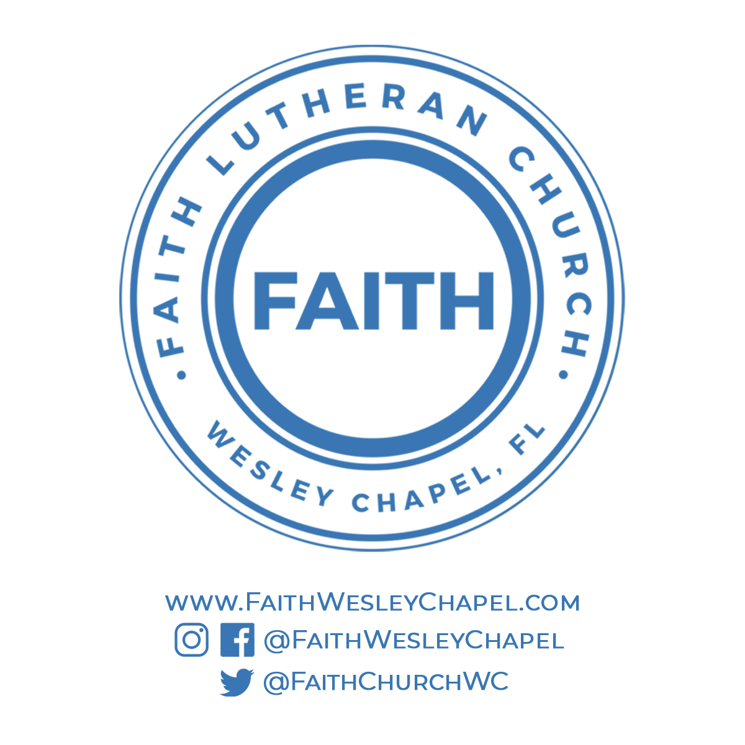**@FaithWesleyChapel**

**@FaithWesleyChapel**

**@FaithChurchWC**