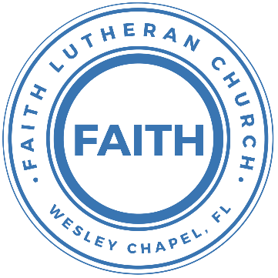

**Leading our community into a deep connection in Christ**

**Worship Service for September 29, 2024 at 11 AM**

**Welcome**

**Invocation**

**Confession and Forgiveness:**

**P:** Our Heavenly Father asks us to come into His presence, But we are sinful and unworthy. Truly, all have sinned and fall short of the glory of God, but Jesus Christ died on the cross that we may be forgiven and washed clean of all our sins by His blood poured out on the cross.  
**C:** Lord, if You wash us, we will certainly be clean and pure.

**P:** We join together in singing, “At the Cross”

**At the Cross (Love Ran Red)**

There’s a place where mercy reigns and never dies.

There’s a place where streams of grace flows deep and wide.

*Pre-Chorus:*

All the love, I’ve ever found,

Comes like a flood, comes flowing down.

*Chorus:*At the cross, at the cross, I surrender my life.I’m in awe of you. I’m in awe of you.Where your love ran red, and my sins washed white.I owe all to you. I owe all to you, Jesus.

There’s a place where sin and shame are powerless,

Where my heart has peace with God and forgiveness.

*Pre-Chorus:*

All the love, I’ve ever found,

Comes like a flood, comes flowing down.

*(Chorus)*

**P:** We take a moment to bow before His cross and silently reflect on our lives and confess our sins.

*(a time of silence to reflect and personally confess our sins)*

**C:** Heavenly Father, we confess that we have sinned against you in thought, word, and deed. We have not loved you with our whole heart and have not loved our neighbor as ourselves. We are truly sorry and we humbly repent. For the sake of your Son Jesus Christ and His suffering and death on the cross, have mercy on us and forgive us; that we may delight in your will, and walk in your ways, to the glory of your Name. Amen

**At the Cross (Love Ran Red) continues…**

*Bridge:*

Here my hope is found, here on holy ground.

Here I bow down. Here I bow down.

Here arms open wide. Here you saved my life.

Here I bow down. Here I bow.

*(Repeat Bridge)*

*(Chorus 2x)* © Countless Wonder Publishing

**P:** The Lord our God is merciful and gracious, longsuffering, and abounding in goodness and truth, keeping mercy for thousands, forgiving iniquity and transgression and sin. Therefore I announce unto you the grace of our Lord Jesus Christ. In His stead and by the command of my Lord Jesus Christ, I forgive you all your sins in the name of the Father and of the Son and of the Holy Spirit.  
**C:** Amen.

**Song of Praise and Thanksgiving -** Gratitude

All my words fall short. I got nothing new.  
How could I express all my gratitude?

I could sing these songs, as I often do

But every song must end and You never do

Chorus:  
So I throw up my hands and praise You again and again  
'Cause all that I have is a Hallelujah. Hallelujah!  
And I know it's not much but I've nothing else fit for a King  
Except for a heart singing, Hallelujah  Hallelujah

I've got one response. I've got just one move

With my arm stretched wide, I will worship You

*(Chorus)*

Bridge:

So come on, my soul, oh, don't you get shy on me. Lift up your song,

'Cause you've got a lion inside of those lungs

Get up and praise the Lord

*(Repeat 2x)*

*(Chorus)*© 2021 Bethel Worship Publishing

**Old Testament Reading -** Proverbs 3:1-18

My son, do not forget my teaching, but let your heart keep my commandments, for length of days and years of life and peace they will add to you. Let not steadfast love and faithfulness forsake you; bind them around your neck; write them on the tablet of your heart. So you will find favor and good success in the sight of God and man. Trust in the Lord with all your heart, and do not lean on your own understanding. In all your ways acknowledge him, and he will make straight your paths. Be not wise in your own eyes; fear the Lord, and turn away from evil. It will be healing to your flesh and refreshment to your bones. Honor the Lord with your wealth and with the firstfruits of all your produce; then your barns will be filled with plenty, and your vats will be bursting with wine. My son, do not despise the Lord's discipline or be weary of his reproof, for the Lord reproves him whom he loves, as a father the son in whom he delights. Blessed is the one who finds wisdom, and the one who gets understanding, for the gain from her is better than gain from silver and her profit better than gold. She is more precious than jewels, and nothing you desire can compare with her. Long life is in her right hand; in her left hand are riches and honor. Her ways are ways of pleasantness, and all her paths are peace. She is a tree of life to those who lay hold of her; those who hold her fast are called blessed.

**Reader:** This is the Word of the Lord.  
**C:** Thanks be to God.

**Epistle Reading -** Romans 12:1-6

I appeal to you therefore, brothers, by the mercies of God, to present your bodies as a living sacrifice, holy and acceptable to God, which is your spiritual worship. Do not be conformed to this world, but be transformed by the renewal of your mind, that by testing you may discern what is the will of God, what is good and acceptable and perfect.

For by the grace given to me I say to everyone among you not to think of himself more highly than he ought to think, but to think with sober judgment, each according to the measure of faith that God has assigned. For as in one body we have many members, and the members do not all have the same function, so we, though many, are one body in Christ, and individually members one of another. Having gifts that differ according to the grace given to us, let us use them

**Reader:** This is the Word of the Lord.  
**C:** Thanks be to God.

**Gospel Reading -** Matthew 13:44-46

“The kingdom of heaven is like treasure hidden in a field, which a man found and covered up. Then in his joy he goes and sells all that he has and buys that field.

“Again, the kingdom of heaven is like a merchant in search of fine pearls, who, on finding one pearl of great value, went and sold all that he had and bought it.

**P:** This is the Gospel of the Lord.  
**C:** Praise be to You, O Christ.

**Children's Message** *(Children dismissed to Children's Church)*

**Sermon Hymn -** Praise To The Lord The Almighty

Praise to the Lord the Almighty, the King of creation.

O my soul, praise Him for He is your health and salvation.

Let all who hear, now to His temple draw near,

Joining in glad adoration.

Praise to the Lord who o’er all things is wondrously reigning,

And as on wings of an eagle, uplifting, sustaining.

Have you not seen, all that is needful has been,

Sent by His gracious ordaining?

Praise to the Lord! O let all that is in me adore Him.  
All that has life and breath come now with praises before Him.  
Let the “Amen” sound from His people again.  
Gladly forever adore Him. © Public Domain

**Sermon -** "Commitment Sunday"

**Time of Commitment**

**Song -** Turn Your Eyes Upon Jesus

O soul are you weary and troubled?

No light in the darkness you see?

There's light for a look at the Savior,

And life more abundant and free.

Chorus:

Turn your eyes upon Jesus,

Look full in His wonderful face;

And the things of earth will grow strangely dim,

In the light of His glory and grace.

*(Repeat last 2 lines at the end of the last chorus.)*

His word shall not fail you He promised   
Believe Him and all will be well.   
Then go to a world that is dying,   
His perfect salvation to tell

*(Chorus)* © 1922 Public Domain, Words: New Spring, and Music: 1922 New Spring

**Prayers:** *Text in prayer requests to (813) 326-5255‬*

**Nicene Creed** *(stand)*

I believe in one God, the Father Almighty, maker of heaven and earth and of all things visible and invisible.

And in one Lord Jesus Christ, the only-begotten Son of God, begotten of His Father before all worlds, God of God, Light of Light, very God of very God, begotten, not made, being of one substance with the Father, by whom all things were made; who for us men and for our salvation came down from heaven and was incarnate by the Holy Spirit of the virgin Mary and was made man; and was crucified also for us under Pontius Pilate. He suffered and was buried. And the third day He rose again according to the Scriptures and ascended into heaven and sits at the right hand of the Father. And He will come again with glory to judge both the living and the dead, whose kingdom will have no end.

And I believe in the Holy Spirit, the Lord and Giver of Life, who proceeds from the Father and the Son, who with the Father and the Son together is worshiped and glorified, who spoke by the prophets. And I believe in one holy Christian and apostolic Church, I acknowledge one Baptism for the remission of sins, and I look for the resurrection of the dead and the life of the world to come. Amen.

**The Lord's Prayer** *(stand)*

Our Father who art in heaven, hallowed be Thy name, Thy kingdom come, Thy will be done on earth as it is in heaven.  Give us this day our daily bread; and forgive us our trespasses as we forgive those who trespass against us; and lead us not into temptation, but deliver us from evil.  For Thine is the kingdom and the power and the glory forever and ever.  Amen

**Offering**

**Benediction** *– The online service ends. The closing hymn video is on the Livestream page bulletin at FaithWesleyChapel.com with lyrics below. See announcements below as well.*

**Closing Song -**We Are

Every secret, every shame, every fear, every pain,

Live inside the dark, but that’s not who we are.

We are children of the day.

Pre-Chorus:

So wake up sleeper, lift your head.

We were meant for more than this

Fight the shadows conquer death.

Make the most of the time we have left

Chorus:  
We are the light of the world. We are the city on a hill  
We are the light of the world  
We gotta, we gotta, we gotta let the light shine  
*(Repeat)*  
Let the light shine, let the light shine

We are called to the spread the news.  
Tell the world the simple truth.  
Jesus came to save. There’s freedom in His Name.  
So let it all break through

*(Pre-Chorus)*

*(Chorus)*

Bridge:  
We are the light we are the light we are the light  
So let your light shine brighter  
We the light we are the light we are the light... Jesus  
You are the light you are the light you are the light.  
We will lift you high and Shine, shine, shine

*(Chorus)* © 2011 Alletrop Music, Centricity Music Publishing

|  |  |
| --- | --- |
| **Serving This Week** | |
|  | |
| **O.T. Reader:** Josh Strasheim | **Children’s Church Teacher:** |
| **Epistle Reader:** Melissa Steinbrueck | Halston & Ben |
| **Acolyte:** Eli Bingamen | **Children’s Church Assistant:** |
| **Com. Asst:** Larry Chmiel | Jakob Torgrimson |
|  | |
| **Serving Next Week** | |
|  | |
| **1st Reader:** Kaylee Steinbrueck | **Children’s Church Teacher:** |
| **2nd Reader:** Kelsey Torgrimson | N/A – Youth Sunday |
| **Acolyte:** Lawrence Finnerty | **Children’s Church Assistant:** |
| **Com. Asst:** Larry Chmiel | N/A – Youth Sunday |

**Upcoming Events**

**Today, 11 AM – Commitment Sunday**  
Faith Lutheran Church

**Oct 6, 11 AM – New Series, "Joining Jesus on His Mission"**  
Faith Lutheran Church

**Oct 8, 7 PM – Growth Group Bible Study**  
Renee’s Home

**www.FaithWesleyChapel.com**

**Faith YouTube**

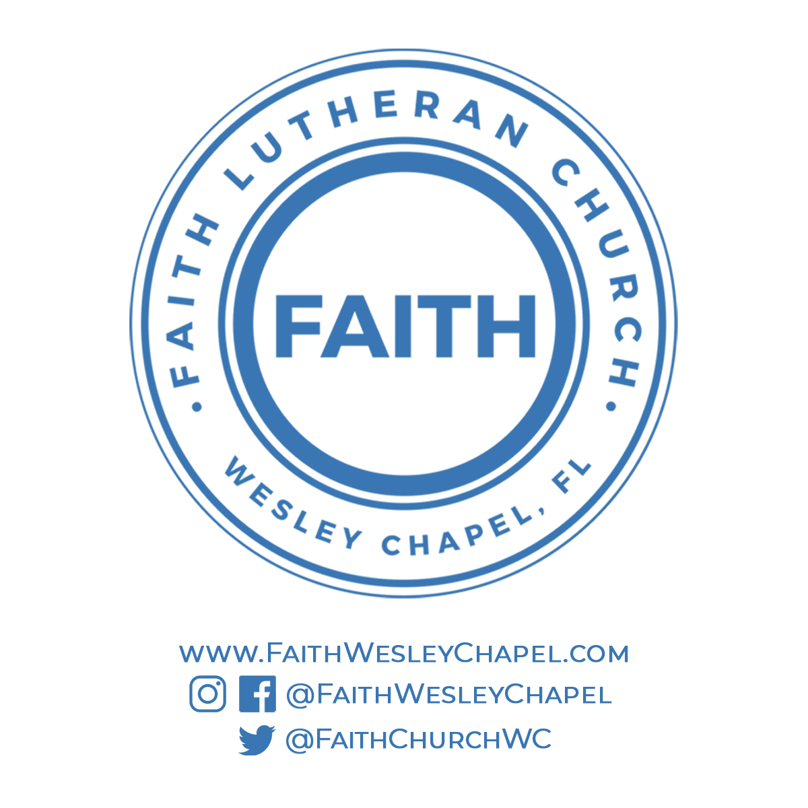**@FaithWesleyChapel**

**@FaithWesleyChapel**

**@FaithChurchWC**