

**Leading our community into a deep connection in Christ**

**Worship Service for October 6, 2024 at 11 AM**

**Welcome**

**Opening Song:**Down In My Heart

I’ve got the joy, joy, joy, joy down in my heart, (where?)  
Down in my heart, (where?), down in my heart.  
I’ve got the joy, joy, joy, joy down in my heart, (where?)  
Down in my heart to stay.

Chorus:  
And I’m so happy, so very happy.   
I’ve got the love of Jesus in my heart.  
And I’m so happy, so very happy.   
I’ve got the love of Jesus in my heart

I’ve got the peace that passes understanding down in my heart…

*(Chorus)*

I’ve got the love of Jesus, love of Jesus, down in my heart…

*(Chorus)*

I’ve got the wonderful love of my blessed redeemer way down in the depths of my heart…

*(Chorus)* © Public Domain

**Invocation**

**Confession and Forgiveness:**

**P:** We have come here today to worship the Lord.  In worship we hear the Word of God, we receive God's blessings, and respond with thanks and praise.  We begin by seeking God's blessing of forgiveness.  He has promised to remove the guilt and shame of our sin through the sacrifice of Jesus Christ on the cross.

*(a time of silence to reflect and personally confess our sins)*

**P:** Let us confess our sins to the Lord.

**P:** Heavenly Father,  
**C:** Heavenly Father,

**P:** I have done things that were wrong.  
**C:** I have done things that were wrong.  
  
**P:** I have been mean to others.  
**C:** I have been mean to others.

**P:** I have not obeyed my parents.  
**C:** I have not obeyed my parents.

**P:** I have not obeyed You, God.  
**C:** I have not obeyed You, God.

**P:** But I am very sorry.  
**C:** But I am very sorry.

**P:** Please forgive me.  
**C:** Please forgive me.

**P:** I love You very much.  
**C:** I love You very much.

**P:** And I know You love me, too.  
**C:** And I know You love me, too.

**P:** Amen.  
**C:** Amen.

**P:** God has heard your apology.  He loves you very much.  God has told us that when we believe and trust in Him, He makes us His children.  As far as the east is from the west, so far does he remove our sins from us. He has told me to tell you that you are forgiven.  So, as His servant, I forgive you in the name of the Father and of the Son and of the Holy Spirit.   
**C:** Amen.

**Song:**Jesus Loves Me

Verse 1:

Jesus loves me this I know, for the Bible tells me so.

Little ones to Him belong. They are weak, but He is strong.

Chorus:

Yes, Jesus loves me. Yes, Jesus loves me.

Yes, Jesus loves me, the Bible tells me so.

Verse 2:

Jesus loves me, He who died, Heaven's gates to open wide.

He will wash away my sin, let His little child come in.

*(Chorus)* © Public Domain

**First Reading -**Titus 2:11

God has shown us clearly how very kind he is. He has come to save all people.

**Reader:** This is the Word of the Lord.  
**C:** Thanks be to God.

**Children's Message**"Jesus Is on a Mission"

**Song:**Mighty To Save

Everyone needs compassion, a Love that's never failing.

Let mercy fall on me.

Everyone needs forgiveness, the kindness of a savior.

The hope of nations

Chorus:

Savior, He can move the mountains.

My God is mighty to save. He is mighty to save.

Forever, author of salvation,

He rose and conquered the grave. Jesus conquered the grave.

So take me as you find me, all my fears and failures,

And fill my life again.

I give my life to follow everything I believe in.

Now I surrender. (I surrender)

*(Chorus)*

Bridge:

Shine your light and let the whole world see singing,

For the glory of the risen king, Jesus.

Shine your light and let the whole world see singing,

For the glory of the risen king

*(Chorus 2x)* © 2006 Hillsong Publishing

**Second Reading -**Ezekiel 34:11

“For thus says the Lord God: Behold, I, I myself will search for my sheep and will seek them out."

**Reader:** This is the Word of the Lord.  
**C:** Thanks be to God.

**Children's Message**"Jesus Is on the Move"

**Song:**Every Move I Make

Verse:  
Every move I make, I make in You.  
You make me move, Jesus.  
Every breath I take, I breathe in You.

Every step I take, I take in You.  
You are my way, Jesus.  
Every breath I take, I breathe in You.

Chorus:  
Waves of mercy, waves of grace,  
Everywhere I look, I see Your face.  
Your love has captured me.  
Oh my God, this love, how can it be?

Bridge:  
Na Na Na...  
*(Repeat)*

*(Verse)*

*(Chorus)*

*(Bridge (2x)* © 1996 Mercy/Vineyard Publishing, Vineyard Songs Canada, and ION Publishing

**Gospel Reading -**Mark 1:16-20

Passing alongside the Sea of Galilee, he saw Simon and Andrew the brother of Simon casting a net into the sea, for they were fishermen. And Jesus said to them, “Follow me, and I will make you become fishers of men.” And immediately they left their nets and followed him. And going on a little farther, he saw James the son of Zebedee and John his brother, who were in their boat mending the nets. And immediately he called them, and they left their father Zebedee in the boat with the hired servants and followed him.

**P:** This is the Gospel of the Lord.  
**C:** Praise be to You, O Christ.

**Sermon Hymn:**Now All The Vault Of Heaven Resounds *(sit)*

Now all the vault of Heav'n resounds,

In praise of love that still abound,

“Christ has triumphed! He is living!"

Sing, choirs of angels, loud and clear.

Repeat their song of glory here.

“Christ has triumphed! Christ has triumphed!

Alleluia, alleluia, alleluia.”

Eternal is the gift He brings.

Therefore, our heart with rapture sings,

“Christ has triumphed! He is living!"

Now, still, He comes to give us life,

And by His presence stills all strife.

Christ has triumphed! He is living!

Alleluia, alleluia, alleluia.

Adoring praises now we bring

And with the heavenly blessed sing,

“Christ has triumphed, Alleluia!

Be to the Father, and our Lord,

To Spirit blest, most holy God,

All the glory, never-ending!

Alleluia, alleluia, alleluia.“ © 1989,1994 Lorenz Publishing Company

**Sermon –**"The Mission of Jesus"

**Prayers:** *Text in prayer requests to (813) 326-5255***The Lord's Prayer** *(stand)*

Our Father who art in heaven, hallowed be Thy name, Thy kingdom come, Thy will be done on earth as it is in heaven.  Give us this day our daily bread; and forgive us our trespasses as we forgive those who trespass against us; and lead us not into temptation, but deliver us from evil.  For Thine is the kingdom and the power and the glory forever and ever.  Amen

**Offering**

**Benediction** *– The online service ends. The closing hymn video is on the Livestream page bulletin at FaithWesleyChapel.com with lyrics below. See announcements below as well.*

**Closing Song:**God So Loved

Come all you weary. Come all you thirsty.

Come to the well that never runs dry.

Drink of the Water. Come and thirst no more.

Come all you sinners. Come find His mercy.

Come to the table. He Will satisfy.

Taste of His goodness. Find what you’re looking for.

Chorus 1:

For God so loved the World that He gave us,

His one and only Son to save us.

Whoever believes in Him, will live forever.

Bring all your failures. Bring your addictions.

Come lay them down at the Foot of the cross.

Jesus is waiting there with open arms.

*(Chorus 1)*

Chorus 2:

The power of Hell forever defeated.

Now, it is well. I’m Walking in freedom.

For God so loved, God so loved the world.

Bridge:

Praise God! Praise God from whom all blessings flow.

Praise Him! Praise Him for the wonders of His love.

*(Repeat)*

His amazing love!

*(Chorus 1 and 2)*

Bring all your failures. Bring your addictions.

Come lay them down at the Foot of the cross.

Jesus is waiting there with open arms. © 2019 Andrew Bergthold Designee

|  |  |
| --- | --- |
| **Serving This Week** | |
|  | |
| **1st Reader:** Kaylee Steinbrueck | **Children’s Church Teacher:** |
| **2nd Reader:** Kelsey Torgrimson | N/A – No Children’s Church |
| **Acolyte:** Lawrence Finnerty | **Children’s Church Assistant:** |
| **Com. Asst:** Larry Chmiel | N/A – No Children’s Church |
|  | |
| **Serving Next Week** | |
|  | |
| **O.T. Reader:** Darlene Mueller | **Children’s Church Teacher:** |
| **Epistle Reader:** Larry Chmiel | Melissa Steinbrueck |
| **Acolyte:** Kaylee Steinbrueck | **Children’s Church Assistant:** |
| **Com. Asst:** Larry Chmiel | Kelsey Torgrimson |

**Hey Youth!!**Do you know any worship songs you’d like to sing as part of our youth service? Do you want to sing or play an instrument? Let Pastor Kurt know. We want you to be a part of the service.

**Upcoming Events**

**Today, 11 AM – New Series, "Joining Jesus on His Mission"**  
Faith Lutheran Church

**Oct 8, 7 PM – Growth Group Bible Study**  
Renee’s Home

**Oct 16, 7 PM – Council Meeting**  
Ginger Dunn’s Home

**www.FaithWesleyChapel.com**

**Faith YouTube**

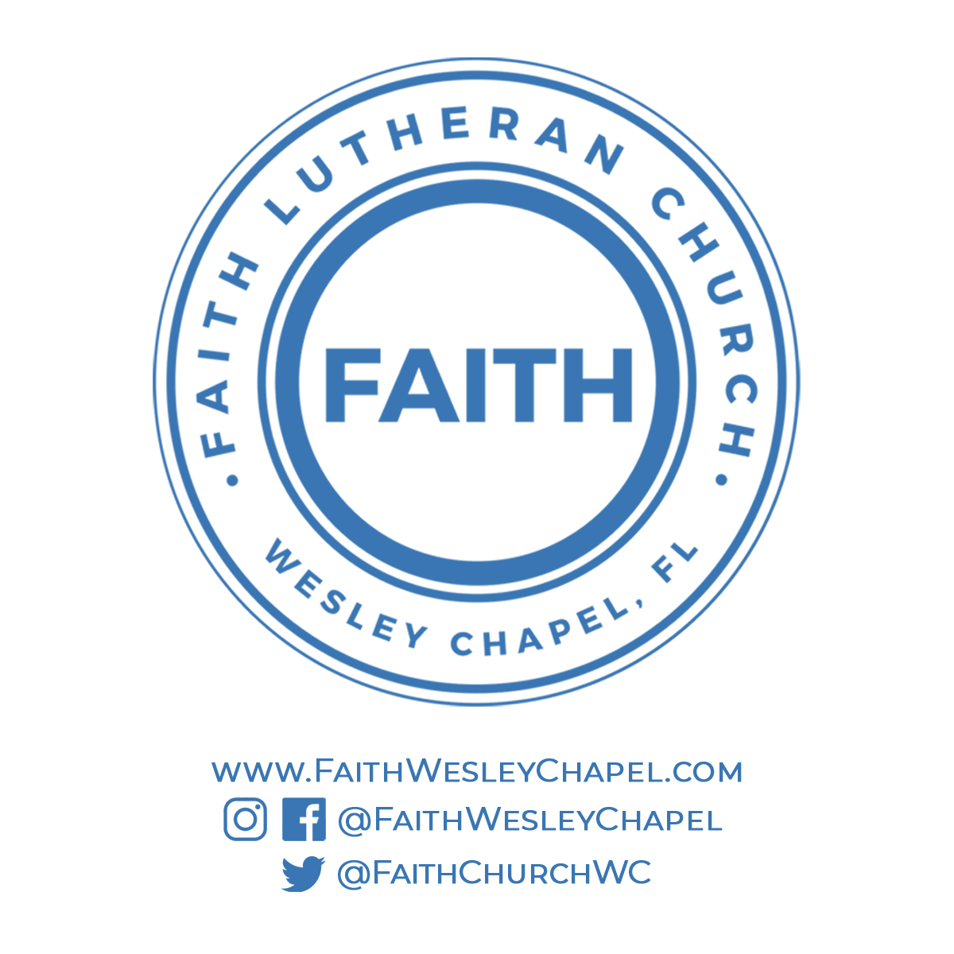**@FaithWesleyChapel**

**@FaithWesleyChapel**

**@FaithChurchWC**