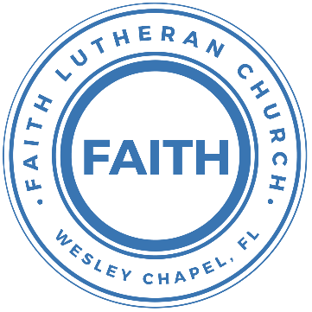

**Leading our community into a deep connection in Christ**

**___________________________________________________**

**Worship Service for October 27, 2024 at 11 AM**

**Welcome**

**Opening Song:**I Will Follow

Where You go, I’ll go. Where You stay, I’ll stay.

When You move, I’ll move. I will follow...

All Your ways are good. All Your ways are sure.

I will trust in You alone.

Higher than my sight, high above my life, I will trust in You alone.

Chorus:

Where You go, I’ll go. Where You stay, I’ll stay.

When You move, I’ll move. I will follow You.

Who You love, I'll love. How You serve I'll serve.

If this life I lose, I will follow You, Yeah. I will follow You.

Light unto the world, light unto my life, I will live for You alone.

You're the one I seek knowing I will find,

All I need in You alone, in You alone.

*(Chorus)*

Bridge:

In You there's life everlasting. In You there's freedom for my soul.

In You there's joy, unending joy, and I will follow.

*(Chorus 2x)* *© 2010 SHOUT! Publishing, Vamos Publishing, and So Essential Tunes*

**Invocation**

**Reading** - Romans 3:19-28

Now we know that whatever the law says it speaks to those who are under the law, so that every mouth may be stopped, and the whole world may be held accountable to God. For by works of the law no human being will be justified in his sight, since through the law comes knowledge of sin.

But now the righteousness of God has been manifested apart from the law, although the Law and the Prophets bear witness to it— the righteousness of God through faith in Jesus Christ for all who believe. For there is no distinction: for all have sinned and fall short of the glory of God, and are justified by his grace as a gift, through the redemption that is in Christ Jesus, whom God put forward as a propitiation by his blood, to be received by faith. This was to show God's righteousness, because in his divine forbearance he had passed over former sins. It was to show his righteousness at the present time, so that he might be just and the justifier of the one who has faith in Jesus.

Then what becomes of our boasting? It is excluded. By what kind of law? By a law of works? No, but by the law of faith. For we hold that one is justified by faith apart from works of the law.

**Reader:** This is the Word of the Lord.  
**C:** Thanks be to God.

**Confession and Forgiveness:**

**P:** On this Reformation Sunday, we remember and celebrate the Reformation which recovered the true Gospel message that we are saved by faith alone, not by our works. The Law, what God commands us to do, primarily gives us knowledge our sin. It does not tell us how to become right with God, rather it reveals to us that we are not right with God. We have nothing to boast about. All have sinned. It convicts us so that we come to God in repentance to confess our sins.  
**C:** Lord, Your Law is good. Open my eyes to see how I have failed to follow Your Law.

*(A time of silence to reflect and personally confess our sins. As a guide, you may wish to consider the 10 Commandments and reflect on how you have lived up to them.)*

**P:** I said, "I will confess my transgressions to the LORD." And you forgave the guilt of my sin. Let us confess our sin before the Lord. Let us confess together.  
**C:** Heavenly Father, we confess that we are sinners.  We have sinned against you and our neighbors. We have not loved you with our whole heart and we have not loved our neighbors as ourselves. We justly deserve Your punishment.  For the sake of Your Son, Jesus Christ, have mercy on us.  Forgive us, renew us, and lead us, so that we may delight in Your will and walk in Your ways to the glory of Your holy name.  Amen.

**P:** But now the righteousness of God has been manifested apart from the law, through faith in Jesus Christ for all who believe. You are justified by his grace as a gift, through the redemption that is in Christ Jesus, whom God put forward as a propitiation by his blood, to be received by faith. Therefore, upon this, your confession, as a called and ordained servant of the Lord, in the stead and by the command of my Lord, Jesus Christ, I forgive you all your sins in the name of the Father and of the Son and of the Holy Spirit.  
**C:** Amen.

**Song of Praise and Thanksgiving -** What a Friend

Everybody has trials and temptations.  
Everybody knows heartbreak, isolation.

Pre-Chorus:  
But we can lay our burdens down. Lay our burdens down.

Chorus:  
What a friend we have in Jesus. East to west my sins are gone.  
I see grace on every horizon.  
And forever and ever His heart is my home.

Everybody has fears, everybody got worries.  
Everybody knows sorrow, devastation.

Pre-Chorus:  
But we can lay our burdens down. Lay our burdens down.

*(Chorus)*

Bridge:  
No more betrayal, for He is faithful.  
He fills me up and my cup runneth over.  
No more betrayal, for He is faithful.  
How He has proven it over and over.  
(Repeat)

*(Chorus 2x)*

And forever and ever His heart is my home. © All Essential Music

**Epistle Reading -** Hebrews 10:19-25

Therefore, brothers, since we have confidence to enter the holy places by the blood of Jesus, by the new and living way that he opened for us through the curtain, that is, through his flesh, and since we have a great priest over the house of God, let us draw near with a true heart in full assurance of faith, with our hearts sprinkled clean from an evil conscience and our bodies washed with pure water. Let us hold fast the confession of our hope without wavering, for he who promised is faithful. And let us consider how to stir up one another to love and good works, not neglecting to meet together, as is the habit of some, but encouraging one another, and all the more as you see the Day drawing near.

**Reader:** This is the Word of the Lord.  
**C:** Thanks be to God.

**Gospel Reading -** Luke 10:25-37

After this the Lord appointed seventy-two others and sent them on ahead of him, two by two, into every town and place where he himself was about to go. And he said to them, “The harvest is plentiful, but the laborers are few. Therefore pray earnestly to the Lord of the harvest to send out laborers into his harvest. Go your way; behold, I am sending you out as lambs in the midst of wolves. Carry no moneybag, no knapsack, no sandals, and greet no one on the road. Whatever house you enter, first say, ‘Peace be to this house!’ And if a son of peace is there, your peace will rest upon him. But if not, it will return to you. And remain in the same house, eating and drinking what they provide, for the laborer deserves his wages.

**P:** This is the Gospel of the Lord.  
**C:** Praise be to You, O Christ.

**Children's Message**

**Sermon Hymn -** I Love To Tell The Story

I love to tell the story of unseen things above,   
Of Jesus and His glory, of Jesus and his love.  
I love to tell the story because I know 'tis true.  
It satisfies my longings as nothing else can do.

Chorus:  
I love to tell the story. 'Twill be my theme in glory,  
To tell the old, old story of Jesus and his love.

I love to tell the story. 'Tis pleasant to repeat,   
What seems each time I tell it more wonderfully sweet.  
I love to tell the story for some have never heard,   
The message of salvation from God's own Holy Word.

*(Chorus)*

I love to tell the story, for those who know it best,  
Seem hungering and thirsting to hear it like the rest.  
And when in scenes of glory, I sing the new, new song,  
Twill be the old, old story that I have loved so long.

Chorus:  
I love to tell the story. 'Twill be my theme in glory,  
To tell the old, old story of Jesus and his love. © Public Domain

**Sermon -** "Joining Jesus in Our Neighborhoods"

**Prayers:** *Text in prayer requests to (813) 326-5255‬*

**Apostles' Creed** *(stand)*

I believe in God, the Father almighty,  
maker of heaven and earth,

And in Jesus Christ, his only Son, our Lord,  
who was conceived by the Holy Spirit,  
born of the Virgin Mary,  
suffered under Pontius Pilate,  
was crucified, died and was buried.  
He descended into hell.  
The third day he rose again from the dead.  
He ascended into heaven and sits at the right hand of God  
the Father almighty.  
From there he will come to judge the living and the dead.

I believe in the Holy Spirit,  
the holy Christian Church,  
the communion of saints,  
the forgiveness of sins,  
the resurrection of the body,  
and the life everlasting. Amen.

**The Lord's Prayer** *(stand)*

Our Father who art in heaven, hallowed be Thy name, Thy kingdom come, Thy will be done on earth as it is in heaven.  Give us this day our daily bread; and forgive us our trespasses as we forgive those who trespass against us; and lead us not into temptation, but deliver us from evil.  For Thine is the kingdom and the power and the glory forever and ever.  Amen

**Offering**

**Benediction** *– The online service ends. The closing hymn video is on the Livestream page bulletin at FaithWesleyChapel.com with lyrics below. See announcements below as well.*

**Closing Song -**Stand Up Stand Up For Jesus *(stand)*

Stand up, stand up for Jesus, ye soldiers of the cross.

Lift high His royal banner; it must not suffer loss.

From vict'ry unto vict'ry His army He shall lead,

Till ev'ry foe is vanquished, and Christ is Lord indeed.

Stand up, stand up for Jesus; the trumpet call obey;

Stand forth in mighty conflict in this His glorious day.

Let all His faithful serve Him against unnumbered foes;

Let courage rise with danger and strength to strength oppose.

Stand up, stand up for Jesus; stand in His strength alone.

The arm of flesh will fail you, ye dare not trust your own.

Put on the Gospel armor; each piece put on with prayer.

Where duty calls or danger, be never wanting there.

Stand up, stand up for Jesus; the strife will not be long;

This day the din of battle, the next the victor's song.

The soldiers, overcoming, their crown of life shall see,

And with the King of Glory shall reign eternally. © Public Domain

|  |  |
| --- | --- |
| **Serving This Week** | |
|  | |
| **First Reader:** Josh Strasheim | **Children’s Church Teacher:** |
| **Epistle Reader:** Ginger Torgrimson | Halston & Ben |
| **Acolyte:** Kaylee Steinbrueck | **Children’s Church Assistant:** |
| **Com. Asst:** Larry Chmiel | N/A |
|  | |
| **Serving Next Week** | |
|  | |
| **1st Reader:** Kaylee Steinbrueck | **Children’s Church Teacher:** |
| **2nd Reader:** Kelsey Torgrimson | N/A – No children’s church |
| **Acolyte:** Thomas Horness | **Children’s Church Assistant:** |
| **Com. Asst:** Larry Chmiel | N/A – No children’s church |
|  | |

**Upcoming Events**

**Today, After Service – Voter Meeting**  
Faith Lutheran Church

**Nov 2, 8 AM - 1 PM – Foundation of Caring Fall Market Booth**  
38135 Market Square, Zephyrhills, FL

**Nov 17, After Service – Stockings for Soldiers**  
Faith Lutheran Church

**Dec 8, 6 PM – Christmas in the Park**  
Wesley Chapel District Park

[**www.FaithWesleyChapel.com**](http://www.FaithWesleyChapel.com)

 **Faith YouTube**

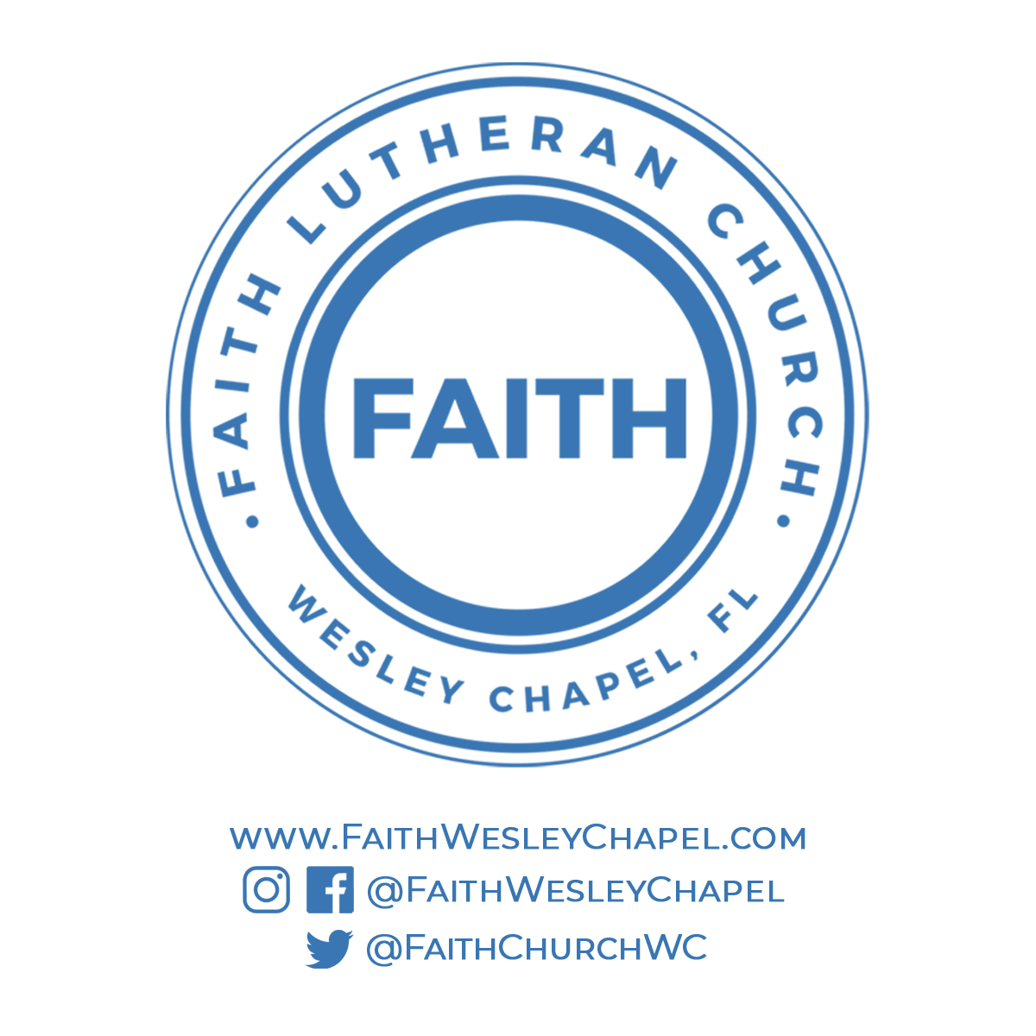**@FaithWesleyChapel**

**@FaithWesleyChapel**

**@FaithChurchWC**