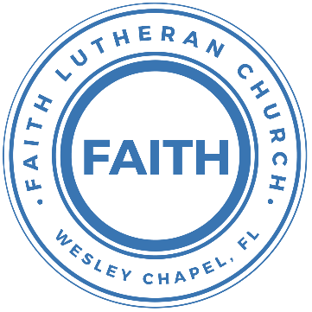

**Leading our community into a deep connection in Christ**

**Worship Service for November 3, 2024 at 11 AM**

**Welcome**

**Opening Song:**Father Abraham

Father Abraham had many sons. Many sons had Father Abraham.

I am one of them and so are you. So, let's just praise the Lord!

Right arm  
Left arm  
Right foot  
Left foot  
Chin up  
Turn around  
Sit down © Public Domain

**Invocation**

**Confession and Forgiveness:**

**P:** We have come here today to worship the Lord.  In worship we hear the Word of God, we receive God's blessings, and respond with thanks and praise.  We begin by seeking God's blessing of forgiveness.  He has promised to remove the guilt and shame of our sin through the sacrifice of Jesus Christ on the cross.

*(a time of silence to reflect and personally confess our sins)*

**P:** Let us confess our sins to the Lord.

**P:** Heavenly Father,  
**C:** Heavenly Father,

**P:** I have done things that were wrong.  
**C:** I have done things that were wrong.  
  
**P:** I have been mean to others.  
**C:** I have been mean to others.

**P:** I have not obeyed my parents.  
**C:** I have not obeyed my parents.

**P:** I have not obeyed You, God.  
**C:** I have not obeyed You, God.

**P:** But I am very sorry.  
**C:** But I am very sorry.

**P:** Please forgive me.  
**C:** Please forgive me.

**P:** I love You very much.  
**C:** I love You very much.

**P:** And I know You love me, too.  
**C:** And I know You love me, too.

**P:** Amen.  
**C:** Amen.

**P:** God has heard your apology.  He loves you very much.  God has told us that when we believe and trust in Him, He makes us His children.  As far as the east is from the west, so far does he remove our sins from us. He has told me to tell you that you are forgiven.  So, as His servant, I forgive you in the name of the Father and of the Son and of the Holy Spirit.   
**C:** Amen.

**Song:**God Is So Good

God is so good. God is so good.  
God is so good. He's so good to me.

He died for me. He died for me so.  
He died for me. He's so good to me.

He loves me so. He loves me so.  
He loves me so. He's so good to me. © Public Domain

**First Reading -**Deuteronomy 6:4-7a

“Listen, Israelites! The Lord our God, the Lord is one. Love the Lord your God with all your mind and with all your strength. Love him with all that you are. Always think about these commands that I am giving you today. Teach them to your children at all times."

**Reader:** This is the Word of the Lord.  
**C:** Thanks be to God.

**Children's Message**"Learning about God"

**Song:**We Believe

In this time of desperation, when all we know is doubt and fear, There is only One foundation. We believe. We believe.  
In this broken generation, when all is dark, You help us see.  
There is only One salvation. We believe. We believe

Chorus:  
We believe in God the Father. We believe in Jesus Christ.  
We believe in the Holy Spirit, and He's given us new life.  
We believe in the crucifixion.   
We believe that He conquered death.  
We believe in the resurrection,   
And He's comin' back again we believe

So, let our faith be more than anthems,  
Greater than the songs we sing.  
And in our weakness and temptations,   
We believe! We believe!

Chorus:  
We believe in God the Father. We believe in Jesus Christ.  
We believe in the Holy Spirit, and He's given us new life.  
We believe in the crucifixion.   
We believe that He conquered death.  
We believe in the resurrection, and He's comin' back again.

Let the lost be found and the dead be raised!  
In the here and now, let love invade!  
Let the church live loud, in our God will say   
We believe! We believe!

And the gates of hell will not prevail!  
For the power of God has torn the veil!  
Now we know Your love will never fail!   
We believe! We believe!

*(Chorus)* © Abundant Life Ministries UK, Integrity worship Music, Integrity’s Praise! Music, and Travis Ryan Music

**Second Reading -**Deuteronomy 6:4-9

““Listen, Israelites! The Lord our God, the Lord is one. Love the Lord your God with all your mind and with all your strength. Love him with all that you are. Always think about these commands that I am giving you today. Teach them to your children at all times. And you shall talk of them when you sit in your house, and when you walk by the way, and when you lie down, and when you rise. You shall bind them as a sign on your hand, and they shall be as frontlets between your eyes."

**Reader:** This is the Word of the Lord.  
**C:** Thanks be to God.

**Children's Message**"A Sign on Your Hand and Frontlets Between Your Eyes"

**Gospel Reading -**Mark 12:28-31

And one of the scribes came up and heard them disputing with one another, and seeing that he answered them well, asked him, “Which commandment is the most important of all?” Jesus answered, “The most important is, ‘Hear, O Israel: The Lord our God, the Lord is one. And you shall love the Lord your God with all your heart and with all your soul and with all your mind and with all your strength.’ The second is this: ‘You shall love your neighbor as yourself.’ There is no other commandment greater than these.”

**P:** This is the Gospel of the Lord.  
**C:** Praise be to You, O Christ.

**Sermon Hymn:**Cornerstone

My hope is built on nothing less,   
Than Jesus' blood and righteousness.  
I dare not trust the sweetest frame,   
But wholly trust in Jesus' name.

Chorus:

Christ alone, Cornerstone, Weak made strong in the Savior's love.

Through the storm He is Lord, Lord of all.

Verse 2:  
When darkness seems to hide His face,   
I rest on His unchanging grace.  
In every high and stormy gale My anchor holds within the veil.  
My anchor holds within the veil.

*(Chorus)*

He is Lord. Lord of all.

Verse 3:

When He shall come with trumpet sound,

Oh, may I then in Him be found,

Dressed in His righteousness alone,

Faultless, stand before the throne.

*(Chorus)*  © 2011 Hillsong Music

**Sermon –**"Your Living Will and Testament"

Sermon Text: Hebrews 9:15-22

Therefore he is the mediator of a new covenant, so that those who are called may receive the promised eternal inheritance, since a death has occurred that redeems them from the transgressions committed under the first covenant. For where a will is involved, the death of the one who made it must be established. For a will takes effect only at death, since it is not in force as long as the one who made it is alive. Therefore not even the first covenant was inaugurated without blood. For when every commandment of the law had been declared by Moses to all the people, he took the blood of calves and goats, with water and scarlet wool and hyssop, and sprinkled both the book itself and all the people, saying, “This is the blood of the covenant that God commanded for you.” And in the same way he sprinkled with the blood both the tent and all the vessels used in worship. Indeed, under the law almost everything is purified with blood, and without the shedding of blood there is no forgiveness of sins.

**Prayers:** *Text in prayer requests to (813) 326-5255*

**The Lord's Prayer** *(stand)*

Our Father who art in heaven, hallowed be Thy name, Thy kingdom come, Thy will be done on earth as it is in heaven.  Give us this day our daily bread; and forgive us our trespasses as we forgive those who trespass against us; and lead us not into temptation, but deliver us from evil.  For Thine is the kingdom and the power and the glory forever and ever.  Amen

**Offering**

**Benediction** *– The online service ends. The closing hymn video is on the Livestream page bulletin at FaithWesleyChapel.com with lyrics below. See announcements below as well.*

**Closing Song:**A Mighty Fortress Is Our God

A mighty fortress is our God, a bulwark never failing;

Our helper He, amid the flood of mortal ills prevailing.

For still our ancient foe does seek to work us woe;

His craft and power are great and armed with cruel hate.

On earth is not his equal.

Did we in our own strength confide our striving would be losing.

Were not the right Man on our side,  
The Man of God's own choosing.

You ask who that may be? Christ Jesus, it is he;

Lord Sabaoth His name, from age to age the same;

And He must win the battle.

And though this world, with devils filled,  
Should threaten to undo us.

We will not fear, for God has willed,  
His truth to triumph through us.

The prince of darkness grim, we tremble not for him.

His rage we can endure, for lo! his doom is sure.

One little word shall fell him.

That Word above all earthly powers no thanks to them abideth;

The Spirit and the gifts are ours through Him who with us sideth.

Let goods and kindred go, this mortal life also.

The body they may kill: God's truth abideth still!

His kingdom is forever. © Public Domain

|  |  |
| --- | --- |
| **Serving This Week** | |
|  | |
| **1st Reader:** Kaylee Steinbrueck | **Children’s Church Teacher:** |
| **2nd Reader:** Kelsey Torgrimson | N/A – No Children’s Church |
| **Acolyte:** Thomas Horness | **Children’s Church Assistant:** |
| **Com. Asst:** Larry Chmiel | N/A – No Children’s Church |
|  | |
| **Serving Next Week** | |
|  | |
| **O.T. Reader:** Kaylee Steinbrueck | **Children’s Church Teacher:** |
| **Epistle Reader:** Larry Chmiel | Melissa Steinbrueck |
| **Acolyte:** Lawrence Finerty | **Children’s Church Assistant:** |
| **Com. Asst:** Larry Chmiel | Kaylee Steinbrueck |
|  | |

**Upcoming Events**

**Nov 10, After Service – Stockings for Soldiers**  
Faith Lutheran Church

**Nov 12, 7 PM – Growth Group**  
Renee’s house

**Dec 8, 6 PM – Christmas in the Park**  
Wesley Chapel District Park

**www.FaithWesleyChapel.com**

**Faith YouTube**

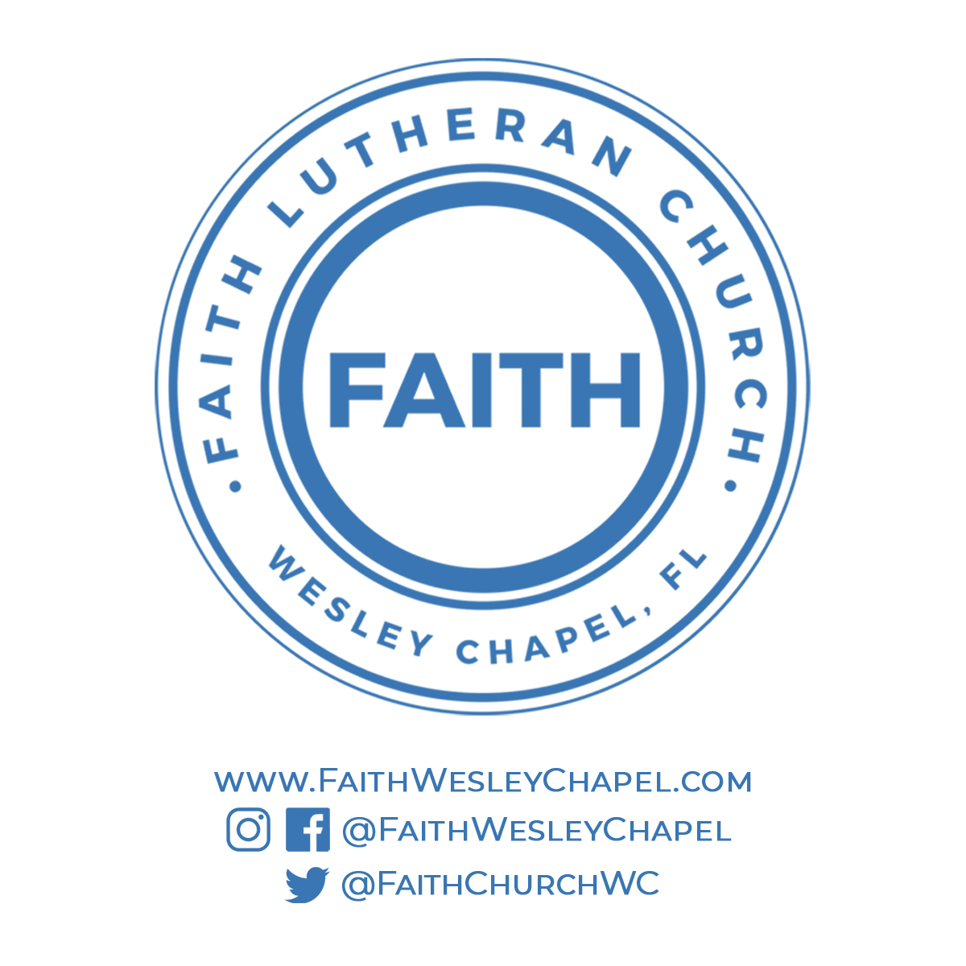**@FaithWesleyChapel**

**@FaithWesleyChapel**

**@FaithChurchWC**