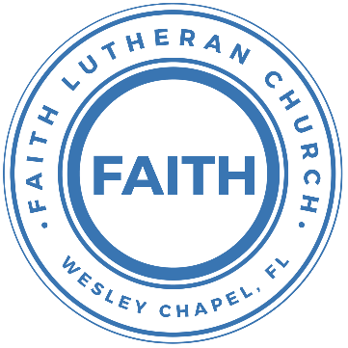

**Leading our community into a deep connection in Christ**

**Worship Service for November 17, 2024 at 11 AM**

**Welcome**

**Opening Song:** Sing To The King

Verse 1:

Sing to the King who is coming to reign.  
Glory to Jesus, the Lamb that was slain.

Life and salvation His empire shall bring,

And joy to the nations when Jesus is King.

Chorus:

Come, let us sing a song, a song declaring that we belong to Jesus.

He’s all we need.

Lift up a heart of praise. Sing now with voices raised to Jesus.

Sing to the King.

Verse 2:

For His returning we watch and we pray.

We will be ready the dawn of that day.

We'll join in singing with all the redeemed,

'Cause Satan is vanquished and Jesus is King.

*(Chorus 2x)* © 2003

**Invocation**

**Confession and Forgiveness:**

**P:** As we gather, today, let us cleanse our hearts and our consciences by confessing our sin to God.

*(Time of silence for reflection and confession)*

**C:** Heavenly Father, we confess that we are sinful and unclean. We have sinned against you and against our neighbor in our thoughts, words, and actions.  We are truly sorry for our sins and sincerely repent of them. We ask for Your mercy. For the sake of Jesus Christ's bitter suffering and death, please forgive us and renew us that we may walk in Your Spirit to the glory of Your holy name. Amen

**P:** The Lord has heard your confession. Therefore, as a called and ordained servant of the Lord, in the stead and by the command of my Lord, Jesus Christ, I forgive you all your sins in the name of the Father and of the Son and of the Holy Spirit.  
**C:** Amen

**Song of Praise and Thanksgiving:** This Is the Feast

Refrain:  
This is the feast of victory for our God. Alleluia, alleluia, alleluia.

Worthy is Christ, the Lamb who was slain,  
Whose blood set us free to be people of God.   
*(Refrain)*

Power, riches, wisdom, and strength,  
And honor, blessing, and glory are His. *(Refrain)*

Sing with all the people of God,  
And join in the hymn of all creation;

“Blessing, honor, glory, and might,  
Be to God and the Lamb forever. Amen.”   
*(Refrain)*

For the Lamb who was slain has begun his reign. Alleluia!  
*(Refrain)* © 2008 Sharon Dennis, Doris Au MacDonald, and Lutheran Book of Worship

**Old Testament Reading** - Daniel 12:1-3

“At that time shall arise Michael, the great prince who has charge of your people. And there shall be a time of trouble, such as never has been since there was a nation till that time. But at that time your people shall be delivered, everyone whose name shall be found written in the book. And many of those who sleep in the dust of the earth shall awake, some to everlasting life, and some to shame and everlasting contempt. And those who are wise shall shine like the brightness of the sky above; and those who turn many to righteousness, like the stars forever and ever.

**Reader:** This is the Word of the Lord.  
**C:** Thanks be to God.

**Epistle Reading** - Hebrews 10:11-25

And every priest stands daily at his service, offering repeatedly the same sacrifices, which can never take away sins. But when Christ had offered for all time a single sacrifice for sins, he sat down at the right hand of God, waiting from that time until his enemies should be made a footstool for his feet. For by a single offering he has perfected for all time those who are being sanctified.

And the Holy Spirit also bears witness to us; for after saying,

“This is the covenant that I will make with them  
 after those days, declares the Lord:  
I will put my laws on their hearts,  
 and write them on their minds,”

then he adds,

“I will remember their sins and their lawless deeds no more.”

Where there is forgiveness of these, there is no longer any offering for sin.

Therefore, brothers, since we have confidence to enter the holy places by the blood of Jesus, by the new and living way that he opened for us through the curtain, that is, through his flesh, and since we have a great priest over the house of God, let us draw near with a true heart in full assurance of faith, with our hearts sprinkled clean from an evil conscience and our bodies washed with pure water. Let us hold fast the confession of our hope without wavering, for he who promised is faithful. And let us consider how to stir up one another to love and good works, not neglecting to meet together, as is the habit of some, but encouraging one another, and all the more as you see the Day drawing near.

**Reader:** This is the Word of the Lord.  
**C:** Thanks be to God.

**Gospel Reading** - Mark 13:1-13

And as he came out of the temple, one of his disciples said to him, “Look, Teacher, what wonderful stones and what wonderful buildings!” And Jesus said to him, “Do you see these great buildings? There will not be left here one stone upon another that will not be thrown down.”

And as he sat on the Mount of Olives opposite the temple, Peter and James and John and Andrew asked him privately, “Tell us, when will these things be, and what will be the sign when all these things are about to be accomplished?” And Jesus began to say to them, “See that no one leads you astray. Many will come in my name, saying, ‘I am he!’ and they will lead many astray. And when you hear of wars and rumors of wars, do not be alarmed. This must take place, but the end is not yet. For nation will rise against nation, and kingdom against kingdom. There will be earthquakes in various places; there will be famines. These are but the beginning of the birth pains.

“But be on your guard. For they will deliver you over to councils, and you will be beaten in synagogues, and you will stand before governors and kings for my sake, to bear witness before them. And the gospel must first be proclaimed to all nations. And when they bring you to trial and deliver you over, do not be anxious beforehand what you are to say, but say whatever is given you in that hour, for it is not you who speak, but the Holy Spirit. And brother will deliver brother over to death, and the father his child, and children will rise against parents and have them put to death. And you will be hated by all for my name's sake. But the one who endures to the end will be saved.

**P:** This is the Gospel of the Lord.  
**C:** Praise be to You, O Christ.

**Children's Message** *(Children dismissed to Children's Church)*

**Sermon Hymn***–*We Will Dance

Verse 1  
Sing a song of celebration.  
Lift up a shout of praise, For the Bridegroom will come,  
The Glorious One.  
And Oh - We will look on His Face.  
We'll go - to a much better place.  
Dance with all your might.  
Lift up your hands and clap for joy,  
For the time's drawing near, when He will appear.  
And oh - we will stand by His side, A strong, pure spotless bride.

Chorus  
We will dance on the streets that are golden;  
The glorious bride, and the Great Son of Man.  
Every tongue and tribe and nation,  
Will join in the Song of the Lamb.

*(Verse 1)*

*(Chorus 2x)* © 1993 Mercy/Vineyard Publishing

**Sermon** - "Signs of Jesus' Return"

**Prayers:** *Text in prayer requests to (813) 326-5255*

**Nicene Creed** *(stand)*

I believe in one God, the Father Almighty, maker of heaven and earth and of all things visible and invisible.

And in one Lord Jesus Christ, the only-begotten Son of God, begotten of His Father before all worlds, God of God, Light of Light, very God of very God, begotten, not made, being of one substance with the Father, by whom all things were made; who for us men and for our salvation came down from heaven and was incarnate by the Holy Spirit of the virgin Mary and was made man; and was crucified also for us under Pontius Pilate. He suffered and was buried. And the third day He rose again according to the Scriptures and ascended into heaven and sits at the right hand of the Father. And He will come again with glory to judge both the living and the dead, whose kingdom will have no end.

And I believe in the Holy Spirit, the Lord and Giver of Life, who proceeds from the Father and the Son, who with the Father and the Son together is worshiped and glorified, who spoke by the prophets. And I believe in one holy Christian and apostolic Church, I acknowledge one Baptism for the remission of sins, and I look for the resurrection of the dead and the life of the world to come. Amen.

**The Lord's Prayer** *(stand)*

Our Father who art in heaven, hallowed be Thy name, Thy kingdom come, Thy will be done on earth as it is in heaven.  Give us this day our daily bread; and forgive us our trespasses as we forgive those who trespass against us; and lead us not into temptation, but deliver us from evil.  For Thine is the kingdom and the power and the glory forever and ever.  Amen

**Offering**

**Benediction** *– The online service ends. The closing hymn video is on the Livestream page bulletin at FaithWesleyChapel.com with lyrics below. See announcements below as well.*

**Closing Song:**Oh, When the Saints

Oh, when the saints go marching in,

Oh, when the saints go marching in,

Oh Lord, I want to be in that number,

When the saints go marching in.

And when the sun refuse to shine,

And when the sun refuse to shine,

Oh Lord, I want to be in that number,

When the sun refuse to shine.

Oh, when the trumpet sounds its call,

Oh, when the trumpet sounds its call,

Oh Lord, I want to be in that number,

When the trumpet sounds its call. © Public Domain

|  |  |
| --- | --- |
| **Serving This Week** | |
|  | |
| **O.T. Reader:** Melissa Steinbrueck | **Children’s Church Teacher:** |
| **Epistle Reader:** Vanessa Frost | Halston & Ben |
| **Acolyte:** Kaylee Steinbrueck | **Children’s Church Assistant:** |
| **Com. Asst:** Richard Steinbrueck | N/A |
|  | |
| **Serving Next Week** | |
|  | |
| **O.T. Reader:** TBD | **Children’s Church Teacher:** |
| **Epistle Reader:** TBD | Melissa Steinbrueck |
| **Acolyte:** Lawrence Finnerty | **Children’s Church Assistant:** |
| **Com. Asst:** Richard Steinbrueck | Kaylee Steinbrueck |
|  | |

**Upcoming Events**

**Today, After Church – Move Storage Closet**  
Faith Lutheran Church

**Nov 19, 7 PM – Council Meeting**  
The Strasheim’s Home

**Dec 8, 6 PM – Christmas in the Park**  
Wesley Chapel District Park

**Dec 14, 6 PM – Open House Christmas Party**  
The Chmiel’s Home

**www.FaithWesleyChapel.com**

**Faith YouTube**

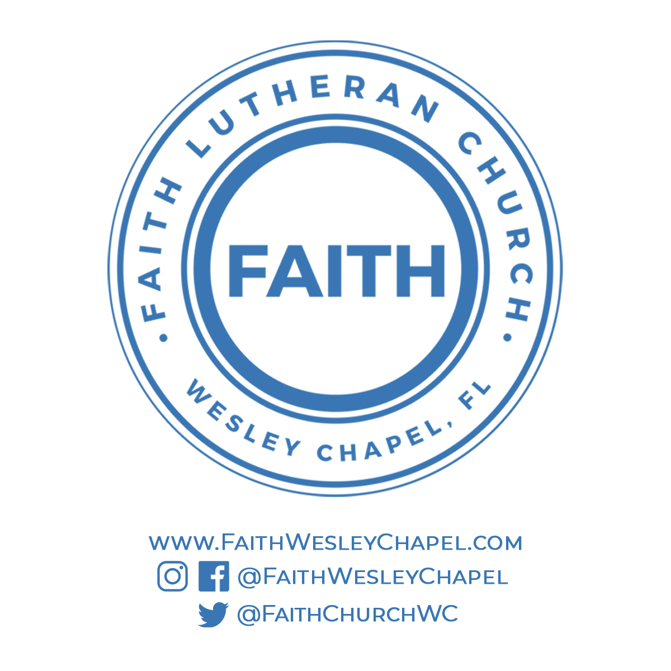**@FaithWesleyChapel**

**@FaithWesleyChapel**

**@FaithChurchWC**