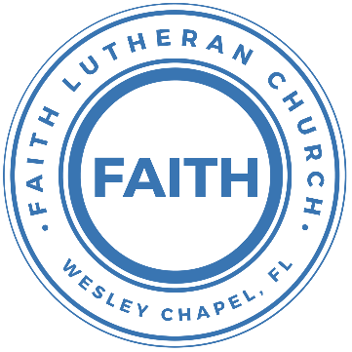

**Leading our community into a deep connection in Christ**

**Worship Service for December 1, 2024 at 11 AM**

**Welcome**

**Opening Song:**Praise Ye The Lord, Hallelujah

Side 1: Hallelu, hallelu, hallelu, hallelujah,

Side 2: Praise ye the Lord.

Side 1: Hallelu, hallelu, hallelu, hallelujah,

Side 2: Praise ye the Lord.

Side 2: Praise ye the Lord.

Side 1: Hallelujah,

Side 2: Praise ye the Lord.

Side 1: Hallelujah,

Side 2: Praise ye the Lord.  
Side 1: Hallelujah,

All: Praise ye the Lord.

(Repeat all) © Public Domain

**Invocation**

**Responsive Advent Introit -** Isaiah 9:6

**P:** For to us a child is born,  
**C:** To us a son is given;

**P:** And the government shall be upon his shoulder,  
**C:** And his name shall be called Wonderful Counselor,

**P:** Mighty God,  
**C:** Everlasting Father,

**All:** Prince of Peace.

**Confession and Forgiveness:**

**P:** We have come here today to worship the Lord.  In worship we hear the Word of God, we receive God's blessings, and respond with thanks and praise.  We begin by seeking God's blessing of forgiveness.  He has promised to remove the guilt and shame of our sin through the sacrifice of Jesus Christ on the cross.

*(a time of silence to reflect and personally confess our sins)*

**P:** Let us confess our sins to the Lord.

**P:** Heavenly Father,  
**C:** Heavenly Father,

**P:** I have done things that were wrong.  
**C:** I have done things that were wrong.  
  
**P:** I have been mean to others.  
**C:** I have been mean to others.

**P:** I have not obeyed my parents.  
**C:** I have not obeyed my parents.

**P:** I have not obeyed You, God.  
**C:** I have not obeyed You, God.

**P:** But I am very sorry.  
**C:** But I am very sorry.

**P:** Please forgive me.  
**C:** Please forgive me.

**P:** I love You very much.  
**C:** I love You very much.

**P:** And I know You love me, too.  
**C:** And I know You love me, too.

**P:** Amen.  
**C:** Amen.

**P:** God has heard your apology.  He loves you very much.  God has told us that when we believe and trust in Him, He makes us His children.  As far as the east is from the west, so far does he remove our sins from us. He has told me to tell you that you are forgiven.  So, as His servant, I forgive you in the name of the Father and of the Son and of the Holy Spirit.   
**C:** Amen.

**Song:**Jesus Loves Me

Verse 1:

Jesus loves me this I know, for the Bible tells me so.

Little ones to Him belong. They are weak, but He is strong.

Chorus:

Yes, Jesus loves me. Yes, Jesus loves me.

Yes, Jesus loves me, the Bible tells me so.

Verse 2:

Jesus loves me, He who died, Heaven's gates to open wide.

He will wash away my sin, let His little child come in.

*(Chorus)* © Public Domain

**First Reading -**Genesis 17:5

No longer will you be called Abram; your name will be Abraham, for I have made you a father of many nations.

**Reader:** This is the Word of the Lord.  
**C:** Thanks be to God.

**Children's Message**"What Does a Name Tell Us?"

**Song:**What Child Is This

What child is this, who, laid to rest, on Mary’s lap is sleeping?  
Whom angels greet with anthems sweet while shepherds watch are keeping?  
This, this is Christ the king, whom shepherds guard and angels sing;  
Haste, haste to bring him laud, the babe, the son of Mary!

Why lies He in such mean estate where ox and lamb are feeding?  
Good Christian, fear; for sinners here, the silent Word is pleading.  
Nails, spear shall pierce Him through, the cross be borne for me, for you;  
Hail, hail the Word made flesh, the babe, the son of Mary!

So bring Him incense, gold, and myrrh;  
Come, peasant, king, to own Him  
The King of kings salvation brings; let loving hearts enthrone Him.  
Raise, raise the song on high, the virgin sings her lullaby;  
Joy, joy, for Christ is born, the babe, the son of Mary! © Public Domain

**Second Reading -**Matthew 1:21

“She will bear a son, and you shall call his name Jesus, for he will save his people from their sins.”

**Reader:** This is the Word of the Lord.  
**C:** Thanks be to God.

**Children's Message**"The Many Names of Jesus"

**Song:**Savior Of The Nations Come

Savior of the nations, come, virgin's Son, make here Thy home!

Marvel now, O heaven and earth, that the Lord chose such a birth.

Not by human flesh and blood, by the Spirit of our God,

Was the Word of God made flesh  
Woman's Off-Spring, pure and fresh.

Thou, the Father's only Son, hast o'er sin the vict'ry won.

Boundless shall Thy kingdom be; when shall we its glories see?

Praise to God the Father sing. Praise to God the Son, our King.

Praise to God the Spirit be ever and eternally. © Public Domain

**Sermon –**"What's In a Name?”

Sermon Text: Acts 4:8-12

Then Peter, filled with the Holy Spirit, said to them, “Rulers of the people and elders, if we are being examined today concerning a good deed done to a crippled man, by what means this man has been healed, let it be known to all of you and to all the people of Israel that by the name of Jesus Christ of Nazareth, whom you crucified, whom God raised from the dead—by him this man is standing before you well. This Jesus is the stone that was rejected by you, the builders, which has become the cornerstone. And there is salvation in no one else, for there is no other name under heaven given among men by which we must be saved.”

**Prayers:** *Text in prayer requests to (813) 326-5255*

**The Lord's Prayer** *(stand)*

Our Father who art in heaven, hallowed be Thy name, Thy kingdom come, Thy will be done on earth as it is in heaven.  Give us this day our daily bread; and forgive us our trespasses as we forgive those who trespass against us; and lead us not into temptation, but deliver us from evil.  For Thine is the kingdom and the power and the glory forever and ever.  Amen

**Offering**

**Benediction** *– The online service ends. The closing hymn video is on the Livestream page bulletin at FaithWesleyChapel.com with lyrics below. See announcements below as well.*

**Closing Song -**Go Tell It On The Mountain

Chorus:  
Go tell it on the mountain, over the hills and everywhere.  
Go tell it on the mountain that Jesus Christ is born.

While shepherds kept their watching o'er silent flocks by night,  
Behold throughout the heavens there shone a Holy Light.

*(Chorus)*

The shepherds feared and trembled when lo, above the earth,  
Rang out the angel chorus that hailed our Savior’s birth.

*(Chorus)*

Down in a lowly manger, the humble Christ was born,  
And brought us God's salvation that blessed Christmas morn!

*(Chorus)* © 1945 © Galaxy Music Corporation

|  |  |
| --- | --- |
| **Serving This Week** | |
|  | |
| **1st Reader:** Lawrence Finnerty | **Children’s Church Teacher:** |
| **2nd Reader:** Kelsey Torgrimson | N/A – No Children’s Church |
| **Acolyte:** Jakob Torgrimson | **Children’s Church Assistant:** |
| **Com. Asst:** Larry Chmiel | N/A – No Children’s Church |
|  | |
| **Serving Next Week** | |
|  | |
| **O.T. Reader:** Larry Chmiel | **Children’s Church Teacher:** |
| **Epistle Reader:** Josh Strasheim | Melissa Steinbrueck |
| **Acolyte:** Kaylee Steinbrueck | **Children’s Church Assistant:** |
| **Com. Asst:** Larry Chmiel | Kelsey Torgrimson |
|  | |

**Upcoming Events**

**Dec 8, 11 AM Faith and Food Worship Service**  
Faith Lutheran Church

**Dec 8, 6 PM – Christmas in the Park**  
Wesley Chapel District Park

**Dec 10, 7 PM – Growth Group**  
Renee’s house

**Dec 14, 6 PM – Open House Christmas Party**The Chmiel’s Home

**Dec 24, 6 PM Christmas Eve Service**  
Faith Lutheran Church

**www.FaithWesleyChapel.com**

**Faith YouTube**

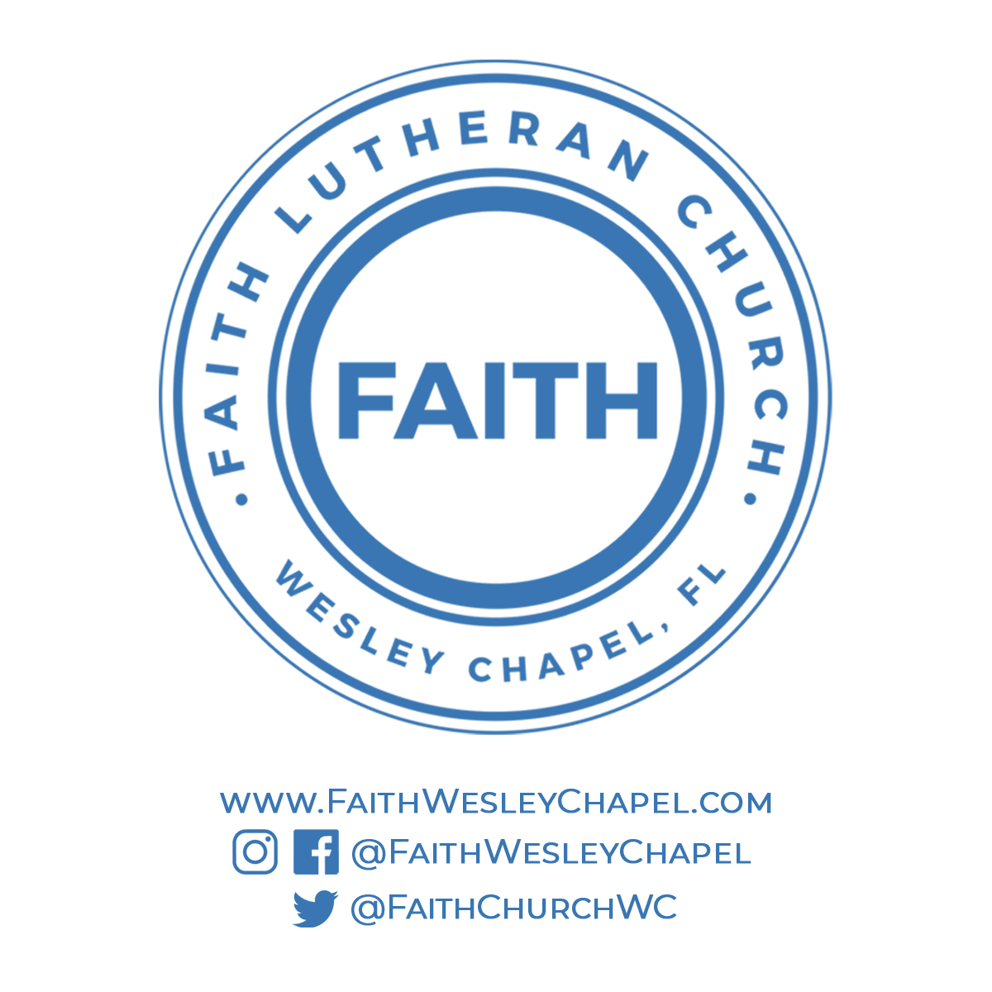**@FaithWesleyChapel**

**@FaithWesleyChapel**

**@FaithChurchWC**