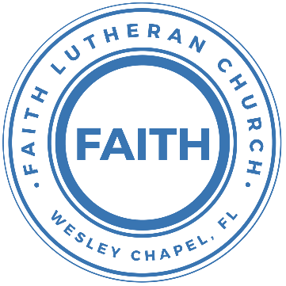

**Leading our community into a deep connection in Christ**

**___________________________________________________**

**Worship Service for December 8, 2024 at 11 AM**

**Welcome**

**Pray for the Food** - **People get food**

**Invocation** *(stand)*

**Confession and Forgiveness:** *(stand)*

**P:** As we gather, today, let us cleanse our hearts and our consciences by confessing our sin to God.

*(Time of silence for reflection and confession)*

**C:** Heavenly Father, we confess that we are sinful and unclean. We have sinned against you and against our neighbor in our thoughts, words, and actions.  We are truly sorry for our sins and sincerely repent of them. We ask for Your mercy. For the sake of Jesus Christ's bitter suffering and death, please forgive us and renew us that we may walk in Your Spirit to the glory of Your holy name. Amen

**P:** The Lord has heard your confession. Therefore, as a called and ordained servant of the Lord, in the stead and by the command of my Lord, Jesus Christ, I forgive you all your sins in the name of the Father and of the Son and of the Holy Spirit.  
**C:** Amen

**Song of Praise and Thanksgiving –** O Come, O Come, Emmanuel

O come, O come, Emmanuel, and ransom captive Israel,

That mourns in lonely exile here, until the Son of God appear.

Chorus:

Rejoice! Rejoice! Emmanuel shall come to thee, O Israel.

O come, Thou Key of David, come,  
And open wide our heav’nly home.

Make safe the way that leads on high,  
And close the path to misery.

*(Chorus)*

O come, Thou Dayspring, come and cheer,

Our spirits by Thine advent here,

And drive away the shades of night,

And pierce the clouds and bring us light.

*(Chorus)*

O come, Desire of nations, bind all people in one heart and mind.

Bid envy strife and quarrels cease.

Fill all the world with heaven's peace.

*(Chorus)* © 1982 The Jubilate Group

**Old Testament Reading:**Isaiah 9:1-7

But there will be no gloom for her who was in anguish. In the former time he brought into contempt the land of Zebulun and the land of Naphtali, but in the latter time he has made glorious the way of the sea, the land beyond the Jordan, Galilee of the nations.

The people who walked in darkness  
 have seen a great light;  
those who dwelt in a land of deep darkness,  
 on them has light shone.  
You have multiplied the nation;  
 you have increased its joy;  
they rejoice before you  
 as with joy at the harvest,  
 as they are glad when they divide the spoil.  
For the yoke of his burden,  
 and the staff for his shoulder,  
 the rod of his oppressor,  
 you have broken as on the day of Midian.  
For every boot of the tramping warrior in battle tumult  
 and every garment rolled in blood  
 will be burned as fuel for the fire.  
For to us a child is born,  
 to us a son is given;  
and the government shall be upon his shoulder,  
 and his name shall be called  
Wonderful Counselor, Mighty God,  
 Everlasting Father, Prince of Peace.  
Of the increase of his government and of peace  
 there will be no end,  
on the throne of David and over his kingdom,  
 to establish it and to uphold it  
with justice and with righteousness  
 from this time forth and forevermore.  
The zeal of the Lord of hosts will do this.

**Reader:** This is the Word of the Lord.  
**C:** Thanks be to God.

**Epistle Reading:** Romans 11:32–36

For God has consigned all to disobedience, that he may have mercy on all.

Oh, the depth of the riches and wisdom and knowledge of God! How unsearchable are his judgments and how inscrutable his ways!

“For who has known the mind of the Lord,  
 or who has been his counselor?”  
“Or who has given a gift to him  
 that he might be repaid?”

For from him and through him and to him are all things. To him be glory forever. Amen.

Look carefully then how you walk, not as unwise but as wise, making the best use of the time, because the days are evil. Therefore do not be foolish, but understand what the will of the Lord is.

**Reader:** This is the Word of the Lord.  
**C:** Thanks be to God.

**Gospel Reading** - Matthew 7:24–29

“Everyone then who hears these words of mine and does them will be like a wise man who built his house on the rock. And the rain fell, and the floods came, and the winds blew and beat on that house, but it did not fall, because it had been founded on the rock. And everyone who hears these words of mine and does not do them will be like a foolish man who built his house on the sand. And the rain fell, and the floods came, and the winds blew and beat against that house, and it fell, and great was the fall of it.”

And when Jesus finished these sayings, the crowds were astonished at his teaching, for he was teaching them as one who had authority, and not as their scribes.

**P:** This is the Gospel of the Lord.  
**C:** Praise be to You, O Christ.

**Sermon Song –** Jesus Messiah

He became sin, who knew no sin,  
That we might become His Righteousness.   
He humbled Himself and carried the cross.   
Love so amazing, love so amazing!

Chorus:  
Jesus Messiah, Name above all names,  
Blessed Redeemer, Emmanuel,  
The rescue for sinners, the ransom from Heaven,  
Jesus Messiah, Lord of all.

His body the bread, His blood the wine,  
Broken and poured out all for love.  
The whole earth trembled and the veil was torn.  
Love so amazing, love so amazing!

*(Chorus)*

All our hope is in You. All our hope is in You.  
All the glory to You, God, The light of the world.

*(Chorus)*

Jesus Messiah, Lord of all. He is the Lord of all! Lord of all. © 2008 Vamos Publishing and Alletrop Music

**Sermon/Discussion** – "Jesus, Our Wonderful Counselor"

**Prayers**

**Apostles' Creed** *(stand)*

I believe in God, the Father almighty, maker of heaven and earth,  
And in Jesus Christ, his only Son, our Lord,  
who was conceived by the Holy Spirit,  
born of the Virgin Mary, suffered under Pontius Pilate,  
was crucified, died and was buried. He descended into hell.  
The third day he rose again from the dead.  
He ascended into heaven and sits at the right hand of God  
the Father almighty.  
From there he will come to judge the living and the dead.  
I believe in the Holy Spirit, the holy Christian Church,  
the communion of saints, the forgiveness of sins,  
the resurrection of the body, and the life everlasting. Amen.

**The Lord's Prayer** *(stand)*

Our Father who art in heaven, hallowed be Thy name, Thy kingdom come, Thy will be done on earth as it is in heaven.  Give us this day our daily bread; and forgive us our trespasses as we forgive those who trespass against us; and lead us not into temptation, but deliver us from evil.  For Thine is the kingdom and the power and the glory forever and ever.  Amen

**Offering**

**Benediction** *– The online service ends. The closing hymn video is on the Livestream page bulletin at FaithWesleyChapel.com with lyrics below. See announcements below as well.*

**Closing Song -**Go Tell It On The Mountain

Chorus:  
Go tell it on the mountain, over the hills and everywhere.  
Go tell it on the mountain that Jesus Christ is born.

While shepherds kept their watching o'er silent flocks by night,  
Behold throughout the heavens there shone a Holy Light.

*(Chorus)*

The shepherds feared and trembled when lo, above the earth,  
Rang out the angel chorus that hailed our Savior’s birth.

*(Chorus)*

Down in a lowly manger, the humble Christ was born,  
And brought us God's salvation that blessed Christmas morn!

*(Chorus)* © 1945 © Galaxy Music Corporation

|  |  |
| --- | --- |
| **Serving This Week** | |
|  | |
| **O.T. Reader:** Larry Chmiel | **Children’s Church Teacher:** |
| **Epistle Reader :** Josh Strasheim | Melissa Steinbrueck |
| **Acolyte:** Kaylee Steinbrueck | **Children’s Church Assistant:** |
| **Com. Asst:** Larry Chmiel | Kelsey Torgrimson |
|  | |
| **Serving Next Week** | |
|  | |
| **O.T. Reader:** N/A | **Children’s Church Teacher:** |
| **Epistle Reader:** Vanessa Frost | Halston & Ben |
| **Acolyte:** Thomas Horness | **Children’s Church Assistant:** |
| **Com. Asst:** Larry Chmiel | N/A |
|  | |
|  | |
|  | |
|  | |
|  | |

**Upcoming Events**

**Today, 6 PM – Christmas in the Park**  
Wesley Chapel District Park

**Dec 10, 7 PM – Growth Group**  
Renee’s house - 3436 Chapel Creek Cir Wesley Chapel, FL 33544

**Dec 14, 6 PM – Open House Christmas Party**The Chmiel’s Home

**Dec 24, 6 PM Christmas Eve Service**  
Faith Lutheran Church

[**www.FaithWesleyChapel.com**](http://www.FaithWesleyChapel.com)

 **Faith YouTube**

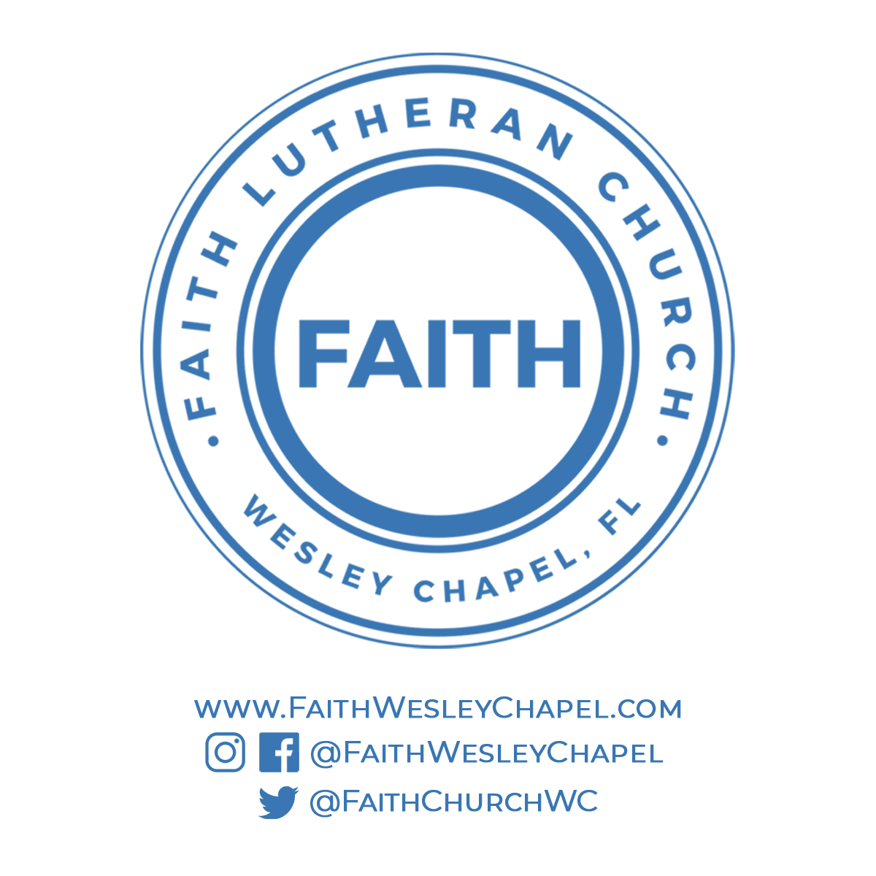**@FaithWesleyChapel**

**@FaithWesleyChapel**

**@FaithChurchWC**