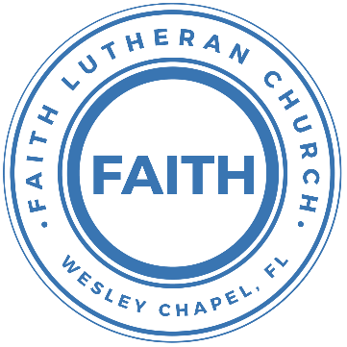

**Leading our community into a deep connection in Christ**

**Worship Service for December 15, 2024 at 11 AM**

**Welcome**

**Opening Song:** Come Thou Long Expected Jesus

Come thou long-expected Jesus, born to set thy people free,

From our fears and sins release us; let us find our rest in thee.

Israel’s strength and consolation, hope of all the earth thou art,

Dear desire of ev’ry nation, joy of every longing heart.

Come to earth to taste our sadness, He whose glories knew no end;  
by His life He brings us gladness, Our Redeemer, Shepherd, Friend.   
Leaving riches without number, born within a cattle stall;  
This the everlasting wonder, Christ was born the Lord of all!

Born Thy people to deliver, born a child and yet a king.  
Born to reign in us forever, now Thy gracious kingdom bring.  
By Thine own eternal Spirit; rule in all our hearts alone.  
By Thine all sufficient merit, raise us to Thy glorious throne.  
 © Public Domain

**Invocation**

**Confession and Forgiveness:**

**P:** Come into the presence of the Lord our God.  
**C:** Have mercy, O Lord. If you, Lord, kept a record of sins, Lord, who could stand; but if we confess our sins, he is faithful and just to forgive us our sins and to cleanse us from all unrighteousness.

*(A time of silence to reflect and personally confess our sins)*

**P:** I said, "I will confess my transgressions to the LORD." And you forgave the guilt of my sin. Let us confess our sin before the Lord. Let us confess together.  
**C:** Heavenly Father, we confess that we are sinners.  We have sinned against you and our neighbors. We have not loved you with our whole heart and we have not loved our neighbors as ourselves. We justly deserve Your punishment.  For the sake of Your Son, Jesus Christ, have mercy on us.  Forgive us, renew us, and lead us, so that we may delight in Your will and walk in Your ways to the glory of Your holy name.  Amen.

**P:** The Lord is gracious and merciful. He promises to forgive our sins. Therefore, upon this, your confession, as a called and ordained servant of the Lord, in the stead and by the command of my Lord, Jesus Christ, I forgive you all your sins in the name of the Father and of the Son and of the Holy Spirit.  
**C:** Amen.

**Song of Praise and Thanksgiving:** Joyful, Joyful We Adore Thee

Joyful, joyful we adore Thee, God of glory, Lord of love!  
Hearts unfold like flow'rs before Thee, praising Thee, their sun above.  
Melt the clouds of sin and sadness. Drive the gloom of doubt away.  
Giver of immortal gladness, fill us with the light of day.

All Thy works with joy surround Thee. Earth and heav'n reflect Thy rays.   
Stars and angels sing around Thee, center of unbroken praise. Field and forest, vale and mountain, flow'ry meadow, flashing sea, Chanting bird, and flowing fountain call us to rejoice in Thee.

Thou art giving and forgiving, ever blessing, ever blest,  
Wellspring of the joy of living, Ocean-depth of happy rest!  
Father, Son, and Holy Spirit, fountainhead of love divine:  
Joyful, we Thy heav'n inherit! Joyful, we by grace are Thine.  
 © Public Domain

**Epistle Reading** - Titus 2:11–14

For the grace of God has appeared, bringing salvation for all people, training us to renounce ungodliness and worldly passions, and to live self-controlled, upright, and godly lives in the present age, waiting for our blessed hope, the appearing of the glory of our great God and Savior Jesus Christ, who gave himself for us to redeem us from all lawlessness and to purify for himself a people for his own possession who are zealous for good works.

**Reader:** This is the Word of the Lord.  
**C:** Thanks be to God.

**Gospel Reading** - John 5:16–18; 8:48–59

And this was why the Jews were persecuting Jesus, because he was doing these things on the Sabbath. But Jesus answered them, “My Father is working until now, and I am working.”

This was why the Jews were seeking all the more to kill him, because not only was he breaking the Sabbath, but he was even calling God his own Father, making himself equal with God....

...The Jews answered him, “Are we not right in saying that you are a Samaritan and have a demon?” Jesus answered, “I do not have a demon, but I honor my Father, and you dishonor me. Yet I do not seek my own glory; there is One who seeks it, and he is the judge. Truly, truly, I say to you, if anyone keeps my word, he will never see death.” The Jews said to him, “Now we know that you have a demon! Abraham died, as did the prophets, yet you say, ‘If anyone keeps my word, he will never taste death.’ Are you greater than our father Abraham, who died? And the prophets died! Who do you make yourself out to be?” Jesus answered, “If I glorify myself, my glory is nothing. It is my Father who glorifies me, of whom you say, ‘He is our God.’ But you have not known him. I know him. If I were to say that I do not know him, I would be a liar like you, but I do know him and I keep his word. Your father Abraham rejoiced that he would see my day. He saw it and was glad.” So the Jews said to him, “You are not yet fifty years old, and have you seen Abraham?” Jesus said to them, “Truly, truly, I say to you, before Abraham was, I am.” So they picked up stones to throw at him, but Jesus hid himself and went out of the temple.

**P:** This is the Gospel of the Lord.  
**C:** Praise be to You, O Christ.

**Children's Message** *(Children dismissed to Children's Church)*

**Sermon Hymn***–*Angels From The Realms of Glory (Emmanuel)

Angels from the realms of glory wing your flight o'er all the earth.

You who sang creation's story now proclaim Messiah's birth.

Come and worship. Come and worship.

Worship Christ the newborn King.

Shepherds in the field abiding watching o'er your flocks by night.

God with man is now residing yonder shines the infant light.

Come and worship. Come and worship.

Worship Christ the newborn King.

Chorus:  
Emmanuel, Emmanuel,  
You are the God who saves us, worthy of all our praises.  
Emmanuel, Emmanuel,  
Come have Your way among us. We welcome You here, Lord Jesus.  
Come have Your way among us. We welcome You here, Lord Jesus.

Come and worship, worship Christ the newborn King.

God is with us, even now His love is here.  
*(Repeat)*

His love is here.

*(Chorus)*© 2015 © Thankyou Music (Admin. by Capitol CMG Publishing), Integrity Worship Music (Admin. by Capitol CMG Publishing (IMI)), and Leadworship Songs (Admin. by Capitol CMG Publishing (IMI)

**Sermon** - "Jesus, Our Mighty God"

Isaiah 9:6

For to us a child is born, to us a son is given . . . and His name shall be called Wonderful Counselor, Mighty God, Everlasting Father, Prince of Peace.

**P:** This is the Word of the Lord.  
**C:** Thanks be to God.

**Prayers:** *Text in prayer requests to (813) 326-5255*

**Nicene Creed** *(stand)*

I believe in one God, the Father Almighty, maker of heaven and earth and of all things visible and invisible.

And in one Lord Jesus Christ, the only-begotten Son of God, begotten of His Father before all worlds, God of God, Light of Light, very God of very God, begotten, not made, being of one substance with the Father, by whom all things were made; who for us men and for our salvation came down from heaven and was incarnate by the Holy Spirit of the virgin Mary and was made man; and was crucified also for us under Pontius Pilate. He suffered and was buried. And the third day He rose again according to the Scriptures and ascended into heaven and sits at the right hand of the Father. And He will come again with glory to judge both the living and the dead, whose kingdom will have no end.

And I believe in the Holy Spirit, the Lord and Giver of Life, who proceeds from the Father and the Son, who with the Father and the Son together is worshiped and glorified, who spoke by the prophets. And I believe in one holy Christian and apostolic Church, I acknowledge one Baptism for the remission of sins, and I look for the resurrection of the dead and the life of the world to come. Amen.

**The Lord's Prayer** *(stand)*

Our Father who art in heaven, hallowed be Thy name, Thy kingdom come, Thy will be done on earth as it is in heaven.  Give us this day our daily bread; and forgive us our trespasses as we forgive those who trespass against us; and lead us not into temptation, but deliver us from evil.  For Thine is the kingdom and the power and the glory forever and ever.  Amen

**Offering**

**Benediction** *– The online service ends. The closing hymn video is on the Livestream page bulletin at FaithWesleyChapel.com with lyrics below. See announcements below as well.*

**Closing Song:**He Shall Reign Forevermore

In the bleak mid-winter, all creation groans  
For a world in darkness, frozen like a stone  
Light is breaking, in a stable for a throne

Chorus:  
And He shall reign forevermore, forevermore  
And He shall reign forevermore, forevermore  
Unto us a child is born, The King of kings and Lord of lords  
And He shall reign forevermore, forevermore

If I were a wise man, I would travel far  
And if I were a shepherd, I would do my part  
But poor as I am, I will give to Him my heart

*(Chorus)*

Here within a manger lies the One who made the starry skies  
This baby born for sacrifice, Christ, the Messiah  
Into our hopes, into our fears, The Savior of the world appears  
The promise of eternal years, Christ, the Messiah

Chorus 2:   
He shall reign forevermore, forevermore  
He shall reign forevermore, forevermore  
He shall reign forevermore, forevermore  
And He shall reign forevermore, forevermore  
Unto us a child is born, The King of kings and Lord of lords  
And He shall reign forevermore, forevermore  
© 2015 © S. D. G. Publishing (Admin. by Capitol CMG Publishing), Sixsteps Songs (Admin. by Capitol CMG Publishing), Worship Together Music (Admin. by Capitol CMG Publishing), Be Essential Songs (Admin. by Essential Music Publishing LLC), and I Am A Pilgrim Songs (Admin. by Essential Music Publishing LLC)

|  |  |
| --- | --- |
| **Serving This Week** | |
|  | |
| **Gospel Reader:** N/A | **Children’s Church Teacher:** |
| **Epistle Reader:** Vanessa Frost | Halston & Ben |
| **Acolyte:** Thomas Horness | **Children’s Church Assistant:** |
| **Com. Asst:** Larry Chmiel | N/A |
|  | |
| **Serving Next Week** | |
|  | |
| **O.T. Reader:** N/A | **Children’s Church Teacher:** |
| **Epistle Reader:** Darlene Mueller | Melissa Steinbrueck |
| **Acolyte:** Lawrence Finnerty | **Children’s Church Assistant:** |
| **Com. Asst:** Larry Chmiel | Kaylee Steinbrueck |
|  | |

**Upcoming Events**

**Dec 24, 6 PM Christmas Eve Service**  
Faith Lutheran Church 

**www.FaithWesleyChapel.com**

**Faith YouTube**

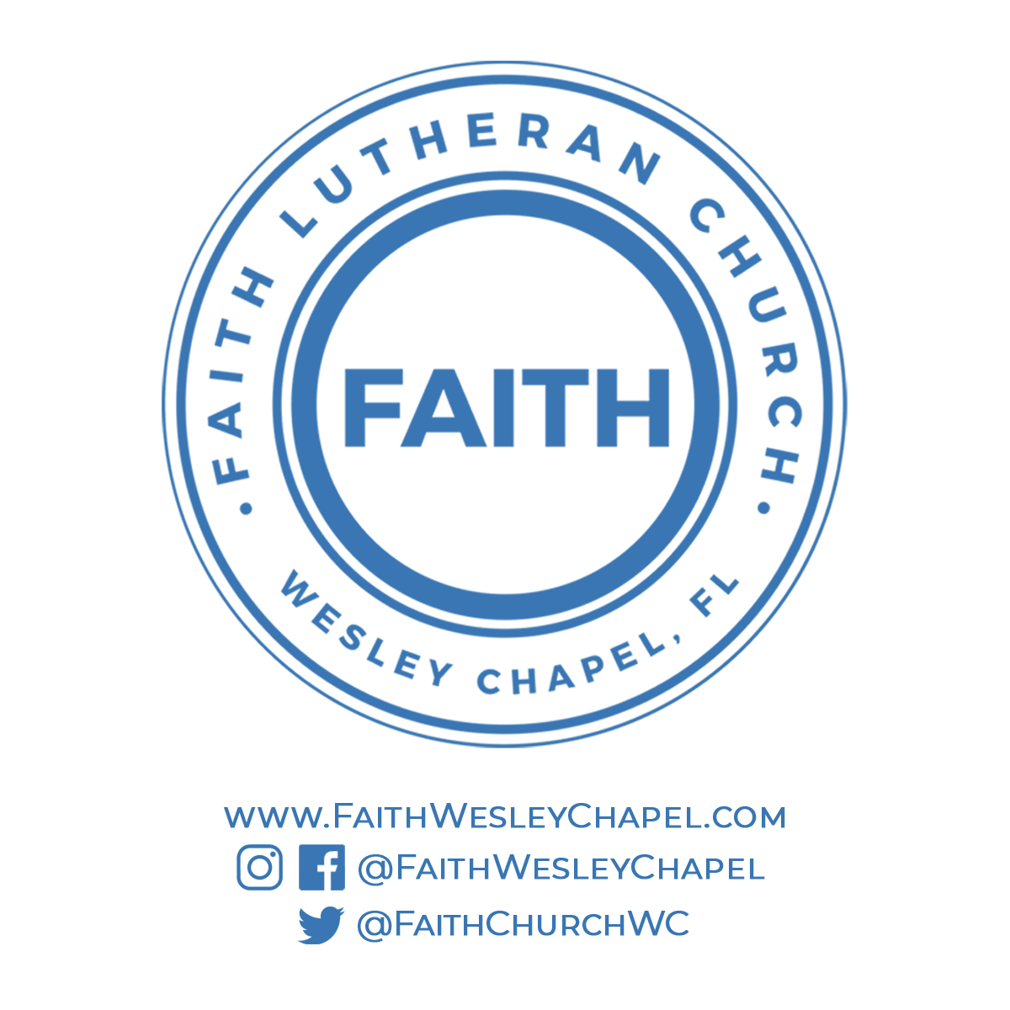**@FaithWesleyChapel**

**@FaithWesleyChapel**

**@FaithChurchWC**