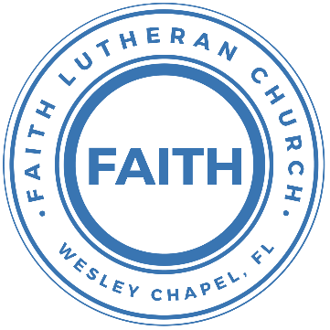

**Leading our community into a deep connection in Christ**

**Worship Service for December 22, 2024 at 11 AM**

**Welcome**

**Opening Song:** O Little Town of Bethlehem

Oh, little town of Bethlehem how still we see thee lie.  
Above the dark and dreamless sleep the silent stars go by,  
Yet, in thy dark streets shineth the everlasting light.  
The hopes and fears of all the years are met in thee tonight.

How silently, how silently, the wondrous gift is given.  
So, God imparts to human hearts the blessings of His Heaven.  
No ear may hear His coming, but in this world of sin,  
Where meek souls will receive Him still the dear Christ enters in.

Oh, holy child of Bethlehem descend on us we pray.  
Cast out our sin and enter in, be born in us today.  
We hear the Christmas angels, their great glad tidings tell.  
Oh come to us, abide with us, our lord, Emanuel. © Public Domain

**Invocation**

**Confession and Forgiveness:**

**P:** Come into the presence of the Lord our God.  
**C:** Have mercy, O Lord. If you, Lord, kept a record of sins, Lord, who could stand; but if we confess our sins, he is faithful and just to forgive us our sins and to cleanse us from all unrighteousness.

*(A time of silence to reflect and personally confess our sins)*

**P:** I said, "I will confess my transgressions to the LORD." And you forgave the guilt of my sin. Let us confess our sin before the Lord. Let us confess together.  
**C:** Heavenly Father, we confess that we are sinners.  We have sinned against you and our neighbors. We have not loved you with our whole heart and we have not loved our neighbors as ourselves. We justly deserve Your punishment.  For the sake of Your Son, Jesus Christ, have mercy on us.  Forgive us, renew us, and lead us, so that we may delight in Your will and walk in Your ways to the glory of Your holy name.  Amen.

**P:** The Lord is gracious and merciful. He promises to forgive our sins. Therefore, upon this, your confession, as a called and ordained servant of the Lord, in the stead and by the command of my Lord, Jesus Christ, I forgive you all your sins in the name of the Father and of the Son and of the Holy Spirit.  
**C:** Amen.

**Song of Praise and Thanksgiving:** The First Noel

Verse 1:

The first Noel the angel did say

Was to certain poor Shepherds in fields as they lay:

In fields where they lay keeping their sheep

On a cold winter's night that was so deep.

Chorus:  
Noel, Noel, Noel, Noel, Born is the King of Israel.

They looked up and saw a star,  
Shining in the east beyond them far:  
And to the earth it gave great light.  
And so it continued both day and night.

(Chorus)

Then let us all with one accord   
Sing praises to our heavenly Lord,   
That hath made heaven and earth of nought,  
And with his blood mankind has bought.

(Chorus) © Public Domain

**Epistle Reading** - Colossians 1:15–20

He is the image of the invisible God, the firstborn of all creation. For by him all things were created, in heaven and on earth, visible and invisible, whether thrones or dominions or rulers or authorities—all things were created through him and for him. And he is before all things, and in him all things hold together. And he is the head of the body, the church. He is the beginning, the firstborn from the dead, that in everything he might be preeminent. For in him all the fullness of God was pleased to dwell, and through him to reconcile to himself all things, whether on earth or in heaven, making peace by the blood of his cross.

**Reader:** This is the Word of the Lord.  
**C:** Thanks be to God.

**Gospel Reading** - John 14:1–11

“Let not your hearts be troubled. Believe in God; believe also in me. In my Father's house are many rooms. If it were not so, would I have told you that I go to prepare a place for you? And if I go and prepare a place for you, I will come again and will take you to myself, that where I am you may be also. And you know the way to where I am going.” Thomas said to him, “Lord, we do not know where you are going. How can we know the way?” Jesus said to him, “I am the way, and the truth, and the life. No one comes to the Father except through me. If you had known me, you would have known my Father also. From now on you do know him and have seen him.”

Philip said to him, “Lord, show us the Father, and it is enough for us.” Jesus said to him, “Have I been with you so long, and you still do not know me, Philip? Whoever has seen me has seen the Father. How can you say, ‘Show us the Father’? Do you not believe that I am in the Father and the Father is in me? The words that I say to you I do not speak on my own authority, but the Father who dwells in me does his works. Believe me that I am in the Father and the Father is in me, or else believe on account of the works themselves.

**P:** This is the Gospel of the Lord.  
**C:** Praise be to You, O Christ.

**Children's Message** *(Children dismissed to Children's Church)*

**Sermon Hymn***–*He Has Come For Us (God Rest Ye Merry Gentlemen)

God rest ye merry gentlemen let nothing you dismay

Remember Christ our Savior was born on Christmas day

To save us all from Satan's power when we were gone astray

Oh tidings of comfort and joy, comfort and joy

Oh tidings of comfort and joy

Chorus:

He has come for us, this Jesus

He's the hope for all mankind

He has come for us, the Messiah

Born to give us life (He is born to give us life)

From God our heavenly Father a blessed angel came

And unto certain shepherds brought tidings of the same

How that in Bethleham was born the Son of God by name

Oh tidings of comfort and joy, comfort and joy

Oh tidings of comfort and joy

(Chorus)  
 © 2009 Word Music, LLC, Windsor Way Music, GrangeHill Music, and Peertunes, Ltd.

**Sermon** - "Everlasting Father"

Isaiah 9:6-7

For to us a child is born, to us a son is given . . . and His name shall be called Wonderful Counselor, Mighty God, Everlasting Father, Prince of Peace. Of the increase of His government and of peace there will be no end, on the throne of David and over His kingdom, to establish it and to uphold it with justice and with righteousness from this time forth and forevermore.

**P:** This is the Word of the Lord.  
**C:** Thanks be to God.

**Prayers:** *Text in prayer requests to (813) 326-5255*

**Nicene Creed** *(stand)*

I believe in one God, the Father Almighty, maker of heaven and earth and of all things visible and invisible.

And in one Lord Jesus Christ, the only-begotten Son of God, begotten of His Father before all worlds, God of God, Light of Light, very God of very God, begotten, not made, being of one substance with the Father, by whom all things were made; who for us men and for our salvation came down from heaven and was incarnate by the Holy Spirit of the virgin Mary and was made man; and was crucified also for us under Pontius Pilate. He suffered and was buried. And the third day He rose again according to the Scriptures and ascended into heaven and sits at the right hand of the Father. And He will come again with glory to judge both the living and the dead, whose kingdom will have no end.

And I believe in the Holy Spirit, the Lord and Giver of Life, who proceeds from the Father and the Son, who with the Father and the Son together is worshiped and glorified, who spoke by the prophets. And I believe in one holy Christian and apostolic Church, I acknowledge one Baptism for the remission of sins, and I look for the resurrection of the dead and the life of the world to come. Amen.

**The Lord's Prayer** *(stand)*

Our Father who art in heaven, hallowed be Thy name, Thy kingdom come, Thy will be done on earth as it is in heaven.  Give us this day our daily bread; and forgive us our trespasses as we forgive those who trespass against us; and lead us not into temptation, but deliver us from evil.  For Thine is the kingdom and the power and the glory forever and ever.  Amen

**Offering**

**Benediction** *– The online service ends. The closing hymn video is on the Livestream page bulletin at FaithWesleyChapel.com with lyrics below. See announcements below as well.*

**Closing Song:**Angels We Have Heard on High

Angels we have heard on high, sweetly singing o’er the plains,  
And the mountains in reply, echoing their joyous strains.  
Gloria, in excelsis Deo. Gloria, in excelsis Deo.

Shepherds why this jubilee? Why your joyous strains prolong?  
What the gladsome tidings be which inspire your heavenly song?  
Gloria, in excelsis Deo. Gloria, in excelsis Deo.

Come to Bethlehem and see Him whose birth the angels sing;  
Come adore on bended knee Christ the Lord the newborn King.  
Gloria, in excelsis Deo. Gloria, in excelsis Deo. © Public Domain

|  |  |
| --- | --- |
| **Serving This Week** | |
|  | |
| **Gospel Reader:** N/A | **Children’s Church Teacher:** |
| **Epistle Reader:** Darlene Mueller | Melissa Steinbrueck |
| **Acolyte:** Lawrence Finnerty | **Children’s Church Assistant:** |
| **Com. Asst:** Larry Chmiel | Kaylee Steinbrueck |
|  | |
| **Serving Christmas Eve** | |
|  | |
| **1st Reader:** Halston Quinn | **Children’s Church Teacher:** |
| **2nd Reader:** Judy Steinbrueck  **3rd Reader:** Larry Chmiel | N/A |
| **Acolyte:** Kaylee Steinbrueck | **Children’s Church Assistant:** |
| **Com. Asst:** Larry Chmiel | N/A |
| **Serving December 29** | |
|  | |
| **O.T. Reader:** Larry Chmiel | **Children’s Church Teacher:** |
| **Epistle Reader:** Darlene Mueller | Melissa Steinbrueck |
| **Acolyte:** Lawrence Finnerty | **Children’s Church Assistant:** |
| **Com. Asst:** Larry Chmiel | Kaylee Steinbrueck |
|  | |

**Upcoming Events**

**Dec 24, 6 PM - Christmas Eve Service**  
Faith Lutheran Church 

**Dec 29, 11 AM – Faith and Food Worship Service**  
Faith Lutheran Church

**www.FaithWesleyChapel.com**

**Faith YouTube**

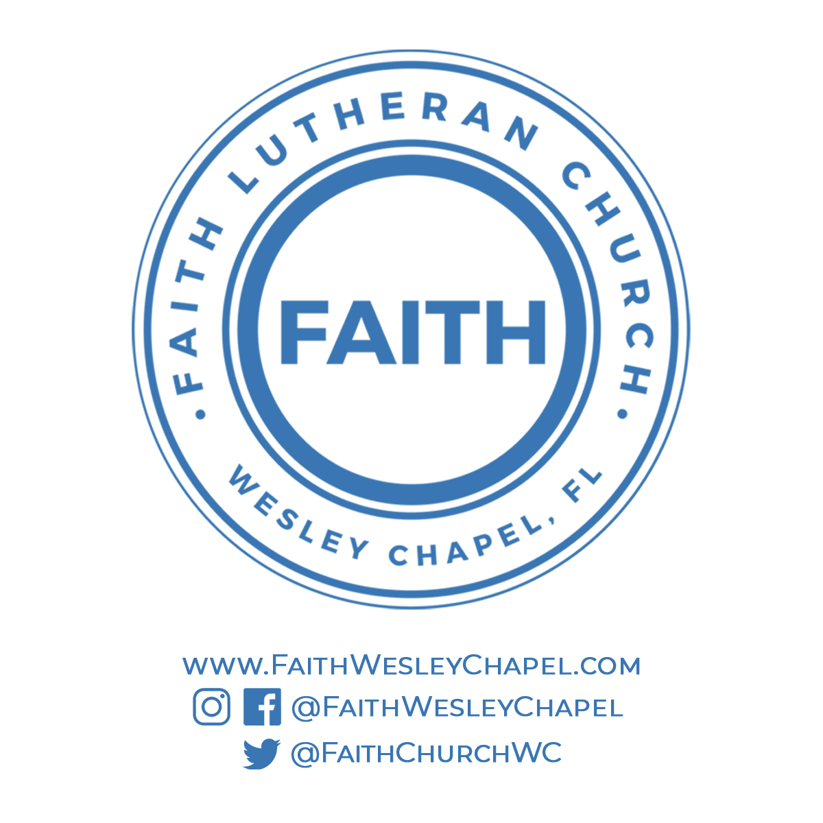**@FaithWesleyChapel**

**@FaithWesleyChapel**

**@FaithChurchWC**