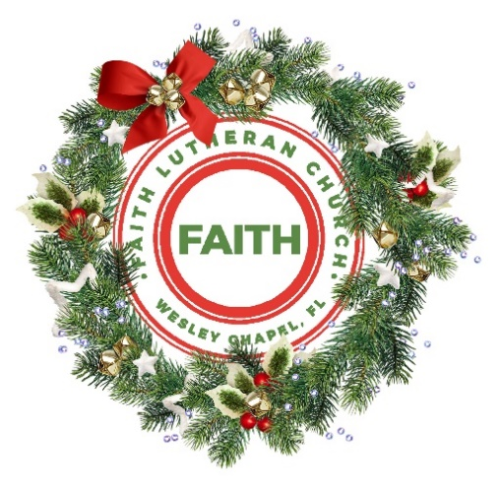

**Leading our community into a deep connection in Christ**

**Christmas Eve Worship Service for December 24, 2024 at 6 PM**

**Welcome**

**Opening Song:** Hark! The Herald Angels Sing

Hark the herald angels sing "Glory to the new born King.  
Peace on earth and mercy mild, God and sinners reconciled."  
Joyful all ye nations rise. Join the triumph of the skies.  
With angelic host proclaim, "Christ is born in Bethlehem."  
Hark the herald angels sing, "Glory to the new born King."

Christ, by highest heaven adored; Christ the everlasting Lord;  
Late in time behold him come, Offspring of the Virgin’s womb.  
Veiled in flesh, the God-head see; hail the incarnate Deity.  
Pleased as man with men to dwell, Jesus, our Immanuel.  
Hark the herald angels sing, "Glory to the new born King."

Hail! the heaven-born Prince of Peace.   
Hail, the son of Righteousness.  
Light and life to all He brings, risen with healing in His wings.  
Mild He lays His glory by, born that man no more may die,  
Born to raise each child of earth, born to give them second birth.  
Hark the herald angels sing, "Glory to the new born King."  
Hark the herald angels sing, "Glory to the new born King."   
 © Public Domain  
  
**Invocation**

**Confession and Forgiveness:**

**P:** Arise, Brothers and Sisters, for your light has come! The Glory of the Lord rises upon you. Do not let the darkness of your sin remain. Let the light of Jesus shine in every dark and sinful corner of your life. Do not fear! For on that first Christmas day your Savior was born, who is Christ the Lord. He came not to condemn the world, but to save the world through His death and resurrection.

*(a time of silence to reflect and personally confess our sins)*

**C:** Heavenly Father, we confess that we are sinful and unclean. We have sinned against you and against our neighbor in our thoughts, words, and actions.  We are truly sorry for our sins and sincerely repent of them. We ask for Your mercy. For the sake of Jesus Christ's bitter suffering and death, please forgive us and renew us that we may walk in Your Spirit to the glory of Your holy name. Amen

**P:** The Lord has heard your confession. Therefore, as a called and ordained servant of the Lord, in the stead and by the command of my Lord, Jesus Christ, I forgive you all your sins in the name of the Father and of the Son and of the Holy Spirit.  
**C:** Amen

**Song:**O Come All Ye Faithful / Angels We Have Heard on High (Medley)

Oh come all ye faithful, joyful and triumphant!  
Oh come ye, oh come ye to Bethlehem;  
Come and behold Him, born the King of angels  
Oh, come let us adore Him. Oh, come let us adore Him  
Oh, come let us adore Him, Christ the Lord!

Angels we have heard on high sweetly singing o’er the plains,  
And the mountains in reply, echoing their joyous strains.  
Gloria, in excelsis Deo! Gloria, in excelsis Deo!

Come to Bethlehem and see Him whose birth the angels sing.  
Come adore on bended knee Christ the Lord the newborn King.  
Gloria, in excelsis Deo! Gloria, in excelsis Deo!

Yea, Lord we greet Thee, born this happy morning;  
Jesus, to Thee be glory giv’n!  
Word of the Father now in flesh appearing!  
Oh, come let us adore Him. Oh, come let us adore Him  
Oh, come let us adore Him, Christ the Lord! © Public Domain

**First Reading -**Luke 2:1-7

In those days a decree went out from Caesar Augustus that all the world should be registered. This was the first registration when Quirinius was governor of Syria. And all went to be registered, each to his own town. And Joseph also went up from Galilee, from the town of Nazareth, to Judea, to the city of David, which is called Bethlehem, because he was of the house and lineage of David, to be registered with Mary, his betrothed, who was with child. And while they were there, the time came for her to give birth. And she gave birth to her firstborn son and wrapped him in swaddling cloths and laid him in a manger, because there was no place for them in the inn.

**P:** This is the Gospel of the Lord.  
**C:** Praise be to You, o Christ.

**Children's Message**"Jesus Name and Your Name"

**Song:**Away in a Manger

Away in a manger, no crib for a bed,  
The little Lord Jesus, lay down His sweet head.  
The stars in the sky looked down where He lay  
The little Lord Jesus, asleep on the hay.

Be near me Lord Jesus, I ask Thee to stay,  
Close by me forever and love me I pray.  
Bless all the dear children in Thy tender care,  
And take us to heaven to live with Thee there. © Public Domain

**Second Reading -**Luke 2:8-14

And in the same region there were shepherds out in the field, keeping watch over their flock by night. And an angel of the Lord appeared to them, and the glory of the Lord shone around them, and they were filled with great fear. And the angel said to them, “Fear not, for behold, I bring you good news of great joy that will be for all the people. For unto you is born this day in the city of David a Savior, who is Christ the Lord. And this will be a sign for you: you will find a baby wrapped in swaddling cloths and lying in a manger.” And suddenly there was with the angel a multitude of the heavenly host praising God and saying,

“Glory to God in the highest,  
 and on earth peace among those with whom he is pleased!”

**P:** This is the Gospel of the Lord.  
**C:** Praise be to You, o Christ.

**Children's Message**"Jesus is the Prince of Peace"

**Song:**It Came Upon a Midnight Clear

It came upon a midnight clear, that glorious song of old,

From angels bending near the earth to touch their harps of gold.

"Peace on the earth, good will to men from heaven's all gracious King;"

The world in solemn stillness lay, to hear the angels sing.

Yet, with the woes of sin and strife the world hath suffered long.

Beneath the angel-strain have rolled two thousand years of wrong.

And man, at war with man, hears not the love song which they bring.

O hush the noise, ye men of strife, and hear the angels sing.

For lo! the days are hastening on by prophet bards foretold,

When, with the ever-circling years, shall come the Age of Gold.

When peace shall over all the earth its ancient splendors fling,

And all the world give back the song which now the angels sing.  
 © Public Domain

**Third Reading -** Luke 2:15-20

When the angels went away from them into heaven, the shepherds said to one another, “Let us go over to Bethlehem and see this thing that has happened, which the Lord has made known to us.” And they went with haste and found Mary and Joseph, and the baby lying in a manger. And when they saw it, they made known the saying that had been told them concerning this child. And all who heard it wondered at what the shepherds told them. But Mary treasured up all these things, pondering them in her heart. And the shepherds returned, glorifying and praising God for all they had heard and seen, as it had been told them.

**P:** This is the Gospel of the Lord.  
**C:** Praise be to You, o Christ.

**Sermon -** "Prince of Peace"

Isaiah 9:6  
For to us a child is born, to us a son is given . . . and His name shall be called Wonderful Counselor, Mighty God, Everlasting Father, Prince of Peace.

**Prayers:** *Text in prayer requests to (813) 326-5255*

**The Lord's Prayer**

Our Father who art in heaven, hallowed be Thy name, Thy kingdom come, Thy will be done on earth as it is in heaven.  Give us this day our daily bread; and forgive us our trespasses as we forgive those who trespass against us; and lead us not into temptation, but deliver us from evil.  For Thine is the kingdom and the power and the glory forever and ever.  Amen

**Offering and Special Music: O Holy Night**

**Apostles' Creed** *(stand)*

I believe in God, the Father almighty, maker of heaven and earth,

And in Jesus Christ, his only Son, our Lord,  
who was conceived by the Holy Spirit,  
born of the Virgin Mary, suffered under Pontius Pilate,  
was crucified, died and was buried. He descended into hell.  
The third day he rose again from the dead.  
He ascended into heaven  
and sits at the right hand of God  
the Father almighty.  
From there he will come to judge the living and the dead.  
I believe in the Holy Spirit, the holy Christian Church,  
the communion of saints, the forgiveness of sins,  
the resurrection of the body, and the life everlasting. Amen.

**Offering**

**Benediction** *– The online service ends. The closing hymn video is on the Livestream page bulletin at FaithWesleyChapel.com with lyrics below. See announcements below as well.*

**Closing Song:**Joy to The World

Joy to the World, the Lord is come! Let earth receive her King.  
Let every heart prepare Him room,  
And Heaven and nature sing, and Heaven and nature sing,  
And Heaven, and Heaven, and nature sing.

Joy to the World, the Savior reigns! Let men their songs employ.  
While fields and floods, rocks, hills and plains,  
Repeat the sounding joy, repeat the sounding joy,  
Repeat, repeat, the sounding joy.

He rules the world with truth and grace,  
And makes the nations prove, The glories of, His righteousness,  
And wonders of His love, and wonders of His love,  
And wonders, wonders, of His love! © Public Domain

|  |  |
| --- | --- |
| **Serving This Week** | |
|  | |
| **1st Reader:** Halston Quinn | **Children’s Church Teacher:** |
| **2nd Reader:** Richard Steinbrueck  **3rd Reader:** Larry Chmiel | N/A |
| **Acolyte:** Kaylee Steinbrueck | **Children’s Church Assistant:** |
| **Com. Asst:** Larry Chmiel | N/A |
|  | |
|  | |
| **Serving Next Week** | |
|  | |
| **O.T. Reader:** Larry Chmiel | **Children’s Church Teacher:** |
| **Epistle Reader:** Darlene Mueller | Melissa Steinbrueck |
| **Acolyte:** Lawrence Finnerty | **Children’s Church Assistant:** |
| **Com. Asst:** Larry Chmiel | Kaylee Steinbrueck |

**Upcoming Events**

**Dec. 29, 11 AM – Faith and Food Service**  
Faith Lutheran Church

**www.FaithWesleyChapel.com**

**Faith YouTube**

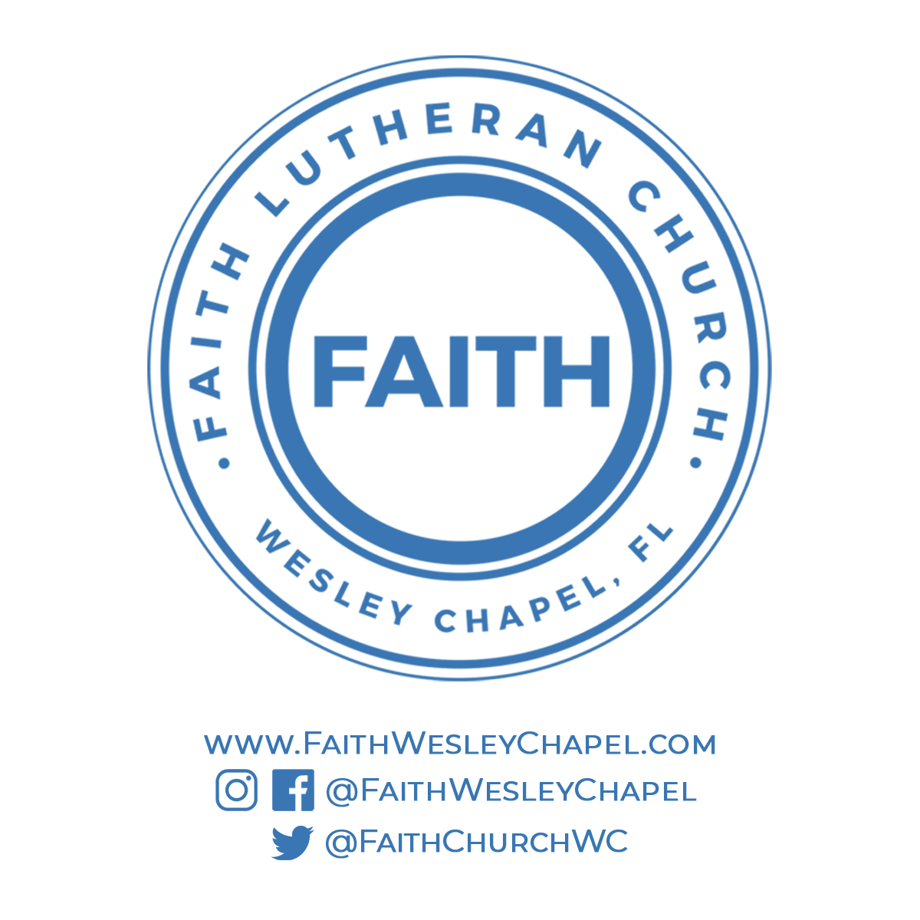**@FaithWesleyChapel**

**@FaithWesleyChapel**

**@FaithChurchWC**