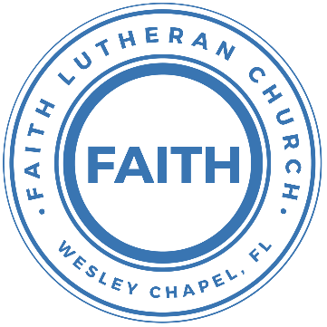

**Leading our community into a deep connection in Christ**

**Worship Service for December 29, 2024 at 11 AM**

**Welcome**

**Pray for the Food** - **People get food**

**Invocation** *(stand)*

**Responsive Reading** - Psalm 111

**All:** Praise the Lord!

**P:** I will give thanks to the Lord with my whole heart,  
**C:** In the company of the upright, in the congregation.

**P:** Great are the works of the Lord, studied by all who delight in them.  
**C:** Full of splendor and majesty is his work, and his righteousness endures forever.

**P:** He has caused his wondrous works to be remembered;  
**C:** The Lord is gracious and merciful.

**P:** He provides food for those who fear him; he remembers his covenant forever.  
**C:** He has shown his people the power of his works, in giving them the inheritance of the nations.

**P:** The works of his hands are faithful and just; all his precepts are trustworthy;  
**C:** They are established forever and ever, to be performed with faithfulness and uprightness.

**P:** He sent redemption to his people; he has commanded his covenant forever.  
**C:** Holy and awesome is his name!

**P:** The fear of the Lord is the beginning of wisdom;  
**C:** All those who practice it have a good understanding.

**All:** His praise endures forever!

**Confession and Forgiveness:** *(stand)*

**P:** As we gather, today, let us cleanse our hearts and our consciences by confessing our sin to God.

*(Time of silence for reflection and confession)*

**C:** Heavenly Father, we confess that we are sinful and unclean. We have sinned against you and against our neighbor in our thoughts, words, and actions.  We are truly sorry for our sins and sincerely repent of them. We ask for Your mercy. For the sake of Jesus Christ's bitter suffering and death, please forgive us and renew us that we may walk in Your Spirit to the glory of Your holy name. Amen

**P:** The Lord has heard your confession. Therefore, as a called and ordained servant of the Lord, in the stead and by the command of my Lord, Jesus Christ, I forgive you all your sins in the name of the Father and of the Son and of the Holy Spirit.  
**C:** Amen

**Songs of Praise and Thanksgiving –** Joy to The World

Joy to the World, the Lord is come! Let earth receive her King.

Let every heart prepare Him room,

And Heaven and nature sing, and Heaven and nature sing,

And Heaven, and Heaven, and nature sing.

Joy to the World, the Savior reigns! Let men their songs employ.

While fields and floods, rocks, hills and plains,

Repeat the sounding joy, repeat the sounding joy,

Repeat, repeat, the sounding joy.

He rules the world with truth and grace,

And makes the nations prove, The glories of, His righteousness,

And wonders of His love, and wonders of His love,

And wonders, wonders, of His love! © Public Domain

**Old Testament Reading:**Exodus 13:1-3a, 11–15

The Lord said to Moses, “Consecrate to me all the firstborn. Whatever is the first to open the womb among the people of Israel, both of man and of beast, is mine.”  
Then Moses said to the people, “Remember this day in which you came out from Egypt, out of the house of slavery, for by a strong hand the Lord brought you out from this place. No leavened bread shall be eaten...

...“When the Lord brings you into the land of the Canaanites, as he swore to you and your fathers, and shall give it to you, you shall set apart to the Lord all that first opens the womb. All the firstborn of your animals that are males shall be the Lord's. Every firstborn of a donkey you shall redeem with a lamb, or if you will not redeem it you shall break its neck. Every firstborn of man among your sons you shall redeem. And when in time to come your son asks you,

‘What does this mean?’ you shall say to him, ‘By a strong hand the Lord brought us out of Egypt, from the house of slavery. For when Pharaoh stubbornly refused to let us go, the Lord killed all the firstborn in the land of Egypt, both the firstborn of man and the firstborn of animals. Therefore I sacrifice to the Lord all the males that first open the womb, but all the firstborn of my sons I redeem.’

**Reader:** This is the Word of the Lord.  
**C:** Thanks be to God.

**Epistle Reading:** Colossians 3:12-17

Put on then, as God's chosen ones, holy and beloved, compassionate hearts, kindness, humility, meekness, and patience, bearing with one another and, if one has a complaint against another, forgiving each other; as the Lord has forgiven you, so you also must forgive. And above all these put on love, which binds everything together in perfect harmony. And let the peace of Christ rule in your hearts, to which indeed you were called in one body. And be thankful. Let the word of Christ dwell in you richly, teaching and admonishing one another in all wisdom, singing psalms and hymns and spiritual songs, with thankfulness in your hearts to God. And whatever you do, in word or deed, do everything in the name of the Lord Jesus, giving thanks to God the Father through him.

**Reader:** This is the Word of the Lord.  
**C:** Thanks be to God.

**Gospel Reading** - Luke 2:22–40

And when the time came for their purification according to the Law of Moses, they brought him up to Jerusalem to present him to the Lord (as it is written in the Law of the Lord, “Every male who first opens the womb shall be called holy to the Lord”) and to offer a sacrifice according to what is said in the Law of the Lord, “a pair of turtledoves, or two young pigeons.” Now there was a man in Jerusalem, whose name was Simeon, and this man was righteous and devout, waiting for the consolation of Israel, and the Holy Spirit was upon him. And it had been revealed to him by the Holy Spirit that he would not see death before he had seen the Lord's Christ. And he came in the Spirit into the temple, and when the parents brought in the child Jesus, to do for him according to the custom of the Law, he took him up in his arms and blessed God and said,

“Lord, now you are letting your servant depart in peace,  
 according to your word;  
for my eyes have seen your salvation  
 that you have prepared in the presence of all peoples,  
a light for revelation to the Gentiles,  
 and for glory to your people Israel.”

And his father and his mother marveled at what was said about him. And Simeon blessed them and said to Mary his mother, “Behold, this child is appointed for the fall and rising of many in Israel, and for a sign that is opposed (and a sword will pierce through your own soul also), so that thoughts from many hearts may be revealed.”

And there was a prophetess, Anna, the daughter of Phanuel, of the tribe of Asher. She was advanced in years, having lived with her husband seven years from when she was a virgin, and then as a widow until she was eighty-four. She did not depart from the temple, worshiping with fasting and prayer night and day. And coming up at that very hour she began to give thanks to God and to speak of him to all who were waiting for the redemption of Jerusalem.

And when they had performed everything according to the Law of the Lord, they returned into Galilee, to their own town of Nazareth. And the child grew and became strong, filled with wisdom. And the favor of God was upon him.

**P:** This is the Gospel of the Lord.  
**C:** Praise be to You, O Christ.

**Sermon Song –** Oh Come All Ye Faithful *(sit)*

Oh come all ye faithful, joyful and triumphant!  
Oh come ye, oh come ye to Bethlehem;  
Come and behold Him, born the King of angels.  
Oh come let us adore Him. Oh come let us adore Him.  
Oh come let us adore Him, Christ the Lord!

Sing choirs of angels. Sing in exultation.  
Sing all ye citizens of hea’en above!  
“Glory to God! Glory in the highest!”  
Oh come let us adore Him. Oh come let us adore Him.  
Oh come let us adore Him, Christ the Lord!

Yea, Lord, we greet Thee, born this happy morning;  
Jesus, to Thee be glory giv’n!  
Word of the Father now in flesh appearing!  
Oh come let us adore Him. Oh come let us adore Him.  
Oh come let us adore Him, Christ the Lord! © Public Domain

**Sermon/Discussion** – "You Are the Lord's and This Year is the Lord's"

**Prayers**

**Nicene Creed** *(stand)*

I believe in one God, the Father Almighty, maker of heaven and earth and of all things visible and invisible.

And in one Lord Jesus Christ, the only-begotten Son of God, begotten of His Father before all worlds, God of God, Light of Light, very God of very God, begotten, not made, being of one substance with the Father, by whom all things were made; who for us men and for our salvation came down from heaven and was incarnate by the Holy Spirit of the virgin Mary and was made man; and was crucified also for us under Pontius Pilate. He suffered and was buried. And the third day He rose again according to the Scriptures and ascended into heaven and sits at the right hand of the Father. And He will come again with glory to judge both the living and the dead, whose kingdom will have no end.

And I believe in the Holy Spirit, the Lord and Giver of Life, who proceeds from the Father and the Son, who with the Father and the Son together is worshiped and glorified, who spoke by the prophets. And I believe in one holy Christian and apostolic Church, I acknowledge one Baptism for the remission of sins, and I look for the resurrection of the dead and the life of the world to come. Amen.

**The Lord's Prayer**

Our Father who art in heaven, hallowed be Thy name, Thy kingdom come, Thy will be done on earth as it is in heaven.  Give us this day our daily bread; and forgive us our trespasses as we forgive those who trespass against us; and lead us not into temptation, but deliver us from evil.  For Thine is the kingdom and the power and the glory forever and ever.  Amen

**Offering**

**Benediction** *– The online service ends. The closing hymn video is on the Livestream page bulletin at FaithWesleyChapel.com with lyrics below. See announcements below as well.*

**Closing Song:** Praise God From Whom All Blessings Flow *(stand)*

Praise God from Whom all blessings flow.  
Praise Him all creatures here below.  
Praise Him above, ye heavenly hosts.  
Praise Father, Son and Holy Ghost.  
Amen

|  |  |
| --- | --- |
| **Serving This Week** | |
|  | |
| **O.T. Reader:** Larry Chmiel | **Children’s Church Teacher:** |
| **Epistle Reader:** Darlene Mueller | Melissa Steinbrueck |
| **Acolyte:** Lawrence Finnerty | **Children’s Church Assistant:** |
| **Com. Asst:** Larry Chmiel | Kaylee Steinbrueck |
|  | |
| **Serving Next Week** | |
|  | |
| **1st Reader:** Kelsey Torgrimson | **Children’s Church Teacher:** |
| **2nd Reader:** Melissa Steinbrueck | N/A – Children’s Service |
| **Acolyte:** Kaylee Steinbrueck | **Children’s Church Assistant:** |
| **Com. Asst:** Larry Chmiel | N/A – Children’s Service |

**Upcoming Events**

**Jan 11, 11 AM – Faith and Food Worship Service**  
Faith Lutheran Church

**Jan 14, 7 PM – Growth Group Bible Study**  
Renee’s Home

**www.FaithWesleyChapel.com**

**Faith YouTube**

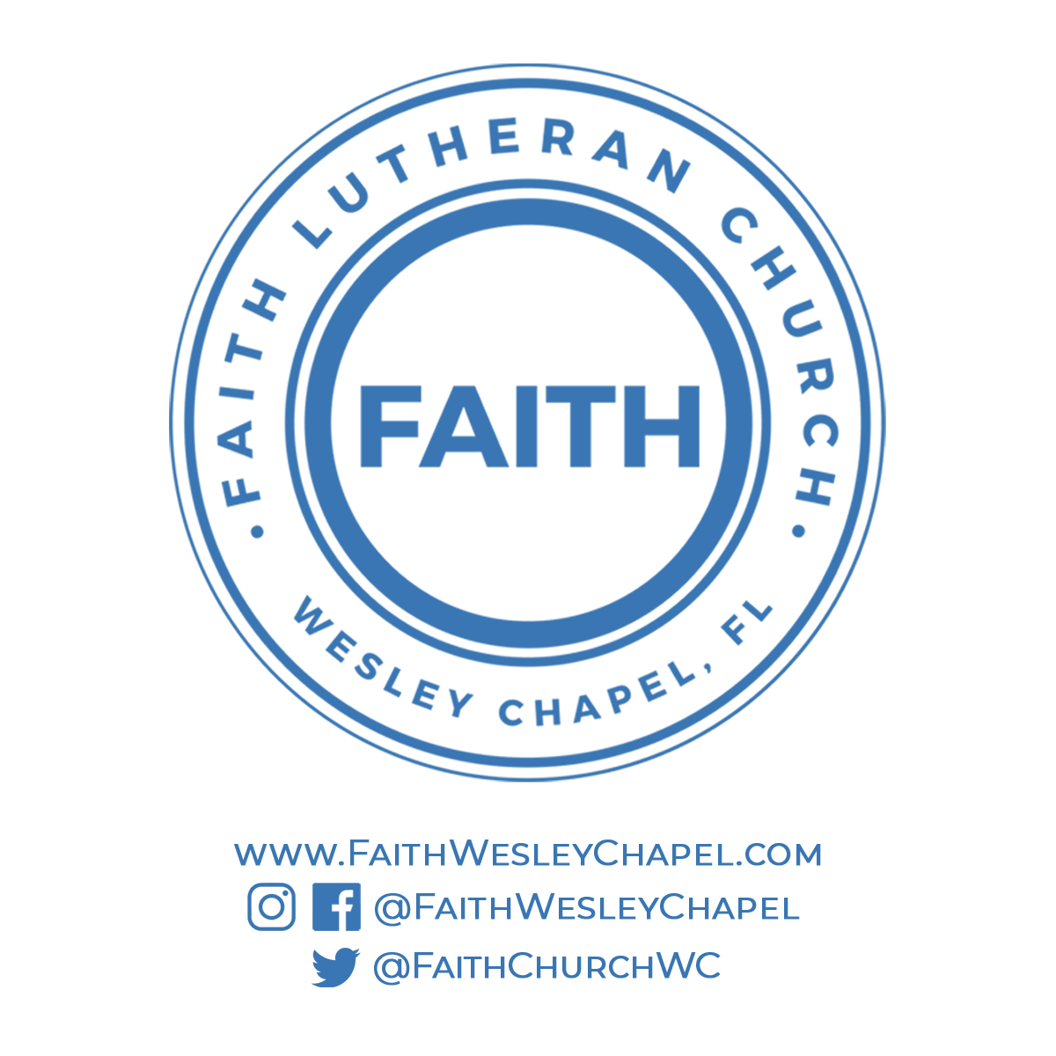**@FaithWesleyChapel**

**@FaithWesleyChapel**

**@FaithChurchWC**