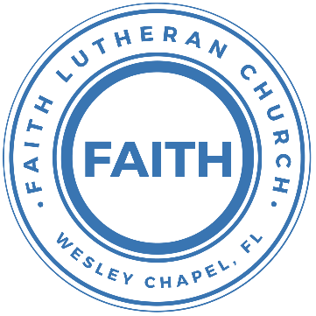

**Leading our community into a deep connection in Christ**

**___________________________________________________**

**Worship Service for January 5, 2025 at 11 AM**

**Welcome**

**Opening Song:**This Little Light of Mine

This little light of mine, I'm gonna let it shine.  
This little light of mine, I'm gonna let it shine.  
This little light of mine, I'm gonna let it shine,  
Let it shine, let it shine, let it shine.

Hide it under a bushel, NO!, I'm gonna let it shine.  
Hide it under a bushel, NO!, I'm gonna let it shine.  
Hide it under a bushel, NO!, I'm gonna let it shine,  
Let it shine, let it shine, let it shine.

Won't let Satan blow it out, I'm gonna let it shine.  
Won't let Satan blow it out, I'm gonna let it shine.  
Won't let Satan blow it out, I'm gonna let it shine,  
Let it shine, let it shine, let it shine.

Let it shine 'til Jesus comes, I'm gonna let it shine.  
Let it shine 'til Jesus comes, I'm gonna let it shine.  
Let it shine 'til Jesus comes, I'm gonna let it shine,  
Let it shine, let it shine, let it shine. © Public Domain

**Invocation**

**Confession and Forgiveness:**

**P:** We have come here today to worship the Lord.  In worship we hear the Word of God, we receive God's blessings, and respond with thanks and praise.  We begin by seeking God's blessing of forgiveness.  He has promised to remove the guilt and shame of our sin through the sacrifice of Jesus Christ on the cross.

*(a time of silence to reflect and personally confess our sins)*

**P:** Let us confess our sins to the Lord.

**P:** Heavenly Father,  
**C:** Heavenly Father,

**P:** I have done things that were wrong.  
**C:** I have done things that were wrong.  
  
**P:** I have been mean to others.  
**C:** I have been mean to others.

**P:** I have not obeyed my parents.  
**C:** I have not obeyed my parents.

**P:** I have not obeyed You, God.  
**C:** I have not obeyed You, God.

**P:** But I am very sorry.  
**C:** But I am very sorry.

**P:** Please forgive me.  
**C:** Please forgive me.

**P:** I love You very much.  
**C:** I love You very much.

**P:** And I know You love me, too.  
**C:** And I know You love me, too.

**P:** Amen.  
**C:** Amen.

**P:** God has heard your apology.  He loves you very much.  God has told us that when we believe and trust in Him, He makes us His children.  As far as the east is from the west, so far does he remove our sins from us. He has told me to tell you that you are forgiven.  So, as His servant, I forgive you in the name of the Father and of the Son and of the Holy Spirit.   
**C:** Amen.

**Song:**God Is So Good

God is so good. God is so good.  
God is so good. He's so good to me.

He died for me. He died for me so.  
He died for me. He's so good to me.

He loves me so. He loves me so.  
He loves me so. He's so good to me. © Public Domain

**First Reading -**Matthew 2:1-2

Now after Jesus was born in Bethlehem of Judea in the days of Herod the king, behold, wise men from the east came to Jerusalem, saying, “Where is he who has been born king of the Jews? For we saw his star when it rose and have come to worship him.”

**Reader:** This is the Word of the Lord.  
**C:** Thanks be to God.

**Children's Message**"The Star"

**Song:**Hark! The Herald Angels Sing

Hark the herald angels sing "Glory to the new born King.  
Peace on earth and mercy mild, God and sinners reconciled."  
Joyful all ye nations rise. Join the triumph of the skies.  
With angelic host proclaim, "Christ is born in Bethlehem."  
Hark the herald angels sing, "Glory to the new born King."

Christ, by highest heaven adored; Christ the everlasting Lord;  
Late in time behold him come, Offspring of the Virgin’s womb.  
Veiled in flesh, the God-head see; hail the incarnate Deity.  
Pleased as man with men to dwell, Jesus, our Immanuel.  
Hark the herald angels sing, "Glory to the new born King."

Hail! the heaven-born Prince of Peace.   
Hail, the son of Righteousness.  
Light and life to all He brings, risen with healing in His wings.  
Mild He lays His glory by, born that man no more may die,  
Born to raise each child of earth, born to give them second birth.  
Hark the herald angels sing, "Glory to the new born King."  
Hark the herald angels sing, "Glory to the new born King."   
 © Public Domain

**Second Reading -**Isaiah 60:1–3

Arise, shine, for your light has come,  
 and the glory of the Lord has risen upon you.  
For behold, darkness shall cover the earth,  
 and thick darkness the peoples;  
but the Lord will arise upon you,  
 and his glory will be seen upon you.  
And nations shall come to your light,  
 and kings to the brightness of your rising.

**Reader:** This is the Word of the Lord.  
**C:** Thanks be to God.

**Children's Message**"What Does Light Do?"

**Gospel Reading -**Matthew 2:1-12

Now after Jesus was born in Bethlehem of Judea in the days of Herod the king, behold, wise men from the east came to Jerusalem, saying, “Where is he who has been born king of the Jews? For we saw his star when it rose and have come to worship him.” When Herod the king heard this, he was troubled, and all Jerusalem with him; and assembling all the chief priests and scribes of the people, he inquired of them where the Christ was to be born. They told him, “In Bethlehem of Judea, for so it is written by the prophet:

“‘And you, O Bethlehem, in the land of Judah,  
 are by no means least among the rulers of Judah;  
for from you shall come a ruler  
 who will shepherd my people Israel.’”

Then Herod summoned the wise men secretly and ascertained from them what time the star had appeared. And he sent them to Bethlehem, saying, “Go and search diligently for the child, and when you have found him, bring me word, that I too may come and worship him.” After listening to the king, they went on their way. And behold, the star that they had seen when it rose went before them until it came to rest over the place where the child was. When they saw the star, they rejoiced exceedingly with great joy. And going into the house, they saw the child with Mary his mother, and they fell down and worshiped him. Then, opening their treasures, they offered him gifts, gold and frankincense and myrrh. And being warned in a dream not to return to Herod, they departed to their own country by another way.

**P:** This is the Gospel of the Lord.  
**C:** Praise be to You, O Christ.

**Sermon Hymn:**Shine Jesus Shine

Verse 1:  
Lord the light of your love is shining  
In the midst of the darkness shining  
Jesus light of the world shine upon us  
set us free by the truth you now bring us  
Shine on me, shine on me...

Chorus:  
Shine Jesus shine, fill this land with the father's glory  
Blaze spirit blaze, set our hearts on fire  
Flow river flow, flood the nations with grace and mercy  
Send forth your word, Lord and let there be light!

Verse 2:  
Lord, I come to your awesome presence  
From the shadows into your radiance  
By the blood I may enter your brightness  
Search me, try me, consume all my darkness  
Shine on me, shine on me...

*(Chorus)*

Verse 3:  
As we gaze on your kingly brightness  
So our faces display your likeness  
Ever changing from glory to glory  
Mirrored here may our lives tell your story  
Shine on me, shine on me...

*(Chorus)*  © 1987 Make Way Music

**Sermon –**"Epiphany: A Great Light Shown into Deep Darkness"

**Prayers:** *Text in prayer requests to (813) 326-5255*

**The Lord's Prayer**

Our Father who art in heaven, hallowed be Thy name, Thy kingdom come, Thy will be done on earth as it is in heaven.  Give us this day our daily bread; and forgive us our trespasses as we forgive those who trespass against us; and lead us not into temptation, but deliver us from evil.  For Thine is the kingdom and the power and the glory forever and ever.  Amen

**Offering**

**Benediction** *– The online service ends. The closing hymn video is on the Livestream page bulletin at FaithWesleyChapel.com with lyrics below. See announcements below as well.*

**Closing Song:**Marvelous Light

Chorus:  
Into marvelous light I'm running, out of darkness out of shame.  
By the cross you are the truth, You are the life, You are the way.

I once was fatherless, a stranger with no hope.  
Your kindness wakened me, wakened me from my sleep, now.  
Your love it beckons deeply, a call to come and die.  
By grace now I will come. Take this life, take your life!

Pre-Chorus:  
Sin has lost its power! Death has lost its sting!  
From the grave you've risen victoriously!

*(Chorus)*

My dead heart now is beating, my deepest stains now clean.  
Your breath fills up my lungs, now I'm free, now I'm free.  
*(Repeat)*

*(Pre-Chorus)*

*(Chorus)*

Bridge:  
Lift my hands and spin around. See the light that I have found,  
Oh the marvelous light, marvelous light!  
*(Repeat)*

*(Chorus 2x)*  © 2005 sixsteps Music

|  |  |
| --- | --- |
| **Serving This Week** | |
|  | |
| **1st Reader:** Kelsey Torgrimson | **Children’s Church Teacher:** |
| **2nd Reader:** Melissa Steinbrueck | N/A – No Children’s Church |
| **Acolyte:** Kaylee Steinbrueck | **Children’s Church Assistant:** |
| **Com. Asst:** Larry Chmiel | N/A – No Children’s Church |
|  | |
| **Serving Next Week** | |
|  | |
| **O.T. Reader:** Darlene Mueller | **Children’s Church Teacher:** |
| **Epistle Reader:** Josh Strasheim | Melissa Steinbrueck |
| **Acolyte:** Lawrence Finnerty | **Children’s Church Assistant:** |
| **Com. Asst:** Larry Chmiel | Kaylee Steinbrueck |

**Upcoming Events**

**Jan 11, 11 AM – Faith and Food Worship Service**  
Faith Lutheran Church

**Jan 14, 7 PM – Growth Group Bible Study**  
Renee’s Home

[**www.FaithWesleyChapel.com**](http://www.FaithWesleyChapel.com)

 **Faith YouTube**

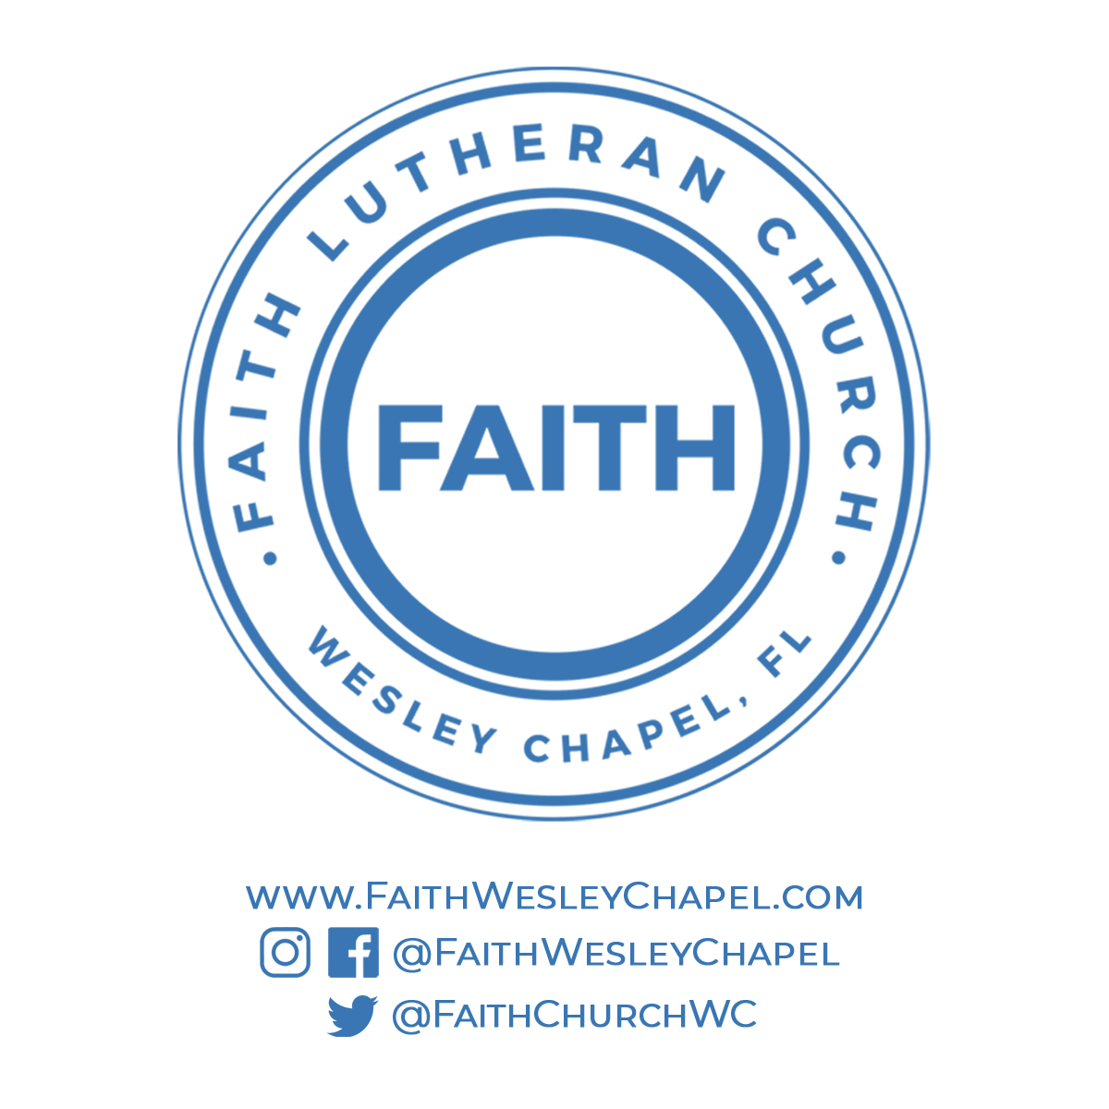**@FaithWesleyChapel**

**@FaithWesleyChapel**

**@FaithChurchWC**