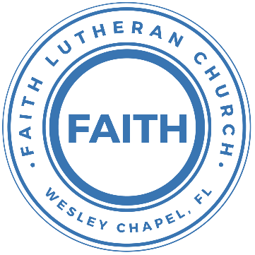

**Leading our community into a deep connection in Christ**

**___________________________________________________**

**Worship Service for January 12, 2025 at 11 AM**

**Welcome**

**Pray for the Food** - **People get food**

**Invocation** *(stand)*

**Confession and Forgiveness:** *(stand)*

**P:** As we gather, today, let us cleanse our hearts and our consciences by confessing our sin to God.

*(Time of silence for reflection and confession)*

**C:** Heavenly Father, we confess that we are sinful and unclean. We have sinned against you and against our neighbor in our thoughts, words, and actions.  We are truly sorry for our sins and sincerely repent of them. We ask for Your mercy. For the sake of Jesus Christ's bitter suffering and death, please forgive us and renew us that we may walk in Your Spirit to the glory of Your holy name. Amen

**P:** The Lord has heard your confession. Therefore, as a called and ordained servant of the Lord, in the stead and by the command of my Lord, Jesus Christ, I forgive you all your sins in the name of the Father and of the Son and of the Holy Spirit.  
**C:** Amen

**Songs of Praise and Thanksgiving –** The Church’s One Foundation

The church's one foundation is Jesus Christ, her Lord;

she is his new creation by water and the Word:

from heav'n he came and sought her to be his holy bride;

with his own blood he bought her, and for her life he died.

Elect from ev’ry nation, yet one o'er all the earth,

her charter of salvation one Lord, one faith, one birth;

one holy name she blesses, partakes one holy food,

and to one hope she presses, with ev'ry grace endued.

Through toil and tribulation, and tumult of her war,

she waits the consummation of peace forevermore;

till with the vision glorious her longing eyes are blest,

and the great church victorious shall be the church at rest.

Yet she on earth hath union with God the Three in One,

and mystic sweet communion with those whose rest is won:

O blessed heav'nly chorus! Lord, save us by Your grace,

that we, like saints before us, may see You face to face.

© Public Domain

**Old Testament Reading:**1 Kings 8:6–13

Then the priests brought the ark of the covenant of the Lord to its place in the inner sanctuary of the house, in the Most Holy Place, underneath the wings of the cherubim. For the cherubim spread out their wings over the place of the ark, so that the cherubim overshadowed the ark and its poles. And the poles were so long that the ends of the poles were seen from the Holy Place before the inner sanctuary; but they could not be seen from outside. And they are there to this day. There was nothing in the ark except the two tablets of stone that Moses put there at Horeb, where the Lord made a covenant with the people of Israel, when they came out of the land of Egypt. And when the priests came out of the Holy Place, a cloud filled the house of the Lord, so that the priests could not stand to minister because of the cloud, for the glory of the Lord filled the house of the Lord.

Then Solomon said, “The Lord has said that he would dwell in thick darkness. I have indeed built you an exalted house, a place for you to dwell in forever.”

**Reader:** This is the Word of the Lord.  
**C:** Thanks be to God.

**Epistle Reading:** Romans 12:1–5

I appeal to you therefore, brothers, by the mercies of God, to present your bodies as a living sacrifice, holy and acceptable to God, which is your spiritual worship. Do not be conformed to this world, but be transformed by the renewal of your mind, that by testing you may discern what is the will of God, what is good and acceptable and perfect.

For by the grace given to me I say to everyone among you not to think of himself more highly than he ought to think, but to think with sober judgment, each according to the measure of faith that God has assigned. For as in one body we have many members, and the members do not all have the same function, so we, though many, are one body in Christ, and individually members one of another.

**Reader:** This is the Word of the Lord.  
**C:** Thanks be to God.

**Gospel Reading** - Luke 2:41–52

Now his parents went to Jerusalem every year at the Feast of the Passover. And when he was twelve years old, they went up according to custom. And when the feast was ended, as they were returning, the boy Jesus stayed behind in Jerusalem. His parents did not know it, but supposing him to be in the group they went a day's journey, but then they began to search for him among their relatives and acquaintances, and when they did not find him, they returned to Jerusalem, searching for him. After three days they found him in the temple, sitting among the teachers, listening to them and asking them questions. And all who heard him were amazed at his understanding and his answers. And when his parents saw him, they were astonished. And his mother said to him, “Son, why have you treated us so? Behold, your father and I have been searching for you in great distress.” And he said to them, “Why were you looking for me? Did you not know that I must be in my Father's house?” And they did not understand the saying that he spoke to them. And he went down with them and came to Nazareth and was submissive to them. And his mother treasured up all these things in her heart.

And Jesus increased in wisdom and in stature and in favor with God and man.

**P:** This is the Gospel of the Lord.  
**C:** Praise be to You, O Christ.

**Sermon Song –** In Christ Alone

In Christ alone my hope is found.   
He is my light, my strength, my song.  
This Cornerstone, this solid ground,  
Firm through the fiercest drought and storm.  
What heights of love, what depths of peace,  
When fears are stilled, when strivings cease.  
My Comforter, my All in All. Here in the love of Christ I stand.

In Christ alone, who took on flesh,   
Fullness of God in helpless babe.  
This gift of love and righteousness,   
Scorned by the ones He came to save.  
‘Til on that cross as Jesus died,   
The wrath of God was satisfied.  
For every sin on Him was laid, Here in the death of Christ I live.

There in the ground His body lay,   
Light of the world by darkness slain.  
Then bursting forth in glorious Day,   
Up from the grave He rose again.  
And as He stands in victory,   
Sin’s curse has lost its grip on me.  
For I am His and He is mine,   
Bought with the precious blood of Christ.

No guilt in life, no fear in death,   
This is the power of Christ in me.  
From life’s first cry to final breath,   
Jesus commands my destiny.  
No power of hell, no scheme of man,   
Can ever pluck me from His hand.  
‘Til He returns or calls me home,   
Here in the power of Christ I’ll stand.  
No power of hell, no scheme of man,   
Can ever pluck me from His hand.  
‘Til He returns or calls me home,   
Here in the power of Christ I’ll stand. © 2001 Thankyou Music

**Sermon/Discussion** – "In My Father’s House"

**Prayers**

**Apostles' Creed** *(stand)*

I believe in God, the Father almighty, maker of heaven and earth,  
And in Jesus Christ, his only Son, our Lord,  
who was conceived by the Holy Spirit,  
born of the Virgin Mary, suffered under Pontius Pilate,  
was crucified, died and was buried. He descended into hell.  
The third day he rose again from the dead.  
He ascended into heaven and sits at the right hand of God  
the Father almighty.  
From there he will come to judge the living and the dead.  
I believe in the Holy Spirit, the holy Christian Church,  
the communion of saints, the forgiveness of sins,  
the resurrection of the body, and the life everlasting. Amen.

**The Lord's Prayer** *(stand)*

Our Father who art in heaven, hallowed be Thy name, Thy kingdom come, Thy will be done on earth as it is in heaven.  Give us this day our daily bread; and forgive us our trespasses as we forgive those who trespass against us; and lead us not into temptation, but deliver us from evil.  For Thine is the kingdom and the power and the glory forever and ever.  Amen

**Offering**

**Benediction** *– The online service ends. The closing hymn video is on the Livestream page bulletin at FaithWesleyChapel.com with lyrics below. See announcements below as well.*

**Closing Song:** Praise God From Whom All Blessings Flow *(stand)*

Praise God from Whom all blessings flow.  
Praise Him all creatures here below.  
Praise Him above, ye heavenly hosts.  
Praise Father, Son and Holy Ghost.  
Amen

|  |  |
| --- | --- |
| **Serving This Week** | |
|  | |
| **O.T. Reader:** Darlene Mueller | **Children’s Church Teacher:** |
| **Epistle Reader :** Vanessa Frost | Melissa Steinbrueck |
| **Acolyte:** Kaylee Steinbrueck | **Children’s Church Assistant:** |
| **Com. Asst:** Lawrence Finnerty | Kaylee Steinbrueck |
|  | |
| **Serving Next Week** | |
|  | |
| **O.T. Reader:** Richard Steinbrueck | **Children’s Church Teacher:** |
| **Epistle Reader:** Ginger Dunn | Halston & Ben |
| **Acolyte:** Kaylee Steinbrueck | **Children’s Church Assistant:** |
| **Com. Asst:** Larry Chmiel | N/A |

**Upcoming Events**

**Jan 14, 7 PM – Council Meeting**  
TBD

**Jan 21, 7 PM – Growth Group Bible Study**  
Renee’s Home

**Jan 26, After the Service – State of the Church Voter Meeting**  
Faith Lutheran Church

[**www.FaithWesleyChapel.com**](http://www.FaithWesleyChapel.com)

 **Faith YouTube**

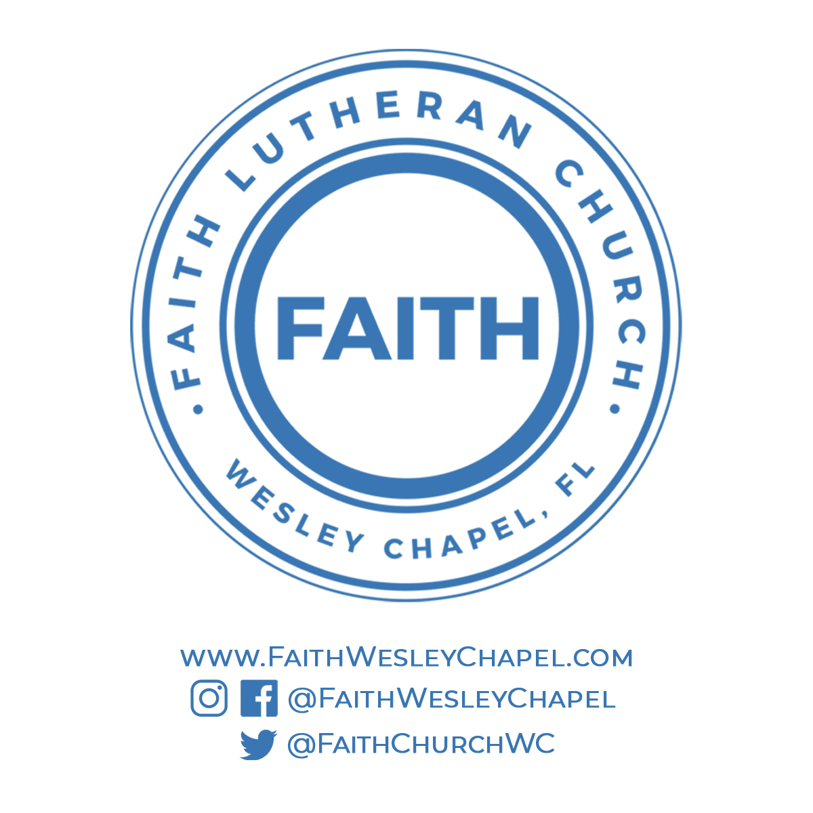**@FaithWesleyChapel**

**@FaithWesleyChapel**

**@FaithChurchWC**