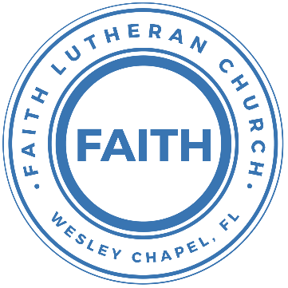

**Leading our community into a deep connection in Christ**

**___________________________________________________**

**Worship Service for February 2, 2025 at 11 AM**

**Welcome**

**Opening Song:**Down In My Heart

I’ve got the joy, joy, joy, joy down in my heart, (where?)  
Down in my heart, (where?), down in my heart.  
I’ve got the joy, joy, joy, joy down in my heart, (where?)  
Down in my heart to stay.

Chorus:  
And I’m so happy, so very happy.   
I’ve got the love of Jesus in my heart.  
And I’m so happy, so very happy.   
I’ve got the love of Jesus in my heart

I’ve got the peace that passes understanding down in my heart…

*(Chorus)*

I’ve got the love of Jesus, love of Jesus, down in my heart…

*(Chorus)*

I’ve got the wonderful love of my blessed redeemer way down in the depths of my heart…

*(Chorus)* © Public Domain

**Invocation**

**Confession and Forgiveness:**

**P:** We have come here today to worship the Lord.  In worship we hear the Word of God, we receive God's blessings, and respond with thanks and praise.  We begin by seeking God's blessing of forgiveness.  He has promised to remove the guilt and shame of our sin through the sacrifice of Jesus Christ on the cross.

*(a time of silence to reflect and personally confess our sins)*

**P:** Let us confess our sins to the Lord.

**P:** Heavenly Father,  
**C:** Heavenly Father,

**P:** I have done things that were wrong.  
**C:** I have done things that were wrong.  
  
**P:** I have been mean to others.  
**C:** I have been mean to others.

**P:** I have not obeyed my parents.  
**C:** I have not obeyed my parents.

**P:** I have not obeyed You, God.  
**C:** I have not obeyed You, God.

**P:** But I am very sorry.  
**C:** But I am very sorry.

**P:** Please forgive me.  
**C:** Please forgive me.

**P:** I love You very much.  
**C:** I love You very much.

**P:** And I know You love me, too.  
**C:** And I know You love me, too.

**P:** Amen.  
**C:** Amen.

**P:** God has heard your apology.  He loves you very much.  God has told us that when we believe and trust in Him, He makes us His children.  As far as the east is from the west, so far does he remove our sins from us. He has told me to tell you that you are forgiven.  So, as His servant, I forgive you in the name of the Father and of the Son and of the Holy Spirit.   
**C:** Amen.

**Song:**Jesus Loves Me

Verse 1:

Jesus loves me this I know, for the Bible tells me so.

Little ones to Him belong. They are weak, but He is strong.

Chorus:

Yes, Jesus loves me. Yes, Jesus loves me.

Yes, Jesus loves me, the Bible tells me so.

Verse 2:

Jesus loves me, He who died, Heaven's gates to open wide.

He will wash away my sin, let His little child come in.

*(Chorus)* © Public Domain

**First Reading -**Matthew 3:13-14

Then Jesus came from Galilee to the Jordan to John, to be baptized by him. John would have prevented him, saying, “I need to be baptized by you, and do you come to me?”

**Reader:** This is the Word of the Lord.  
**C:** Thanks be to God.

**Children's Message**"Your Baptism"

**Song:**Living Hope

How great the chasm that lay between us.

How high the mountain I could not climb.

In desperation, I turned to heaven,  
And spoke Your name into the night.

Then through the darkness Your loving kindness,

Tore through the shadows of my soul.

The work is finished, the end is written,  
Jesus Christ, my Living Hope.

Who could imagine so great a mercy.

What heart could fathom such boundless grace.

The God of ages stepped down from glory,  
To wear my sin and bear my shame.

The cross has spoken. I am forgiven.

The King of Kings calls me His own.

Beautiful Savior I’m Yours forever,

Jesus Christ, my Living Hope.

Chorus:

Hallelujah, praise the one who set me free!

Hallelujah, death has lost its grip on me!

You have broken every chain. There’s salvation in Your Name,

Jesus Christ, my Living Hope.

Then came the morning that sealed the promise,

Your buried body began to breathe.

Out of the silence the roaring Lion,

Declared the grave has no claim on me.

*(Repeat)*

Jesus, Yours is the victory!

*(Chorus 2x)* © Bethel Music Publishing and Remaining portion is unaffiliated

**Second Reading -**Matthew 3:16-17

And when Jesus was baptized, immediately he went up from the water, and behold, the heavens were opened to him, and he saw the Spirit of God descending like a dove and coming to rest on him; and behold, a voice from heaven said, “This is my beloved Son, with whom I am well pleased.”

**Reader:** This is the Word of the Lord.  
**C:** Thanks be to God.

**Children's Message**"My Beloved Son"

**Gospel Reading -**Matthew 3:13-17

Then Jesus came from Galilee to the Jordan to John, to be baptized by him. John would have prevented him, saying, “I need to be baptized by you, and do you come to me?” But Jesus answered him, “Let it be so now, for thus it is fitting for us to fulfill all righteousness.” Then he consented. And when Jesus was baptized, immediately he went up from the water, and behold, the heavens were opened to him, and he saw the Spirit of God descending like a dove and coming to rest on him; and behold, a voice from heaven said, “This is my beloved Son, with whom I am well pleased.”

**P:** This is the Gospel of the Lord.  
**C:** Praise be to You, O Christ.

**Sermon Hymn:**On Jordan’s Bank the Baptist’s Cry

Verse 1:

On Jordan's bank the Baptist’s cry

Announces that the Lord is nigh.

Awake and harken, for He brings

Glad tidings of the King of Kings!

Verse 3:

We hail you as our Savior, Lord,

Our refuge and our great reward.

Without Your grace we waste away

Like flowers that wither and decay.

Verse 4:

All praise to You, eternal Son,

Whose advent has our freedom won,

Whom with the Father we adore,

And Holy Spirit, evermore. © Public Domain

**Sermon –**"The Baptism of Jesus"

**Prayers:** *Text in prayer requests to (813) 326-5255*

**The Lord's Prayer**

Our Father who art in heaven, hallowed be Thy name, Thy kingdom come, Thy will be done on earth as it is in heaven.  Give us this day our daily bread; and forgive us our trespasses as we forgive those who trespass against us; and lead us not into temptation, but deliver us from evil.  For Thine is the kingdom and the power and the glory forever and ever.  Amen

**Offering**

**Benediction** *– The online service ends. The closing hymn video is on the Livestream page bulletin at FaithWesleyChapel.com with lyrics below. See announcements below as well.*

**Closing Song -**Echo

When night has fallen, when fear is common,

Still You're calling me. When faith is lost and,

My hope exhausted, You will be my strength.

Pre-Chorus:

When my mind says I'm not good enough, God,  
You're enough for me.

I've decided I'm not giving up 'cause You won't give up on me.

You won't give up on me!

Chorus:

Your love is holding on and it won't let go.

I feel it breaking out like an echo.  
Your love is holding on and it won't let go.  
I feel it breaking out like an echo.

Post-Chorus:

Echo in my so-o-o-o-oul, So-o-o-o-oul.

Echo in my so-o-o-o-oul, So-o-o-o-oul.

Verse 2:

In every season You keep repeating promises to me.

Now there's no stopping what you have started,

Until it is complete.

Pre-Chorus:

When my mind says I'm not good enough, God,  
You're enough for me.

I've decided I'm not giving up 'cause You won't give up on me.

You won't give up on me!

*(Chorus)*

*(Post-Chorus 2x)* © Elevation Worship Publishing

|  |  |
| --- | --- |
| **Serving This Week** | |
|  | |
| **1st Reader:** Kaylee Steinbrueck | **Children’s Church Teacher:** |
| **2nd Reader:** Kelsey Torgrimson | N/A – No Children’s Church |
| **Acolyte:** Lawrence Finnerty | **Children’s Church Assistant:** |
| **Com. Asst:** Richard Steinbrueck | N/A – No Children’s Church |
|  | |
| **Serving Next Week** | |
|  | |
| **O.T. Reader:** Ginger Dunn | **Children’s Church Teacher:** |
| **Epistle Reader:** **Richard Steinbrueck** | Melissa Steinbrueck |
| **Acolyte:** Kaylee Steinbrueck | **Children’s Church Assistant:** |
| **Com. Asst:** Richard Steinbrueck | Kaylee Steinbrueck |

**Upcoming Events**

**Feb 9, 11 AM – Faith and Food Service**Faith Lutheran Church

**Feb 11, 7PM – Growth Group Bible Study**  
Renee’s Home

[**www.FaithWesleyChapel.com**](http://www.FaithWesleyChapel.com)

 **Faith YouTube**

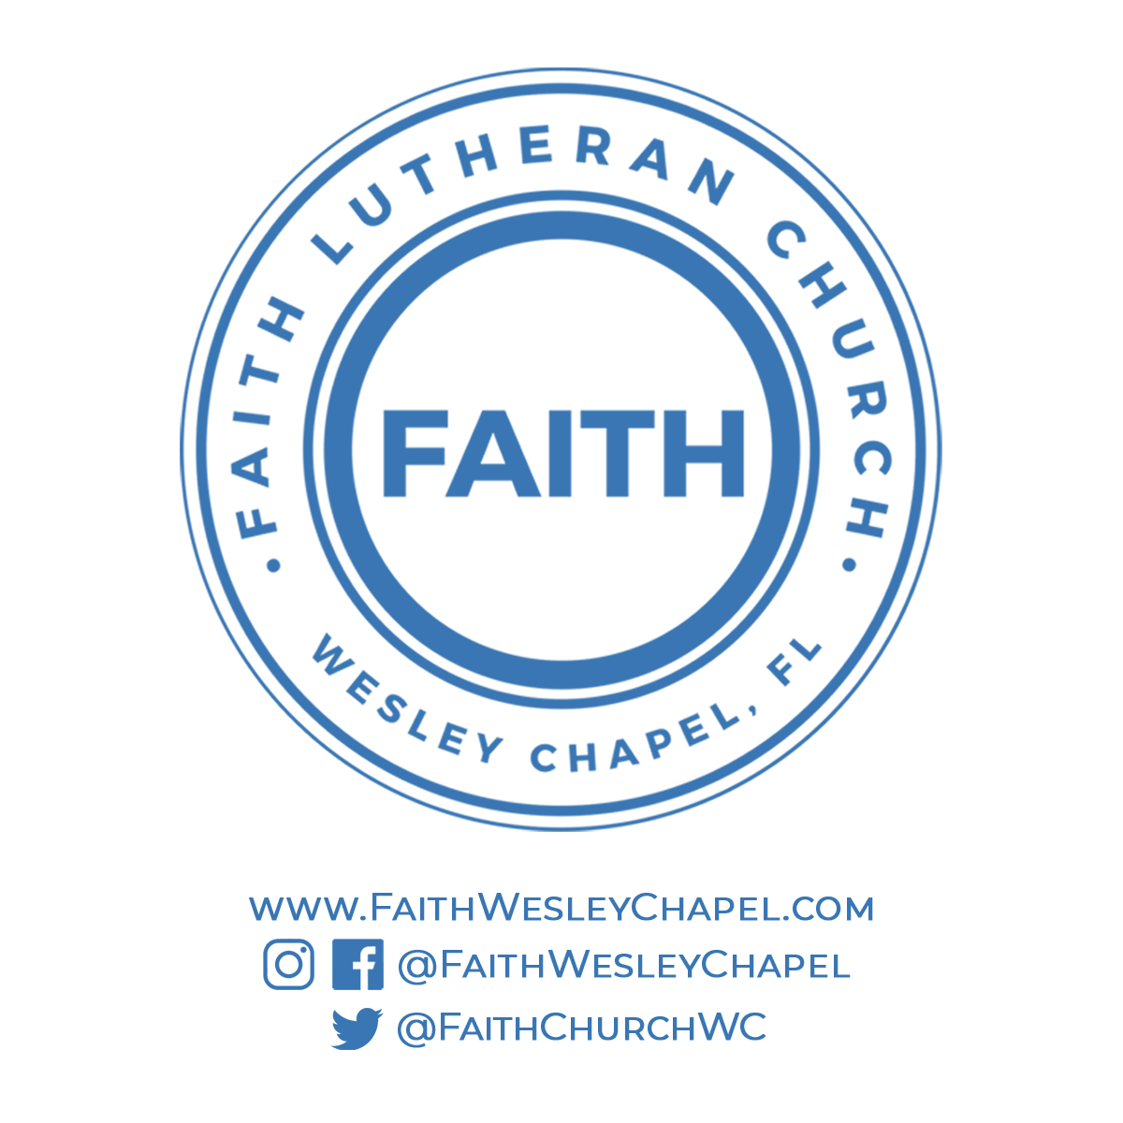**@FaithWesleyChapel**

**@FaithWesleyChapel**

**@FaithChurchWC**