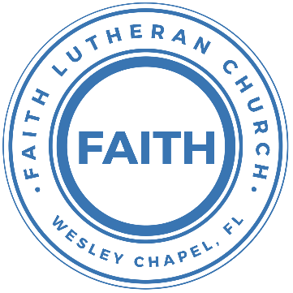

**Leading our community into a deep connection in Christ**

**Worship Service for February 23, 2025 at 11 AM**

**Welcome**

**Opening Song:**Praise Ye The Lord, Hallelujah

Side 1: Hallelu, hallelu, hallelu, hallelujah,

Side 2: Praise ye the Lord.

Side 1: Hallelu, hallelu, hallelu, hallelujah,

Side 2: Praise ye the Lord.

Side 2: Praise ye the Lord.

Side 1: Hallelujah,

Side 2: Praise ye the Lord.

Side 1: Hallelujah,

Side 2: Praise ye the Lord.  
Side 1: Hallelujah,

All: Praise ye the Lord.

(Repeat all) © Public Domain

**Invocation**

**Confession and Forgiveness:**

**P:** We have come here today to worship the Lord.  In worship we hear the Word of God, we receive God's blessings, and respond with thanks and praise.  We begin by seeking God's blessing of forgiveness.  He has promised to remove the guilt and shame of our sin through the sacrifice of Jesus Christ on the cross.

*(a time of silence to reflect and personally confess our sins)*

**P:** Let us confess our sins to the Lord.

**P:** Heavenly Father,  
**C:** Heavenly Father,

**P:** I have done things that were wrong.  
**C:** I have done things that were wrong.  
  
**P:** I have been mean to others.  
**C:** I have been mean to others.

**P:** I have not obeyed my parents.  
**C:** I have not obeyed my parents.

**P:** I have not obeyed You, God.  
**C:** I have not obeyed You, God.

**P:** But I am very sorry.  
**C:** But I am very sorry.

**P:** Please forgive me.  
**C:** Please forgive me.

**P:** I love You very much.  
**C:** I love You very much.

**P:** And I know You love me, too.  
**C:** And I know You love me, too.

**P:** Amen.  
**C:** Amen.

**P:** God has heard your apology.  He loves you very much.  God has told us that when we believe and trust in Him, He makes us His children.  As far as the east is from the west, so far does he remove our sins from us. He has told me to tell you that you are forgiven.  So, as His servant, I forgive you in the name of the Father and of the Son and of the Holy Spirit.   
**C:** Amen.

**Song:**Jesus Loves Me

Jesus loves me this I know, for the Bible tells me so.

Little ones to Him belong. They are weak, but He is strong.

Chorus:

Yes, Jesus loves me. Yes, Jesus loves me.

Yes, Jesus loves me, the Bible tells me so.

Jesus loves me, He who died, Heaven's gates to open wide.

He will wash away my sin, let His little child come in.

*(Chorus)* © Public Domain

**First Reading -**1 Corinthians 13:13

So now faith, hope, and love abide, these three; but the greatest of these is love.

**Reader:** This is the Word of the Lord.  
**C:** Thanks be to God.

**Children's Message**"What Is Love?"

**Song:**How Deep The Father’s Love For Us

How deep the Father's love for us, how vast beyond all measure.

That He should give His only Son, to make a wretch His treasure.

How great the pain of searing loss, the Father turned His face away,

As wounds which mar the Chosen One, bring many sons to glory.

Behold the Man upon a cross, my sin upon His shoulders.

Ashamed, I hear my mocking voice call out among the scoffers.

It was my sin that held Him there until it was accomplished.

His dying breath has brought me life; I know that it is finished.

I will not boast in anything: no gifts, no power, no wisdom,

But I will boast in Jesus Christ; his death and resurrection.

Why should I gain from His reward? I cannot give an answer.

But this I know with all my heart: His wounds have paid my ransom.

But this I know with all my heart: His wounds have paid my ransom.

© 1995 Thankyou Music

**Second Reading -**1 Corinthians 13:4-7

Love is patient and kind; love does not envy or boast; it is not arrogant or rude. It does not insist on its own way; it is not irritable or resentful; it does not rejoice at wrongdoing, but rejoices with the truth. Love bears all things, believes all things, hopes all things, endures all things.

**Reader:** This is the Word of the Lord.  
**C:** Thanks be to God.

**Children's Message**"Showing Love"

**Gospel Reading -**Luke 18:31–43

And taking the twelve, he said to them, “See, we are going up to Jerusalem, and everything that is written about the Son of Man by the prophets will be accomplished. For he will be delivered over to the Gentiles and will be mocked and shamefully treated and spit upon. And after flogging him, they will kill him, and on the third day he will rise.” But they understood none of these things. This saying was hidden from them, and they did not grasp what was said.

As he drew near to Jericho, a blind man was sitting by the roadside begging. And hearing a crowd going by, he inquired what this meant. They told him, “Jesus of Nazareth is passing by.” And he cried out, “Jesus, Son of David, have mercy on me!” And those who were in front rebuked him, telling him to be silent. But he cried out all the more, “Son of David, have mercy on me!” And Jesus stopped and commanded him to be brought to him. And when he came near, he asked him, “What do you want me to do for you?” He said, “Lord, let me recover my sight.” And Jesus said to him, “Recover your sight; your faith has made you well.” And immediately he recovered his sight and followed him, glorifying God. And all the people, when they saw it, gave praise to God.

**P:** This is the Gospel of the Lord.  
**C:** Praise be to You, O Christ.

**Song:**Lord, Whose Love Through Humble Service

Lord, whose love through humble service  
Bore the weight of human need,  
Who upon the cross, forsaken, offered mercy’s perfect deed:  
We, your servants, bring the worship not of voice alone, but heart,  
Consecrating to your purpose every gift that you impart.

Still your children wander homeless; still the hungry cry for bread;  
Still the captives long for freedom; still in grief we mourn our dead.  
As, O Lord, your deep compassion healed the sick and freed the soul,  
Use the love your Spirit kindles still to save and make us whole.

As we worship, grant us vision, till your love’s revealing light  
In its height and depth and greatness dawns upon our quickened sight,  
Making known the needs and burdens your compassion bids us bear,  
Stirring us to tireless striving your abundant life to share.

Called by worship to your service, forth in your dear name we go  
To the child, the youth, the aged, love in living deeds to show;  
Hope and health, good will and comfort,  
Counsel, aid, and peace we give,  
That your servants, Lord, in freedom,  
May your mercy know, and live. © Public Domain

**Sermon –**"The Greatest of These Is Love"

Sermon Reading - 1 Corinthians 13:1-13

If I speak in the tongues of men and of angels, but have not love, I am a noisy gong or a clanging cymbal. And if I have prophetic powers, and understand all mysteries and all knowledge, and if I have all faith, so as to remove mountains, but have not love, I am nothing. If I give away all I have, and if I deliver up my body to be burned, but have not love, I gain nothing.

Love is patient and kind; love does not envy or boast; it is not arrogant or rude. It does not insist on its own way; it is not irritable or resentful; it does not rejoice at wrongdoing, but rejoices with the truth. Love bears all things, believes all things, hopes all things, endures all things.

Love never ends. As for prophecies, they will pass away; as for tongues, they will cease; as for knowledge, it will pass away. For we know in part and we prophesy in part, but when the perfect comes, the partial will pass away. When I was a child, I spoke like a child, I thought like a child, I reasoned like a child. When I became a man, I gave up childish ways. For now we see in a mirror dimly, but then face to face. Now I know in part; then I shall know fully, even as I have been fully known.

So now faith, hope, and love abide, these three; but the greatest of these is love.

**Prayers:** *Text in prayer requests to (813) 326-5255*

**The Lord's Prayer** *(stand)*

Our Father who art in heaven, hallowed be Thy name, Thy kingdom come, Thy will be done on earth as it is in heaven.  Give us this day our daily bread; and forgive us our trespasses as we forgive those who trespass against us; and lead us not into temptation, but deliver us from evil.  For Thine is the kingdom and the power and the glory forever and ever.  Amen

**Offering**

**Benediction** *– The online service ends. The closing hymn video is on the Livestream page bulletin at FaithWesleyChapel.com with lyrics below. See announcements below as well.*

**Closing Song -**They'll Know We Are Christians By Our Love

Verse 1:  
We are one in the Spirit, we are one in the Lord;  
We are one in the Spirit, we are one in the Lord;  
And we pray that all unity will one day be restored.

Chorus:  
And they'll know we are Christians by our love, by our love,  
Yes, they'll know we are Christians by our love.

Verse 2:  
We will walk with each other, we will walk hand in hand;  
We will walk with each other, we will walk hand in hand;  
And together we'll spread the news that God is in our land.

*(Chorus)*

Verse 3:  
We will work with each other, we will work side by side;  
We will work with each other, we will work side by side;  
And we'll guard each one's dignity and save each other's pride.

*(Chorus)* © 1966 F.E.L. Publications. Assigned 1991 Lorenz Publishing Company

|  |  |
| --- | --- |
| **Serving This Week** | |
|  | |
| **1st Reader:** Thomas Horness | **Children’s Church Teacher:** |
| **2nd Reader:** Kaylee Steinbrueck | N/A – No Children’s Church |
| **Acolyte:** Eli Steinbrueck | **Children’s Church Assistant:** |
| **Com. Asst:** Larry Chmiel | N/A – No Children’s Church |
|  | |
| **Serving Next Week** | |
|  | |
| **O.T. Reader:** Ginger Dunn | **Children’s Church Teacher:** |
| **Epistle Reader:** Richard Steinbrueck | Melissa Steinbrueck |
| **Acolyte:** Kaylee Steinbrueck | **Children’s Church Assistant:** |
| **Com. Asst:** Richard Steinbrueck | Kaylee Steinbrueck |

**Upcoming Events**

**March 5, 7 PM – Ash Wednesday Worship Service**  
Grace Community Church

**March 6, 7 PM – Growth Group Bible Study** (In-Person & Online)Rich Steinbrueck’s Home

**March 9, 11 AM – Faith and Food Worship Service**  
Faith Lutheran Church

**www.FaithWesleyChapel.com**

**Faith YouTube**

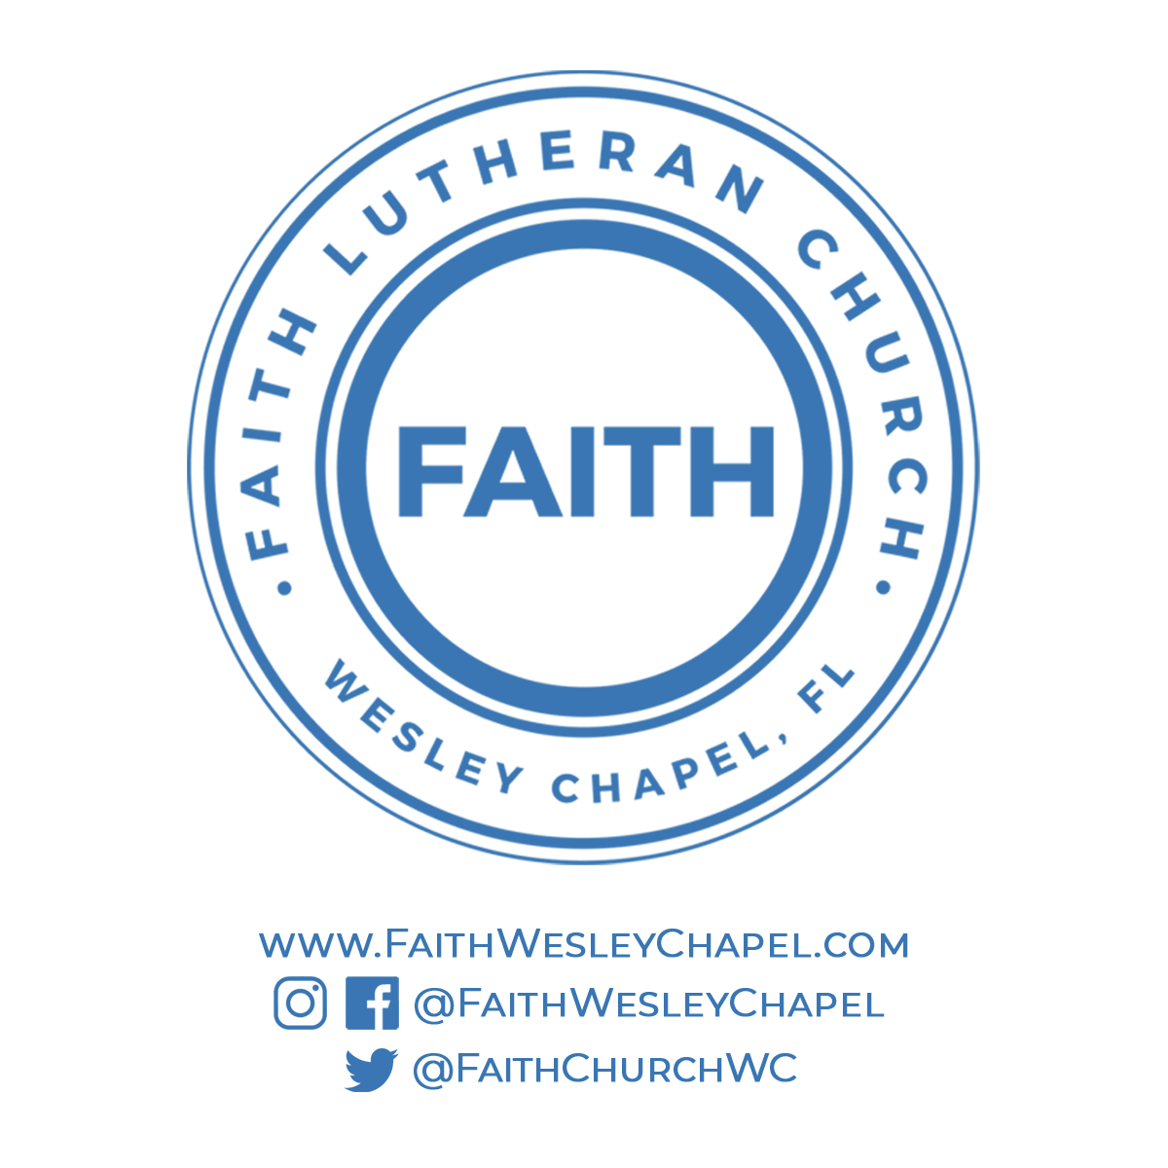**@FaithWesleyChapel**

**@FaithWesleyChapel**

**@FaithChurchWC**