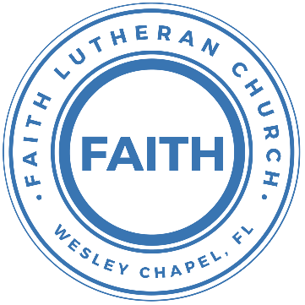

**Leading our community into a deep connection in Christ**

**Worship Service for March 16, 2025 at 11 AM**

**Welcome**

**Opening Song:** Blessed Be Your Name

Verse 1:  
Blessed be Your name in the land that is plentiful.  
Where Your streams of abundance flow, blessed be Your name.  
Blessed be Your name when I'm found in the desert place.  
Though I walk through the wilderness, blessed be Your name.

Pre-Chorus:

Every blessing You pour out I'll turn back to praise.

When the darkness closes in, Lord still I will say,

Chorus:

Blessed be the name of the Lord. Blessed be Your name.

Blessed be the name of the Lord. Blessed be Your glorious name.

Verse 2:

Blessed be Your name when the sun's shining down on me.

When the world's "all as it should be," blessed be Your name.

Blessed be Your name on the road marked with suffering.

Though there's pain in the offering, blessed be Your name.

*(Pre-Chorus)  
(Chorus)*

Bridge:

You give and take away. You give and take away.

My heart will choose to say, “Lord, blessed be Your name.”

*(Pre-Chorus)  
(Chorus)* © 2002 Thankyou Music

**Invocation**

**Confession and Forgiveness:**

**P:** Come into the presence of the Lord our God.  
**C:** Have mercy, O Lord. If you, Lord, kept a record of sins, Lord, who could stand; but if we confess our sins, he is faithful and just to forgive us our sins and to cleanse us from all unrighteousness.

*(A time of silence to reflect and personally confess our sins)*

**P:** I said, "I will confess my transgressions to the LORD." And you forgave the guilt of my sin. Let us confess our sin before the Lord. Let us confess together.  
**C:** Heavenly Father, we confess that we are sinners.  We have sinned against you and our neighbors. We have not loved you with our whole heart and we have not loved our neighbors as ourselves. We justly deserve Your punishment.  For the sake of Your Son, Jesus Christ, have mercy on us.  Forgive us, renew us, and lead us, so that we may delight in Your will and walk in Your ways to the glory of Your holy name.  Amen.

**P:** The Lord is gracious and merciful. He promises to forgive our sins. Therefore, upon this, your confession, as a called and ordained servant of the Lord, in the stead and by the command of my Lord, Jesus Christ, I forgive you all your sins in the name of the Father and of the Son and of the Holy Spirit.  
**C:** Amen.

**Song of Praise and Thanksgiving:** Cornerstone

My hope is built on nothing less,   
Than Jesus' blood and righteousness.  
I dare not trust the sweetest frame,   
But wholly trust in Jesus' name.

Chorus:

Christ alone, Cornerstone, Weak made strong in the Savior's love.

Through the storm He is Lord, Lord of all.

Verse 2:

When darkness seems to hide His face,

I rest on His unchanging grace.

In every high and stormy gale My anchor holds within the veil.

My anchor holds within the veil.

*(Chorus)*

He is Lord. Lord of all.

Verse 3:

When He shall come with trumpet sound,

Oh, may I then in Him be found,

Dressed in His righteousness alone,

Faultless, stand before the throne.

*(Chorus)*  © 2011 Hillsong Music

**Old Testament Reading** - Genesis 32:22-32

The same night he arose and took his two wives, his two female servants, and his eleven children, and crossed the ford of the Jabbok. He took them and sent them across the stream, and everything else that he had. And Jacob was left alone. And a man wrestled with him until the breaking of the day. When the man saw that he did not prevail against Jacob, he touched his hip socket, and Jacob's hip was put out of joint as he wrestled with him. Then he said, “Let me go, for the day has broken.” But Jacob said, “I will not let you go unless you bless me.” And he said to him, “What is your name?” And he said, “Jacob.” Then he said, “Your name shall no longer be called Jacob, but Israel, for you have striven with God and with men, and have prevailed.” Then Jacob asked him, “Please tell me your name.” But he said, “Why is it that you ask my name?” And there he blessed him. So Jacob called the name of the place Peniel, saying, “For I have seen God face to face, and yet my life has been delivered.” The sun rose upon him as he passed Penuel, limping because of his hip. Therefore to this day the people of Israel do not eat the sinew of the thigh that is on the hip socket, because he touched the socket of Jacob's hip on the sinew of the thigh.

**Reader:** This is the Word of the Lord.  
**C:** Thanks be to God.

**Epistle Reading** - 1 Thessalonians 4:1-7

Finally, then, brothers, we ask and urge you in the Lord Jesus, that as you received from us how you ought to walk and to please God, just as you are doing, that you do so more and more. For you know what instructions we gave you through the Lord Jesus. For this is the will of God, your sanctification: that you abstain from sexual immorality; that each one of you know how to control his own body in holiness and honor, not in the passion of lust like the Gentiles who do not know God; that no one transgress and wrong his brother in this matter, because the Lord is an avenger in all these things, as we told you beforehand and solemnly warned you. For God has not called us for impurity, but in holiness.

**Reader:** This is the Word of the Lord.  
**C:** Thanks be to God.

**Gospel Reading** - Matthew 15:21-28

And Jesus went away from there and withdrew to the district of Tyre and Sidon. And behold, a Canaanite woman from that region came out and was crying, “Have mercy on me, O Lord, Son of David; my daughter is severely oppressed by a demon.” But he did not answer her a word. And his disciples came and begged him, saying, “Send her away, for she is crying out after us.” He answered, “I was sent only to the lost sheep of the house of Israel.” But she came and knelt before him, saying, “Lord, help me.” And he answered, “It is not right to take the children's bread and throw it to the dogs.” She said, “Yes, Lord, yet even the dogs eat the crumbs that fall from their masters' table.” Then Jesus answered her, “O woman, great is your faith! Be it done for you as you desire.” And her daughter was healed instantly.

**P:** This is the Gospel of the Lord.  
**C:** Praise be to You, O Christ.

**Children's Message** *(Children dismissed to Children's Church)*

**Sermon Hymn***–*I Surrender All

Verse 1:

All to Jesus I surrender. All to Him I freely give.

I will ever love and trust Him. In His presence daily live.

Chorus:

I surrender all. I surrender all. All to Thee my blessed Savior, I surrender all.

Verse 2:

All to Jesus I surrender. Humbly at His feet I bow.

Worldly pleasures all forsaken. Take me, Jesus, take me now.

*(Chorus)*

Verse 4:

All to Jesus I surrender. Lord, I give myself to Thee.

Fill me with Thy love and power. Let Thy blessing fall on me.

*(Chorus 2x)* © 2005 Maranatha! Music, Nickeldimeus Music, and LAVIKMUSIC

**Sermon** - "Wrestling with God"

**Prayers:** *Text in prayer requests to (813) 326-5255*

**Nicene Creed** *(stand)*

I believe in one God, the Father Almighty, maker of heaven and earth and of all things visible and invisible.

And in one Lord Jesus Christ, the only-begotten Son of God, begotten of His Father before all worlds, God of God, Light of Light, very God of very God, begotten, not made, being of one substance with the Father, by whom all things were made; who for us men and for our salvation came down from heaven and was incarnate by the Holy Spirit of the virgin Mary and was made man; and was crucified also for us under Pontius Pilate. He suffered and was buried. And the third day He rose again according to the Scriptures and ascended into heaven and sits at the right hand of the Father. And He will come again with glory to judge both the living and the dead, whose kingdom will have no end.

And I believe in the Holy Spirit, the Lord and Giver of Life, who proceeds from the Father and the Son, who with the Father and the Son together is worshiped and glorified, who spoke by the prophets. And I believe in one holy Christian and apostolic Church, I acknowledge one Baptism for the remission of sins, and I look for the resurrection of the dead and the life of the world to come. Amen.

**The Lord's Prayer** *(stand)*

Our Father who art in heaven, hallowed be Thy name, Thy kingdom come, Thy will be done on earth as it is in heaven.  Give us this day our daily bread; and forgive us our trespasses as we forgive those who trespass against us; and lead us not into temptation, but deliver us from evil.  For Thine is the kingdom and the power and the glory forever and ever.  Amen

**Offering**

**Benediction** *– The online service ends. The closing hymn video is on the Livestream page bulletin at FaithWesleyChapel.com with lyrics below. See announcements below as well.*

**Closing Song:**How Great Is Our God

The splendor of a King, clothed in majesty,

Let all the earth rejoice, all the earth rejoice.

He wraps himself in light, and darkness tries to hide,

And trembles at His voice, trembles at His voice.

Chorus:

How great is our God. Sing with me.

How great is our God. All will see,

How great, how great is our God.

Age to age He stands, and time is in His hands,

Beginning and the end, beginning at the end.

The Godhead, three in one, Father, Spirit, Son,

The Lion and the Lamb, the Lion and the Lamb.

*(Chorus)*

Bridge:

Name above all names, Worthy of all praise,

My heart will sing, “How great is our God.”

*Repeat*

*(Chorus)* © 2004 Alletrop Music

|  |  |
| --- | --- |
| **Serving This Week** | |
|  | |
| **O.T. Reader:** Josh Strasheim | **Children’s Church Teacher:** |
| **Epistle Reader:** Ginger Torgrimson | Halston & Ben |
| **Acolyte:** Lawrence Finnerty | **Children’s Church Assistant:** |
| **Com. Asst:** Richard Steinbrueck | N/A |
|  | |
| **Serving Next Week** | |
|  | |
| **O.T. Reader:** Melissa Steinbrueck | **Children’s Church Teacher:** |
| **Epistle Reader:** Darlene Mueller | Melissa Steinbrueck |
| **Acolyte:** Eli Steinbrueck | **Children’s Church Assistant:** |
| **Com. Asst:** Larry Chmiel | Kelsey Torgrimson |

**Upcoming Events**

**Mar 20, 7 PM – Growth Group Bible Study** (In-Person and Online)Rich Steinbrueck’s Home

**Wed 26, 7 PM – Council Meeting**   
Larry’s House

**Tues 25, 7 PM – Growth Group**  
Davi’s Home

**www.FaithWesleyChapel.com**

**Faith YouTube**

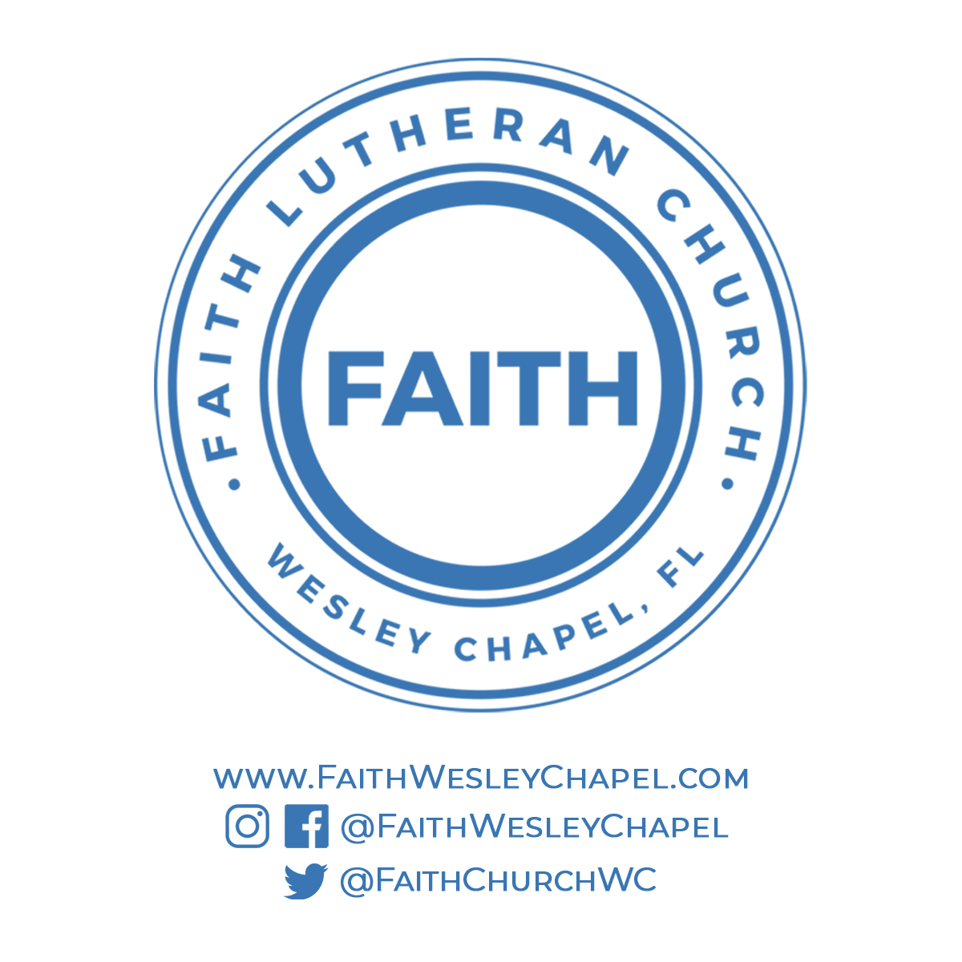**@FaithWesleyChapel**

**@FaithWesleyChapel**

**@FaithChurchWC**