

**Leading our community into a deep connection in Christ**

**___________________________________________________**

**Worship Service for March 23, 2025 at 11 AM**

**Welcome**

**Invocation**

**Confession and Forgiveness:**

**P:** When we come into the presence of God we cannot help but see our sinfulness. God does not require us to cleanse our own sin and be perfect of our own power for, surely, we could never achieve this. Instead, He tells us to come just as we are and receive His great mercy.

**Song:** Just As I Am

Just as I am, without one plea,  
But that Thy blood was shed for me,  
And that Thou bidd'st me come to Thee,   
O Lamb of God, I come! I come!

Just as I am, and waiting not,To rid my soul of one dark blot,  
To Thee whose blood can cleanse each spot,  
O Lamb of God, I come! I come!

Just as I am, though tossed about,  
With many a conflict, many a doubt,  
Fightings and fears within, without, Lamb of God, I come! I come!

*(a time of silence to reflect and personally confess our sins)*

**C:** Heavenly Father, we confess that we have sinned against you and each other. We are truly sorry and we humbly repent. For the sake of your Son Jesus Christ and His suffering and death on the cross, please forgive us and help us to live according to Your ways. Amen

**Just As I Am Verse 4:**Just as I am, Thou wilt receive,  
Wilt welcome, pardon, cleanse, relieve,  
Because Thy promise I believe,  
O Lamb of God, I come! I come! © Public Domain

**P: Words of Forgiveness**  
**C:** Amen.

**Song of Praise and Thanksgiving -** O Praise The Name (Anástasis)

I cast my mind to Calvary Where Jesus bled and died for me.  
I see His wounds, His hands, His feet.   
My Savior on that cursed tree.

His body bound and drenched in tears.

They laid Him down in Joseph's tomb.

The entrance sealed by heavy stone, Messiah still and all alone.

Chorus:

O praise the Name of the Lord our God.

O praise His Name forevermore.

For endless days, we will sing Your praise,

Oh Lord, oh Lord our God.

Then on the third, at break of dawn, the Son of heaven rose again.

O trampled death, where is your sting.

The angels roar for Christ the King.

*(Chorus)*

He shall return in robes of white.

The blazing sun shall pierce the night.

And I will rise among the saints, my gaze transfixed on Jesus' face.

*(Chorus 2x)* © 2015 © Hillsong Music Publishing

**Old Testament Reading -** Jeremiah 26:1-15

In the beginning of the reign of Jehoiakim the son of Josiah, king of Judah, this word came from the Lord: “Thus says the Lord: Stand in the court of the Lord's house, and speak to all the cities of Judah that come to worship in the house of the Lord all the words that I command you to speak to them; do not hold back a word. It may be they will listen, and every one turn from his evil way, that I may relent of the disaster that I intend to do to them because of their evil deeds. You shall say to them, ‘Thus says the Lord: If you will not listen to me, to walk in my law that I have set before you, and to listen to the words of my servants the prophets whom I send to you urgently, though you have not listened, then I will make this house like Shiloh, and I will make this city a curse for all the nations of the earth.’”

The priests and the prophets and all the people heard Jeremiah speaking these words in the house of the Lord. And when Jeremiah had finished speaking all that the Lord had commanded him to speak to all the people, then the priests and the prophets and all the people laid hold of him, saying, “You shall die! Why have you prophesied in the name of the Lord, saying, ‘This house shall be like Shiloh, and this city shall be desolate, without inhabitant’?” And all the people gathered around Jeremiah in the house of the Lord.

When the officials of Judah heard these things, they came up from the king's house to the house of the Lord and took their seat in the entry of the New Gate of the house of the Lord. Then the priests and the prophets said to the officials and to all the people, “This man deserves the sentence of death, because he has prophesied against this city, as you have heard with your own ears.”

Then Jeremiah spoke to all the officials and all the people, saying, “The Lord sent me to prophesy against this house and this city all the words you have heard. Now therefore mend your ways and your deeds, and obey the voice of the Lord your God, and the Lord will relent of the disaster that he has pronounced against you. But as for me, behold, I am in your hands. Do with me as seems good and right to you. Only know for certain that if you put me to death, you will bring innocent blood upon yourselves and upon this city and its inhabitants, for in truth the Lord sent me to you to speak all these words in your ears.”

**Reader:** This is the Word of the Lord. **C:** Thanks be to God.

**Epistle Reading -** Ephesians 5:1-14

Therefore be imitators of God, as beloved children. And walk in love, as Christ loved us and gave himself up for us, a fragrant offering and sacrifice to God.

But sexual immorality and all impurity or covetousness must not even be named among you, as is proper among saints. Let there be no filthiness nor foolish talk nor crude joking, which are out of place, but instead let there be thanksgiving. For you may be sure of this, that everyone who is sexually immoral or impure, or who is covetous (that is, an idolater), has no inheritance in the kingdom of Christ and God. Let no one deceive you with empty words, for because of these things the wrath of God comes upon the sons of disobedience. Therefore do not become partners with them; for at one time you were darkness, but now you are light in the Lord. Walk as children of light (for the fruit of light is found in all that is good and right and true), and try to discern what is pleasing to the Lord. Take no part in the unfruitful works of darkness, but instead expose them. For it is shameful even to speak of the things that they do in secret. But when anything is exposed by the light, it becomes visible, for anything that becomes visible is light. Therefore it says,

“Awake, O sleeper, and arise from the dead, and Christ will shine on you.”

**Reader:** This is the Word of the Lord. **C:** Thanks be to God.

**Gospel Reading -** Luke 11:14–28

Now he was casting out a demon that was mute. When the demon had gone out, the mute man spoke, and the people marveled. But some of them said, “He casts out demons by Beelzebul, the prince of demons,” while others, to test him, kept seeking from him a sign from heaven. But he, knowing their thoughts, said to them, “Every kingdom divided against itself is laid waste, and a divided household falls. And if Satan also is divided against himself, how will his kingdom stand? For you say that I cast out demons by Beelzebul. And if I cast out demons by Beelzebul, by whom do your sons cast them out? Therefore they will be your judges. But if it is by the finger of God that I cast out demons, then the kingdom of God has come upon you. When a strong man, fully armed, guards his own palace, his goods are safe; but when one stronger than he attacks him and overcomes him, he takes away his armor in which he trusted and divides his spoil. Whoever is not with me is against me, and whoever does not gather with me scatters.

“When the unclean spirit has gone out of a person, it passes through waterless places seeking rest, and finding none it says, ‘I will return to my house from which I came.’ And when it comes, it finds the house swept and put in order. Then it goes and brings seven other spirits more evil than itself, and they enter and dwell there. And the last state of that person is worse than the first.”

As he said these things, a woman in the crowd raised her voice and said to him, “Blessed is the womb that bore you, and the breasts at which you nursed!” But he said, “Blessed rather are those who hear the word of God and keep it!”

**P:** This is the Gospel of the Lord.  
**C:** Praise be to You, O Christ.

**Children's Message**

**Sermon Hymn -** Take My Life And Let It Be

Take my life and let it be consecrated, Lord, to Thee;  
Take my moments and my days. Let them flow in ceaseless praise.

Take my hands and let them move at the impulse of Thy love;  
Take my feet and let them be swift and beautiful for Thee.

Take my will and make it Thine. It shall be no longer mine;  
Take my heart, it is Thine own. It shall be Thy royal throne.

Take my love, my Lord, I pour at Thy feet its treasure store;  
Take myself, and I will be ever, only, all for Thee.   
 © DO NOT VERIFY: SEECOMBO RECORD

**Sermon -** "You're an Imitator...But of Who?"

**Prayers:** *Text in prayer requests to (813) 326-5255‬*

**Apostles' Creed** *(stand)*

I believe in God, the Father almighty, maker of heaven and earth,  
And in Jesus Christ, his only Son, our Lord,  
who was conceived by the Holy Spirit,  
born of the Virgin Mary, suffered under Pontius Pilate,  
was crucified, died and was buried. He descended into hell.  
The third day he rose again from the dead.  
He ascended into heaven and sits at the right hand of God  
the Father almighty.  
From there he will come to judge the living and the dead.  
I believe in the Holy Spirit, the holy Christian Church,  
the communion of saints, the forgiveness of sins,  
the resurrection of the body, and the life everlasting. Amen.

**The Lord's Prayer** *(stand)*

Our Father who art in heaven, hallowed be Thy name, Thy kingdom come, Thy will be done on earth as it is in heaven.  Give us this day our daily bread; and forgive us our trespasses as we forgive those who trespass against us; and lead us not into temptation, but deliver us from evil.  For Thine is the kingdom and the power and the glory forever and ever.  Amen

**Benediction** *– The online service ends. The closing hymn video is on the Livestream page bulletin at FaithWesleyChapel.com with lyrics below. See announcements below as well.*

**Closing Song -**Marvelous Light

Chorus:  
Into marvelous light I'm running, out of darkness out of shame.  
By the cross you are the truth, You are the life, You are the way.

I once was fatherless, a stranger with no hope.  
Your kindness wakened me, wakened me from my sleep, now.  
Your love it beckons deeply, a call to come and die.  
By grace now I will come. Take this life, take your life!

Pre-Chorus:  
Sin has lost its power! Death has lost its sting!  
From the grave you've risen victoriously!

*(Chorus)*

My dead heart now is beating, my deepest stains now clean.  
Your breath fills up my lungs, now I'm free, now I'm free.  
*(Repeat)*

*(Pre-Chorus)*

*(Chorus)*

Bridge:  
Lift my hands and spin around. See the light that I have found,  
Oh the marvelous light, marvelous light!  
*(Repeat)*

*(Chorus 2x)*  © 2005 sixsteps Music

|  |  |
| --- | --- |
| **Serving This Week** | |
|  | |
| **O.T. Reader:** Melissa Steinbrueck | **Children’s Church Teacher:** |
| **Epistle Reader:** Darlene Mueller | Melissa Steinbrueck |
| **Acolyte:** Eli Steinbrueck | **Children’s Church Assistant:** |
| **Com. Asst:** Larry Chmiel | Kelsey Torgrimson |
|  | |
| **Serving Next Week** | |
|  | |
| **O.T. Reader:** Larry Chmiel | **Children’s Church Teacher:** |
| **Epistle Reader:** Ginger Torgrimson | Halston & Ben |
| **Acolyte:** Thomas Horness | **Children’s Church Assistant:** |
| **Com. Asst:** Larry Chmiel | N/A |

**Upcoming Events**

**Mar 25, 7 PM – Growth Group Bible Study** (In-Person)Davi’s Home

**Mar 26, 7 PM Council Meeting**  
Larry Chmiel’s Home

**Mar 27, 7 PM – Growth Group Bible Study** (In-Person and Online)Rich Steinbrueck’s Home

[**www.FaithWesleyChapel.com**](http://www.FaithWesleyChapel.com)

 **Faith YouTube**

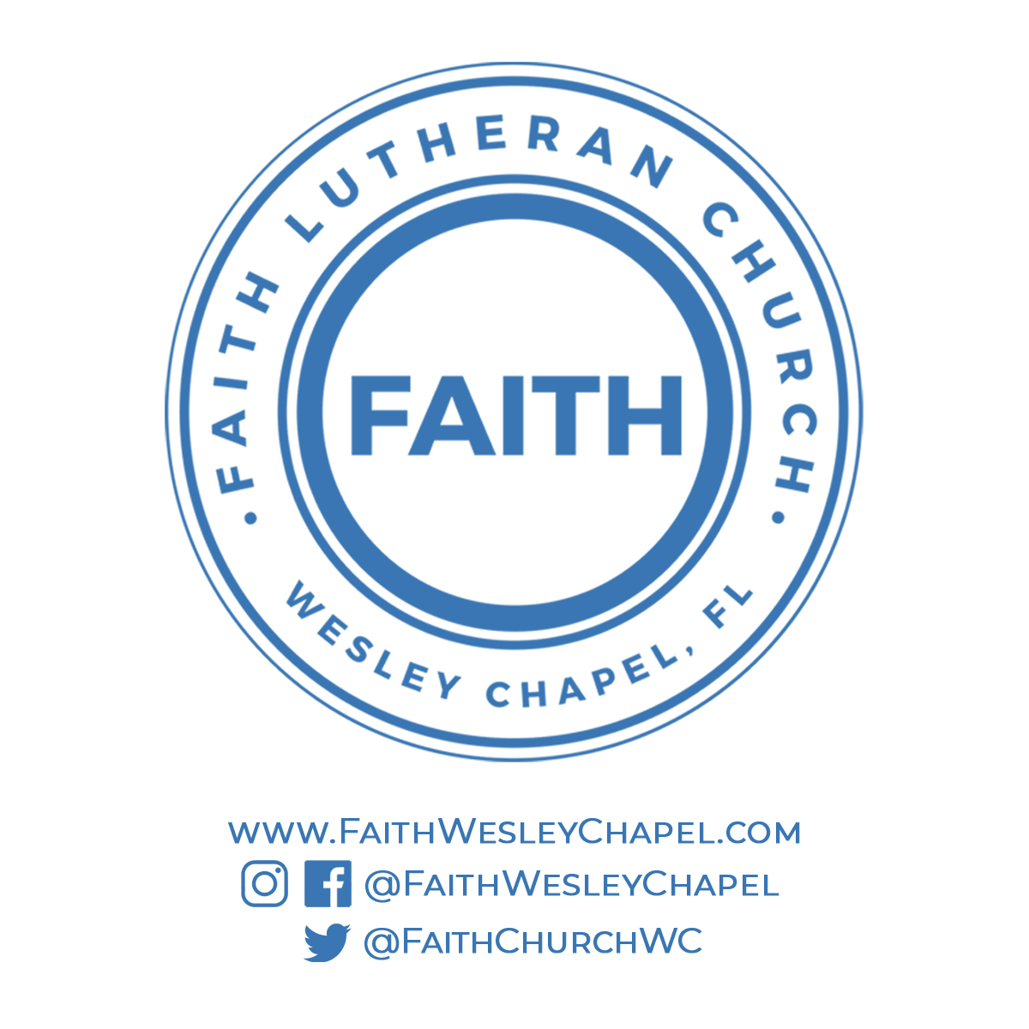**@FaithWesleyChapel**

**@FaithWesleyChapel**

**@FaithChurchWC**