

**Leading our community into a deep connection in Christ**

**Worship Service for March 30, 2025 at 11 AM**

**Welcome**

**Opening Song:**In Christ Alone

In Christ alone my hope is found. He is my light, my strength, my song.  
This Cornerstone, this solid ground,  
Firm through the fiercest drought and storm.  
What heights of love, what depths of peace,  
When fears are stilled, when strivings cease.  
My Comforter, my All in All. Here in the love of Christ I stand.

In Christ alone, who took on flesh, Fullness of God in helpless babe.  
This gift of love and righteousness,   
Scorned by the ones He came to save.  
‘Til on that cross as Jesus died, The wrath of God was satisfied.  
For every sin on Him was laid. Here in the death of Christ I live.

There in the ground His body lay, Light of the World by darkness slain.  
Then bursting forth in glorious day, up from the grave He rose again.  
And as He stands in victory, sin’s curse has lost its grip on me.  
For I am His and He is mine, bought with the precious blood of Christ.

No guilt in life, no fear in death, this is the power of Christ in me.  
From life’s first cry to final breath, Jesus commands my destiny.  
No power of hell, no scheme of man, can ever pluck me from His hand.  
‘Til He returns or calls me home, here in the power of Christ I’ll stand.  
*(Repeat last two lines)* © 2001 Thankyou Music

**Invocation**

**Confession and Forgiveness:**

**P:** Come into the presence of God. It is God, Himself, who bids us to come to Him in prayer, especially when we have sinned, so that we may receive His forgiveness. So, we enter His courts with confidence that if we confess our sins, He will forgive us as He promised.

*(A time of silence to reflect and personally confess our sins)*

**C:** Heavenly Father, we confess that we have sinned against you in thought, word, and deed. We have not loved you with our whole heart and have not loved our neighbor as ourselves. We are truly sorry and we humbly repent. For the sake of your Son Jesus Christ and His suffering and death on the cross, have mercy on us and forgive us; that we may delight in your will, and walk in your ways, to the glory of your Name. Amen

**P:** **Words of Forgiveness**  
**C:** Amen.

**Song of Praise and Thanksgiving -** Living Hope

How great the chasm that lay between us.

How high the mountain I could not climb.

In desperation, I turned to heaven,  
And spoke Your name into the night.

Then through the darkness Your loving kindness,

Tore through the shadows of my soul.

The work is finished, the end is written,  
Jesus Christ, my Living Hope.

Who could imagine so great a mercy.

What heart could fathom such boundless grace.

The God of ages stepped down from glory,  
To wear my sin and bear my shame.

The cross has spoken. I am forgiven. The King of Kings calls me His own.

Beautiful Savior I’m Yours forever, Jesus Christ, my Living Hope.

Chorus:

Hallelujah, praise the one who set me free!

Hallelujah, death has lost its grip on me!

You have broken every chain. There’s salvation in Your Name,

Jesus Christ, my Living Hope.

Then came the morning that sealed the promise,

Your buried body began to breathe.

Out of the silence the roaring Lion,

Declared the grave has no claim on me.

*(Repeat)*

Jesus, Yours is the victory!

*(Chorus 2x)* © Bethel Music Publishing and Remaining portion is unaffiliated

**Old Testament Reading -** Isaiah 49:8-13

Thus says the Lord:  
“In a time of favor I have answered you;  
 in a day of salvation I have helped you;  
I will keep you and give you  
 as a covenant to the people,  
to establish the land,  
 to apportion the desolate heritages,  
saying to the prisoners, ‘Come out,’  
 to those who are in darkness, ‘Appear.’  
They shall feed along the ways;  
 on all bare heights shall be their pasture;  
they shall not hunger or thirst,  
 neither scorching wind nor sun shall strike them,  
for he who has pity on them will lead them,  
 and by springs of water will guide them.  
And I will make all my mountains a road,  
 and my highways shall be raised up.  
Behold, these shall come from afar,  
 and behold, these from the north and from the west,  
 and these from the land of Syene.”

Sing for joy, O heavens, and exult, O earth;  
 break forth, O mountains, into singing!  
For the Lord has comforted his people  
 and will have compassion on his afflicted.

**Reader:** This is the Word of the Lord.  
**C:** Thanks be to God.

**Epistle Reading -** Acts 2:41-47

So those who received his word were baptized, and there were added that day about three thousand souls.

And they devoted themselves to the apostles' teaching and the fellowship, to the breaking of bread and the prayers. And awe came upon every soul, and many wonders and signs were being done through the apostles. And all who believed were together and had all things in common. And they were selling their possessions and belongings and distributing the proceeds to all, as any had need. And day by day, attending the temple together and breaking bread in their homes, they received their food with glad and generous hearts, praising God and having favor with all the people. And the Lord added to their number day by day those who were being saved.

**Reader:** This is the Word of the Lord.  
**C:** Thanks be to God.

**Gospel Reading -** John 6:1-15

After this Jesus went away to the other side of the Sea of Galilee, which is the Sea of Tiberias. And a large crowd was following him, because they saw the signs that he was doing on the sick. Jesus went up on the mountain, and there he sat down with his disciples. Now the Passover, the feast of the Jews, was at hand. Lifting up his eyes, then, and seeing that a large crowd was coming toward him, Jesus said to Philip, “Where are we to buy bread, so that these people may eat?” He said this to test him, for he himself knew what he would do. Philip answered him, “Two hundred denarii worth of bread would not be enough for each of them to get a little.” One of his disciples, Andrew, Simon Peter's brother, said to him, “There is a boy here who has five barley loaves and two fish, but what are they for so many?” Jesus said, “Have the people sit down.” Now there was much grass in the place. So the men sat down, about five thousand in number. Jesus then took the loaves, and when he had given thanks, he distributed them to those who were seated. So also the fish, as much as they wanted. And when they had eaten their fill, he told his disciples, “Gather up the leftover fragments, that nothing may be lost.” So they gathered them up and filled twelve baskets with fragments from the five barley loaves left by those who had eaten. When the people saw the sign that he had done, they said, “This is indeed the Prophet who is to come into the world!”

Perceiving then that they were about to come and take him by force to make him king, Jesus withdrew again to the mountain by himself.

**P:** This is the Gospel of the Lord.  
**C:** Praise be to You, O Christ.

**Children's Message** *(Children dismissed to Children's Church)*

**Sermon Hymn -** Christ, the Life of All the Living

Christ, the Life of all the living. Christ, the death of death, our foe,  
Who, Thyself for me once giving to the darkest depths of woe:  
Through thy suff'rings, death, and merit, I eternal life inherit.  
Thousand, thousand thanks shall be, dearest Jesus, unto Thee.

Thou, ah! Thou, hast taken on Thee bonds and stripes, a cruel rod;  
Pain and scorn were heaped upon Thee, O Thou sinless Son of God!  
Thus didst Thou my soul deliver from the bonds of sin forever.  
Thousand, thousand thanks shall be, dearest Jesus, unto Thee.

Thou hast suffered great affliction and hast borne it patiently,  
Even death by crucifixion, fully to atone for me;  
Thou didst choose to be tormented that my doom should be prevented.  
Thousand, thousand thanks shall be, dearest Jesus, unto Thee.

Then, for all that wrought my pardon, for Thy sorrows deep and sore,  
For Thine anguish in the Garden, I will thank Thee evermore,  
Thank Thee for Thy groaning, sighing, for Thy bleeding and Thy dying,  
For that last triumphant cry, and shall praise Thee, Lord, on high. © Public Domain

**Sermon -** "The Time of Favor"

**Prayers:** *Text in prayer requests to (813) 326-5255‬*

**Nicene Creed** *(stand)*

I believe in one God, the Father Almighty, maker of heaven and earth and of all things visible and invisible.

And in one Lord Jesus Christ, the only-begotten Son of God, begotten of His Father before all worlds, God of God, Light of Light, very God of very God, begotten, not made, being of one substance with the Father, by whom all things were made; who for us men and for our salvation came down from heaven and was incarnate by the Holy Spirit of the virgin Mary and was made man; and was crucified also for us under Pontius Pilate. He suffered and was buried. And the third day He rose again according to the Scriptures and ascended into heaven and sits at the right hand of the Father. And He will come again with glory to judge both the living and the dead, whose kingdom will have no end.

And I believe in the Holy Spirit, the Lord and Giver of Life, who proceeds from the Father and the Son, who with the Father and the Son together is worshiped and glorified, who spoke by the prophets. And I believe in one holy Christian and apostolic Church, I acknowledge one Baptism for the remission of sins, and I look for the resurrection of the dead and the life of the world to come. Amen.

**The Lord's Prayer** *(stand)*

Our Father who art in heaven, hallowed be Thy name, Thy kingdom come, Thy will be done on earth as it is in heaven.  Give us this day our daily bread; and forgive us our trespasses as we forgive those who trespass against us; and lead us not into temptation, but deliver us from evil.  For Thine is the kingdom and the power and the glory forever and ever.  Amen

**Benediction** *– The online service ends. The closing hymn video is on the Livestream page bulletin at FaithWesleyChapel.com with lyrics below. See announcements below as well.*

**Closing Song -**God So Loved

Come all you weary. Come all you thirsty.

Come to the well that never runs dry.

Drink of the Water. Come and thirst no more.

Come all you sinners. Come find His mercy.

Come to the table. He Will satisfy.

Taste of His goodness. Find what you’re looking for.

Chorus 1:

For God so loved the World that He gave us,

His one and only Son to save us.

Whoever believes in Him, will live forever.

Bring all your failures. Bring your addictions.

Come lay them down at the Foot of the cross.

Jesus is waiting there with open arms.

*(Chorus 1)*

Chorus 2:

The power of Hell forever defeated.

Now, it is well. I’m Walking in freedom.

For God so loved, God so loved the world.

Bridge:

Praise God! Praise God from whom all blessings flow.

Praise Him! Praise Him for the wonders of His love.

*(Repeat)*

His amazing love!

*(Chorus 1)*

*(Chorus 2)*

Bring all your failures. Bring your addictions.

Come lay them down at the Foot of the cross.

Jesus is waiting there with open arms. © 2019 Andrew Bergthold Designee

|  |  |
| --- | --- |
| **Serving This Week** | |
|  | |
| **O.T. Reader:** Larry Chmiel | **Children’s Church Teacher:** |
| **Epistle Reader:** Ginger Torgrimson | Halston & Ben |
| **Acolyte:** Thomas Horness | **Children’s Church Assistant:** |
| **Com. Asst:** Larry Chmiel | N/A |
|  | |
| **Serving Next Week** | |
|  | |
| **1st Reader:** Jakob Torgrimson | **Children’s Church Teacher:** |
| **2nd Reader:** Kaylee Steinbrueck | N/A – Children’s Service |
| **Acolyte:** Lawrence Finnerty | **Children’s Church Assistant:** |
| **Com. Asst:** Larry Chmiel | N/A – Children’s Service |

**Upcoming Events**

**Apr 3, 7 PM – Growth Group Bible Study** (In-Person and Online)Rich Steinbrueck’s Home

**Holy Week Schedule**

**Apr 13, 11 AM – Palm Sunday – Faith and Food Worship Service**   
Faith Lutheran Church

**Apr 17, 7 PM – Maundy Thursday – Joint Service with Grace**   
Grace Community Church

**Apr 18, 7 PM – Good Friday Tenebrae Service**   
Faith Lutheran Church

**Apr 20, 10 AM – Easter Breakfast | 11 AM – Easter Worship Noon – Egg Grab**   
Faith Lutheran Church

**www.FaithWesleyChapel.com**

**Faith YouTube**

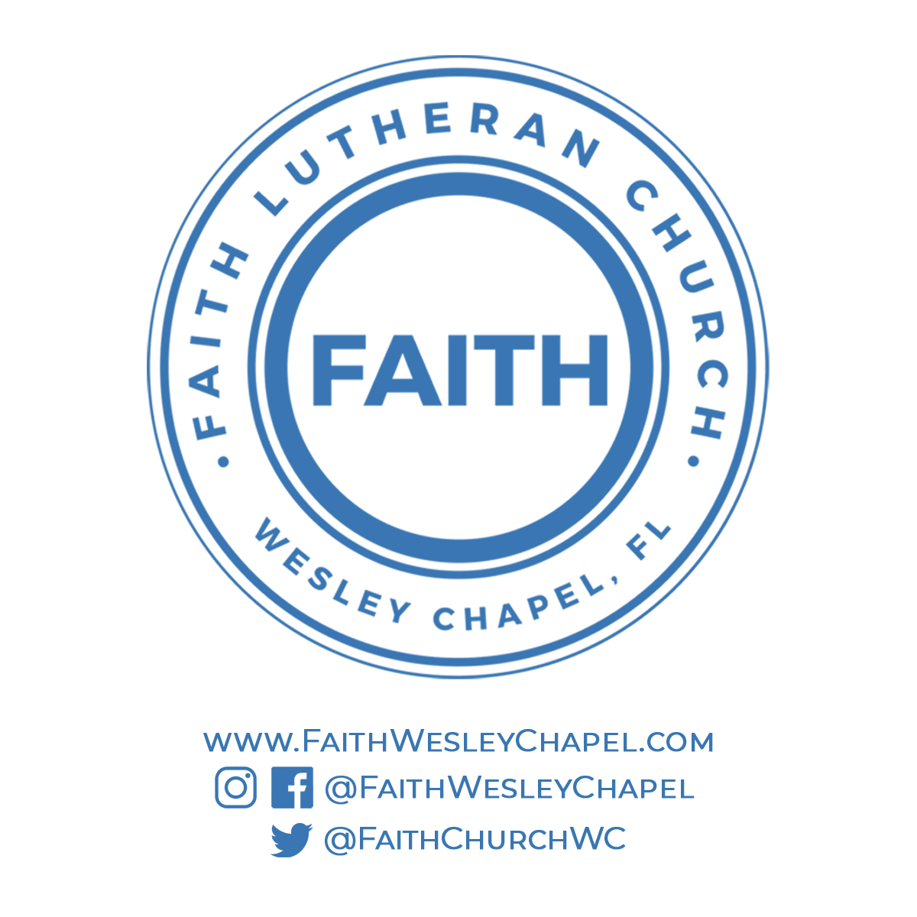**@FaithWesleyChapel**

**@FaithWesleyChapel**

**@FaithChurchWC**