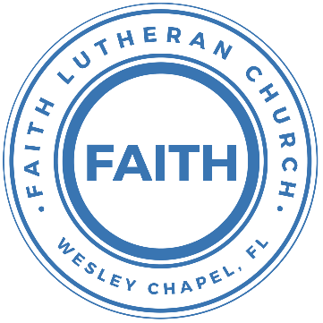

**Leading our community into a deep connection in Christ**

**Worship Service for April 6, 2025 at 11 AM**

**Welcome**

**Opening Song:**Father Abraham

Father Abraham had many sons. Many sons had Father Abraham.

I am one of them and so are you. So, let's just praise the Lord!

Right arm  
Left arm  
Right foot  
Left foot  
Chin up  
Turn around  
Sit down © Public Domain

**Invocation**

**Confession and Forgiveness:**

**P:** We have come here today to worship the Lord.  In worship we hear the Word of God, we receive God's blessings, and respond with thanks and praise.  We begin by seeking God's blessing of forgiveness.  He has promised to remove the guilt and shame of our sin through the sacrifice of Jesus Christ on the cross.

*(a time of silence to reflect and personally confess our sins)*

**P:** Let us confess our sins to the Lord.

**P:** Heavenly Father,  
**C:** Heavenly Father,

**P:** I have done things that were wrong.  
**C:** I have done things that were wrong.  
  
**P:** I have been mean to others.  
**C:** I have been mean to others.

**P:** I have not obeyed my parents.  
**C:** I have not obeyed my parents.

**P:** I have not obeyed You, God.  
**C:** I have not obeyed You, God.

**P:** But I am very sorry.  
**C:** But I am very sorry.

**P:** Please forgive me.  
**C:** Please forgive me.

**P:** I love You very much.  
**C:** I love You very much.

**P:** And I know You love me, too.  
**C:** And I know You love me, too.

**P:** Amen.  
**C:** Amen.

**P:** God has heard your apology.  He loves you very much.  God has told us that when we believe and trust in Him, He makes us His children.  As far as the east is from the west, so far does he remove our sins from us. He has told me to tell you that you are forgiven.  So, as His servant, I forgive you in the name of the Father and of the Son and of the Holy Spirit.   
**C:** Amen.

**Song:**God Is So Good

God is so good. God is so good.  
God is so good. He's so good to me.

He died for me. He died for me so.  
He died for me. He's so good to me.

He loves me so. He loves me so.  
He loves me so. He's so good to me. © Public Domain

**First Reading -**Genesis 22:7-14

Isaac said to his father Abraham, “Father!” Abraham answered, “Yes, son?” Isaac said, “I see the wood and the fire. But where is the lamb we will burn as a sacrifice?” Abraham answered, “God himself is providing the lamb for the sacrifice, my son.”

So both Abraham and his son went together to that place. When they came to the place where God told them to go, Abraham built an altar. He carefully laid the wood on the altar. Then he tied up his son Isaac and laid him on the altar on top of the wood. Then Abraham reached for his knife to kill his son.

But the angel of the Lord stopped him. The angel called from heaven and said, “Abraham, Abraham!” Abraham answered, “Yes?” The angel said, “Don’t kill your son or hurt him in any way. Now I can see that you do respect and obey God. I see that you are ready to kill your son, your only son, for me.”

Then Abraham noticed a ram whose horns were caught in a bush. So Abraham went and took the ram. He offered it, instead of his son, as a sacrifice to God. So Abraham gave that place a name, “The Lord Provides.” Even today people say, “On the mountain of the Lord, he will give us what we need.”

**Reader:** This is the Word of the Lord. **C:** Thanks be to God.

**Children's Message**"The Lord Provides"

**Song:**At The Cross (Love Ran Red)

There’s a place, where mercy reigns and never dies  
There’s a place, where streams of grace flows deep and wide

Pre-Chorus  
All the love, I’ve ever found  
Comes like a flood, comes flowing down

Chorus  
At the cross, at the cross, I surrender my life  
I’m in awe of you; I’m in awe of you  
Where your love ran red, and my sins washed white  
I owe all to you, I owe all to you, Jesus

There’s a place, where sin and shame are powerless  
Where my heart has peace with God, and forgiveness

(*Pre-Chorus*)

(*Chorus*)

Bridge  
Here my hope is found, here on holy ground  
Here I bow down, here I bow down  
Here arms open wide, here you saved my life  
Here I bow down, here I bow

(*Chorus*) © Countless Wonder Publishing

**Second Reading -**Genesis 22:1-2

After these things God decided to test Abraham’s faith. God said to him, “Abraham!” And he said, “Yes!” Then God said, “Take your son to the land of Moriah and kill your son there as a sacrifice for me. This must be Isaac, your only son, the one you love. Use him as a burnt offering on one of the mountains there. I will tell you which mountain.”

**Reader:** This is the Word of the Lord. **C:** Thanks be to God.

**Children's Message**"What Would You Sacrifice?"

**Gospel Reading –**John 8:42–59  
Jesus said to them, “If God were your Father, you would love me,

for I came from God and I am here. I came not of my own accord, but he sent me. Why do you not understand what I say? It is because you cannot bear to hear my word. You are of your father the devil, and your will is to do your father's desires. He was a murderer from the beginning, and does not stand in the truth, because there is no truth in him. When he lies, he speaks out of his own character, for he is a liar and the father of lies. But because I tell the truth, you do not believe me. Which one of you convicts me of sin? If I tell the truth, why do you not believe me? Whoever is of God hears the words of God. The reason why you do not hear them is that you are not of God.”

The Jews answered him, “Are we not right in saying that you are a Samaritan and have a demon?” Jesus answered, “I do not have a demon, but I honor my Father, and you dishonor me. Yet I do not seek my own glory; there is One who seeks it, and he is the judge. Truly, truly, I say to you, if anyone keeps my word, he will never see death.” The Jews said to him, “Now we know that you have a demon! Abraham died, as did the prophets, yet you say, ‘If anyone keeps my word, he will never taste death.’ Are you greater than our father Abraham, who died? And the prophets died! Who do you make yourself out to be?” Jesus answered, “If I glorify myself, my glory is nothing. It is my Father who glorifies me, of whom you say, ‘He is our God.’ But you have not known him. I know him. If I were to say that I do not know him, I would be a liar like you, but I do know him and I keep his word. Your father Abraham rejoiced that he would see my day. He saw it and was glad.” So the Jews said to him, “You are not yet fifty years old, and have you seen Abraham?” Jesus said to them, “Truly, truly, I say to you, before Abraham was, I am.” So they picked up stones to throw at him, but Jesus hid himself and went out of the temple.

**P:** This is the Gospel of the Lord. **C:** Praise be to You, O Christ.

**Song:**Seek Ye First

Seek ye first, the Kingdom of God and His righteousness,  
And all these things shall be added unto you. Allelu, Alleluia.

Ask and it shall be given unto you. Seek and ye shall find.  
Knock and it shall be opened unto you. Allelu, Alleluia.

Man shall not live by bread alone, but by every word,  
That proceeds out from the mouth of the Lord. Allelu, Alleluia.

© Public Domain

**Sermon –**“Sacrificing Something Precious”

Sermon Reading – Genesis 22:1-14

After these things God tested Abraham and said to him, “Abraham!” And he said, “Here I am.” He said, “Take your son, your only son Isaac, whom you love, and go to the land of Moriah, and offer him there as a burnt offering on one of the mountains of which I shall tell you.” So Abraham rose early in the morning, saddled his donkey, and took two of his young mn with him, and his son Isaac. And he cut the wood for the burnt offering and arose and went to the place of which God had told him. On the third day Abraham lifted up his eyes and saw the place from afar. Then Abraham said to his young men, “Stay here with the donkey; I and the boy will go over there and worship and come again to you.” And Abraham took the wood of the burnt offering and laid it on Isaac his son. And he took in his hand the fire and the knife. So they went both of them together.

**Prayers:** *Text in prayer requests to (813) 326-5255*

**The Lord's Prayer**

Our Father who art in heaven, hallowed be Thy name, Thy kingdom come, Thy will be done on earth as it is in heaven.  Give us this day our daily bread; and forgive us our trespasses as we forgive those who trespass against us; and lead us not into temptation, but deliver us from evil.  For Thine is the kingdom and the power and the glory forever and ever.  Amen

**Benediction** *– The online service ends. The closing hymn video is on the Livestream page bulletin at FaithWesleyChapel.com with lyrics below. See announcements below as well.*

**Closing Song:**This Is Amazing Grace

Who breaks the power of sin and darkness

Whose love is mighty and so much stronger

The King of Glory, the King above all kings

Who shakes the whole earth with holy thunder

Who leaves us breathless in awe and wonder

The King of Glory, the King above all kings

Chorus:

This is amazing grace. This is unfailing love

That You would take my place. That You would bear my cross

You would lay down Your life, that I would be set free

Jesus, I sing for all that You've done for me

Who brings our chaos back into order

Who makes the orphan a son and daughter

The King of Glory, The King of Glory

Who rules the nations with truth and justice

Shines like the sun in all of its brilliance

The King of Glory, the King above all kings

*(Chorus)*

Bridge:

Worthy is the Lamb who was slain

Worthy is the King who conquered the grave

*(Repeat 2x)*

Worthy is the Lamb who was slain. Worthy! Worthy! Worthy!

*(Chorus) © 2012 Bethel Music, Seems Like Music, Sing My Songs, Phil Wickham Music, and Warner Chappell Music*

|  |  |
| --- | --- |
| **Serving This Week** | |
|  | |
| **1st Reader:** Jakob Torgrimson | **Children’s Church Teacher:** |
| **2nd Reader:** Kaylee Steinbrueck | N/A – No Children’s Church |
| **Acolyte:** Lawrence Finnerty | **Children’s Church Assistant:** |
| **Com. Asst:** Larry Chmiel | N/A – No Children’s Church |
|  | |
| **Serving Next Week** | |
|  | |
| **O.T. Reader:** Richard Steinbrueck | **Children’s Church Teacher:** |
| **Epistle Reader:** Vanessa Frost | Melissa Steinbrueck |
| **Acolyte:** Kaylee Steinbrueck | **Children’s Church Assistant:** |
| **Com. Asst:** Larry Chmiel | Kaylee Steinbrueck |

**Upcoming Events**

**April 10, 7 PM – Growth Group Bible Study** (In-Person andOnline)Rich Steinbrueck’s Home

**Holy Week Schedule**

**Apr 13, 11 AM – Palm Sunday – Faith and Food Worship Service**   
Faith Lutheran Church

**Apr 17, 7 PM – Maundy Thursday – Joint Service with Grace**   
Grace Community Church

**Apr 18, 7 PM – Good Friday Tenebrae Service**   
Faith Lutheran Church

**Apr 20, 10 AM – Easter Breakfast | 11 AM – Easter Worship Noon – Egg Grab**   
Faith Lutheran Church

**www.FaithWesleyChapel.com**

**Faith YouTube**

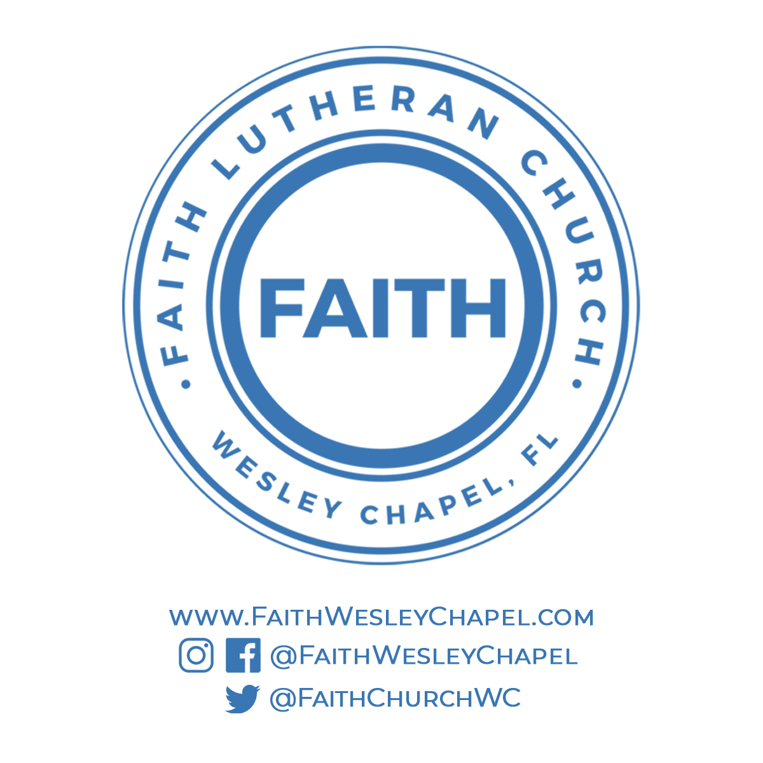**@FaithWesleyChapel**

**@FaithWesleyChapel**

**@FaithChurchWC**