

**Leading our community into a deep connection in Christ**

**Easter Sunday Worship Service for April 20, 2025 at 11 AM**

**Welcome**

**Gospel Reading** - John 3:1-15

Now there was a man of the Pharisees named Nicodemus, a ruler of the Jews. This man came to Jesus by night and said to him, “Rabbi, we know that you are a teacher come from God, for no one can do these signs that you do unless God is with him.” Jesus answered him, “Truly, truly, I say to you, unless one is born again he cannot see the kingdom of God.” Nicodemus said to him, “How can a man be born when he is old? Can he enter a second time into his mother's womb and be born?” Jesus answered, “Truly, truly, I say to you, unless one is born of water and the Spirit, he cannot enter the kingdom of God. That which is born of the flesh is flesh, and that which is born of the Spirit is spirit. Do not marvel that I said to you, ‘You must be born again.’ The wind blows where it wishes, and you hear its sound, but you do not know where it comes from or where it goes. So it is with everyone who is born of the Spirit.” Nicodemus said to him, “How can these things be?” Jesus answered him, “Are you the teacher of Israel and yet you do not understand these things? Truly, truly, I say to you, we speak of what we know, and bear witness to what we have seen, but you do not receive our testimony. If I have told you earthly things and you do not believe, how can you believe if I tell you heavenly things? No one has ascended into heaven except he who descended from heaven, the Son of Man. And as Moses lifted up the serpent in the wilderness, so must the Son of Man be lifted up, that whoever believes in him may have eternal life.

**P:** This is the Gospel of the Lord.  
**C:** Praise be to You, O Christ.

**Opening Song:** Christ Has Arisen, Alleluia

Verse 1:Christ has arisen, alleluia. Rejoice and praise Him, alleluia.For our Redeemer burst from the tomb,Even from death, dispelling its gloom.

Refrain:

Let us sing praise to Him with endless joy;

Death’s fearful sting He has come to destroy.

Our sin forgiving, alleluia! Jesus is living, alleluia!

Verse 2:

For three long days, the grave did its worst,

Until its strength by God was dispersed.

He who gives life did death undergo;

And in its conquest, His might did show.

*(Refrain)*

Verse 4:

Go spread the news: He’s not in the grave;

He has arisen this world to save.

Jesus’ redeeming labors are done; even the battle with sin is won.

*(Refrain)* Tr. © 1977 Augsburg Publishing House; © 1968

**Invocation**

**Confession and Forgiveness:** *(stand)*

**P:** As we gather, today, let us cleanse our hearts and our consciences by confessing our sin to God.

*(Time of silence for reflection and confession)*

**C:** Heavenly Father, we confess that we are sinful and unclean. We have sinned against you and against our neighbor in our thoughts, words, and actions.  We are truly sorry for our sins and sincerely repent of them. We ask for Your mercy. For the sake of Jesus Christ's bitter suffering and death, please forgive us and renew us that we may walk in Your Spirit to the glory of Your holy name. Amen

**P:** The Lord has heard your confession. Therefore, as a called and ordained servant of the Lord, in the stead and by the command of my Lord, Jesus Christ, I forgive you all your sins in the name of the Father and of the Son and of the Holy Spirit.  
**C:** Amen

**Song of Praise and Thanksgiving:** Christ Is Risen

Let no one caught in sin remain inside the lie of inward shame.  
We fix our eyes upon the cross and run to Him who showed great love  
And bled for us. Freely You've bled for us.

Chorus:  
Christ is risen from the dead, trampling over death by death.  
Come awake, come awake, come and rise up from the grave.  
Christ is risen from the dead, we are one with Him again.  
Come awake, come awake, come and rise up from the grave.

Beneath the weight of all our sin You bowed to none but Heaven's will  
No scheme of Hell, no scoffer's crown,   
No burden great can hold You down.  
In strength You reign. Forever let Your church proclaim.

*(Chorus)*

O death, where is your sting? O hell, where is your victory?  
O church, come stand in the light.  
The glory of God has defeated the night!  
O death, where is your sting? O hell, where is your victory?  
O church, come stand in the light.  
Our God is not dead. He is alive! He is alive!

*(Chorus)* © 2009 Thankyou Music, spiritandsong.com, Unknown, and SHOUT! Publishing

**Old Testament Reading** - Job 19:23-27

“Oh that my words were written!  
 Oh that they were inscribed in a book!  
Oh that with an iron pen and lead  
 they were engraved in the rock forever!  
For I know that my Redeemer lives,  
 and at the last he will stand upon the earth.  
And after my skin has been thus destroyed,  
 yet in my flesh I shall see God,  
whom I shall see for myself,  
 and my eyes shall behold, and not another.  
 My heart faints within me!

**Reader:** This is the Word of the Lord.  
**C:** Thanks be to God.

**Epistle Reading** - 1 Corinthians 15:51-57

Behold! I tell you a mystery. We shall not all sleep, but we shall all be changed, in a moment, in the twinkling of an eye, at the last trumpet. For the trumpet will sound, and the dead will be raised imperishable, and we shall be changed. For this perishable body must put on the imperishable, and this mortal body must put on immortality. When the perishable puts on the imperishable, and the mortal puts on immortality, then shall come to pass the saying that is written:

“Death is swallowed up in victory.”  
“O death, where is your victory?  
 O death, where is your sting?”

The sting of death is sin, and the power of sin is the law. But thanks be to God, who gives us the victory through our Lord Jesus Christ.

**Reader:** This is the Word of the Lord.  
**C:** Thanks be to God.

**Children's Message** *(Children return to their seats)*

**Sermon Hymn***–*Jesus Christ is Risen, Today

Jesus Christ is ris'n today, Alleluia!

Our triumphant holy day, Alleluia!

Who did once upon the cross, Alleluia!

Suffer to redeem our loss, Alleluia!

Hymns of praise then let us sing, Alleluia!

Unto Christ, our heav'nly king, Alleluia!

Who endured the cross and grave, Alleluia!

Sinners to redeem and save, Alleluia!

But the pains which He endured, Alleluia!

Our salvation have procured; Alleluia!

Now above the sky He’s king, Alleluia!

Where the angels ever sing, Alleluia!

Sing we to our God above, Alleluia!

Praise eternal as His love; Alleluia!

Praise Him, all ye heav'nly host, Alleluia!

Father, Son, and Holy Ghost. Alleluia! © Public Domain

**Sermon** - "Resurrection Day"

**Prayers:** *Text in prayer requests to (813) 326-5255*

**Nicene Creed** *(stand)*

I believe in one God, the Father Almighty, maker of heaven and earth and of all things visible and invisible.

And in one Lord Jesus Christ, the only-begotten Son of God, begotten of His Father before all worlds, God of God, Light of Light, very God of very God, begotten, not made, being of one substance with the Father, by whom all things were made; who for us men and for our salvation came down from heaven and was incarnate by the Holy Spirit of the virgin Mary and was made man; and was crucified also for us under Pontius Pilate. He suffered and was buried. And the third day He rose again according to the Scriptures and ascended into heaven and sits at the right hand of the Father. And He will come again with glory to judge both the living and the dead, whose kingdom will have no end.

And I believe in the Holy Spirit, the Lord and Giver of Life, who proceeds from the Father and the Son, who with the Father and the Son together is worshiped and glorified, who spoke by the prophets. And I believe in one holy Christian and apostolic Church, I acknowledge one Baptism for the remission of sins, and I look for the resurrection of the dead and the life of the world to come. Amen.

**The Lord's Prayer** *(stand)*

Our Father who art in heaven, hallowed be Thy name, Thy kingdom come, Thy will be done on earth as it is in heaven.  Give us this day our daily bread; and forgive us our trespasses as we forgive those who trespass against us; and lead us not into temptation, but deliver us from evil.  For Thine is the kingdom and the power and the glory forever and ever.  Amen.

**Benediction** *– The online service ends. The closing hymn video is on the Livestream page bulletin at FaithWesleyChapel.com with lyrics below. See announcements below as well.*

**Closing Song:**Forever  
The moon and stars they wept. The morning sun was dead.  
The Savior of the world was fallen.  
His body on the cross. His blood poured out for us.  
The weight of every curse upon Him.

One final breath He gave, as Heaven looked away.

The Son of God was laid in darkness.

A battle in the grave. The war on death was waged.

The power of hell forever broken.

Pre-Chorus:

The ground began to shake. The stone was rolled away.

His perfect love could not be overcome.

Now death where is your sting. Our resurrected King,

Has rendered you defeated.

Chorus:

Forever, He is glorified. Forever, He is lifted high!

Forever, He is risen. He is alive; He is alive!

*(Pre-Chorus)*

*(Chorus)*

We sing hallelujah. We sing hallelujah.

We sing hallelujah. The Lamb has overcome!

*(Chorus)* © 2013 Bethel Music

|  |  |
| --- | --- |
| **Serving This Week** | |
|  | |
| **O.T. Reader:** Josh Strasheim | **Children’s Church Teacher:** |
| **Epistle Reader:** Ginger Dunn | N/A – No Children’s Church |
| **Acolyte:** Eli Steinbrueck | **Children’s Church Assistant:** |
| **Com. Asst:** Larry Chmiel | N/A – No Children Church |
|  | |
| **Serving Next Week** | |
|  | |
| **O.T. Reader:** Ginger Torgrimson | **Children’s Church Teacher:** |
| **Epistle Reader:** Darlene Mueller | Halston & Ben |
| **Acolyte:** Lawrence Finnerty | **Children’s Church Assistant:** |
| **Com. Asst:** Larry Chmiel | N/A |

**Upcoming Events**

**Apr 22, 7 PM – Growth Group Bible Study**  
Davi’s Home

**April 24, 7 PM – Growth Group Bible Study** (In-Person and Online)Rich Steinbrueck’s Home

**May 4, After Service – Pizza and Game Day**   
Faith Lutheran Church

**www.FaithWesleyChapel.com**

**Faith YouTube**

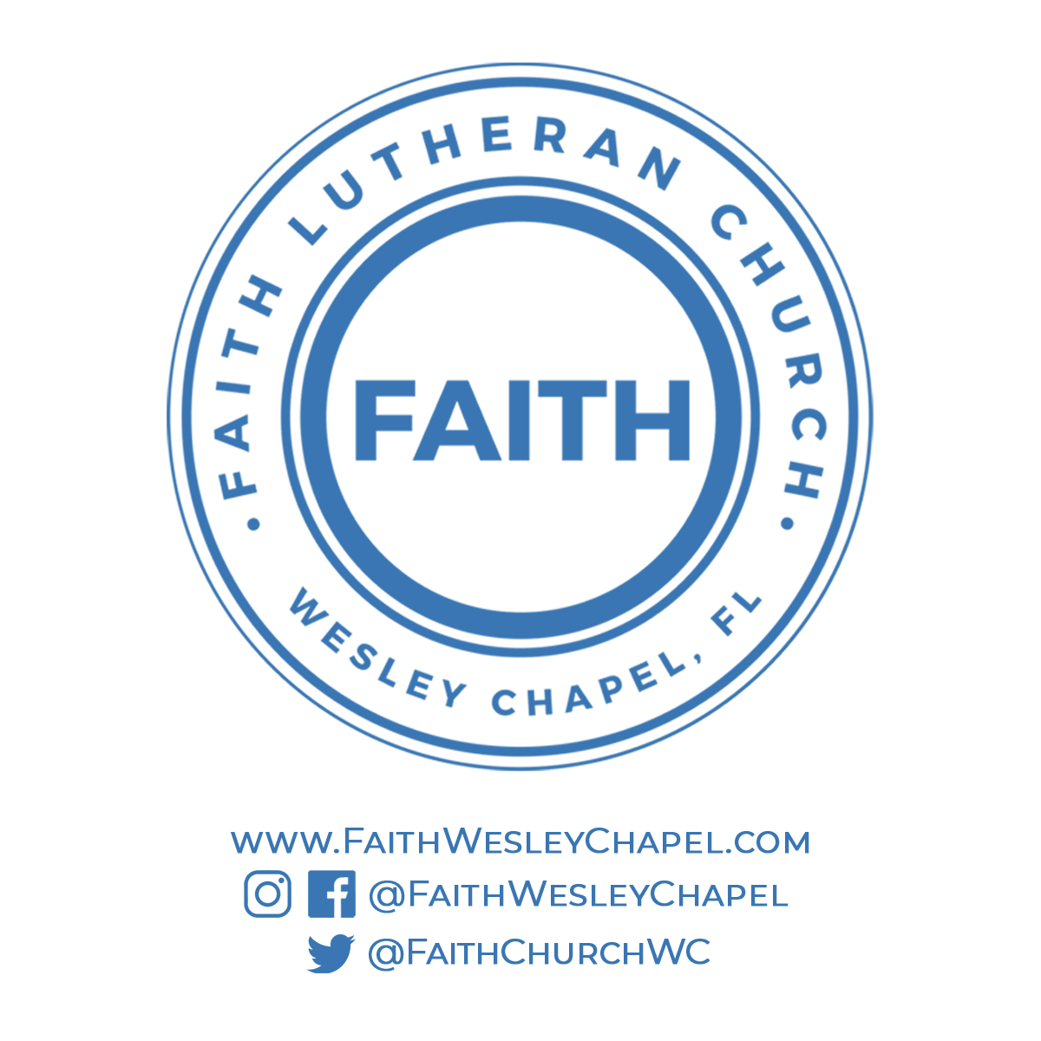**@FaithWesleyChapel**

**@FaithWesleyChapel**

**@FaithChurchWC**