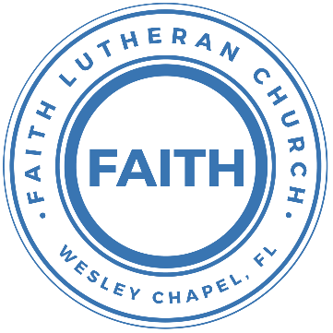

**Leading our community into a deep connection in Christ**

**___________________________________________________**

**Worship Service for April 27, 2025 at 11 AM**

**Welcome**

**Opening Song:**I Know that My Redeemer Lives   
I know that my Redeemer lives.  
What comfort this sweet sentence gives!  
He lives, He lives, who once was dead.  
He lives, my ever-living Head.

He lives triumphant from the grave. He lives eternally to save.

He lives all-glorious in the sky. He lives exalted there on high.

He lives to silence all my fears; He lives to wipe away my tears;

He lives to calm my troubled heart; He lives all blessings to impart.

He lives, all glory to His name! He lives, my Jesus, still the same.

Oh, the sweet joy this sentence gives;  
I know that my Redeemer lives!

I know that my Redeemer lives! © Public Domain

**Invocation**

**Confession and Forgiveness:  
P:** Come into the presence of the Lord our God.  
**C:** Have mercy, O Lord. If you, Lord, kept a record of sins, Lord, who could stand; but if we confess our sins, he is faithful and just to forgive us our sins and to cleanse us from all unrighteousness.

*(A time of silence to reflect and personally confess our sins)*

**P:** I said, "I will confess my transgressions to the LORD." And you forgave the guilt of my sin. Let us confess our sin before the Lord. Let us confess together.  
**C:** Heavenly Father, we confess that we are sinners.  We have sinned against you and our neighbors. We have not loved you with our whole heart and we have not loved our neighbors as ourselves. We justly deserve Your punishment.  For the sake of Your Son, Jesus Christ, have mercy on us.  Forgive us, renew us, and lead us, so that we may delight in Your will and walk in Your ways to the glory of Your holy name.  Amen.

**P:** The Lord is gracious and merciful. He promises to forgive our sins. Therefore, upon this, your confession, as a called and ordained servant of the Lord, in the stead and by the command of my Lord, Jesus Christ, I forgive you all your sins in the name of the Father and of the Son and of the Holy Spirit.  
**C:** Amen.

**Song -** Now All The Vault Of Heaven Resounds *(sit)*

Now all the vault of Heav'n resounds,

In praise of love that still abound,

“Christ has triumphed! He is living!"

Sing, choirs of angels, loud and clear.

Repeat their song of glory here.

“Christ has triumphed! Christ has triumphed!

Alleluia, alleluia, alleluia.”

Eternal is the gift He brings.

Therefore, our heart with rapture sings,

“Christ has triumphed! He is living!"

Now, still, He comes to give us life,

And by His presence stills all strife.

Christ has triumphed! He is living!  
Alleluia, alleluia, alleluia.

Adoring praises now we bring  
And with the heavenly blessed sing,  
“Christ has triumphed, Alleluia!  
Be to the Father, and our Lord,  
To Spirit blest, most holy God,  
All the glory, never-ending!  
Alleluia, alleluia, alleluia.“ © 1989,1994 Lorenz Publishing Company

**Old Testament Reading -** Ezekiel 37:1-14The hand of the Lord was upon me, and he brought me out in the Spirit of the Lord and set me down in the middle of the valley; it was full of bones. And he led me around among them, and behold, there were very many on the surface of the valley, and behold, they were very dry. And he said to me, “Son of man, can these bones live?” And I answered, “O Lord God, you know.” Then he said to me, “Prophesy over these bones, and say to them, O dry bones, hear the word of the Lord. Thus says the Lord God to these bones: Behold, I will cause breath to enter you, and you shall live. And I will lay sinews upon you, and will cause flesh to come upon you, and cover you with skin, and put breath in you, and you shall live, and you shall know that I am the Lord.”

So I prophesied as I was commanded. And as I prophesied, there was a sound, and behold, a rattling, and the bones came together, bone to its bone. And I looked, and behold, there were sinews on them, and flesh had come upon them, and skin had covered them. But there was no breath in them. Then he said to me, “Prophesy to the breath; prophesy, son of man, and say to the breath, Thus says the Lord God: Come from the four winds, O breath, and breathe on these slain, that they may live.” So I prophesied as he commanded me, and the breath came into them, and they lived and stood on their feet, an exceedingly great army.

Then he said to me, “Son of man, these bones are the whole house of Israel. Behold, they say, ‘Our bones are dried up, and our hope is lost; we are indeed cut off.’ Therefore prophesy, and say to them, Thus says the Lord God: Behold, I will open your graves and raise you from your graves, O my people. And I will bring you into the land of Israel. And you shall know that I am the Lord, when I open your graves, and raise you from your graves, O my people. And I will put my Spirit within you, and you shall live, and I will place you in your own land. Then you shall know that I am the Lord; I have spoken, and I will do it, declares the Lord.”

**Reader:** This is the Word of the Lord. **C:** Thanks be to God.

**Epistle Reading -** 1 John 5:4–10For everyone who has been born of God overcomes the world. And this is the victory that has overcome the world—our faith. Who is it that overcomes the world except the one who believes that Jesus is the Son of God? This is he who came by water and blood—Jesus Christ; not by the water only but by the water and the blood. And the Spirit is the one who testifies, because the Spirit is the truth. For there are three that testify: the Spirit and the water and the blood; and these three agree. If we receive the testimony of men, the testimony of God is greater, for this is the testimony of God that he has borne concerning his Son. Whoever believes in the Son of God has the testimony in himself. Whoever does not believe God has made him a liar, because he has not believed in the testimony that God has borne concerning his Son.

**Reader:** This is the Word of the Lord. **C:** Thanks be to God.

**Gospel Reading -** John 20:19–31  
On the evening of that day, the first day of the week, the doors being locked where the disciples were for fear of the Jews, Jesus came and stood among them and said to them, “Peace be with you.” When he had said this, he showed them his hands and his side. Then the disciples were glad when they saw the Lord. Jesus said to them again, “Peace be with you. As the Father has sent me, even so I am sending you.” And when he had said this, he breathed on them and said to them, “Receive the Holy Spirit. If you forgive the sins of any, they are forgiven them; if you withhold forgiveness from any, it is withheld.”

Now Thomas, one of the twelve, called the Twin, was not with them when Jesus came. So the other disciples told him, “We have seen the Lord.” But he said to them, “Unless I see in his hands the mark of the nails, and place my finger into the mark of the nails, and place my hand into his side, I will never believe.”

Eight days later, his disciples were inside again, and Thomas was with them. Although the doors were locked, Jesus came and stood among them and said, “Peace be with you.” Then he said to Thomas, “Put your finger here, and see my hands; and put out your hand, and place it in my side. Do not disbelieve, but believe.” Thomas answered him, “My Lord and my God!” Jesus said to him, “Have you believed because you have seen me? Blessed are those who have not seen and yet have believed.”

Now Jesus did many other signs in the presence of the disciples, which are not written in this book; but these are written so that you may believe that Jesus is the Christ, the Son of God, and that by believing you may have life in his name.

**P:** This is the Gospel of the Lord. **C:** Praise be to You, O Christ.

**Children's Message**

**Sermon Hymn –** Because He Lives (Amen)   
I believe in the Son. I believe in the risen One  
I believe I overcome. By the power of His blood

Chorus  
Amen, Amen. I’m alive, I’m alive because He lives  
Amen, Amen. Let my song join the one that never ends  
Because He lives

I was dead in the grave. I was covered in sin and shame  
I heard mercy call my name. He rolled the stone away

*(Chorus)*

Bridge  
Because He lives, I can face tomorrow  
Because He lives, Every fear is gone  
I know He holds my life my future in His hands

(Chorus 2x) © 2014

**Sermon -** "Fear and Peace, Unbelief and Faith, Death and Life"

**Prayers:** *Text in prayer requests to (813) 326-5255‬*

**Apostles' Creed** *(stand)*I believe in God, the Father almighty, maker of heaven and earth,

And in Jesus Christ, his only Son, our Lord,  
who was conceived by the Holy Spirit,  
born of the Virgin Mary, suffered under Pontius Pilate,  
was crucified, died and was buried. He descended into hell.  
The third day he rose again from the dead.  
He ascended into heaven  
and sits at the right hand of God the Father almighty.  
From there he will come to judge the living and the dead.

I believe in the Holy Spirit, the holy Christian Church,  
the communion of saints, the forgiveness of sins,  
the resurrection of the body, and the life everlasting. Amen.

**The Lord's Prayer** *(stand)*  
Our Father who art in heaven, hallowed be Thy name, Thy kingdom come, Thy will be done on earth as it is in heaven.  Give us this day our daily bread; and forgive us our trespasses as we forgive those who trespass against us; and lead us not into temptation, but deliver us from evil.  For Thine is the kingdom and the power and the glory forever and ever.  Amen

**Benediction** *– The online service ends. The closing hymn video is on the Livestream page bulletin at FaithWesleyChapel.com with lyrics below. See announcements below as well.*

**Closing Song –**This Is Our God  
Remember those walls that we called sin and shame?  
They were like prisons that we couldn't escape.  
But He came, and He died, and He rose.  
Those walls are rubble now.

Remember those giants we called death and grave?  
They were like mountains that stood in our way.  
But He came, and He died, and He rose.  
Those giants are dead now.

Chorus  
This is our God, this is who He is, He loves us.  
This is our God, this is what He does, He saves us.  
He bore the cross, beat the grave,  
let heaven and earth proclaim,  
this is our God, King Jesus.

Remember that fear that took our breath away?  
Faith so weak that we could barely pray.  
But He heard, Every word, every whisper.

Now those altars in the wilderness.  
Tell the story of His faithfulness.  
Never once, did He fail, and He never will.

*(Chorus)*

Bridge  
Who pulled me out of that pit? He did. He did.  
Who paid for all of our sins? Nobody but Jesus.  
*(Repeat both lines)*  
Who rescued me from that grave? Yahweh. Yahweh.  
Who gets the glory and praise? Nobody but Jesus.  
*(Repeat both lines)*

*(Chorus)* © Brandon Lake Music

|  |  |
| --- | --- |
| **Serving This Week** | |
|  | |
| **O.T Reader:** Ginger Torgrimson | **Children’s Church Teacher:** |
| **Epistle Reader:** Darlene Mueller | Halton & Ben |
| **Acolyte:** Lawrence Finnerty | **Children’s Church Assistant:** |
| **Com. Asst:** Larry Chmiel | N/A |
|  | |
| **Serving Next Week** | |
|  | |
| **1st Reader:** Thomas Horness | **Children’s Church Teacher:** |
| **2nd Reader:** Kaylee Steinbrueck | N/A – No Children’s Church |
| **Acolyte:** Lawrence Finnerty | **Children’s Church Assistant:** |
| **Com. Asst:** Larry Chmiel | N/A – No Children’s Church |

**Upcoming Events**

**May 1, 7 PM – Growth Group Bible Study** (In-Person and Online)Rich Steinbrueck’s Home

**May 4, After Service – Pizza and Game Day**   
Faith Lutheran Church

**May 11, After Service – Voter Meeting**   
Faith Lutheran Church

[**www.FaithWesleyChapel.com**](http://www.FaithWesleyChapel.com)

 **Faith YouTube**

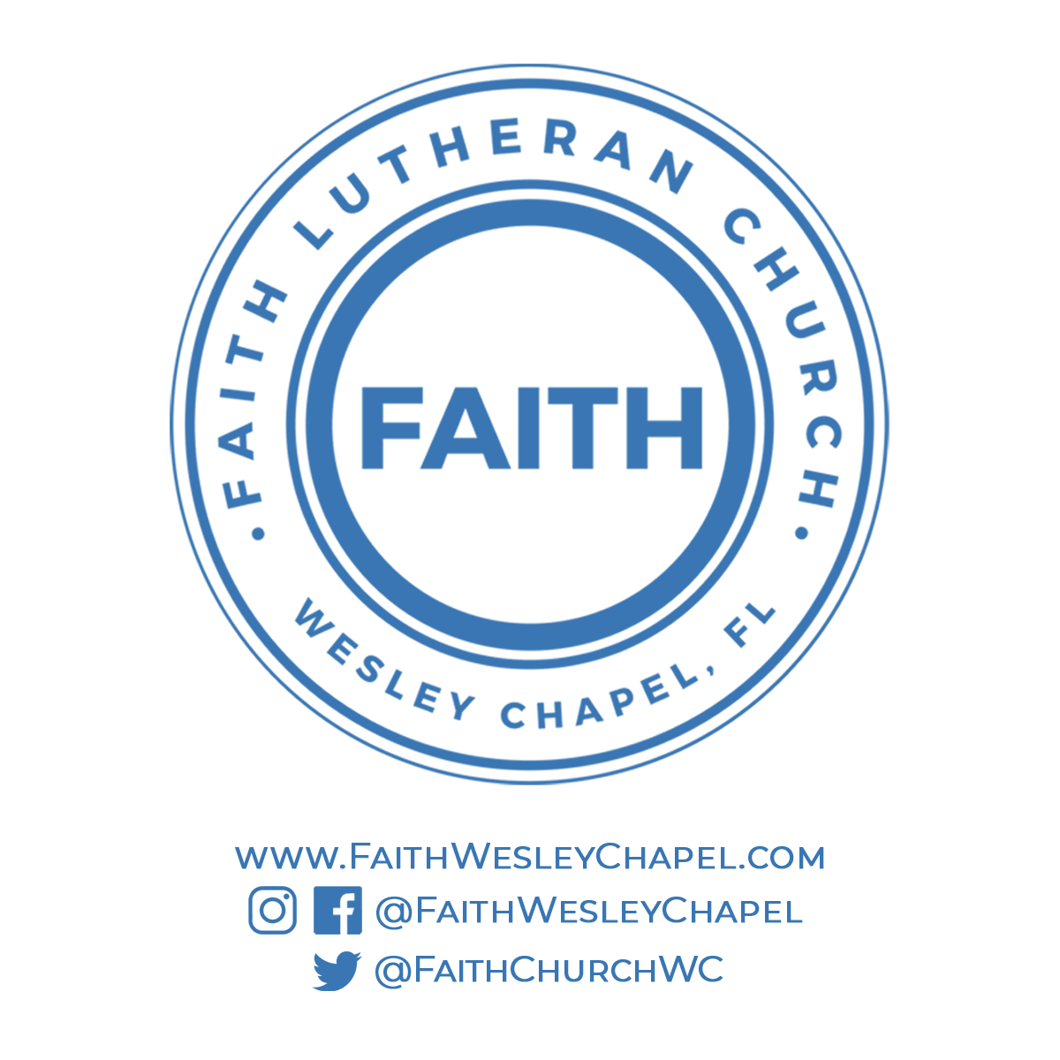**@FaithWesleyChapel**

**@FaithWesleyChapel**

**@FaithChurchWC**