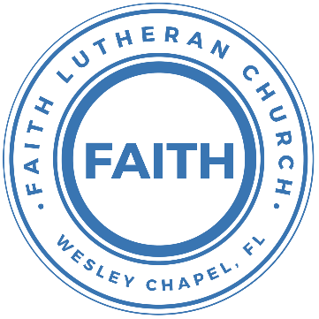

**Leading our community into a deep connection in Christ**

**Worship Service for May 4, 2025 at 11 AM**

**Welcome**

**Opening Song:**I Just Wanna Be A Sheep

Chorus:  
I just wanna be a sheep, baa baa baa baa.  
I just wanna be a sheep, baa baa baa baa.  
I pray the Lord my soul to keep,   
I just wanna be a sheep, baa baa baa baa.

Verse 1:  
Don't wanna be a goat...nope! Don't wanna be a goat...nope!  
Haven't got any hope...nope! Don't wanna be a goat...nope!

Verse 4:  
Don't wanna be a Sadducee. Don't wanna be a Sadducee.  
'Cause they're so sad you see. Don't wanna be a Sadducee.

*(Chorus)*

Verse 5:  
Just wanna be a child of God. Just wanna be a child of God.  
Walkin' the same path He trod. Just wanna be a child of God.

*(Chorus)*  © 1974 Mission Hills Music

**Invocation**

**Confession and Forgiveness:**

**P:** We have come here today to worship the Lord.  In worship we hear the Word of God, we receive God's blessings, and respond with thanks and praise.  We begin by seeking God's blessing of forgiveness.  He has promised to remove the guilt and shame of our sin through the sacrifice of Jesus Christ on the cross.

*(a time of silence to reflect and personally confess our sins)*

**P:** Let us confess our sins to the Lord.

**P:** Heavenly Father,  
**C:** Heavenly Father,

**P:** I have done things that were wrong.  
**C:** I have done things that were wrong.  
  
**P:** I have been mean to others.  
**C:** I have been mean to others.

**P:** I have not obeyed my parents.  
**C:** I have not obeyed my parents.

**P:** I have not obeyed You, God.  
**C:** I have not obeyed You, God.

**P:** But I am very sorry.  
**C:** But I am very sorry.

**P:** Please forgive me.  
**C:** Please forgive me.

**P:** I love You very much.  
**C:** I love You very much.

**P:** And I know You love me, too.  
**C:** And I know You love me, too.

**P:** Amen.  
**C:** Amen.

**P:** God has heard your apology.  He loves you very much.  God has told us that when we believe and trust in Him, He makes us His children.  As far as the east is from the west, so far does he remove our sins from us. He has told me to tell you that you are forgiven.  So, as His servant, I forgive you in the name of the Father and of the Son and of the Holy Spirit.   
**C:** Amen.

**Song:**Jesus Loves Me

Verse 1:

Jesus loves me this I know, For the Bible tells me so.

Little ones to Him belong, They are weak, but He is strong.

Chorus:

Yes, Jesus loves me, Yes, Jesus loves me,

Yes, Jesus loves me, The Bible tells me so.

Verse 2:

Jesus loves me, He who died. Heaven's gates to open wide.

He will wash away my sin, Let His little child come in.

*(Chorus)* © Public Domain

**First Reading -** John 10:11-15

“I am the good shepherd...The worker who is paid to keep the sheep is different from the shepherd. The paid worker does not own the sheep. So when he sees a wolf coming, he runs away and leaves the sheep alone...The man runs away because he is only a paid worker. He does not really care for the sheep. “I am the shepherd who cares for the sheep. I know my sheep just as the Father knows me. And my sheep know me just as I know the Father. I give my life for these sheep.

**Reader:** This is the Word of the Lord.  
**C:** Thanks be to God.

**Children's Message**"The Good Shepherd vs the Hired Hand"

**Song:**Gratitude

All my words fall short. I got nothing new.  
How could I express all my gratitude?

I could sing these songs, as I often do

But every song must end and You never do

Chorus:

So I throw up my hands and praise You again and again

'Cause all that I have is a Hallelujah. Hallelujah!

And I know it's not much but I've nothing else fit for a King

Except for a heart singing, Hallelujah  Hallelujah

I've got one response. I've got just one move

With my arm stretched wide, I will worship You

*(Chorus)*

Bridge:

So come on, my soul, oh, don't you get shy on me. Lift up your song,

'Cause you've got a lion inside of those lungs

Get up and praise the Lord

*(Repeat 2x)*

*(Chorus)*© 2021 Bethel Worship Publishing

**Second Reading -**Ezekiel 34:11-13

The Lord God says, “I myself will be their Shepherd. I will search for my sheep and take care of them. If a shepherd is with his sheep when they begin to wander away, he will go searching for them. In the same way I will search for my sheep. I will save them and bring them back from all the places where they were scattered on that dark and cloudy day. I will bring them back from those nations.

**Reader:** This is the Word of the Lord.  
**C:** Thanks be to God.

**Children's Message**"The Good Shepherd Gathers the Scattered Sheep"

**Song:**I See You

God of love, God of all glory, every day I see new mercy.Great is Your faithfulness!God of love, God of my story, You never fail. You never forsake meGreat is Your faithfulness!

Chorus:

I see You in the morning light. I feel You in the fire by night.

I hear You say, “Child, I am with you. Everything will be alright.”

I see You in the tears that run. I feel You when the healing comes.

I hear You say, “Beloved one, I am with you,” Every moment of my life.

I see You. I see You. I see You. God, I see You.

God of love, God of new vision, every blessing You have given.

Great is Your faithfulness! Oh, how great is Your faithfulness!

*(Chorus)*

Bridge:

I will worship through the storm,  
Through the storm, Through the storm.

All my hope is in You Lord, In You Lord, In You Lord.

I see You in the morning light. I feel You in the fire by night.

I hear You say, “Child, I am with you. Everything will be alright.”  
*(Chorus)* © 2021 Capitol CMG Paragon

**Sermon –**"Jesus is Our Good Shepherd"

Sermon Reading – John 10:11-16

“I am the good shepherd. The good shepherd lays down his life for the sheep. The hired hand is not the shepherd and does not own the sheep. So when he sees the wolf coming, he abandons the sheep and runs away. Then the wolf attacks the flock and scatters it. The man runs away because he is a hired hand and cares nothing for the sheep.

“I am the good shepherd; I know my sheep and my sheep know me— just as the Father knows me and I know the Father—and I lay down my life for the sheep. I have other sheep that are not of this sheep pen. I must bring them also. They too will listen to my voice, and there shall be one flock and one shepherd.

**Prayers:** *Text in prayer requests to (813) 326-5255*

**The Lord's Prayer**

Our Father who art in heaven, hallowed be Thy name, Thy kingdom come, Thy will be done on earth as it is in heaven.  Give us this day our daily bread; and forgive us our trespasses as we forgive those who trespass against us; and lead us not into temptation, but deliver us from evil.  For Thine is the kingdom and the power and the glory forever and ever.  Amen

**Benediction** *– The online service ends. The closing hymn video is on the Livestream page bulletin at FaithWesleyChapel.com with lyrics below. See announcements below as well.*

**Closing Song –**This Is Our God  
Remember those walls that we called sin and shame?  
They were like prisons that we couldn't escape.  
But He came, and He died, and He rose.  
Those walls are rubble now.

Remember those giants we called death and grave?  
They were like mountains that stood in our way.  
But He came, and He died, and He rose.  
Those giants are dead now.

Chorus  
This is our God, this is who He is, He loves us.  
This is our God, this is what He does, He saves us.  
He bore the cross, beat the grave,  
let heaven and earth proclaim,  
this is our God, King Jesus.

Remember that fear that took our breath away?  
Faith so weak that we could barely pray.  
But He heard, Every word, every whisper.

Now those altars in the wilderness.  
Tell the story of His faithfulness.  
Never once, did He fail, and He never will.

*(Chorus)*

Bridge  
Who pulled me out of that pit? He did. He did.  
Who paid for all of our sins? Nobody but Jesus.  
*(Repeat both lines)*  
Who rescued me from that grave? Yahweh. Yahweh.  
Who gets the glory and praise? Nobody but Jesus.  
*(Repeat both lines)*

*(Chorus)* © Brandon Lake Music

|  |  |
| --- | --- |
| **Serving This Week** | |
|  | |
| **1st Reader:** Thomas Horness | **Children’s Church Teacher:** |
| **2nd Reader:** Kaylee Steinbrueck | N/A – No Children’s Church |
| **Acolyte:** Lawrence Finnerty | **Children’s Church Assistant:** |
| **Com. Asst:** Larry Chmiel | N/A – No Children’s Church |
|  | |
| **Serving Next Week** | |
|  | |
| **O.T. Reader:** Josh Strasheim | **Children’s Church Teacher:** |
| **Epistle Reader:** Vanessa Frost | Melissa Steinbrueck |
| **Acolyte:** Eli Steinbrueck | **Children’s Church Assistant:** |
| **Com. Asst:** Larry Chmiel | Kaylee Steinbrueck |

**Upcoming Events**

**May 4, After Service – Pizza and Game Day**   
Faith Lutheran Church

**May 11, After Service – Voter Meeting**   
Faith Lutheran Church

**May 8, 7 PM – Growth Group Bible Study** (In-Person and Online)Rich Steinbrueck’s Home

**www.FaithWesleyChapel.com**

**Faith YouTube**

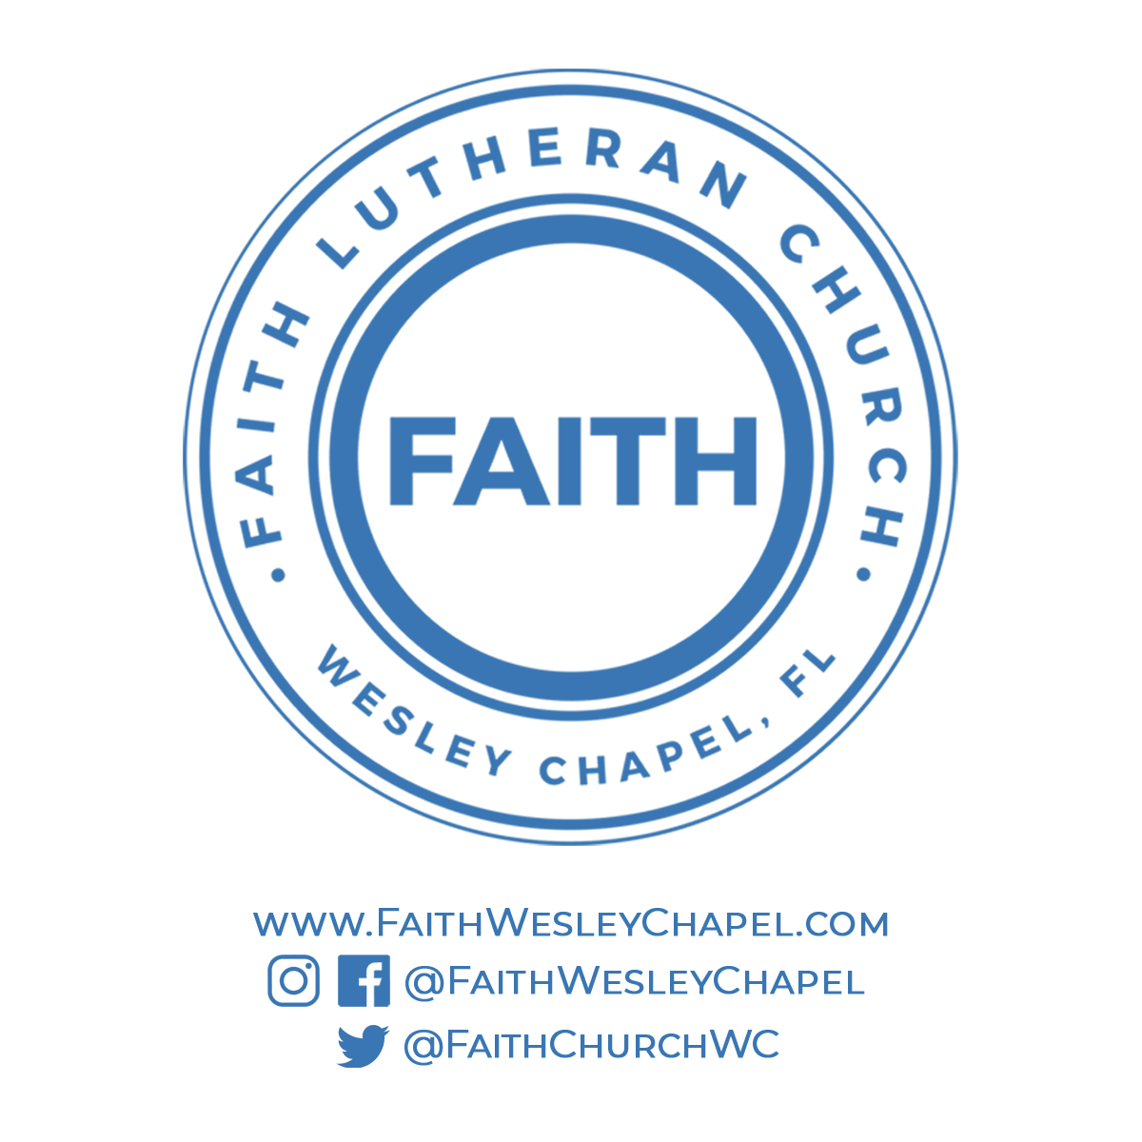**@FaithWesleyChapel**

**@FaithWesleyChapel**

**@FaithChurchWC**