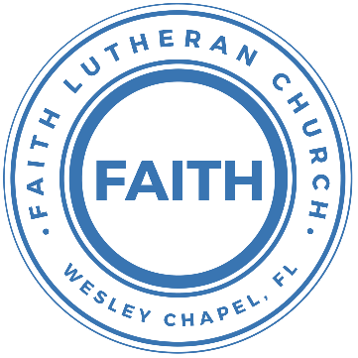

**Leading our community into a deep connection in Christ**

**Worship Service for May 11, 2025 at 11 AM**

**Welcome**

**Pray for the Food** - **People get food**

**Invocation** *(stand)*

**Confession and Forgiveness:** *(stand)*

**P:** As we gather, today, let us cleanse our hearts and our consciences by confessing our sin to God.

*(Time of silence for reflection and confession)*

**C:** Heavenly Father, we confess that we are sinful and unclean. We have sinned against you and against our neighbor in our thoughts, words, and actions.  We are truly sorry for our sins and sincerely repent of them. We ask for Your mercy. For the sake of Jesus Christ's bitter suffering and death, please forgive us and renew us that we may walk in Your Spirit to the glory of Your holy name. Amen

**P:** The Lord has heard your confession. Therefore, as a called and ordained servant of the Lord, in the stead and by the command of my Lord, Jesus Christ, I forgive you all your sins in the name of the Father and of the Son and of the Holy Spirit.  
**C:** Amen

**Songs of Praise and Thanksgiving –** How Deep The Father’s Love For Us

How deep the Father's love for us, how vast beyond all measure.

That He should give His only Son, to make a wretch His treasure.

How great the pain of searing loss, the Father turned His face away,

As wounds which mar the Chosen One, bring many sons to glory.

Behold the Man upon a cross, my sin upon His shoulders.

Ashamed, I hear my mocking voice call out among the scoffers.

It was my sin that held Him there until it was accomplished.

His dying breath has brought me life; I know that it is finished.

I will not boast in anything: no gifts, no power, no wisdom,

But I will boast in Jesus Christ; his death and resurrection.

Why should I gain from His reward? I cannot give an answer.

But this I know with all my heart: His wounds have paid my ransom.

But this I know with all my heart: His wounds have paid my ransom.

© 1995 Thankyou Music  
**Old Testament Reading:**Joshua 24:14-15

“Now therefore fear the Lord and serve him in sincerity and in faithfulness. Put away the gods that your fathers served beyond the River and in Egypt, and serve the Lord. And if it is evil in your eyes to serve the Lord, choose this day whom you will serve, whether the gods your fathers served in the region beyond the River, or the gods of the Amorites in whose land you dwell. But as for me and my house, we will serve the Lord.”

**Reader:** This is the Word of the Lord.  
**C:** Thanks be to God.

**Epistle Reading:** 1 Timothy 5:3-8

Honor widows who are truly widows. But if a widow has children or grandchildren, let them first learn to show godliness to their own household and to make some return to their parents, for this is pleasing in the sight of God. She who is truly a widow, left all alone, has set her hope on God and continues in supplications and prayers night and day, but she who is self-indulgent is dead even while she lives. Command these things as well, so that they may be without reproach. But if anyone does not provide for his relatives, and especially for members of his household, he has denied the faith and is worse than an unbeliever.

**Reader:** This is the Word of the Lord.  
**C:** Thanks be to God.

**Special Music – Praise (sung by Kelsey Torgrimson)**

**Gospel Reading** - Mark 10:13–16

People were bringing little children to Jesus for him to place his hands on them, but the disciples rebuked them. When Jesus saw this, he was indignant. He said to them, “Let the little children come to me, and do not hinder them, for the kingdom of God belongs to such as these. Truly I tell you, anyone who will not receive the kingdom of God like a little child will never enter it.” And he took the children in his arms, placed his hands on them and blessed them.

**P:** This is the Gospel of the Lord.  
**C:** Praise be to You, O Christ.

**Sermon Song –** They'll Know We Are Christians By Our Love

Verse 1:  
We are one in the Spirit, we are one in the Lord;  
We are one in the Spirit, we are one in the Lord;  
And we pray that all unity will one day be restored.

Chorus:  
And they'll know we are Christians by our love, by our love,  
yes, they'll know we are Christians by our love.

Verse 2:  
We will walk with each other, we will walk hand in hand;  
We will walk with each other, we will walk hand in hand;  
And together we'll spread the news that God is in our land.

*(Chorus)*

Verse 3:  
We Will work with each other, we will work side by side;  
We will work with each other, we will work side by side;  
And we'll guard each one's dignity and save each other's pride.

*(Chorus)* © 1966 F.E.L. Publications. Assigned 1991 Lorenz Publishing Company

**Sermon/Discussion** –   
Series: "They’ll Know We Are Christians by Our Love"  
This Week: “Love Your Family”

“A new commandment I give you, that you love one another: just as I have loved you, you also are to love one another. By this all people will know that you are my disciples, if you have love for one another.” John 13:34-35

**Prayers**

**Apostles' Creed** *(stand)*

I believe in God, the Father almighty, maker of heaven and earth,  
And in Jesus Christ, his only Son, our Lord,  
who was conceived by the Holy Spirit,  
born of the Virgin Mary, suffered under Pontius Pilate,  
was crucified, died and was buried. He descended into hell.  
The third day he rose again from the dead.  
He ascended into heaven and sits at the right hand of God  
the Father almighty.  
From there he will come to judge the living and the dead.  
I believe in the Holy Spirit, the holy Christian Church,  
the communion of saints, the forgiveness of sins,  
the resurrection of the body, and the life everlasting. Amen.

**The Lord's Prayer** *(stand)*

Our Father who art in heaven, hallowed be Thy name, Thy kingdom come, Thy will be done on earth as it is in heaven.  Give us this day our daily bread; and forgive us our trespasses as we forgive those who trespass against us; and lead us not into temptation, but deliver us from evil.  For Thine is the kingdom and the power and the glory forever and ever.  Amen

**Benediction** *– The online service ends. The closing hymn video is on the Livestream page bulletin at FaithWesleyChapel.com with lyrics below. See announcements below as well.*

**Closing Song:** Praise God From Whom All Blessings Flow *(stand)*

Praise God from Whom all blessings flow.  
Praise Him all creatures here below.  
Praise Him above, ye heavenly hosts.  
Praise Father, Son and Holy Ghost.  
Amen

|  |  |
| --- | --- |
| **Serving This Week** | |
|  | |
| **O.T. Reader:** Josh Strasheim | **Children’s Church Teacher:** |
| **Epistle Reader :** Vanessa Frost | Melissa Steinbrueck |
| **Acolyte:** Eli Steinbrueck | **Children’s Church Assistant:** |
| **Com. Asst:** Larry Chmiel | Kaylee Steinbrueck |
|  | |
| **Serving Next Week** | |
|  | |
| **O.T. Reader:** Ginger Torgrimson | **Children’s Church Teacher:** |
| **Epistle Reader:** Darlene Mueller | Halston & Ben |
| **Acolyte:** Kaylee Steinbrueck | **Children’s Church Assistant:** |
| **Com. Asst:** Larry Chmiel | N/A |

**Upcoming Events**

**May 11, After Service – Voter Meeting**  
Faith Lutheran Church

**May 13, 7 PM – Growth Group Bible Study**  
Davi’s Home

**May 15, 7 PM – Growth Group Bible Study** (In-Person and Online) Rich Steinbrueck’s Home

**www.FaithWesleyChapel.com**

**Faith YouTube**

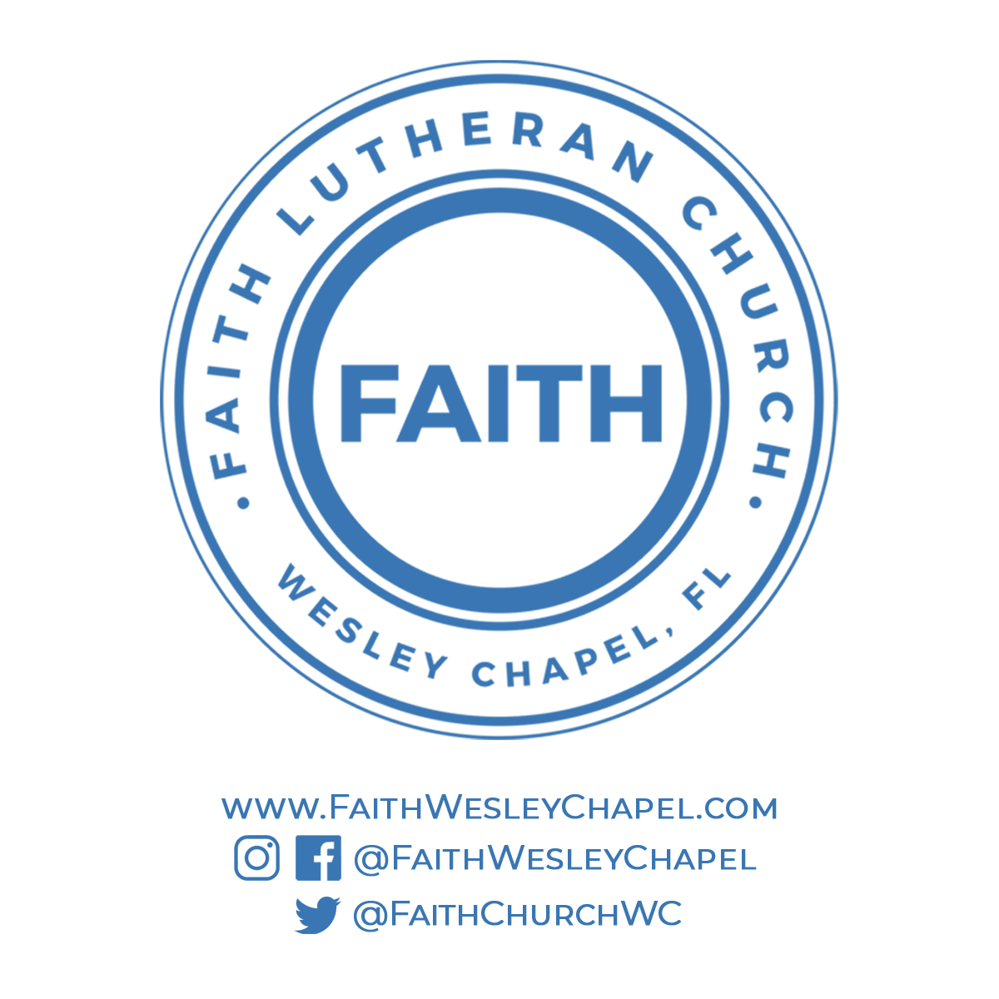**@FaithWesleyChapel**

**@FaithWesleyChapel**

**@FaithChurchWC**