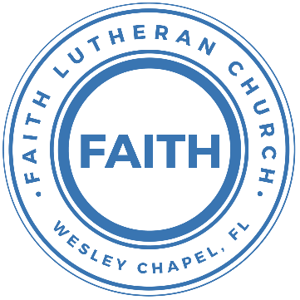

**Leading our community into a deep connection in Christ**

**Worship Service for May 18, 2025 at 11 AM**

**Welcome**

**Welcome Song –** Praise To The Lord The Almighty

Praise to the Lord the Almighty, the King of creation.

O my soul, praise Him for He is your health and salvation.

Let all who hear, now to His temple draw near,

Joining in glad adoration.

Praise to the Lord   
Who will prosper your work and defend you.

Surely His goodness and mercy shall daily attend you.

Ponder anew what the Almighty can do.

As with His love He befriends you.

Praise to the Lord! O let all that is in me adore Him.

All that has life and breath come now with praises before Him.

Let the “Amen” sound from His people again.  
Gladly forever adore Him. © Public Domain

**Invocation**

**Confession and Forgiveness:** *(stand)*

**P:** As we gather, today, let us cleanse our hearts and our consciences by confessing our sin to God.

*(Time of silence for reflection and confession)*

**C:** Heavenly Father, we confess that we are sinful and unclean. We have sinned against you and against our neighbor in our thoughts, words, and actions.  We are truly sorry for our sins and sincerely repent of them. We ask for Your mercy. For the sake of Jesus Christ's bitter suffering and death, please forgive us and renew us that we may walk in Your Spirit to the glory of Your holy name. Amen

**P:** The Lord has heard your confession. Therefore, as a called and ordained servant of the Lord, in the stead and by the command of my Lord, Jesus Christ, I forgive you all your sins in the name of the Father and of the Son and of the Holy Spirit.  
**C:** Amen

**Song of Praise and Thanksgiving:** What a Friend

Everybody has trials and temptations.  
Everybody knows heartbreak, isolation.

Pre-Chorus:  
But we can lay our burdens down. Lay our burdens down.

Chorus:  
What a friend we have in Jesus. East to west my sins are gone.  
I see grace on every horizon.  
And forever and ever His heart is my home.

Everybody has fears, everybody got worries.  
Everybody knows sorrow, devastation.

*(Pre-Chorus)  
(Chorus)*

Bridge:  
No more betrayal, for He is faithful.  
He fills me up and my cup runneth over.  
No more betrayal, for He is faithful.  
How He has proven it over and over.  
(Repeat)

*(Chorus 2x)*

And forever and ever His heart is my home. © All Essential Music

**First Reading** - Galatians 6:1-10

Brothers, if anyone is caught in any transgression, you who are spiritual should restore him in a spirit of gentleness. Keep watch on yourself, lest you too be tempted. Bear one another's burdens, and so fulfill the law of Christ. For if anyone thinks he is something, when he is nothing, he deceives himself. But let each one test his own work, and then his reason to boast will be in himself alone and not in his neighbor. For each will have to bear his own load. Let the one who is taught the word share all good things with the one who teaches. Do not be deceived: God is not mocked, for whatever one sows, that will he also reap. For the one who sows to his own flesh will from the flesh reap corruption, but the one who sows to the Spirit will from the Spirit reap eternal life. And let us not grow weary of doing good, for in due season we will reap, if we do not give up. So then, as we have opportunity, let us do good to everyone, and especially to those who are of the household of faith.

**Reader:** This is the Word of the Lord.  
**C:** Thanks be to God.

**Second Reading** - Hebrews 10:24-25

And let us consider how we may spur one another on toward love and good deeds, not giving up meeting together, as some are in the habit of doing, but encouraging one another—and all the more as you see the Day approaching.

**Reader:** This is the Word of the Lord.  
**C:** Thanks be to God.

**Gospel Reading** - Matthew 25:31-46

When the Son of Man comes in his glory, and all the angels with him, then he will sit on his glorious throne. Before him will be gathered all the nations, and he will separate people one from another as a shepherd separates the sheep from the goats. And he will place the sheep on his right, but the goats on the left. Then the King will say to those on his right, ‘Come, you who are blessed by my Father, inherit the kingdom prepared for you from the foundation of the world. For I was hungry and you gave me food, I was thirsty and you gave me drink, I was a stranger and you welcomed me, I was naked and you clothed me, I was sick and you visited me, I was in prison and you came to me.’ Then the righteous will answer him, saying, ‘Lord, when did we see you hungry and feed you, or thirsty and give you drink? And when did we see you a stranger and welcome you, or naked and clothe you? And when did we see you sick or in prison and visit you?’ And the King will answer them, ‘Truly, I say to you, as you did it to one of the least of these my brothers, you did it to me.’

**P:** This is the Gospel of the Lord.  
**C:** Praise be to You, O Christ.

**Children's Message** *(Children dismissed to Children's Church)*

**Sermon Hymn***–*They'll Know We Are Christians By Our Love

Verse 1:  
We are one in the Spirit, we are one in the Lord;  
We are one in the Spirit, we are one in the Lord;  
And we pray that all unity will one day be restored.

Chorus:  
And they'll know we are Christians by our love, by our love,  
yes, they'll know we are Christians by our love.

Verse 2:  
We will walk with each other, we will walk hand in hand;  
We will walk with each other, we will walk hand in hand;  
And together we'll spread the news that God is in our land.

*(Chorus)*

Verse 3:  
We Will work with each other, we will work side by side;  
We will work with each other, we will work side by side;  
And we'll guard each one's dignity and save each other's pride.

*(Chorus)* © 1966 F.E.L. Publications. Assigned 1991 Lorenz Publishing Company

**Sermon** – Series: “They’ll Know We Are Christians By Our Love”  
 This Week: “Love The Church”

“A new commandment I give you, that you love one another: just as I have loved you, you also are to love one another. By this all people will know that you are my disciples, if you have love for one another.” John 13:34-35

**Prayers:** *Text in prayer requests to (813) 326-5255*

**Nicene Creed** *(stand)*

I believe in one God, the Father Almighty, maker of heaven and earth and of all things visible and invisible.

And in one Lord Jesus Christ, the only-begotten Son of God, begotten of His Father before all worlds, God of God, Light of Light, very God of very God, begotten, not made, being of one substance with the Father, by whom all things were made; who for us men and for our salvation came down from heaven and was incarnate by the Holy Spirit of the virgin Mary and was made man; and was crucified also for us under Pontius Pilate. He suffered and was buried. And the third day He rose again according to the Scriptures and ascended into heaven and sits at the right hand of the Father. And He will come again with glory to judge both the living and the dead, whose kingdom will have no end.

And I believe in the Holy Spirit, the Lord and Giver of Life, who proceeds from the Father and the Son, who with the Father and the Son together is worshiped and glorified, who spoke by the prophets. And I believe in one holy Christian and apostolic Church, I acknowledge one Baptism for the remission of sins, and I look for the resurrection of the dead and the life of the world to come. Amen.

**The Lord's Prayer** *(stand)*

Our Father who art in heaven, hallowed be Thy name, Thy kingdom come, Thy will be done on earth as it is in heaven.  Give us this day our daily bread; and forgive us our trespasses as we forgive those who trespass against us; and lead us not into temptation, but deliver us from evil.  For Thine is the kingdom and the power and the glory forever and ever.  Amen

**Benediction** *– The online service ends. The closing hymn video is on the Livestream page bulletin at FaithWesleyChapel.com with lyrics below. See announcements below as well.*

**Closing Song:** I Will Follow

Where You go, I’ll go. Where You stay, I’ll stay.

When You move, I’ll move. I will follow...

All Your ways are good. All Your ways are sure.

I will trust in You alone.

Higher than my sight, high above my life, I will trust in You alone.

Chorus:

Where You go, I’ll go. Where You stay, I’ll stay.

When You move, I’ll move. I will follow You.

Who You love, I'll love. How You serve I'll serve.

If this life I lose, I will follow You, Yeah. I will follow You.

Light unto the world, light unto my life, I will live for You alone.

You're the one I seek knowing I will find,

All I need in You alone, in You alone.

*(Chorus)*

Bridge:

In You there's life everlasting. In You there's freedom for my soul.

In You there's joy, unending joy, and I will follow.

*(Chorus 2x)* *© 2010 SHOUT! Publishing, Vamos Publishing, and So Essential Tunes*

|  |  |
| --- | --- |
| **Serving This Week** | |
|  | |
| **O.T. Reader:** Ginger Torgrimson | **Children’s Church Teacher:** |
| **Epistle Reader:** Darlene Mueller | Halston & Ben |
| **Acolyte:** Kaylee Steinbrueck | **Children’s Church Assistant:** |
| **Com. Asst:** Larry Chmiel | N/A |
|  | |
| **Serving Next Week** | |
|  | |
| **O.T. Reader:** Larry Chmiel | **Children’s Church Teacher:** |
| **Epistle Reader:** Ginger Dunn | Melissa Steinbrueck |
| **Acolyte:** Thomas Horness | **Children’s Church Assistant:** |
| **Com. Asst:** Larry Chmiel | Kelsey Torgrimosn |

**Upcoming Events**

**May 22, 7 PM – Growth Group Bible Study** (Online)Rich Steinbrueck’s Home

**May 27, After Service – Growth Group Bible Study**  
Renee’s Home

**June 1, After the Service – Lunch & Bible Study with Pastor**Pastor Kurt’s Home

**www.FaithWesleyChapel.com**

**Faith YouTube**

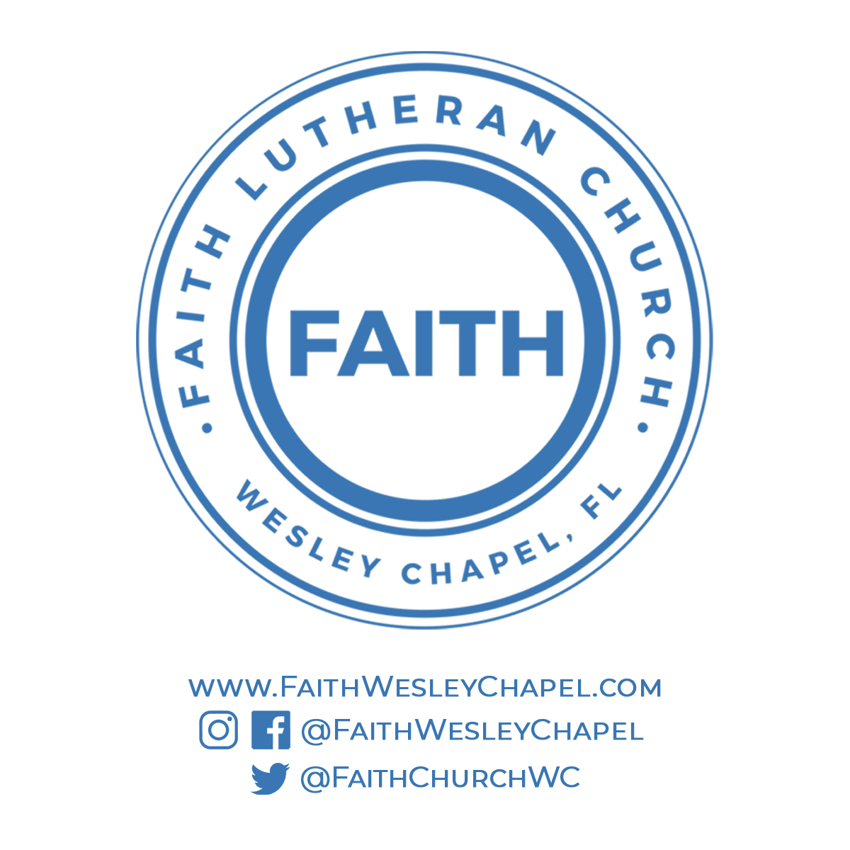**@FaithWesleyChapel**

**@FaithWesleyChapel**

**@FaithChurchWC**