

**Leading our community into a deep connection in Christ**

**___________________________________________________**

**Worship Service for May 25, 2025 at 11 AM**

**Welcome**

**Invocation**

**Song: The Steadfast Love**

The steadfast love of the Lord never ceases

His mercies never come to an end

They are new every morning, New every morning

Great is Thy faithfulness, O Lord. Great is Thy faithfulness

(repeat)

**Confession and Forgiveness:**

**P:** When God created mankind, He said mankind was very good. Then man rebelled against God and sin entered the world. Immediately after, God promised a savior to save His rebellious creation.  
**C:** Praise be to God whose mercies are new every day.

**P:** In the fullness of time, God sent His Son, born of a woman, born under the law, to redeem those under the law.  
**C:** Praise be to God whose mercies are new every day.

**P:** At His baptism, Jesus was numbered among us sinners that He might offer Himself as a sacrifice upon the cross for sinners.  
**C:** Praise be to God whose mercies are new every day.

**P:** Through Jesus Christ, God bids us come to Him and confess our sins, promising to forgive our sins and purify us.  
**C:** Praise be to God whose mercies are new every day. Let us confess our sins and seek God's mercy.

(a time of silence to reflect and personally confess our sins)

**C:** Heavenly Father, we confess that we have sinned against you in thought, word, and deed. We have not loved you with our whole heart and have not loved our neighbor as ourselves. We are truly sorry and we humbly repent. For the sake of your Son Jesus Christ and His suffering and death on the cross, have mercy on us and forgive us; that we may delight in your will, and walk in your ways, to the glory of your Name. Amen

**P:** The Lord our God is merciful and gracious, longsuffering, and abounding in goodness and truth, keeping mercy for thousands, forgiving iniquity and transgression and sin. Therefore, I announce unto you the grace of our Lord Jesus Christ. In His stead and by the command of my Lord Jesus Christ, I forgive you all your sins in the name of the Father and of the Son and of the Holy Spirit.  
**C:** Amen.Praise be to God whose mercies are new every day.

**The Steadfast Love**

The steadfast love of the Lord never ceases

His mercies never come to an end

They are new every morning, New every morning

Great is Thy faithfulness, O Lord. Great is Thy faithfulness

**Song of Praise and Thanksgiving -** This Is the Feast

Refrain:  
This is the feast of victory for our God. Alleluia, alleluia, alleluia.

Worthy is Christ, the Lamb who was slain,  
Whose blood set us free to be people of God.   
*(Refrain)*

Power, riches, wisdom, and strength,  
And honor, blessing, and glory are His. *(Refrain)*

Sing with all the people of God,  
And join in the hymn of all creation;

“Blessing, honor, glory, and might,  
Be to God and the Lamb forever. Amen.”   
*(Refrain)*

For the Lamb who was slain has begun his reign. Alleluia!  
*(Refrain)* © 2008 Sharon Dennis, Doris Au MacDonald, and Lutheran Book of Worship

**Old Testament Reading -** Ecclesiastes 4:9-12

Two are better than one, because they have a good reward for their toil. For if they fall, one will lift up his fellow. But woe to him who is alone when he falls and has not another to lift him up! Again, if two lie together, they keep warm, but how can one keep warm alone? And though a man might prevail against one who is alone, two will withstand him—a threefold cord is not quickly broken.

**Reader:** This is the Word of the Lord.  
**C:** Thanks be to God.

**Epistle Reading -** Philippians 2:1-8

So if there is any encouragement in Christ, any comfort from love, any participation in the Spirit, any affection and sympathy, complete my joy by being of the same mind, having the same love, being in full accord and of one mind. Do nothing from selfish ambition or conceit, but in humility count others more significant than yourselves. Let each of you look not only to his own interests, but also to the interests of others. Have this mind among yourselves, which is yours in Christ Jesus, who, though he was in the form of God, did not count equality with God a thing to be grasped, but emptied himself, by taking the form of a servant, being born in the likeness of men. And being found in human form,

he humbled himself by becoming obedient to the point of death, even death on a cross.

**Reader:** This is the Word of the Lord.  
**C:** Thanks be to God.

**Gospel Reading -** Luke 10:25-37

And behold, a lawyer stood up to put him to the test, saying, “Teacher, what shall I do to inherit eternal life?” He said to him, “What is written in the Law? How do you read it?” And he answered, “You shall love the Lord your God with all your heart and with all your soul and with all your strength and with all your mind, and your neighbor as yourself.” And he said to him, “You have answered correctly; do this, and you will live.”

But he, desiring to justify himself, said to Jesus, “And who is my neighbor?” Jesus replied, “A man was going down from Jerusalem to Jericho, and he fell among robbers, who stripped him and beat him and departed, leaving him half dead. Now by chance a priest was going down that road, and when he saw him he passed by on the other side. So likewise a Levite, when he came to the place and saw him, passed by on the other side. But a Samaritan, as he journeyed, came to where he was, and when he saw him, he had compassion. He went to him and bound up his wounds, pouring on oil and wine. Then he set him on his own animal and brought him to an inn and took care of him. And the next day he took out two denarii and gave them to the innkeeper, saying, ‘Take care of him, and whatever more you spend, I will repay you when I come back.’ Which of these three, do you think, proved to be a neighbor to the man who fell among the robbers?” He said, “The one who showed him mercy.” And Jesus said to him, “You go, and do likewise.”

**P:** This is the Gospel of the Lord.  
**C:** Praise be to You, o Christ.

**Children's Message**

**Sermon Hymn -** They'll Know We Are Christians By Our Love

Verse 1:  
We are one in the Spirit, we are one in the Lord;  
We are one in the Spirit, we are one in the Lord;  
And we pray that all unity will one day be restored.

Chorus:  
And they'll know we are Christians by our love, by our love,  
yes, they'll know we are Christians by our love.

Verse 2:  
We will walk with each other, we will walk hand in hand;  
We will walk with each other, we will walk hand in hand;  
And together we'll spread the news that God is in our land.

*(Chorus)*

Verse 3:  
We Will work with each other, we will work side by side;  
We will work with each other, we will work side by side;  
And we'll guard each one's dignity and save each other's pride.

*(Chorus)* © 1966 F.E.L. Publications. Assigned 1991 Lorenz Publishing Company

**Sermon** – Series: “They’ll Know We Are Christians By Our Love”  
 This Week: “Love Thy Neighbor”

“A new commandment I give you, that you love one another: just as I have loved you, you also are to love one another. By this all people will know that you are my disciples, if you have love for one another.” John 13:34-35

**Prayers:** *Text in prayer requests to (813) 326-5255‬*

**Apostles' Creed** *(stand)*

I believe in God, the Father almighty, maker of heaven and earth,  
And in Jesus Christ, his only Son, our Lord,  
who was conceived by the Holy Spirit,  
born of the Virgin Mary, suffered under Pontius Pilate,  
was crucified, died and was buried. He descended into hell.  
The third day he rose again from the dead.  
He ascended into heaven and sits at the right hand of God  
the Father almighty.  
From there he will come to judge the living and the dead.  
I believe in the Holy Spirit, the holy Christian Church,  
the communion of saints, the forgiveness of sins,  
the resurrection of the body, and the life everlasting. Amen.

**The Lord's Prayer** *(stand)*

Our Father who art in heaven, hallowed be Thy name, Thy kingdom come, Thy will be done on earth as it is in heaven.  Give us this day our daily bread; and forgive us our trespasses as we forgive those who trespass against us; and lead us not into temptation, but deliver us from evil.  For Thine is the kingdom and the power and the glory forever and ever.  Amen

**Benediction** *– The online service ends. The closing hymn video is on the Livestream page bulletin at FaithWesleyChapel.com with lyrics below. See announcements below as well.*

**Closing Song -**We Are

Every secret, every shame, every fear, every pain,

Live inside the dark, but that’s not who we are.

We are children of the day.

Pre-Chorus:  
So wake up sleeper, lift your head.   
We were meant for more than this  
Fight the shadows conquer death.   
Make the most of the time we have left

Chorus:  
We are the light of the world. We are the city on a hill  
We are the light of the world  
We gotta, we gotta, we gotta let the light shine

*(Repeat)*  
Let the light shine, let the light shine

We are called to the spread the news.  
Tell the world the simple truth.  
Jesus came to save. There’s freedom in His Name.  
So let it all break through

*(Chorus)*

Bridge:  
We are the light we are the light we are the light  
So let your light shine brighter  
We the light we are the light we are the light... Jesus  
You are the light you are the light you are the light.  
We will lift you high and Shine, shine, shine

*(Chorus)* © 2011 Alletrop Music, Centricity Music Publishing

*Is the Bible still reliable in a skeptical world? Next Sunday, discover how God’s Spirit still speaks through His Word today and how different groups treat the Bible.* - “Confessing Christ: What Lutherans Believe and Why” Message and Bible study Series

|  |  |
| --- | --- |
| **Serving This Week** | |
|  | |
| **Gospel Reader:** Larry Chmeil | **Children’s Church Teacher:** |
| **Epistle Reader:** Ginger Dunn | Melissa Steinbrueck |
| **Acolyte:** Thomas Horness | **Children’s Church Assistant:** |
| **Com. Asst:** Larry Chmiel | Kelsey Trogrimson |
|  | |
| **Serving Next Week** | |
|  | |
| **1st Reader:** Kaylee Steinbrueck | **Children’s Church Teacher:** |
| **2nd Reader:** Thomas Horness | N/A – No Children’s Church |
| **Acolyte:** Lawrence Finnerty | **Children’s Church Assistant:** |
| **Com. Asst:** Larry Chmiel | N/A – No Children’s Church |

**Upcoming Events**

**May 27, 7 PM – Growth Group Bible Study**  
Renee’s Home

**May 29, 7 PM – Growth Group Bible Study**(Zoom)Rich Steinbrueck’s

**June 1, After the Service – Lunch & Bible Study with Pastor**Pastor Kurt’s Home

**June 14, 10am-Noon – Snow Cones and Treats at the Park Outreach Event**Wesley Chapel District Park

[**www.FaithWesleyChapel.com**](http://www.FaithWesleyChapel.com)

 **Faith YouTube**

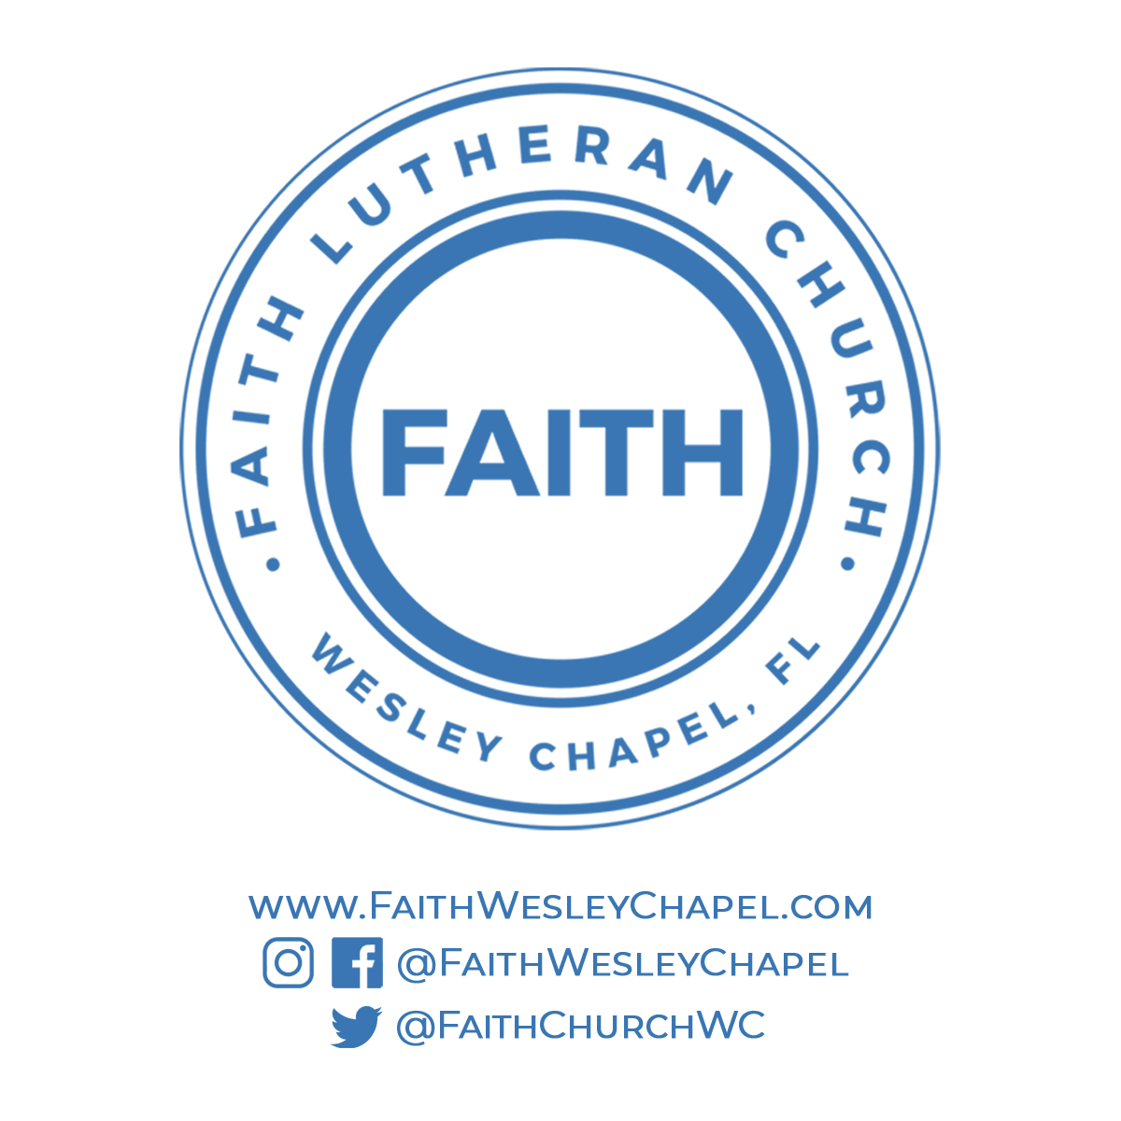**@FaithWesleyChapel**

**@FaithWesleyChapel**

**@FaithChurchWC**