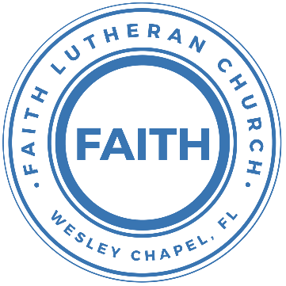

**Leading our community into a deep connection in Christ**

**Worship Service for June 1, 2025 at 11 AM**

**Welcome**

**Opening Song:**This Little Light of Mine

This little light of mine, I'm gonna let it shine.  
This little light of mine, I'm gonna let it shine.  
This little light of mine, I'm gonna let it shine,  
Let it shine, let it shine, let it shine.

Hide it under a bushel, NO!, I'm gonna let it shine.  
Hide it under a bushel, NO!, I'm gonna let it shine.  
Hide it under a bushel, NO!, I'm gonna let it shine,  
Let it shine, let it shine, let it shine.

Won't let Satan blow it out, I'm gonna let it shine.  
Won't let Satan blow it out, I'm gonna let it shine.  
Won't let Satan blow it out, I'm gonna let it shine,  
Let it shine, let it shine, let it shine.

Let it shine 'til Jesus comes, I'm gonna let it shine.  
Let it shine 'til Jesus comes, I'm gonna let it shine.  
Let it shine 'til Jesus comes, I'm gonna let it shine,  
Let it shine, let it shine, let it shine. © Public Domain

**Invocation**

**Confession and Forgiveness:**

**P:** We have come here today to worship the Lord.  In worship we hear the Word of God, we receive God's blessings, and respond with thanks and praise.  We begin by seeking God's blessing of forgiveness.  He has promised to remove the guilt and shame of our sin through the sacrifice of Jesus Christ on the cross.

*(a time of silence to reflect and personally confess our sins)*

**P:** Let us confess our sins to the Lord.

**P:** Heavenly Father,  
**C:** Heavenly Father,

**P:** I have done things that were wrong.  
**C:** I have done things that were wrong.  
  
**P:** I have been mean to others.  
**C:** I have been mean to others.

**P:** I have not obeyed my parents.  
**C:** I have not obeyed my parents.

**P:** I have not obeyed You, God.  
**C:** I have not obeyed You, God.

**P:** But I am very sorry.  
**C:** But I am very sorry.

**P:** Please forgive me.  
**C:** Please forgive me.

**P:** I love You very much.  
**C:** I love You very much.

**P:** And I know You love me, too.  
**C:** And I know You love me, too.

**P:** Amen.  
**C:** Amen.

**P:** God has heard your apology.  He loves you very much.  God has told us that when we believe and trust in Him, He makes us His children.  As far as the east is from the west, so far does he remove our sins from us. He has told me to tell you that you are forgiven.  So, as His servant, I forgive you in the name of the Father and of the Son and of the Holy Spirit.   
**C:** Amen.

**Song:**God Is So Good

God is so good. God is so good.  
God is so good. He's so good to me.

He died for me. He died for me so.  
He died for me. He's so good to me.

He loves me so. He loves me so.  
He loves me so. He's so good to me. © Public Domain

**First Reading -**2 Timothy 3:14-16

But you must continue to believe the things that you have learned. You know that those things are true. You know the teachers who taught you those things. Even when you were a child, you already knew the message of the Bible. The Bible has taught you how you can be truly wise. You understand that God saves you because you believe in Christ Jesus. Everything that is written in the Bible comes from God's Spirit. It helps us in many ways. The Bible teaches us what is true. It warns us when we are doing wrong things. It shows us what is right. It teaches us how to live good lives.

**Reader:** This is the Word of the Lord.  
**C:** Thanks be to God.

**Children's Message**"Learning the Bible"

**Song:**Every Move I Make

Verse:  
Every move I make, I make in You.  
You make me move, Jesus.  
Every breath I take, I breathe in You.

Every step I take, I take in You.  
You are my way, Jesus.  
Every breath I take, I breathe in You.

Chorus:  
Waves of mercy, Waves of grace,  
Everywhere I look, I see Your face.  
Your love has captured me.  
Oh my God, this love, how can it be?

Bridge:  
Na Na Na...  
*(Repeat)*

*(Verse)*

*(Chorus)*

*(Bridge (2x)* © 1996 Mercy/Vineyard Publishing, Vineyard Songs Canada, and ION Publishing

**Second Reading -**Acts 17:11–12

The Jewish people in Berea were better than the people in Thessalonica. They were happy to listen carefully to Paul. Every day they also studied the Bible. They wanted to know if Paul's message was true. Many of the Jewish people in Berea believed the good news about Jesus. Many Greek men and some important Greek women also believed in Jesus.

**Reader:** This is the Word of the Lord.  
**C:** Thanks be to God.

**Children's Message**"Testing Against the Bible"

**Gospel Reading –**John 15:26-16:4a

“But when the Helper comes, whom I will send to you from the Father, the Spirit of truth, who proceeds from the Father, he will bear witness about me. And you also will bear witness, because you have been with me from the beginning.

“I have said all these things to you to keep you from falling away. They will put you out of the synagogues. Indeed, the hour is coming when whoever kills you will think he is offering service to God. And they will do these things because they have not known the Father, nor me. But I have said these things to you, that when their hour comes you may remember that I told them to you.

**P:** This is the Gospel of the Lord.  
**C:** Praise be to You, O Christ.

**Song:** We Believe

In this time of desperation, when all we know is doubt and fear, There is only One foundation. We believe. We believe.  
In this broken generation, when all is dark, You help us see.  
There is only One salvation. We believe. We believe

Chorus:  
We believe in God the Father. We believe in Jesus Christ.  
We believe in the Holy Spirit, and He's given us new life.  
We believe in the crucifixion.   
We believe that He conquered death.  
We believe in the resurrection,   
And He's comin' back again we believe

So, let our faith be more than anthems,  
Greater than the songs we sing.  
And in our weakness and temptations,   
We believe! We believe!

*(Chorus)*

Let the lost be found and the dead be raised!  
In the here and now, let love invade!  
Let the church live loud, in our God will say   
We believe! We believe!

And the gates of hell will not prevail!  
For the power of God has torn the veil!  
Now we know Your love will never fail!   
We believe! We believe!

*(Chorus)*   
© Abundant Life Ministries UK, Integrity worship Music, Integrity’s Praise! Music, and Travis Ryan Music

**Sermon – “**Confessing Christ: What Lutherans Believe and Why”  
This Week: “God Still Speaks: Trusting the Bible in a Noisy World”

**Prayers:** *Text in prayer requests to (813) 326-5255*

**The Lord's Prayer**

Our Father who art in heaven, hallowed be Thy name, Thy kingdom come, Thy will be done on earth as it is in heaven.  Give us this day our daily bread; and forgive us our trespasses as we forgive those who trespass against us; and lead us not into temptation, but deliver us from evil.  For Thine is the kingdom and the power and the glory forever and ever.  Amen

**Benediction** *– The online service ends. The closing hymn video is on the Livestream page bulletin at FaithWesleyChapel.com with lyrics below. See announcements below as well.*

**Closing Song:**Sure Foundation

Chorus  
Jesus you're my firm foundation  
I know I can stand secure  
Jesus you're my firm foundation  
I put my hope in your Holy Word  
I put my hope in your Holy Word

Verse 1  
I have a living hope (echo)  
I have a future (echo)  
God has a plan for me (echo)  
Of this I'm sure, of this I'm sure.

*(Chorus)*

Verse 2  
Your Word is faithful (echo)  
Mighty in power (echo)  
God has delivered me (echo)  
Of this I'm sure, Of this I'm sure

*(Chorus)*  © Public Domain

Pentecost reminds us the Holy Spirit isn’t about noise or power—but about bringing sinners to faith in Jesus. - Join us next week for “Confessing Christ: What Lutherans Believe and Why” Message and Bible study Series

|  |  |
| --- | --- |
| **Serving This Week** | |
|  | |
| **1st Reader:** Kaylee Steinbrueck | **Children’s Church Teacher:** |
| **2nd Reader:** Thomas Horness | Melissa Steinbrueck |
| **Acolyte:** Lawrence Finnerty | **Children’s Church Assistant:** |
| **Com. Asst:** Larry Chmiel | Kelsey Trogrimson |
|  | |
| **Serving Next Week** | |
|  | |
| **O.T. Reader:** Richard Steinbrueck | **Children’s Church Teacher:** |
| **Epistle Reader:** Darlene Mueller | N/A – No Children’s Church |
| **Acolyte:** Kaylee Steinbrueck | **Children’s Church Assistant:** |
| **Com. Asst:** Larry Chmiel | N/A – No Children’s Church |

**Upcoming Events**

**Today, After the Service – Lunch & Bible Study with Pastor**Pastor Kurt’s Home

**June 5, 7 PM – Growth Group Bible Study** (Online)Rich Steinbrueck’s Home

**June 8, After the Service – Snacks & Bible Study with Pastor**Pastor Kurt’s Home

**June 14, 10am-Noon – Snow Cones and Treats at the Park Outreach Event**Wesley Chapel District Park

**www.FaithWesleyChapel.com**

**Faith YouTube**

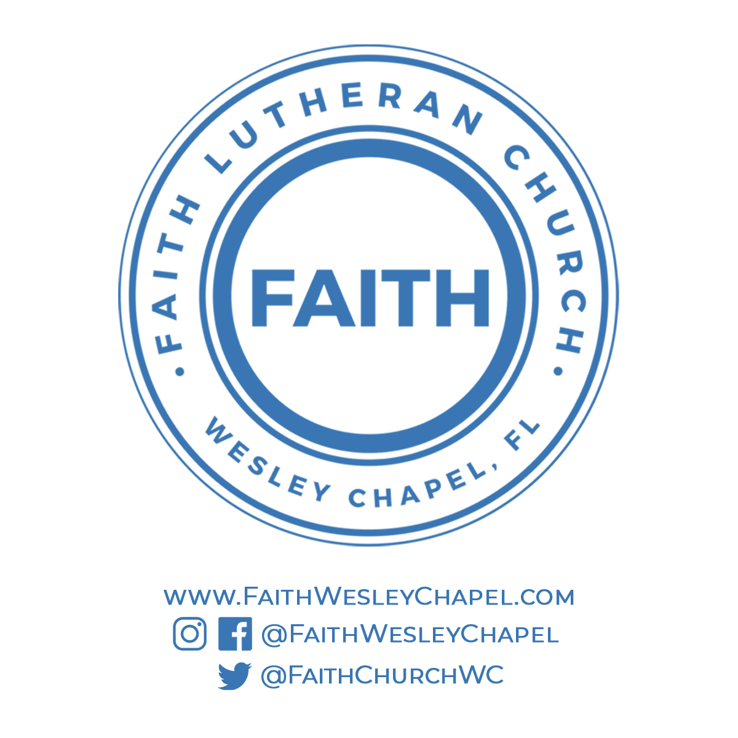**@FaithWesleyChapel**

**@FaithWesleyChapel**

**@FaithChurchWC**