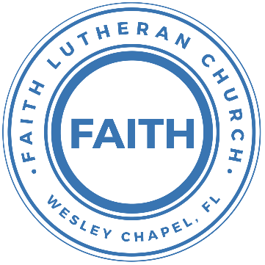

**Leading our community into a deep connection in Christ**

**___________________________________________________**

**Worship Service for June 15, 2025 at 11 AM**

**Welcome**

**Opening Song –** King Of Kings

In the darkness we were waiting, without hope, without light,

Till from heaven You came running. There was mercy in Your eyes.

To fulfil the law and prophets, to a virgin came the Word;

From a throne of endless glory to a cradle in the dirt.

Chorus:  
Praise the Father, Praise the Son, Praise the Spirit, Three in One!  
God of glory, Majesty. Praise forever to the King of Kings!

To reveal the kingdom coming and to reconcile the lost,

To redeem the whole creation, You did not despise the cross.

For even in your suffering You saw to the other side.

Knowing this was our salvation, Jesus, for our sake, You died

*(Chorus)*

And the morning that You rose all of heaven held its breath,

Till that stone was moved for good; for the Lamb had conquered death.

And the dead rose from their tombs. And the angels stood in awe, For the souls of all who'd come to the Father are restored.

And the church of Christ was born. Then, the Spirit lit the flame.

Now this Gospel truth of old shall not kneel, shall not faint.

By His blood and in His name, in His freedom, I am free;

For the love of Jesus Christ who has resurrected me.

Chorus:  
Praise the Father, Praise the Son, Praise the Spirit, Three in One!  
God of glory, Majesty. Praise forever to the King of Kings!  
(Repeat) © 2018 Hillsong Music Publishing

**Invocation**

**Confession and Forgiveness:** *(stand)*

**P:** As we gather, today, let us cleanse our hearts and our consciences by confessing our sin to God.

*(Time of silence for reflection and confession)*

**C:** Heavenly Father, we confess that we are sinful and unclean. We have sinned against you and against our neighbor in our thoughts, words, and actions.  We are truly sorry for our sins and sincerely repent of them. We ask for Your mercy. For the sake of Jesus Christ's bitter suffering and death, please forgive us and renew us that we may walk in Your Spirit to the glory of Your holy name. Amen

**P:** The Lord has heard your confession. Therefore, as a called and ordained servant of the Lord, in the stead and by the command of my Lord, Jesus Christ, I forgive you all your sins in the name of the Father and of the Son and of the Holy Spirit.  
**C:** Amen

**Song of Praise and Thanksgiving:** Glory be to God the Father

Glory be to God the Father, glory be to God the Son,  
Glory be to God the Spirit: great Jehovah, Three in One!  
Glory, glory while eternal ages run!

Glory be to him who loved us, washed us from each spot and stain;  
Glory be to him who bought us, made us kings with him to reign!  
Glory, glory to the Lamb that once was slain!

Glory to the King of angels, glory to the Church’s King,  
Glory to the King of nations; heav'n and earth your praises bring!  
Glory, glory, to the King of glory sing!

Glory, blessing, praise eternal! Thus, the choir of angels sings;  
Honor, riches, pow'r, dominion! Thus, its praise creation brings.  
Glory, glory, glory to the King of kings! © Public Domain

**Old Testament Reading** - Isaiah 6:1–7

In the year that King Uzziah died I saw the Lord sitting upon a throne, high and lifted up; and the train of his robe filled the temple. Above him stood the seraphim. Each had six wings: with two he covered his face, and with two he covered his feet, and with two he flew. And one called to another and said:

“Holy, holy, holy is the Lord of hosts;  
the whole earth is full of his glory!”

And the foundations of the thresholds shook at the voice of him who called, and the house was filled with smoke. And I said: “Woe is me! For I am lost; for I am a man of unclean lips, and I dwell in the midst of a people of unclean lips; for my eyes have seen the King, the Lord of hosts!”

Then one of the seraphim flew to me, having in his hand a burning coal that he had taken with tongs from the altar. And he touched my mouth and said: “Behold, this has touched your lips; your guilt is taken away, and your sin atoned for.”

**Reader:** This is the Word of the Lord.  
**C:** Thanks be to God.

**Epistle Reading** - Romans 11:33-36

Oh, the depth of the riches and wisdom and knowledge of God! How unsearchable are his judgments and how inscrutable his ways!

“For who has known the mind of the Lord,  
 or who has been his counselor?”  
“Or who has given a gift to him  
 that he might be repaid?”

For from him and through him and to him are all things. To him be glory forever. Amen.

**Reader:** This is the Word of the Lord.  
**C:** Thanks be to God.

**Gospel Reading** - John 3:1-17

Now there was a man of the Pharisees named Nicodemus, a ruler of the Jews. This man came to Jesus by night and said to him, “Rabbi, we know that you are a teacher come from God, for no one can do these signs that you do unless God is with him.” Jesus answered him, “Truly, truly, I say to you, unless one is born again he cannot see the kingdom of God.” Nicodemus said to him, “How can a man be born when he is old? Can he enter a second time into his mother's womb and be born?” Jesus answered, “Truly, truly, I say to you, unless one is born of water and the Spirit, he cannot enter the kingdom of God. That which is born of the flesh is flesh, and that which is born of the Spirit is spirit. Do not marvel that I said to you, ‘You must be born again.’ The wind blows where it wishes, and you hear its sound, but you do not know where it comes from or where it goes. So it is with everyone who is born of the Spirit.”

Nicodemus said to him, “How can these things be?” Jesus answered him, “Are you the teacher of Israel and yet you do not understand these things? Truly, truly, I say to you, we speak of what we know, and bear witness to what we have seen, but you do not receive our testimony. If I have told you earthly things and you do not believe, how can you believe if I tell you heavenly things? No one has ascended into heaven except he who descended from heaven, the Son of Man. And as Moses lifted up the serpent in the wilderness, so must the Son of Man be lifted up, that whoever believes in him may have eternal life.

“For God so loved the world, that he gave his only Son, that whoever believes in him should not perish but have eternal life. For God did not send his Son into the world to condemn the world, but in order that the world might be saved through him.

**P:** This is the Gospel of the Lord.  
**C:** Praise be to You, O Christ.

**Children's Message** *(Children dismissed to Children's Church)*

**Sermon Hymn***–*Holy, Holy, Holy

Holy, holy, holy, Lord God almighty:  
Early in the morning our song shall rise to Thee.  
Holy, holy, holy, merciful and mighty,  
God in three persons blessed Trinity.

Holy, holy, holy, all the saints adore Thee,  
Casting down their golden crowns around the glassy sea.  
Cherubim and Seraphim falling down before Thee,  
Which wert and art and evermore shall be.

Holy, holy, holy, though the darkness hide Thee,  
Though the eye of sinful man Thy glory may not see,  
Only Thou art holy there is none beside Thee,  
Perfect in pow’r, in love, and purity.

Holy, holy, holy, Lord God almighty!  
All Thy works shall praise Thy name in earth and sky and sea.  
Holy, holy, holy, merciful and mighty,  
God in three persons blessed Trinity.  
God in three persons blessed Trinity. © Public Domain

**Sermon** - " Holy, Holy, Holy: The Mystery of the Trinity"

**Prayers:** *Text in prayer requests to (813) 326-5255*

**Athanasian Creed** *(stand)*

**P:** Whoever desires to be saved must, above all, hold the catholic faith.  
**C:** Whoever does not keep it whole and undefiled will without doubt perish eternally.

**P:** And the catholic faith is this,  
**C:** That we worship one God in Trinity and Trinity in Unity, neither confusing the persons nor dividing the substance.

**P:** For the Father is one person, the Son is another, and the Holy Spirit is another.  
**C:** But the Godhead of the Father and of the Son and of the Holy Spirit is one: the glory equal, the majesty coeternal.

**P:** Such as the Father is, such is the Son, and such is the Holy Spirit:  
**C:** The Father uncreated, the Son uncreated, the Holy Spirit uncreated;

**P:** The Father infinite, the Son infinite, the Holy Spirit infinite;  
**C:** The Father eternal, the Son eternal, the Holy Spirit eternal.

**P:** And yet there are not three Eternals, but one Eternal,  
**C:** Just as there are not three Uncreated or three Infinites, but one Uncreated and one Infinite.

**P:** In the same way, the Father is almighty, the Son almighty, the Holy Spirit almighty;  
**C:** And yet there are not three Almighties, but one Almighty.

**P:** So the Father is God, the Son is God, the Holy Spirit is God;  
**C:** And yet there arenot three Gods, but one God.

**P:** So the Father is Lord, the Son is Lord, the Holy Spirit is Lord;  
**C:** And yet there are not three Lords, but one Lord.

**P:** Just as we are compelled by the Christian truth to acknowledge each distinct person as God and Lord,  
**C:** So also are we prohibited by the catholic religion to say that there are three Gods or Lords.

**P:** The Father is not made nor created nor begotten by anyone.  
**Men:** The Son is neither made nor created, but begotten of the Father alone.  
**Women:** The Holy Spirit is of the Father and of the Son, neither made nor created nor begotten, but proceeding.

**P:** Thus, there is one Father, not three Fathers; one Son, not three Sons; one Holy Spirit, not three Holy Spirits.  
**Men:** And in this Trinity none is before after another; none is greater or less than another;  
**Women:** But the whole three persons are coeternal with each other and coequal, so that in all things, as has been stated above, the Trinity in Unity and Unity in Trinity is to be worshiped.

**All:** Therefore, whoever desires to be saved must think thus about the Trinity.

**P:** But it is also necessary for everlasting salvation that one faithfully believe the incarnation of our Lord Jesus Christ.  
**C:** Therefore, it is the right faith that we believe and confess that our Lord Jesus Christ, the Son of God, is at the same time both God and man.

**Men:** He is God, begotten from the substance of the Father before all ages;  
**Women:** And He is man, born from the substance of His mother in this age:

**All:** Perfect God and perfect man, composed of a rational soul and human flesh;

**P:** Equal to the Father with respect to His divinity, less than the Father with respect to His humanity.  
**Men:** Although He is God and man, He is not two, but one Christ:  
**Women:** One, however, not by the conversion of the divinity into flesh, but by the assumption of the humanity into God;

**All:** One altogether, not by confusion of substance, but by unity of person.

**P:** For as the rational soul and flesh is one man, so God and man is one Christ,  
**C:** Who suffered for our salvation, descended into hell, rose again the third day from the dead,

**P:** Ascended into heaven, and is seated at the right hand of the Father, God Almighty, from whence He will come to judge the living and the dead.  
**C:** At His coming all people will rise again with their bodies and give an account concerning their own deeds.

**P:** And those who have done good will enter into eternal life, and those who have done evil into eternal fire.  
**C:** This is the catholic faith; whoever does not believe it faithfully and firmly cannot be saved.  
 * Catholic means universal, Christian

**The Lord's Prayer** *(stand)*

Our Father who art in heaven, hallowed be Thy name, Thy kingdom come, Thy will be done on earth as it is in heaven.  Give us this day our daily bread; and forgive us our trespasses as we forgive those who trespass against us; and lead us not into temptation, but deliver us from evil.  For Thine is the kingdom and the power and the glory forever and ever.  Amen

**Offering** *(sit) Give online at:*

**Words of Institution** *(stand)*

**Peace** *(stand)*

**P:** The peace of the Lord be with you all.  
**C:** And also, with you.  
**P:** We greet each other in the peace of Christ.

**Distribution**

**Prayer** *(stand)*

**Benediction** *(stand)*

**Closing Song:**God So Loved

Come all you weary. Come all you thirsty.

Come to the well that never runs dry.

Drink of the Water. Come and thirst no more.

Come all you sinners. Come find His mercy.

Come to the table. He Will satisfy.

Taste of His goodness. Find what you’re looking for.

Chorus 1:

For God so loved the World that He gave us,

His one and only Son to save us.

Whoever believes in Him, will live forever.

Bring all your failures. Bring your addictions.

Come lay them down at the Foot of the cross.

Jesus is waiting there with open arms.

*(Chorus 1)*

Chorus 2:

The power of Hell forever defeated.

Now, it is well. I’m Walking in freedom.

For God so loved, God so loved the world.

Bridge:

Praise God! Praise God from whom all blessings flow.

Praise Him! Praise Him for the wonders of His love.

*(Repeat)*

His amazing love!

Chorus 1:

For God so loved the World that He gave us,

His one and only Son to save us.

Whoever believes in Him, will live forever.

Chorus 2:

The power of Hell forever defeated.

Now, it is well. I’m Walking in freedom.

For God so loved, God so loved the world.

Bring all your failures. Bring your addictions.

Come lay them down at the Foot of the cross.

Jesus is waiting there with open arms. © 2019 Andrew Bergthold Designee

**The Athanasian Creed**The Church’s Confession of the Holy Trinity

Early in the fourth century, a new teaching appeared which claimed that Jesus was not true God. Arius, the north African priest who first proposed this theory, was extremely persuasive, and soon the controversy was so widespread that a church council was called to settle the matter. Out of that meeting in A.D. 325 came the Nicene Creed, which clearly confesses Jesus to be true God. That creed, which was expanded in A.D. 381 in order to defend the divinity of the Holy Spirit, is still widely used today as a confession of the triune faith.

Despite the clarity of the Nicene Creed, the controversy continued for some time. Toward the end of the fifth century, another creed was written that marveled at the mystery of the Trinity in a way that no creed had ever done. Though attributed to Athanasius, a fourth-century opponent of Arius, this anonymous creed clearly came at a later stage in the debate.

The Athanasian Creed proclaims that its teachings concerning the Holy Trinity and our Lord’s incarnation are the catholic faith. In other words, this is what the true church of all times and all places has confessed. More than 15 centuries later, the church continues to confess this truth, confident that the triune God, Father, Son, and Holy Spirit, has given himself for our salvation.

|  |  |
| --- | --- |
| **Serving This Week** | |
|  | |
| **O.T. Reader:** Melissa Steinbrueck | **Children’s Church Teacher:** |
| **Epistle Reader:** Richard Steinbrueck | Melissa Steinbrueck |
| **Acolyte:** Eli Steinbrueck | **Children’s Church Assistant:** |
| **Com. Asst:** Richard Steinbrueck | N/A |
|  | |
| **Serving Next Week** | |
|  | |
| **O.T. Reader:** Josh Strasheim | **Children’s Church Teacher:** |
| **Epistle Reader:** Ginger Dunn | Halston and Ben |
| **Acolyte:** Eli Steinbrueck | **Children’s Church Assistant:** |
| **Com. Asst:** Larry Chmiel | N/A |

**Upcoming Events**

**June 17, 7 PM – Council Meeting**  
Pastor Kurt’s Home

**June 19, 7 PM – Growth Group Bible Study** (Online)Zoom

**June 22, After the Service – Lunch & Bible Study with Pastor**Pastor Kurt’s Home

[**www.FaithWesleyChapel.com**](http://www.FaithWesleyChapel.com)

 **Faith YouTube**

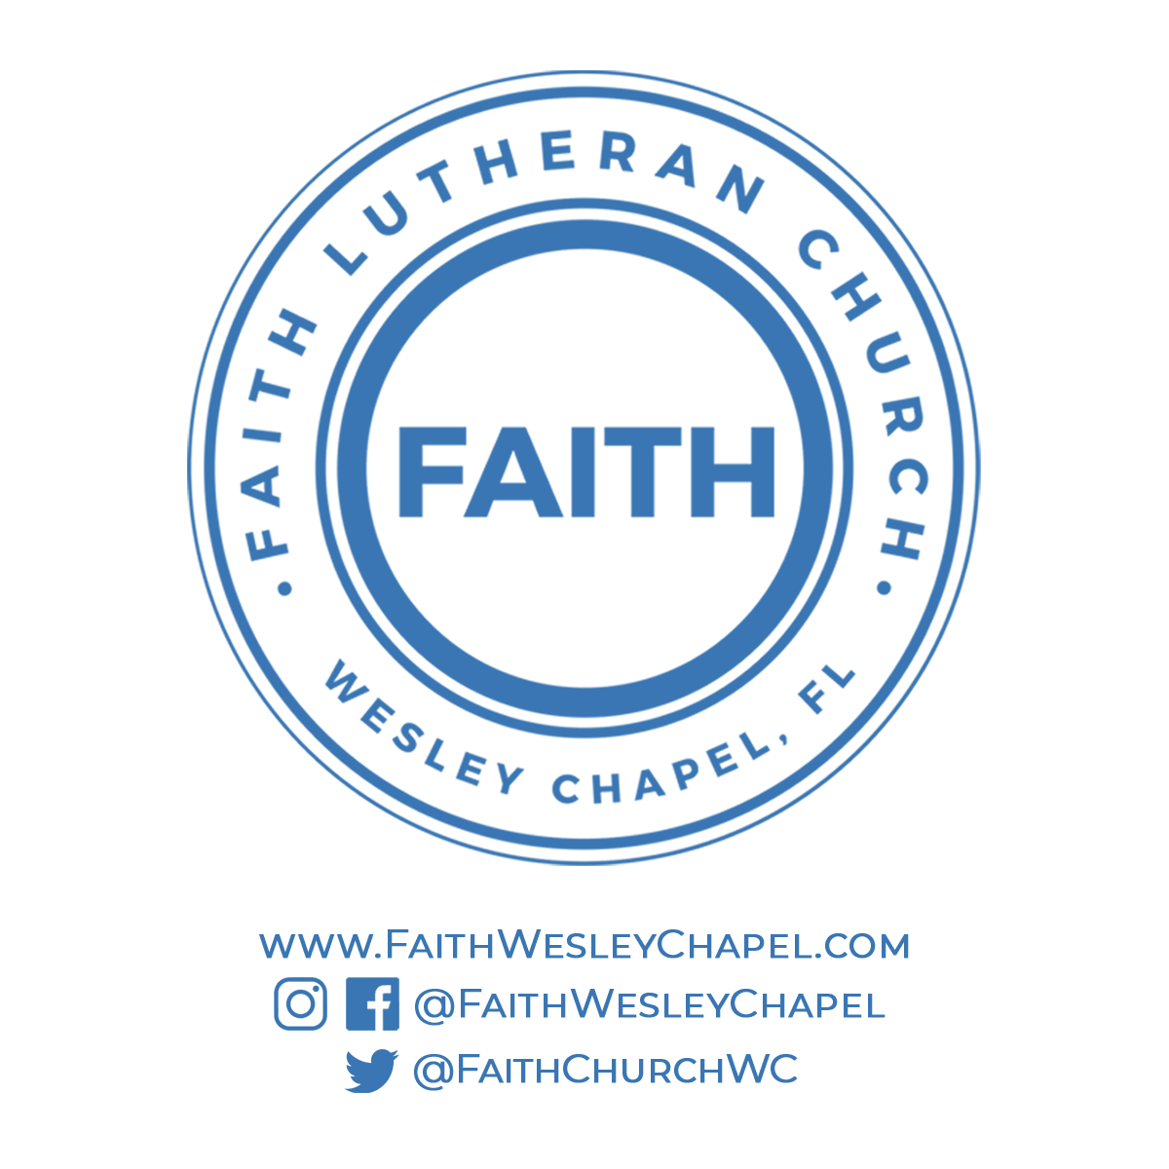**@FaithWesleyChapel**

**@FaithWesleyChapel**

**@FaithChurchWC**