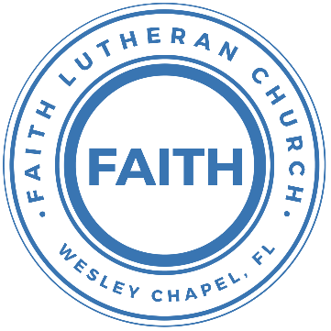

**Leading our community into a deep connection in Christ**

**___________________________________________________**

**Worship Service for June 22, 2025 at 11 AM**

**Welcome**

**Opening Song:**Love Divine All Loves Excelling

Love divine, all loves excelling, joy of heav'n, to earth come down!

Fix in us Thy humble dwelling, all Thy faithful mercies crown.  
Jesus, Thou art all compassion, pure, unbounded love Thou art;  
Visit us with Thy salvation, enter ev'ry trembling heart.

Breathe, O breathe Thy loving Spirit into ev'ry troubled breast;  
Let us all in Thee inherit; let us find Thy promised rest.  
Take away the love of sinning; Alpha and Omega be;  
End of faith, as its beginning, set our hearts at liberty.

Come, Almighty, to deliver; let us all Thy life receive;  
Suddenly return, and never, never-more Thy temples leave.  
Thee we would be always blessing, serve Thee as Thy hosts above,  
Pray and praise Thee without ceasing, glory in Thy perfect love.

Finish then Thy new creation, pure and spotless let us be;  
Let us see Thy great salvation perfectly restored in Thee,  
Changed from glory into glory, till in heav'n we take our place,  
Till we cast our crowns before Thee, lost in wonder, love, and praise!  
 © Public Domain

**Invocation**

**Confession and Forgiveness:**

**P:** Come into the presence of the Lord our God.  
**C:** Have mercy, O Lord. If you, Lord, kept a record of sins, Lord, who could stand; but if we confess our sins, he is faithful and just to forgive us our sins and to cleanse us from all unrighteousness.

*(A time of silence to reflect and personally confess our sins)*

**P:** I said, "I will confess my transgressions to the LORD." And you forgave the guilt of my sin. Let us confess our sin before the Lord. Let us confess together.  
**C:** Heavenly Father, we confess that we are sinners.  We have sinned against you and our neighbors. We have not loved you with our whole heart and we have not loved our neighbors as ourselves. We justly deserve Your punishment.  For the sake of Your Son, Jesus Christ, have mercy on us.  Forgive us, renew us, and lead us, so that we may delight in Your will and walk in Your ways to the glory of Your holy name.  Amen.

**P:** The Lord is gracious and merciful. He promises to forgive our sins. Therefore, upon this, your confession, as a called and ordained servant of the Lord, in the stead and by the command of my Lord, Jesus Christ, I forgive you all your sins in the name of the Father and of the Son and of the Holy Spirit.  
**C:** Amen.

**Song of Praise and Thanksgiving -** Amazing Grace

Amazing grace, how sweet the sound that saved a wretch like me.

I once was lost, but now am found. Was blind but now I see.

T'was grace that taught my heart to fear,

And grace my fears relieved.

How precious did that grace appear, the hour I first believed.

When we've been there ten thousand years,  
bright shining as the sun,

we've no less days to sing God’s praise,  
than when we've first begun. © Public Domain

**Old Testament Reading -** Genesis 15:1–6

After these things the word of the Lord came to Abram in a vision: “Fear not, Abram, I am your shield; your reward shall be very great.” But Abram said, “O Lord God, what will you give me, for I continue childless, and the heir of my house is Eliezer of Damascus?” And Abram said, “Behold, you have given me no offspring, and a member of my household will be my heir.” And behold, the word of the Lord came to him: “This man shall not be your heir; your very own son shall be your heir.” And he brought him outside and said, “Look toward heaven, and number the stars, if you are able to number them.” Then he said to him, “So shall your offspring be.” And he believed the Lord, and he counted it to him as righteousness.

**Reader:** This is the Word of the Lord.  
**C:** Thanks be to God.

**Epistle Reading -** 1 John 4:16-21

So we have come to know and to believe the love that God has for us. God is love, and whoever abides in love abides in God, and God abides in him. By this is love perfected with us, so that we may have confidence for the day of judgment, because as he is so also are we in this world. There is no fear in love, but perfect love casts out fear. For fear has to do with punishment, and whoever fears has not been perfected in love. We love because he first loved us. If anyone says, “I love God,” and hates his brother, he is a liar; for he who does not love his brother whom he has seen cannot love God whom he has not seen. And this commandment we have from him: whoever loves God must also love his brother.

**Reader:** This is the Word of the Lord.  
**C:** Thanks be to God.

**Gospel Reading -** Luke 16:19-31

“There was a rich man who was clothed in purple and fine linen and who feasted sumptuously every day. And at his gate was laid a poor man named Lazarus, covered with sores, who desired to be fed with what fell from the rich man's table. Moreover, even the dogs came and licked his sores. The poor man died and was carried by the angels to Abraham's side. The rich man also died and was buried, and in Hades, being in torment, he lifted up his eyes and saw Abraham far off and Lazarus at his side. And he called out, ‘Father Abraham, have mercy on me, and send Lazarus to dip the end of his finger in water and cool my tongue, for I am in anguish in this flame.’ But Abraham said, ‘Child, remember that you in your lifetime received your good things, and Lazarus in like manner bad things; but now he is comforted here, and you are in anguish. And besides all this, between us and you a great chasm has been fixed, in order that those who would pass from here to you may not be able, and none may cross from there to us.’ And he said, ‘Then I beg you, father, to send him to my father's house— for I have five brothers—so that he may warn them, lest they also come into this place of torment.’ But Abraham said, ‘They have Moses and the Prophets; let them hear them.’ And he said, ‘No, father Abraham, but if someone goes to them from the dead, they will repent.’ He said to him, ‘If they do not hear Moses and the Prophets, neither will they be convinced if someone should rise from the dead.’”

**P:** This is the Gospel of the Lord.  
**C:** Praise be to You, O Christ.

**Children's Message**

**Sermon Hymn -** How Deep The Father's Love For Us

How deep the Father's love for us, how vast beyond all measure,  
That He should give His only Son, to make a wretch His treasure.  
How great the pain of searing loss. The Father turned His face away,  
As wounds which mar the Chosen One, bring many sons to glory.

Behold the Man upon a cross, my sin upon His shoulders.  
Ashamed, I hear my mocking voice call out among the scoffers.  
It was my sin that held Him there until it was accomplished.  
His dying breath has brought me life; I know that it is finished.

I will not boast in anything: no gifts, no power, no wisdom.  
But I will boast in Jesus Christ; his death and resurrection.  
Why should I gain from His reward? I cannot give an answer.  
But this I know with all my heart: His wounds have paid my ransom  
But this I know with all my heart: His wounds have paid my ransom  
 © 1995 Thankyou Music

**Sermon**Series: "Confessing Christ: What Lutherans Believe and Why"  
This Week: "God’s Love, Our Confidence"

**Prayers:** *Text in prayer requests to (813) 326-5255‬*

**Apostles' Creed** *(stand)*

I believe in God, the Father almighty,  
maker of heaven and earth,

And in Jesus Christ, his only Son, our Lord,  
who was conceived by the Holy Spirit,  
born of the Virgin Mary,  
suffered under Pontius Pilate,  
was crucified, died and was buried.  
He descended into hell.  
The third day he rose again from the dead.  
He ascended into heaven and sits at the right hand of God  
the Father almighty.  
From there he will come to judge the living and the dead.

I believe in the Holy Spirit,  
the holy Christian Church,  
the communion of saints,  
the forgiveness of sins,  
the resurrection of the body,  
and the life everlasting. Amen.

**The Lord's Prayer** *(stand)*

Our Father who art in heaven, hallowed be Thy name, Thy kingdom come, Thy will be done on earth as it is in heaven.  Give us this day our daily bread; and forgive us our trespasses as we forgive those who trespass against us; and lead us not into temptation, but deliver us from evil.  For Thine is the kingdom and the power and the glory forever and ever.  Amen

**Benediction** *– The online service ends. The closing hymn video is on the Livestream page bulletin at FaithWesleyChapel.com with lyrics below. See announcements below as well.*

**Offering** *(sit) Give online at:*

**Closing Song -**This Is Amazing Grace

Who breaks the power of sin and darkness?

Whose love is mighty and so much stronger?

The King of Glory, the King above all kings.

Who shakes the whole earth with holy thunder?

Who leaves us breathless in awe and wonder?

The King of Glory, the King above all kings.

Chorus:

This is amazing grace. This is unfailing love,

That You would take my place, that You would bear my cross.

You would lay down Your life, that I would be set free.

Jesus, I sing for all that You've done for me.

Who brings our chaos back into order?

Who makes the orphan a son and daughter?

The King of Glory, The King of Glory.

Who rules the nations with truth and justice,

Shines like the sun in all of its brilliance?

The King of Glory, the King above all kings.

Chorus:

This is amazing grace. This is unfailing love,

That You would take my place, that You would bear my cross.

You would lay down Your life, that I would be set free.

Jesus, I sing for all that You've done for me.

Bridge:

Worthy is the Lamb who was slain!

Worthy is the King who conquered the grave!

*(Repeat 2x)*

Worthy is the Lamb who was slain. Worthy! Worthy! Worthy!

*(Chorus) © 2012 Bethel Music, Seems Like Music, Sing My Songs, Phil Wickham Music, and Warner Chappell Music*

**Join us for Lunch and Bible study this week:** Even in the face of sin and brokenness, God’s love gives us assurance. This week’s Bible study dives into our real condition before God.

**Join us for Lunch and Bible study next week:** God’s invitation is wide, but some reject it. In our Bible study, we’ll examine God’s grace in calling us to faith—free will vs predestination vs ???

|  |  |
| --- | --- |
| **Serving This Week** | |
|  | |
| **O.T. Reader:** Josh Strasheim | **Children’s Church Teacher:** |
| **Epistle Reader:** Ginger Dunn | Halston and Ben |
| **Acolyte:** Eli Steinbrueck | **Children’s Church Assistant:** |
| **Com. Asst:** Larry Chmiel | N/A |
|  | |
| **Serving Next Week** | |
|  | |
| **O.T. Reader:** Melissa Steinbrueck | **Children’s Church Teacher:** |
| **Epistle Reader:** Darlene Mueller | Halston and Ben |
| **Acolyte:** Lawrence Finnerty | **Children’s Church Assistant:** |
| **Com. Asst:** Richard Steinbrueck | N/A |

**Upcoming Events**

**Today, After the Service – Lunch & Bible Study with Pastor**Pastor Kurt’s Home

**June 24, 7 PM – Growth Group Bible Study**  
Renee’s Home

**June 26, 7 PM – Growth Group Bible Study** (Online)Zoom

**June 29, After the Service – Lunch & Bible Study with Pastor**Pastor Kurt’s Home

[**www.FaithWesleyChapel.com**](http://www.FaithWesleyChapel.com)

 **Faith YouTube**

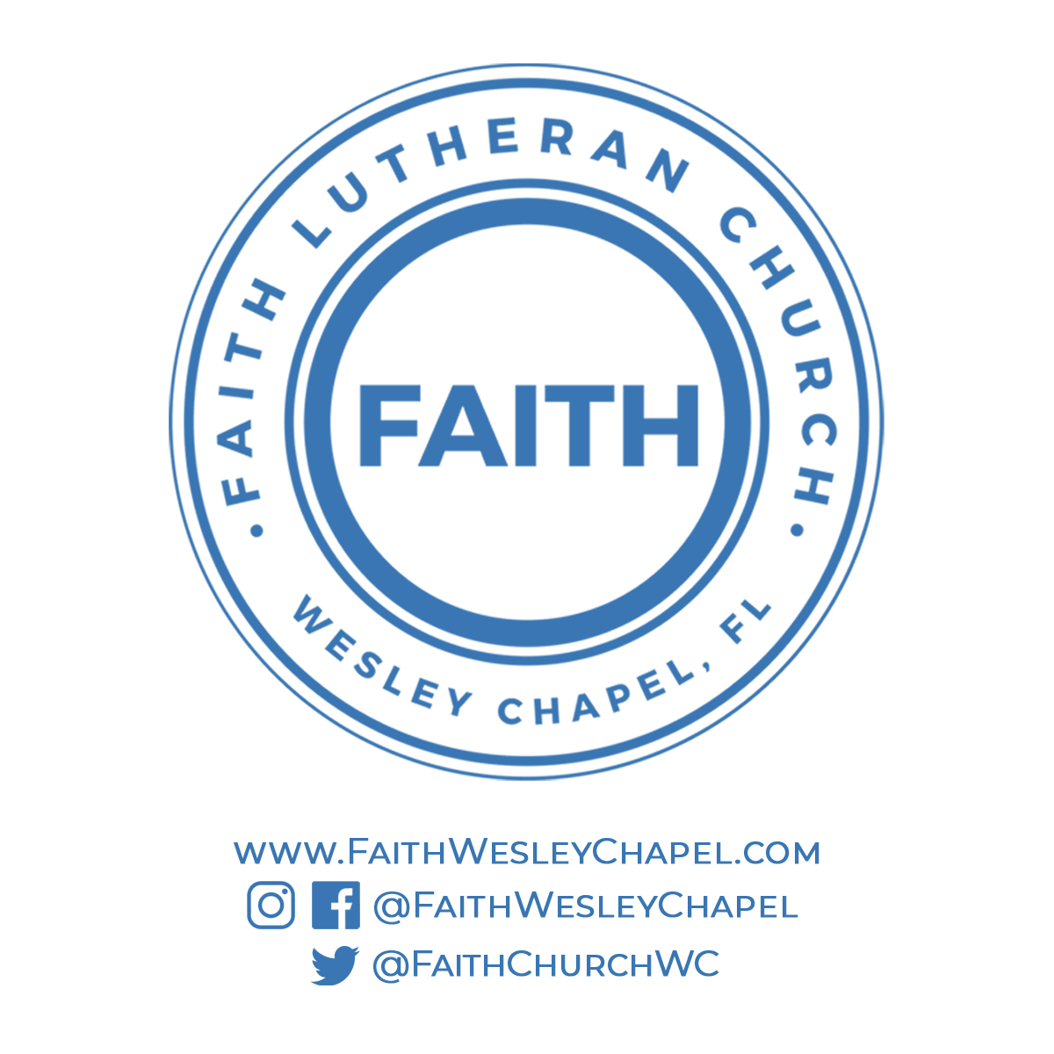**@FaithWesleyChapel**

**@FaithWesleyChapel**

**@FaithChurchWC**