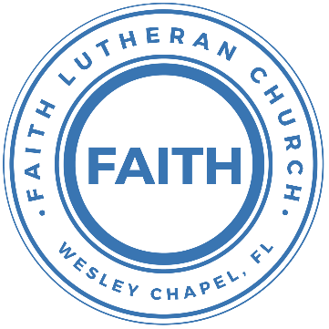

**Leading our community into a deep connection in Christ**

**Worship Service for July 6, 2025 at 11 AM**

**Welcome**

**Opening Song:**Oh, You Can't Get to Heaven

Oh, you can't get to heaven, (Oh, you can't get to heaven,)  
On roller skates. (On roller skates.)  
Oh, you can't get to heaven, (Oh, you can't get to heaven,)  
On roller skates.  
Oh, you can't get to heaven on roller skates,  
'Cause you'd roll right past those pearly gates.  
All my sins are washed away. I've been redeemed.

Oh, you can't get to heaven in a rocking chair…  
'Cause a rocking chair won't get you there.

Oh, you can't get to heaven in a limousine…  
'Cause the Lord don't sell no gasoline.

Oh, you can't get to Heaven in dirty jeans…  
'Cause heaven ain’t got no washing machines.

If you wanna get to heaven believe in Jesus name…  
'Cause it's by His name that we are saved. © Public Domain

**Invocation**

**Confession and Forgiveness:**

**P:** We have come here today to worship the Lord.  In worship we hear the Word of God, we receive God's blessings, and respond with thanks and praise.  We begin by seeking God's blessing of forgiveness.  He has promised to remove the guilt and shame of our sin through the sacrifice of Jesus Christ on the cross.

*(a time of silence to reflect and personally confess our sins)*

**P:** Let us confess our sins to the Lord.

**P:** Heavenly Father,  
**C:** Heavenly Father,

**P:** I have done things that were wrong.  
**C:** I have done things that were wrong.  
  
**P:** I have been mean to others.  
**C:** I have been mean to others.

**P:** I have not obeyed my parents.  
**C:** I have not obeyed my parents.

**P:** I have not obeyed You, God.  
**C:** I have not obeyed You, God.

**P:** But I am very sorry.  
**C:** But I am very sorry.

**P:** Please forgive me.  
**C:** Please forgive me.

**P:** I love You very much.  
**C:** I love You very much.

**P:** And I know You love me, too.  
**C:** And I know You love me, too.

**P:** Amen.  
**C:** Amen.

**P:** God has heard your apology.  He loves you very much.  God has told us that when we believe and trust in Him, He makes us His children.  As far as the east is from the west, so far does he remove our sins from us. He has told me to tell you that you are forgiven.  So, as His servant, I forgive you in the name of the Father and of the Son and of the Holy Spirit.   
**C:** Amen.

**Song:**Jesus Loves Me

Verse 1:

Jesus loves me this I know, For the Bible tells me so.

Little ones to Him belong, They are weak, but He is strong.

Chorus:

Yes, Jesus loves me, Yes, Jesus loves me,

Yes, Jesus loves me, The Bible tells me so.

Verse 2:

Jesus loves me, He who died. Heaven's gates to open wide.

He will wash away my sin, Let His little child come in.

*(Chorus)* © Public Domain

**First Reading -**Isaiah 55:10-11

The rain and the snow come down from the sky,  
 and they do not immediately return there.  
Instead, they give water to the earth,  
 so that crops will grow there.  
Then the farmer has seeds to plant,  
 and people have food to eat.  
It is the same when I give my word to people.  
 It will not return to me without any result.  
No! My word does what I want it to do.  
 What I promise to do will certainly happen.’

**Reader:** This is the Word of the Lord.  
**C:** Thanks be to God.

**Children's Message**"God Gives You Great Gifts!"

**Song:**All The People Said Amen

Verse 1:

You are not alone, if you are lonely.

When you feel afraid, you're not the only.

We are all the same, in need of mercy,

To be forgiven and be free,

It's all you got to lean on but thank God it's all you need.

Chorus:

And all the people said Amen, woah!

And all the people said Amen.

Give thanks to the Lord for His love never ends.

And all the people said Amen. *(Last line repeated on last chorus)*

Verse 2:  
If you're rich or poor, well it don't matter.  
Weak or strong, you know love is what we're after.  
We're all broken, but we're all in this together.  
God knows we stumble and fall.  
And He so loved the world, He sent His son to save us all.

*(Chorus)*

Bridge:

Blessed are the poor in spirit who are torn apart

Blessed are the persecuted and the pure in heart

Blessed are the people hungry for another start

For this is the kingdom, the kingdom of God

*(Chorus 2x)* © 2013 Thankyou Music, Valley Of Songs Music, Universal Music

**Second Reading -**Luke 15:8-10

“Or suppose a woman has ten silver coins and loses one. Doesn’t she light a lamp, sweep the house and search carefully until she finds it? And when she finds it, she calls her friends and neighbors together and says, ‘Rejoice with me; I have found my lost coin.’ In the same way, I tell you, there is rejoicing in the presence of the angels of God over one sinner who repents.”

**P:** This is the Gospel of the Lord.  
**C:** Praise be to You, O Christ.

**Children's Message**"God Seeks Us"

**Epistle Reading –**Romans 10:5-17

For Moses writes about the righteousness that is based on the law, that the person who does the commandments shall live by them. But the righteousness based on faith says, “Do not say in your heart, ‘Who will ascend into heaven?’” (that is, to bring Christ down) “or ‘Who will descend into the abyss?’” (that is, to bring Christ up from the dead). But what does it say? “The word is near you, in your mouth and in your heart” (that is, the word of faith that we proclaim); because, if you confess with your mouth that Jesus is Lord and believe in your heart that God raised him from the dead, you will be saved. For with the heart one believes and is justified, and with the mouth one confesses and is saved. For the Scripture says, “Everyone who believes in him will not be put to shame.” For there is no distinction between Jew and Greek; for the same Lord is Lord of all, bestowing his riches on all who call on him. For “everyone who calls on the name of the Lord will be saved.”

How then will they call on him in whom they have not believed? And how are they to believe in him of whom they have never heard? And how are they to hear without someone preaching? And how are they to preach unless they are sent? As it is written, “How beautiful are the feet of those who preach the good news!” But they have not all obeyed the gospel. For Isaiah says, “Lord, who has believed what he has heard from us?” So faith comes from hearing, and hearing through the word of Christ.

**Reader:** This is the Word of the Lord.  
**C:** Thanks be to God.

**Song:**Thy Strong Word

Thy strong word did cleave the darkness;

At Thy speaking it was done.

For created light we thank Thee,

While Thine ordered seasons run.

Refrain:

Alleluia, alleluia! Praise to Thee who light dost send!

Alleluia, alleluia! Alleluia without end!

Lo, on those who dwelt in darkness,

Dark as night and deep as death,

Broke the light of thy salvation,

Breathed thine own life-giving breath. *(Refrain)*

Thy strong Word be- speaks us righteous;

Bright with thine own holiness,

Glorious now, we press toward glory,

And our lives our hope confess. *(Refrain)*

Give us lips to sing thy glory, Tongues thy mercy to proclaim,

Throats to shout the hope that fills us,

Mouths to speak thy holy name. *(Refrain)*  
 © 1969 Concordia Publishing House

**Sermon –**“Sacrificing Something Precious”

Series: "Confessing Christ: What Lutherans Believe and Why"

This Week: "Faith That Saves: The Spirit and the Gospel"

**Prayers:** *Text in prayer requests to (813) 326-5255*

**The Lord's Prayer**

Our Father who art in heaven, hallowed be Thy name, Thy kingdom come, Thy will be done on earth as it is in heaven.  Give us this day our daily bread; and forgive us our trespasses as we forgive those who trespass against us; and lead us not into temptation, but deliver us from evil.  For Thine is the kingdom and the power and the glory forever and ever.  Amen

**Offering**  *Give online at:*

**Benediction** *(stand)*

**Closing Song:**Go My Children With My Blessing

Go, My children, with My blessing, never alone.

Waking, sleeping, I am with you. You are My own.

In My love’s baptismal river I have made you Mine forever.

Go, My children, with My blessing. You are My own.

Go, My children, sins forgiven, at peace and pure.

Here you learned how much I love you, what I can cure.

Here you heard My dear Son’s story.  
Here you touched Him, saw His glory.

Go, My children, sins forgiven, at peace and pure.

Go, My children, fed and nourished, closer to Me;

Grow in love and love by serving, joyful and free.

Here My Spirit’s power filled you.  
Here His tender comfort stilled you.

Go, My children, fed and nourished, joyful and free.

I the Lord will bless and keep you and give you peace.

I the Lord will smile upon you and give you peace.

I the Lord will be your Father, Savior, Comforter, and Brother.

Go, My children; I will keep you and give you peace.

© 1983, 1987 MorningStar Music Publishers, Concordia Publishing House

|  |  |
| --- | --- |
| **Serving This Week** | |
|  | |
| **1st Reader:** Kaylee Steinbrueck | **Children’s Church Teacher:** |
| **2nd Reader:** Lawrence Finnerty | N/A |
| **Acolyte:** Lawrence Finnerty | **Children’s Church Assistant:** |
| **Com. Asst:** Larry Chmiel | N/A |
|  | |
| **Serving Next Week** | |
|  | |
| **O.T. Reader:** Darlene Meuller | **Children’s Church Teacher:** |
| **Epistle Reader:** Rich Steinbrueck | Melissa Steinbrueck |
| **Acolyte:** Kaylee Steinbrueck | **Children’s Church Assistant:** |
| **Com. Asst:** Larry Chmiel | Kaylee Steinbrueck |

**Upcoming Events**

**Today, After the Service – Lunch & Bible Study with Pastor**Pastor Kurt’s Home

**July 8, 7 PM – Growth Group Bible Study**  
Renee’s Home

**July 10, 7 PM – Growth Group Bible Study** (Online)Zoom

**July 13, After the Service – Lunch & Bible Study with Pastor**Pastor Kurt’s Home

**www.FaithWesleyChapel.com**

**Faith YouTube**

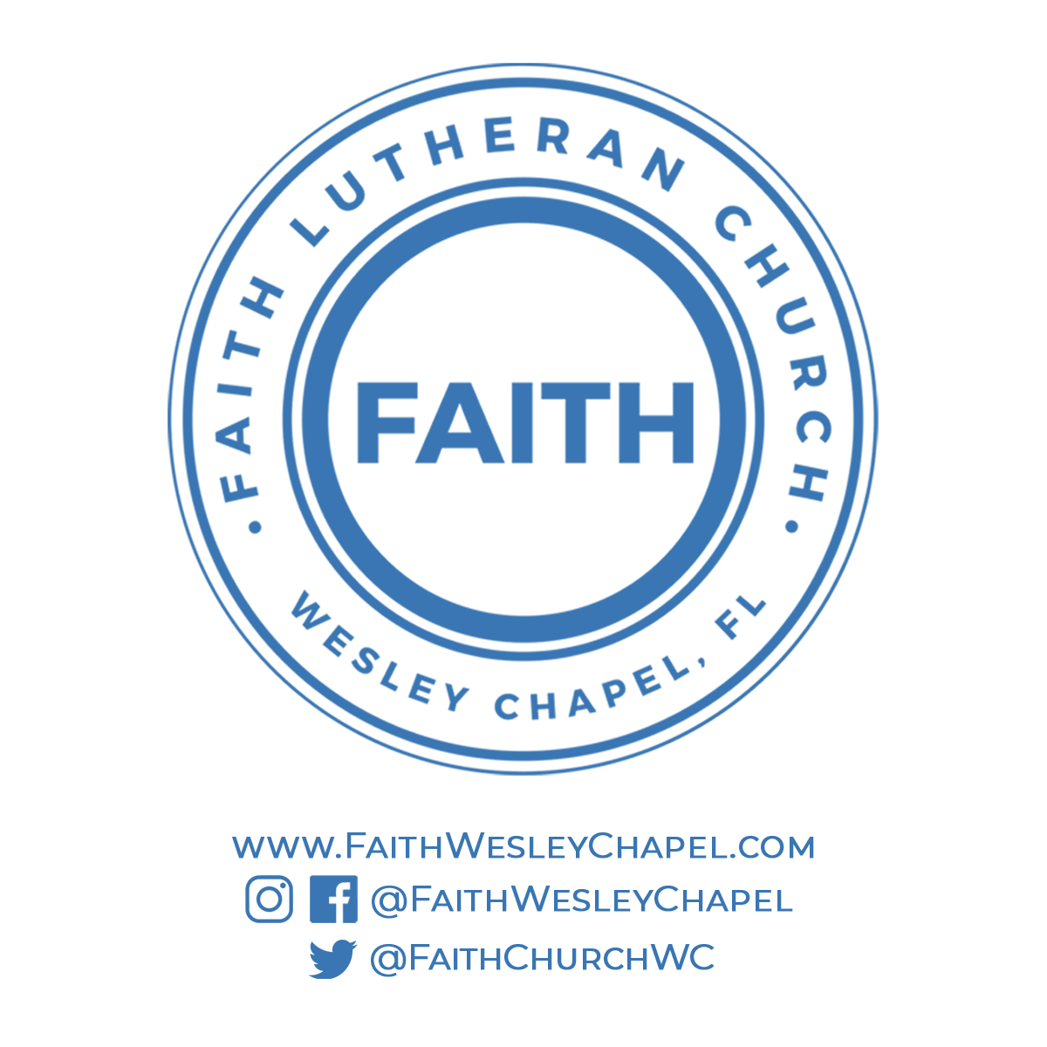**@FaithWesleyChapel**

**@FaithWesleyChapel**

**@FaithChurchWC**