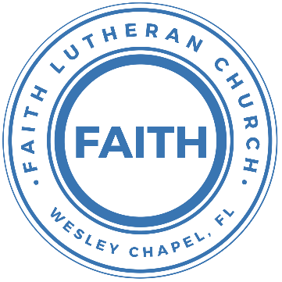

**Leading our community into a deep connection in Christ**

**___________________________________________________**

**Worship Service for July 20, 2024 at 11 AM**

**Welcome** and **Invocation**

**Confession and Forgiveness:**

**P:** When we come into the presence of God we cannot help but see our sinfulness. God does not require us to cleanse our own sin and be perfect of our own power for, surely, we could never achieve this. Instead, He tells us to come as we are and receive His great mercy.

**Song:** Come As You Are

Verse 1:

Come out of sadness from wherever you've been.

Come broken hearted let rescue begin.

Come find your mercy. Oh, sinner come kneel.

Earth has no sorrow that Heaven can't heal.

Earth has no sorrow that Heaven can't heal.

Chorus:

So, lay down your burdens, lay down your shame.

All who are broken, lift up your face.

Oh, wanderer come home. You're not too far.

So, lay down your hurt. Lay down your heart. Come as you are.

Verse 2:

There's hope for the hopeless, and all those who've strayed.

Come sit at the table. Come taste of the grace.

There's rest for the weary, rest that endures.

Earth has no sorrow that Heaven can't cure.

Chorus:

So, lay down your burdens, lay down your shame.

All who are broken, lift up your face.

Oh, wanderer come home. You're not too far.

So, lay down your hurt. Lay down your heart. Come as you are.

Bridge:

Come as you are. Fall in his arms. Come as you are.

*(a time of silence to reflect and personally confess our sins)*

**C:** Heavenly Father, we confess that we have sinned against you and each other. We are truly sorry and we humbly repent. For the sake of your Son Jesus Christ and His suffering and death on the cross, please forgive us and help us to live according to Your ways. Amen

Verse 3:

There's joy for the morning. Oh, sinner be still.

Earth has no sorrow that Heaven can't heal. *(Repeat line)*

*(Chorus)* *© 2014 9 © t One Songs (Admin. by EMI Christian Music Publishing)*

**P:** The Lord our God is merciful and gracious, longsuffering, and abounding in goodness and truth, keeping mercy for thousands, forgiving iniquity and transgression and sin. Therefore, I announce unto you the grace of our Lord Jesus Christ. In His stead and by the command of my Lord Jesus Christ, I forgive you all your sins in the name of the Father and of the Son and of the Holy Spirit.  
**C:** Amen.

**Song of Praise and Thanksgiving:** Gratitude

All my words fall short. I got nothing new.  
How could I express all my gratitude?

I could sing these songs, as I often do

But every song must end and You never do

Chorus:

So I throw up my hands and praise You again and again

'Cause all that I have is a Hallelujah. Hallelujah!

And I know it's not much but I've nothing else fit for a King

Except for a heart singing, Hallelujah  Hallelujah

I've got one response. I've got just one move

With my arm stretched wide, I will worship You

*(Chorus)*

Bridge:

So come on, my soul, oh, don't you get shy on me. Lift up your song,

'Cause you've got a lion inside of those lungs

Get up and praise the Lord

*(Repeat 2x)*

*(Chorus)*© 2021 Bethel Worship Publishing

**Old Testament Reading** –Exodus 24:3–11

Moses came and told the people all the words of the Lord and all the rules. And all the people answered with one voice and said, “All the words that the Lord has spoken we will do.” And Moses wrote down all the words of the Lord. He rose early in the morning and built an altar at the foot of the mountain, and twelve pillars, according to the twelve tribes of Israel. And he sent young men of the people of Israel, who offered burnt offerings and sacrificed peace offerings of oxen to the Lord. And Moses took half of the blood and put it in basins, and half of the blood he threw against the altar. Then he took the Book of the Covenant and read it in the hearing of the people. And they said, “All that the Lord has spoken we will do, and we will be obedient.” And Moses took the blood and threw it on the people and said, “Behold the blood of the covenant that the Lord has made with you in accordance with all these words.” Then Moses and Aaron, Nadab, and Abihu, and seventy of the elders of Israel went up, and they saw the God of Israel. There was under his feet as it were a pavement of sapphire stone, like the very heaven for clearness. And he did not lay his hand on the chief men of the people of Israel; they beheld God, and ate and drank.

**Reader:** This is the Word of the Lord. **C:** Thanks be to God.

**Epistle Reading** –1 Corinthians 10:14-22

Therefore, my beloved, flee from idolatry. I speak as to sensible people; judge for yourselves what I say. The cup of blessing that we bless, is it not a participation in the blood of Christ? The bread that we break, is it not a participation in the body of Christ? Because there is one bread, we who are many are one body, for we all partake of the one bread. Consider the people of Israel: are not those who eat the sacrifices participants in the altar? What do I imply then? That food offered to idols is anything, or that an idol is anything? No, I imply that what pagans sacrifice they offer to demons and not to God. I do not want you to be participants with demons. You cannot drink the cup of the Lord and the cup of demons. You cannot partake of the table of the Lord and the table of demons. Shall we provoke the Lord to jealousy? Are we stronger than he?

**Reader:** This is the Word of the Lord. **C:** Thanks be to God.

**Gospel Reading** –Luke 22:14-20

And when the hour came, he reclined at table, and the apostles with him. And he said to them, “I have earnestly desired to eat this Passover with you before I suffer. For I tell you I will not eat it until it is fulfilled in the kingdom of God.” And he took a cup, and when he had given thanks he said, “Take this, and divide it among yourselves. For I tell you that from now on I will not drink of the fruit of the vine until the kingdom of God comes.” And he took bread, and when he had given thanks, he broke it and gave it to them, saying, “This is my body, which is given for you. Do this in remembrance of me.” And likewise the cup after they had eaten, saying, “This cup that is poured out for you is the new covenant in my blood.

**P:** This is the Gospel of the Lord. **C:** Praise be to You, O Christ.

**Children's Message** *(Children dismissed to Children's Church)*

**Sermon Hymn***–*In Christ Alone

In Christ alone my hope is found.   
He is my light, my strength, my song.  
This Cornerstone, this solid ground,  
Firm through the fiercest drought and storm.  
What heights of love, what depths of peace,  
When fears are stilled, when strivings cease.  
My Comforter, my All in All. Here in the love of Christ I stand.

In Christ alone, who took on flesh,   
Fullness of God in helpless babe.  
This gift of love and righteousness,   
Scorned by the ones He came to save.  
‘Til on that cross as Jesus died, the wrath of God was satisfied.  
For every sin on Him was laid, Here in the death of Christ I live.

There in the ground His body lay,   
Light of the world by darkness slain.  
Then bursting forth in glorious Day,   
Up from the grave He rose again.  
And as He stands in victory, sin’s curse has lost its grip on me.  
For I am His and He is mine,   
Bought with the precious blood of Christ.

No guilt in life, no fear in death,   
This is the power of Christ in me.  
From life’s first cry to final breath, Jesus commands my destiny.  
No power of hell, no scheme of man,   
Can ever pluck me from His hand.  
‘Til He returns or calls me home,   
Here in the power of Christ I’ll stand.  
No power of hell, no scheme of man,   
Can ever pluck me from His hand.  
‘Til He returns or calls me home,   
Here in the power of Christ I’ll stand. © 2001 Thankyou Music

**Sermon**:  
 Series: "Confessing Christ: What Lutherans Believe and Why"  
 This Week: "Take and Eat: Christ for You"

**Prayers:** *Text in prayer requests to (813) 326-5255*

**Nicene Creed** *(stand)*

I believe in one God, the Father Almighty, maker of heaven and earth and of all things visible and invisible.

And in one Lord Jesus Christ, the only-begotten Son of God, begotten of His Father before all worlds, God of God, Light of Light, very God of very God, begotten, not made, being of one substance with the Father, by whom all things were made; who for us men and for our salvation came down from heaven and was incarnate by the Holy Spirit of the virgin Mary and was made man; and was crucified also for us under Pontius Pilate. He suffered and was buried. And the third day He rose again according to the Scriptures and ascended into heaven and sits at the right hand of the Father. And He will come again with glory to judge both the living and the dead, whose kingdom will have no end.

And I believe in the Holy Spirit, the Lord and Giver of Life, who proceeds from the Father and the Son, who with the Father and the Son together is worshiped and glorified, who spoke by the prophets. And I believe in one holy Christian and apostolic Church, I acknowledge one Baptism for the remission of sins, and I look for the resurrection of the dead and the life of the world to come. Amen.

**The Lord's Prayer** *(stand)*

****Our Father who art in heaven, hallowed be Thy name, Thy kingdom come, Thy will be done on earth as it is in heaven.  Give us this day our daily bread; and forgive us our trespasses as we forgive those who trespass against us; and lead us not into temptation, but deliver us from evil.  For Thine is the kingdom and the power and the glory forever and ever.  Amen

**Offering** *(sit) Give online at:*

**Benediction** *– The online service ends. The closing hymn video is on the Livestream page bulletin at FaithWesleyChapel.com with lyrics below. See announcements below as well.*

**Closing Song:**The Wonderful Cross

When I survey the wondrous cross, on which the prince of glory died,

My richest gain I count but loss, and pour contempt on all my pride.

Forbid it, Lord, that I should boast, save in the death of Christ my God.

All the vain things that charm me most, I sacrifice them to His blood.

Chorus:

O the wonderful cross, O the wonderful cross,

Bids me come and die and find that I may truly live.

O the wonderful cross, O the wonderful cross,

All who gather here by grace draw near and bless Your name.

See from his head, His hands, His feet,

Sorrow and love flow mingled down.

Did e’er such love and sorrow meet, or thorns compose so rich a crown.

Chorus:

O the wonderful cross, O the wonderful cross,

Bids me come and die and find that I may truly live.

O the wonderful cross, O the wonderful cross,

All who gather here by grace draw near and bless Your name.

Were the whole realm of nature mine, that were a present far too small

Love so amazing so divine, demands my soul, my life, my all.

*(Chorus)* © 2000 worshiptogether.com Songs (ASCAP)/sixsteps Music (ASCAP) (both admin. by EMI CMG PUblishing)

|  |  |
| --- | --- |
| **Serving This Week** | |
|  | |
| **O.T. Reader:** Ginger Dunn | **Children’s Church Teacher:** |
| **Epistle Reader:** Melissa Steinbrueck | Halston and Ben |
| **Acolyte:** Lawrence Finnerty | **Children’s Church Assistant:** |
| **Com. Asst:** Larry Chmiel | N/A |
|  | |
| **Serving Next Week** | |
|  | |
| **O.T. Reader:** Darlene Mueller | **Children’s Church Teacher:** |
| **Epistle Reader:** Larry Chmiel | Halston and Ben |
| **Acolyte:** Lawrence Finnerty | **Children’s Church Assistant:** |
| **Com. Asst:** Larry Chmiel | N/A |

**Upcoming Events**

**Today, After the Service – Lunch & Bible Study with Pastor**Pastor Kurt’s Home

[**www.FaithWesleyChapel.com**](http://www.FaithWesleyChapel.com)

 **Faith YouTube**

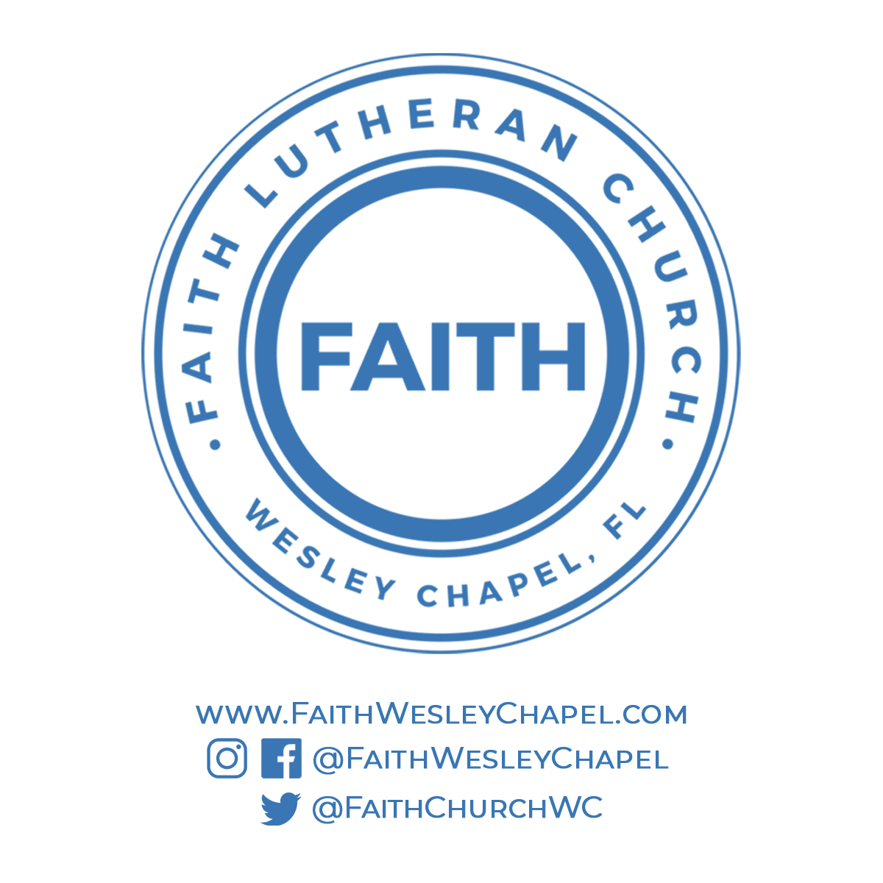**@FaithWesleyChapel**

**@FaithWesleyChapel**

**@FaithChurchWC**