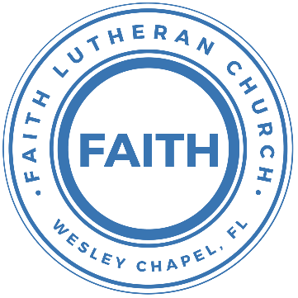

**Leading our community into a deep connection in Christ**

**___________________________________________________**

**Worship Service for July 27, 2024 at 11 AM**

**Welcome**

**Opening Song:** This Is Amazing Grace

Who breaks the power of sin and darkness?

Whose love is mighty and so much stronger?

The King of Glory, the King above all kings.

Who shakes the whole earth with holy thunder?

Who leaves us breathless in awe and wonder?

The King of Glory, the King above all kings.

Chorus:

This is amazing grace. This is unfailing love,

That You would take my place, that You would bear my cross.

You would lay down Your life, that I would be set free.

Jesus, I sing for all that You've done for me.

Who brings our chaos back into order?

Who makes the orphan a son and daughter?

The King of Glory, The King of Glory.

Who rules the nations with truth and justice,

Shines like the sun in all of its brilliance?

The King of Glory, the King above all kings.

*(Chorus)*

Bridge:

Worthy is the Lamb who was slain!

Worthy is the King who conquered the grave!

*(Repeat 2x)*

Worthy is the Lamb who was slain. Worthy! Worthy! Worthy!

Chorus:

This is amazing grace. This is unfailing love,

That You would take my place, that You would bear my cross.

You would lay down Your life, that I would be set free.

Jesus, I sing for all that You've done for me.  
 *© 2012 Bethel Music, Seems Like Music, Sing My Songs, Phil Wickham Music, and Warner Chappell Music*

**Invocation**

**Confession and Forgiveness:**

**P:** Come into the presence of the Lord our God.  
**C:** Have mercy, O Lord. If you, Lord, kept a record of sins, Lord, who could stand; but if we confess our sins, he is faithful and just to forgive us our sins and to cleanse us from all unrighteousness.

*(A time of silence to reflect and personally confess our sins)*

**P:** I said, "I will confess my transgressions to the LORD." And you forgave the guilt of my sin. Let us confess our sin before the Lord. Let us confess together.  
**C:** Heavenly Father, we confess that we are sinners.  We have sinned against you and our neighbors. We have not loved you with our whole heart and we have not loved our neighbors as ourselves. We justly deserve Your punishment.  For the sake of Your Son, Jesus Christ, have mercy on us.  Forgive us, renew us, and lead us, so that we may delight in Your will and walk in Your ways to the glory of Your holy name.  Amen.

**P:** The Lord is gracious and merciful. He promises to forgive our sins. Therefore, upon this, your confession, as a called and ordained servant of the Lord, in the stead and by the command of my Lord, Jesus Christ, I forgive you all your sins in the name of the Father and of the Son and of the Holy Spirit.  
**C:** Amen.

**Song of Praise and Thanksgiving:** Amazing Grace

Amazing grace, how sweet the sound that saved a wretch like me.

I once was lost, but now am found. Was blind but now I see.

T'was grace that taught my heart to fear,

And grace my fears relieved.

How precious did that grace appear, the hour I first believed.

When we've been there ten thousand years,  
bright shining as the sun,

we've no less days to sing God’s praise,  
than when we've first begun. © Public Domain

**Old Testament Reading** –Exodus 20:1-17

And God spoke all these words, saying,

“I am the Lord your God, who brought you out of the land of Egypt, out of the house of slavery.  
“You shall have no other gods before me.  
“You shall not make for yourself a carved image, or any likeness of anything that is in heaven above, or that is in the earth beneath, or that is in the water under the earth. You shall not bow down to them or serve them, for I the Lord your God am a jealous God, visiting the iniquity of the fathers on the children to the third and the fourth generation of those who hate me, but showing steadfast love to thousands of those who love me and keep my commandments.  
“You shall not take the name of the Lord your God in vain, for the Lord will not hold him guiltless who takes his name in vain.  
“Remember the Sabbath day, to keep it holy. Six days you shall labor, and do all your work, but the seventh day is a Sabbath to the Lord your God. On it you shall not do any work, you, or your son, or your daughter, your male servant, or your female servant, or your livestock, or the sojourner who is within your gates. For in six days the Lord made heaven and earth, the sea, and all that is in them, and rested on the seventh day. Therefore the Lord blessed the Sabbath day and made it holy.  
“Honor your father and your mother, that your days may be long in the land that the Lord your God is giving you.  
“You shall not murder.  
“You shall not commit adultery.  
“You shall not steal.  
“You shall not bear false witness against your neighbor.  
“You shall not covet your neighbor's house; you shall not covet your neighbor's wife, or his male servant, or his female servant, or his ox, or his donkey, or anything that is your neighbor's.”

**Reader:** This is the Word of the Lord.  
**C:** Thanks be to God.

**Epistle Reading** –Romans 6:3-11

Do you not know that all of us who have been baptized into Christ Jesus were baptized into his death? We were buried therefore with him by baptism into death, in order that, just as Christ was raised from the dead by the glory of the Father, we too might walk in newness of life.

For if we have been united with him in a death like his, we shall certainly be united with him in a resurrection like his. We know that our old self was crucified with him in order that the body of sin might be brought to nothing, so that we would no longer be enslaved to sin. For one who has died has been set free from sin. Now if we have died with Christ, we believe that we will also live with him. We know that Christ, being raised from the dead, will never die again; death no longer has dominion over him. For the death he died he died to sin, once for all, but the life he lives he lives to God. So you also must consider yourselves dead to sin and alive to God in Christ Jesus.

**Reader:** This is the Word of the Lord.  
**C:** Thanks be to God.

**Gospel Reading** –Matthew 25:31-46

“When the Son of Man comes in his glory, and all the angels with him, then he will sit on his glorious throne. Before him will be gathered all the nations, and he will separate people one from another as a shepherd separates the sheep from the goats. And he will place the sheep on his right, but the goats on the left. Then the King will say to those on his right, ‘Come, you who are blessed by my Father, inherit the kingdom prepared for you from the foundation of the world. For I was hungry and you gave me food, I was thirsty and you gave me drink, I was a stranger and you welcomed me, I was naked and you clothed me, I was sick and you visited me, I was in prison and you came to me.’ Then the righteous will answer him, saying, ‘Lord, when did we see you hungry and feed you, or thirsty and give you drink? And when did we see you a stranger and welcome you, or naked and clothe you? And when did we see you sick or in prison and visit you?’ And the King will answer them, ‘Truly, I say to you, as you did it to one of the least of these my brothers, you did it to me.’

“Then he will say to those on his left, ‘Depart from me, you cursed, into the eternal fire prepared for the devil and his angels. For I was hungry and you gave me no food, I was thirsty and you gave me no drink, I was a stranger and you did not welcome me, naked and you did not clothe me, sick and in prison and you did not visit me.’ Then they also will answer, saying, ‘Lord, when did we see you hungry or thirsty or a stranger or naked or sick or in prison, and did not minister to you?’ Then he will answer them, saying, ‘Truly, I say to you, as you did not do it to one of the least of these, you did not do it to me.’ And these will go away into eternal punishment, but the righteous into eternal life.”

**P:** This is the Gospel of the Lord.  
**C:** Praise be to You, O Christ.

**Children's Message**

**Sermon Hymn:** I Am Trusting Thee, Lord Jesus

I am trusting Thee, Lord Jesus, trusting only Thee;  
Trusting Thee for full salvation, great and free.

I am trusting Thee for pardon; at Thy feet I bow,  
For Thy grace and tender mercy, trusting now.

I am trusting Thee for cleansing in the crimson flood;  
Trusting Thee who made me holy by Thy blood.

I am trusting Thee to guide me; Thou alone shall lead,  
Ev'ry day and hour supplying all my need.

I am trusting Thee for power; Thine can never fail.  
Words which Thou Thyself shall give me must prevail.

I am trusting Thee, Lord Jesus; never let me fall.  
I am trusting Thee forever and for all. © Public Domain

**Sermon -** "Faith and Works"

**Prayers:** *Text in prayer requests to (813) 326-5255‬*

**Apostles' Creed** *(stand)*

I believe in God, the Father almighty, maker of heaven and earth,

And in Jesus Christ, his only Son, our Lord,  
Who was conceived by the Holy Spirit, born of the Virgin Mary,  
Suffered under Pontius Pilate, was crucified, died and was buried.  
He descended into hell.  
The third day he rose again from the dead.  
He ascended into heaven and sits at the right hand of  
God the Father almighty.  
From there he will come to judge the living and the dead.

I believe in the Holy Spirit, the holy Christian Church,  
The communion of saints, the forgiveness of sins,  
The resurrection of the body, and the life everlasting. Amen.

**The Lord's Prayer** *(stand)*

Our Father who art in heaven, hallowed be Thy name, Thy kingdom come, Thy will be done on earth as it is in heaven.  Give us this day our daily bread; and forgive us our trespasses as we forgive those who trespass against us; and lead us not into temptation, but deliver us from evil.  For Thine is the kingdom and the power and the glory forever and ever.  Amen

**Offering** *(sit) Give online at:*

**Benediction** *– The online service ends. The closing hymn video is on the Livestream page bulletin at FaithWesleyChapel.com with lyrics below. See announcements below as well.*

**Closing Song:** How Great Is Our God

The splendor of a King, clothed in majesty,

Let all the earth rejoice, all the earth rejoice.

He wraps himself in light, and darkness tries to hide,

And trembles at His voice, trembles at His voice.

Chorus:

How great is our God. Sing with me.

How great is our God. All will see,

How great, how great is our God.

Age to age He stands, and time is in His hands,

Beginning and the end, beginning at the end.

The Godhead, three in one, Father, Spirit, Son,

The Lion and the Lamb, the Lion and the Lamb.

*(Chorus)*

Bridge:

Name above all names, Worthy of all praise,

My heart will sing, “How great is our God.”

*Repeat*

*(Chorus)* © 2004 Alletrop Music

|  |  |
| --- | --- |
| **Serving This Week** | |
|  | |
| **O.T. Reader:** Darlene Mueller | **Children’s Church Teacher:** |
| **Epistle Reader:** Larry Chmiel | Halston and Ben |
| **Acolyte:** Lawrence Finnerty | **Children’s Church Assistant:** |
| **Com. Asst:** Larry Chmiel | N/A |
|  | |
| **Serving Next Week** | |
|  | |
| **1st Reader:** Kaylee Steinbrueck | **Children’s Church Teacher:** |
| **2nd Reader:** Lawrence Finnerty | N/A |
| **Acolyte:** Eli Steinbrueck | **Children’s Church Assistant:** |
| **Com. Asst:** Larry Chmiel | N/A |

**Upcoming Events**

**Aug 7, 7 PM – Growth Group Bible Study** (Online)Zoom

**Aug 9, 10am - Noon – Snow Cones at the Park** (Outreach)Wesley Chapel District Park

**Aug 10, 11 AM – Faith and Food Worship Service**Faith Lutheran Church

[**www.FaithWesleyChapel.com**](http://www.FaithWesleyChapel.com)

 **Faith YouTube**

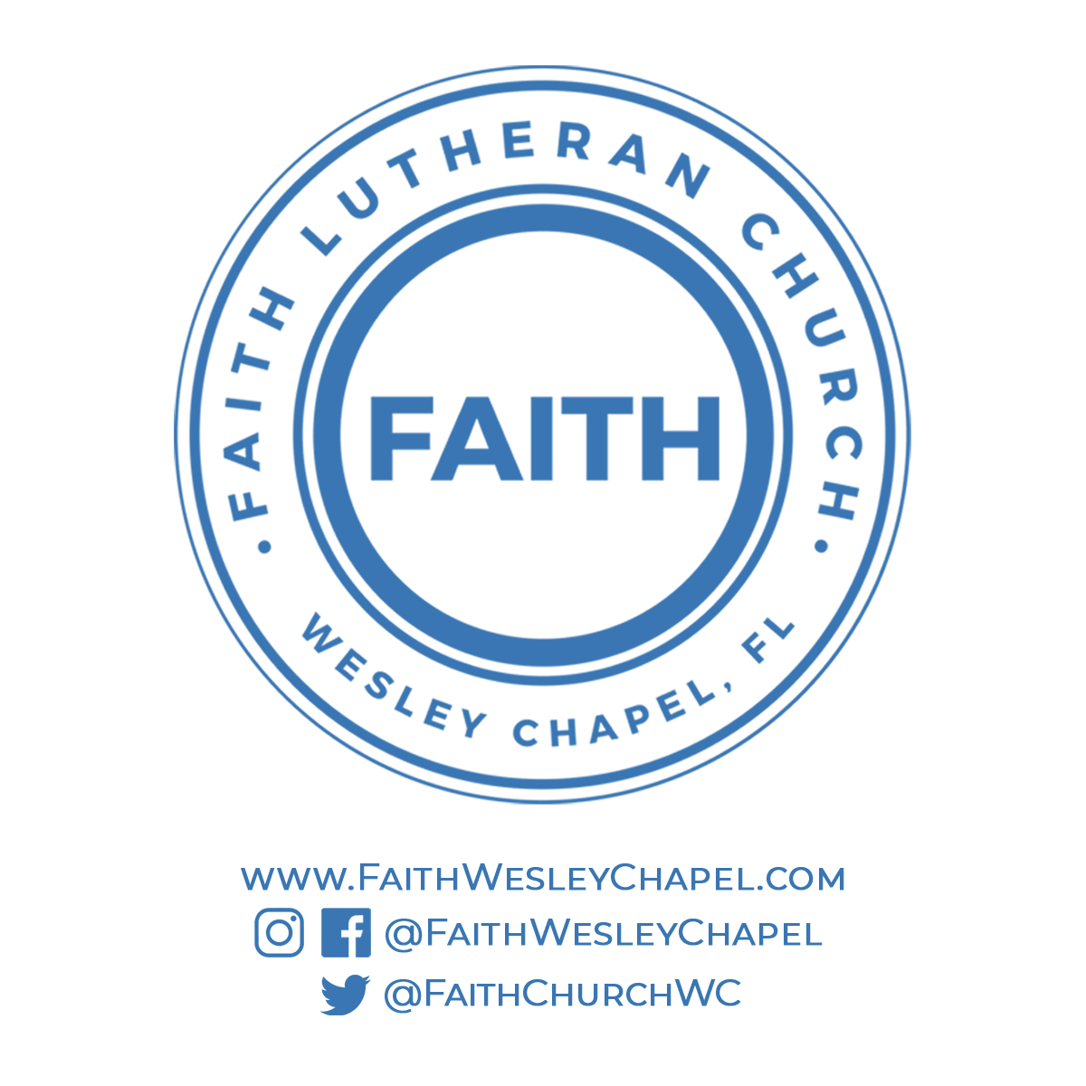**@FaithWesleyChapel**

**@FaithWesleyChapel**

**@FaithChurchWC**