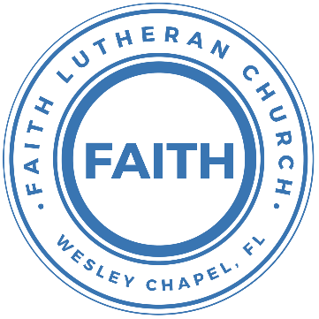

**Leading our community into a deep connection in Christ**

**Worship Service for August 3, 2025 at 11 AM**

**Welcome**

**Opening Song:**Down In My Heart

I’ve got the joy, joy, joy, joy down in my heart, (where?)  
Down in my heart, (where?), down in my heart.  
I’ve got the joy, joy, joy, joy down in my heart, (where?)  
Down in my heart to stay.

Chorus:  
And I’m so happy, so very happy.   
I’ve got the love of Jesus in my heart.  
And I’m so happy, so very happy.   
I’ve got the love of Jesus in my heart

I’ve got the peace that passes understanding down in my heart…

*(Chorus)*

I’ve got the love of Jesus, love of Jesus, down in my heart…

*(Chorus)*

I’ve got the wonderful love of my blessed redeemer way down in the depths of my heart…

*(Chorus)* © Public Domain

**Invocation**

**Confession and Forgiveness:**

**P:** We have come here today to worship the Lord.  In worship we hear the Word of God, we receive God's blessings, and respond with thanks and praise.  We begin by seeking God's blessing of forgiveness.  He has promised to remove the guilt and shame of our sin through the sacrifice of Jesus Christ on the cross.

*(a time of silence to reflect and personally confess our sins)*

**P:** Let us confess our sins to the Lord.

**P:** Heavenly Father,  
**C:** Heavenly Father,

**P:** I have done things that were wrong.  
**C:** I have done things that were wrong.  
  
**P:** I have been mean to others.  
**C:** I have been mean to others.

**P:** I have not obeyed my parents.  
**C:** I have not obeyed my parents.

**P:** I have not obeyed You, God.  
**C:** I have not obeyed You, God.

**P:** But I am very sorry.  
**C:** But I am very sorry.

**P:** Please forgive me.  
**C:** Please forgive me.

**P:** I love You very much.  
**C:** I love You very much.

**P:** And I know You love me, too.  
**C:** And I know You love me, too.

**P:** Amen.  
**C:** Amen.

**P:** God has heard your apology.  He loves you very much.  God has told us that when we believe and trust in Him, He makes us His children.  As far as the east is from the west, so far does he remove our sins from us. He has told me to tell you that you are forgiven.  So, as His servant, I forgive you in the name of the Father and of the Son and of the Holy Spirit.   
**C:** Amen.

**Song:**God Is So Good

God is so good. God is so good.  
God is so good. He's so good to me.

He died for me. He died for me so.  
He died for me. He's so good to me.

He loves me so. He loves me so.  
He loves me so. He's so good to me. © Public Domain

**First Reading -**Mark 8:1-3a, 6-8a

At that time, another large crowd had come to hear Jesus. The people had nothing to eat. Jesus asked his disciples to come to him. He said to them, ‘I feel sorry for this crowd. They have been here with me now for three days and they do not have any food. I do not want to send them back to their homes while they are hungry…. Jesus told the crowd that they should sit down on the ground. Then he took the seven loaves in his hands and he thanked God for them. Then he broke the bread and he gave the pieces to his disciples. The disciples gave the bread to the people. The disciples also had a few small fish, so Jesus thanked God for these. Then he told his disciples to give the fish to the people too. The people ate, and they all had enough food.

**Reader:** This is the Word of the Lord.  
**C:** Thanks be to God.

**Children's Message**"Jesus Feeds Over 4000 People and He Still Feeds Us Today"

**Song:**Good, Good, Father

I've heard a thousand stories of what they think You're like.  
But I've heard the tender whisper of love in the dead of night.  
You tell me that You’re pleased and that I'm never alone.

Chorus:  
You're a good, good father.  
It's who You are. It's who You are. It's who You are.  
And I'm loved by you. It's who I am. It's who I am. It's who I am.

Verse 2:  
I've seen many searching for answers far and wide.  
But I know we're all searching for answers only You provide.  
Because You know just what we need before we say a word.

*(Chorus)*

Bridge:  
You are perfect in all of your ways.  
You are perfect in all of your ways.  
You are perfect in all of your ways to us.

Verse 3:  
Love so undeniable I can hardly speak.  
Peace so unexplainable I can hardly think,  
As You call me deeper still. As You call me deeper still.  
As You call me deeper still into love, love, love.

*(Chorus 2x) © 2014 © Pat Barrett Music*

**Second Reading -**Matthew 6:31-33

Therefore do not be anxious, saying, ‘What shall we eat?’ or ‘What shall we drink?’ or ‘What shall we wear?’ For the Gentiles seek after all these things, and your heavenly Father knows that you need

them all. But seek first the kingdom of God and his righteousness, and all these things will be added to you.

**Reader:** This is the Word of the Lord.  
**C:** Thanks be to God.

**Children's Message**"What Are You Hungry For?"

**Gospel Reading –**Mark 8:1–9

In those days, when again a great crowd had gathered, and they had nothing to eat, he called his disciples to him and said to them, “I have compassion on the crowd, because they have been with me now three days and have nothing to eat. And if I send them away hungry to their homes, they will faint on the way. And some of them have come from far away.” And his disciples answered him, “How can one feed these people with bread here in this desolate place?” And he asked them, “How many loaves do you have?” They said, “Seven.” And he directed the crowd to sit down on the ground. And he took the seven loaves, and having given thanks, he broke them and gave them to his disciples to set before the people; and they set them before the crowd. And they had a few small fish. And having blessed them, he said that these also should be set before them. And they ate and were satisfied. And they took up the broken pieces left over, seven baskets full. And there were about four thousand people. And he sent them away.

**P:** This is the Gospel of the Lord.  
**C:** Praise be to You, o Christ.

**Sermon Hymn:**Seek Ye First

Seek ye first, the Kingdom of God and His righteousness,  
And all these things shall be added unto you. Allelu, Alleluia.

Ask and it shall be given unto you. Seek and ye shall find.  
Knock and it shall be opened unto you. Allelu, Alleluia.

Man shall not live by bread alone, but by every word,  
That proceeds out from the mouth of the Lord. Allelu, Alleluia.

© Public Domain

**Sermon –**“God Feeds People Who Are Hungry”

**Prayers:** *Text in prayer requests to (813) 326-5255*

**The Lord's Prayer**

Our Father who art in heaven, hallowed be Thy name, Thy kingdom come, Thy will be done on earth as it is in heaven.  Give us this day our daily bread; and forgive us our trespasses as we forgive those who trespass against us; and lead us not into temptation, but deliver us from evil.  For Thine is the kingdom and the power and the glory forever and ever.  Amen

**Offering**  *Give online at:*

**Benediction** *– The online service ends. The closing hymn video is on the Livestream page bulletin at FaithWesleyChapel.com with lyrics below. See announcements below as well.*

**Closing Song:**Echo *(sit)*

When night has fallen, when fear is common,

Still You're calling me. When faith is lost and,

My hope exhausted, You will be my strength.

Pre-Chorus:

When my mind says I'm not good enough, God,  
You're enough for me.

I've decided I'm not giving up 'cause You won't give up on me.

You won't give up on me!

Chorus:

Your love is holding on and it won't let go.

I feel it breaking out like an echo.  
Your love is holding on and it won't let go.  
I feel it breaking out like an echo.

Post-Chorus:

Echo in my so-o-o-o-oul, So-o-o-o-oul.

Echo in my so-o-o-o-oul, So-o-o-o-oul.

Verse 2:

In every season You keep repeating promises to me.

Now there's no stopping what you have started,

Until it is complete.

Pre-Chorus:

When my mind says I'm not good enough, God,  
You're enough for me.

I've decided I'm not giving up 'cause You won't give up on me.

You won't give up on me!

*(Chorus)*

*(Post-Chorus 2x)* © Elevation Worship Publishing

|  |  |
| --- | --- |
| **Serving This Week** | |
|  | |
| **1st Reader:** Kaylee Steinbrueck | **Children’s Church Teacher:** |
| **2nd Reader:** Lawrence Finnerty | N/A |
| **Acolyte:** Eli Steinbrueck | **Children’s Church Assistant:** |
| **Com. Asst:** Larry Chmiel | N/A |
|  | |
| **Serving Next Week** | |
|  | |
| **O.T. Reader:** Ben Pike | **Children’s Church Teacher:** |
| **Epistle Reader:** Darlene Mueller | Halston and Ben |
| **Acolyte:** Thomas Horness | **Children’s Church Assistant:** |
| **Com. Asst:** Larry Chmiel | N/A |

**Upcoming Events**

**Aug 7, 7 PM – Growth Group Bible Study** (Online)Zoom

**Aug 9, 10am - Noon – Snow Cones at the Park** (Outreach)Wesley Chapel District Park

**Aug 10, 11 AM – Faith and Food Worship Service**Faith Lutheran Church

**www.FaithWesleyChapel.com**

**Faith YouTube**

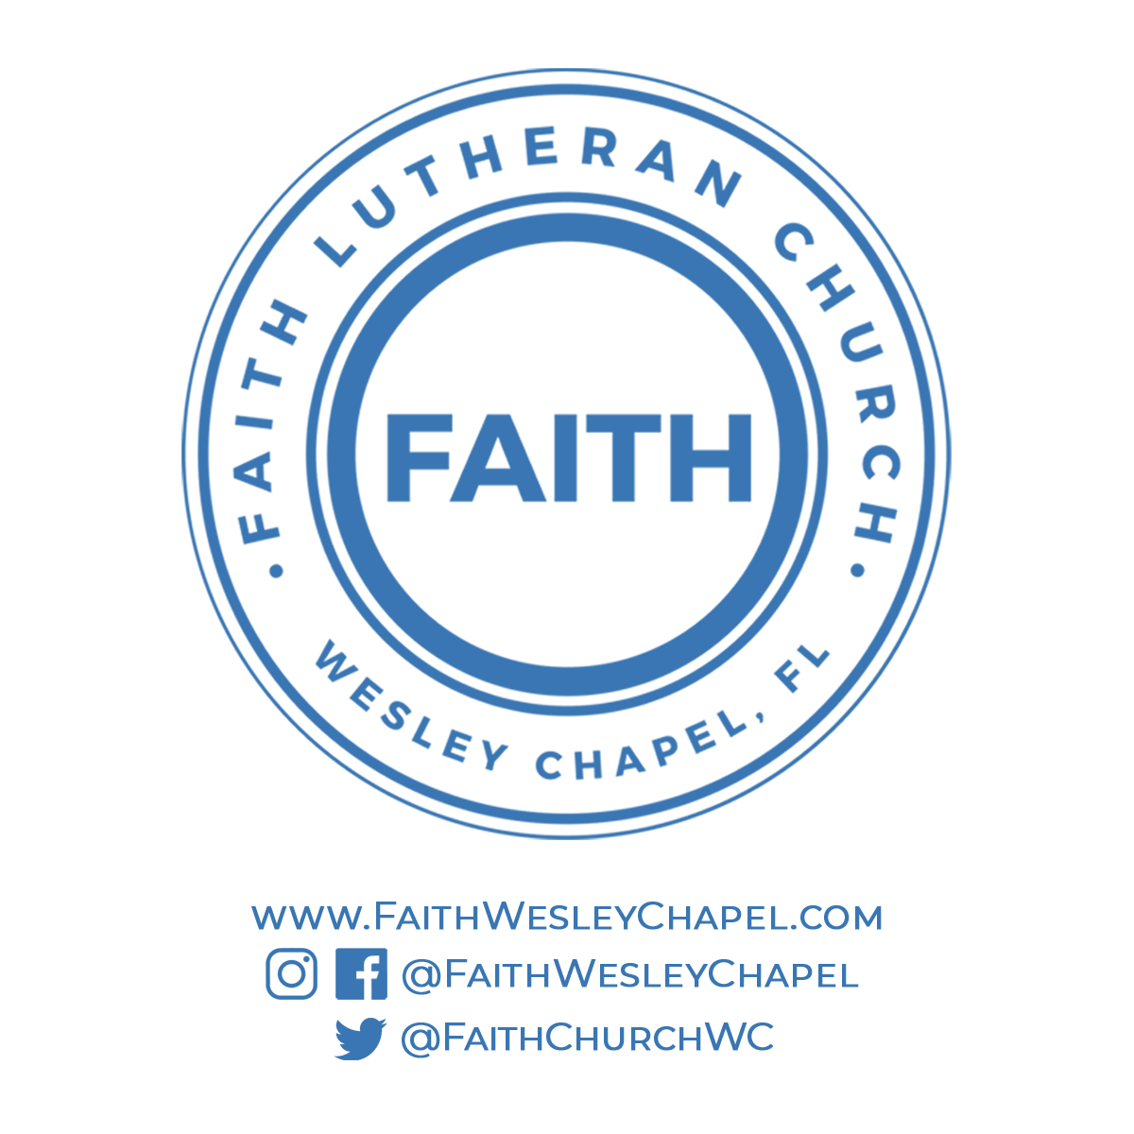**@FaithWesleyChapel**

**@FaithWesleyChapel**

**@FaithChurchWC**