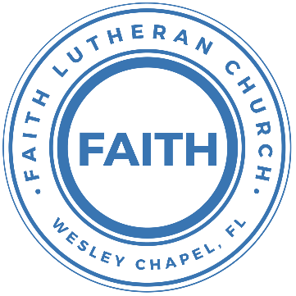

**Leading our community into a deep connection in Christ**

**Worship Service for August 24, 2025 at 11 AM**

**Welcome**

**Invocation**

**Confession and Forgiveness:**

**P:** Our Heavenly Father asks us to come into His presence, But we are sinful and unworthy. Truly, all have sinned and fall short of the glory of God, but Jesus Christ died on the cross that we may be forgiven and washed clean of all our sins by His blood poured out on the cross.  
**C:** Lord, if You wash us, we will certainly be clean and pure.

**P:** We join together in singing, “At the Cross”

**At the Cross (Love Ran Red)**

There’s a place where mercy reigns and never dies.

There’s a place where streams of grace flows deep and wide.

*Pre-Chorus:*

All the love, I’ve ever found,

Comes like a flood, comes flowing down.

*Chorus:*

At the cross, at the cross, I surrender my life.

I’m in awe of you. I’m in awe of you.

Where your love ran red, and my sins washed white.

I owe all to you. I owe all to you, Jesus.

There’s a place where sin and shame are powerless,

Where my heart has peace with God and forgiveness.

*Pre-Chorus:*

All the love, I’ve ever found,

Comes like a flood, comes flowing down.

*Chorus:*

At the cross, at the cross, I surrender my life.

I’m in awe of you. I’m in awe of you.

Where your love ran red, and my sins washed white.

I owe all to you. I owe all to you, Jesus.

**P:** We take a moment to bow before the His cross and silently reflect on our lives and confess our sins.

*(a time of silence to reflect and personally confess our sins)*

**C:** Heavenly Father, we confess that we have sinned against you in thought, word, and deed. We have not loved you with our whole heart and have not loved our neighbor as ourselves. We are truly sorry and we humbly repent. For the sake of your Son Jesus Christ and His suffering and death on the cross, have mercy on us and forgive us; that we may delight in your will, and walk in your ways, to the glory of your Name. Amen

**At the Cross (Love Ran Red) continues…**

*Bridge:*

Here my hope is found, here on holy ground.

Here I bow down. Here I bow down.

Here arms open wide. Here you saved my life.

Here I bow down. Here I bow.

*(Repeat Bridge)*

*(Chorus 2x)* © Countless Wonder Publishing

**P:** The Lord our God is merciful and gracious, longsuffering, and abounding in goodness and truth, keeping mercy for thousands, forgiving iniquity and transgression and sin. Therefore I announce unto you the grace of our Lord Jesus Christ. In His stead and by the command of my Lord Jesus Christ, I forgive you all your sins in the name of the Father and of the Son and of the Holy Spirit.  
**C:** Amen.

**Song of Praise and Thanksgiving -** This Is the Feast

Refrain:  
This is the feast of victory for our God. Alleluia, alleluia, alleluia.

Worthy is Christ, the Lamb who was slain,  
Whose blood set us free to be people of God.   
*(Refrain)*

Power, riches, wisdom, and strength,  
And honor, blessing, and glory are His. *(Refrain)*

Sing with all the people of God,  
And join in the hymn of all creation;

“Blessing, honor, glory, and might,  
Be to God and the Lamb forever. Amen.”   
*(Refrain)*

For the Lamb who was slain has begun his reign. Alleluia!  
*(Refrain)* © 2008 Sharon Dennis, Doris Au MacDonald, and Lutheran Book of Worship

**Old Testament Reading -** Jeremiah 8:4-12

“You shall say to them, Thus says the Lord: When men fall, do they not rise again? If one turns away, does he not return? Why then has this people turned away in perpetual backsliding? They hold fast to deceit; they refuse to return. I have paid attention and listened, but they have not spoken rightly; no man relents of his evil, saying, ‘What have I done?’

Everyone turns to his own course, like a horse plunging headlong into battle. Even the stork in the heavens knows her times, and the turtledove, swallow, and crane keep the time of their coming,  
but my people know not the rules of the Lord.

“How can you say, ‘We are wise, and the law of the Lord is with us’? But behold, the lying pen of the scribes has made it into a lie.  
The wise men shall be put to shame; they shall be dismayed and taken; behold, they have rejected the word of the Lord, so what wisdom is in them? Therefore I will give their wives to others and their fields to conquerors, because from the least to the greatest everyone is greedy for unjust gain; from prophet to priest, everyone deals falsely. They have healed the wound of my people lightly, saying, ‘Peace, peace,’ when there is no peace. Were they ashamed when they committed abomination? No, they were not at all ashamed; they did not know how to blush. Therefore they shall fall among the fallen; when I punish them, they shall be overthrown, says the Lord.

**Reader:** This is the Word of the Lord.  
**C:** Thanks be to God.

**Epistle Reading -** Romans 9:30-10:4

What shall we say, then? That Gentiles who did not pursue righteousness have attained it, that is, a righteousness that is by faith; but that Israel who pursued a law that would lead to righteousness did not succeed in reaching that law. Why? Because they did not pursue it by faith, but as if it were based on works. They have stumbled over the stumbling stone, as it is written,

“Behold, I am laying in Zion a stone of stumbling, and a rock of offense; and whoever believes in him will not be put to shame.”

Brothers, my heart's desire and prayer to God for them is that they may be saved. For I bear them witness that they have a zeal for God, but not according to knowledge. For, being ignorant of the righteousness of God, and seeking to establish their own, they did not submit to God's righteousness. For Christ is the end of the law for righteousness to everyone who believes.

**Reader:** This is the Word of the Lord.  
**C:** Thanks be to God.

**Gospel Reading -** Luke 19:41-48

And when he drew near and saw the city, he wept over it, saying, “Would that you, even you, had known on this day the things that make for peace! But now they are hidden from your eyes. For the days will come upon you, when your enemies will set up a barricade around you and surround you and hem you in on every side and tear you down to the ground, you and your children within you. And they will not leave one stone upon another in you, because you did not know the time of your visitation.”

And he entered the temple and began to drive out those who sold, saying to them, “It is written, ‘My house shall be a house of prayer,’ but you have made it a den of robbers.” And he was teaching daily in the temple. The chief priests and the scribes and the principal men of the people were seeking to destroy him, but they did not find anything they could do, for all the people were hanging on his words.

**P:** This is the Gospel of the Lord.  
**C:** Praise be to You, O Christ.

**Children's Message**

**Sermon Hymn -** King Of Kings *(sit)*

In the darkness we were waiting, without hope, without light,

Till from heaven You came running. There was mercy in Your eyes.

To fulfil the law and prophets, to a virgin came the Word;

From a throne of endless glory to a cradle in the dirt.

Chorus:  
Praise the Father, Praise the Son, Praise the Spirit, Three in One!  
God of glory, Majesty. Praise forever to the King of Kings!

To reveal the kingdom coming and to reconcile the lost,

To redeem the whole creation, You did not despise the cross.

For even in your suffering You saw to the other side.

Knowing this was our salvation, Jesus, for our sake, You died

*(Chorus)*

And the morning that You rose all of heaven held its breath,

Till that stone was moved for good; for the Lamb had conquered death.

And the dead rose from their tombs. And the angels stood in awe, For the souls of all who'd come to the Father are restored.

And the church of Christ was born. Then, the Spirit lit the flame.

Now this Gospel truth of old shall not kneel, shall not faint.

By His blood and in His name, in His freedom, I am free;

For the love of Jesus Christ who has resurrected me.

*(Chorus 2x)* © 2018 Hillsong Music Publishing

**Sermon -** "The Fate of Israel"

**Prayers:** *Text in prayer requests to (813) 326-5255‬*

**Apostles' Creed** *(stand)*

I believe in God, the Father almighty, maker of heaven and earth,  
And in Jesus Christ, his only Son, our Lord,  
who was conceived by the Holy Spirit,  
born of the Virgin Mary, suffered under Pontius Pilate,  
was crucified, died and was buried. He descended into hell.  
The third day he rose again from the dead.  
He ascended into heaven and sits at the right hand of God  
the Father almighty.  
From there he will come to judge the living and the dead.  
I believe in the Holy Spirit, the holy Christian Church,  
the communion of saints, the forgiveness of sins,  
the resurrection of the body, and the life everlasting. Amen.

**The Lord's Prayer** *(stand)*

Our Father who art in heaven, hallowed be Thy name, Thy kingdom come, Thy will be done on earth as it is in heaven.  Give us this day our daily bread; and forgive us our trespasses as we forgive

those who trespass against us; and lead us not into temptation, but deliver us from evil.  For Thine is the kingdom and the power and the glory forever and ever.  Amen

**Offering**  *Give online at:*

**Benediction** *(stand)*

**Closing Song -**Your Grace Is Enough

Great is Your faithfulness oh God.  
You wrestle with the sinner's restless heart.  
You lead us by still waters into mercy,  
And nothing can keep us apart.

Pre-chorus:  
So, remember Your people. Remember Your children.  
Remember Your promise, Oh God.

Chorus:  
Your grace is enough. Your grace is enough.  
Your grace is enough for me.

Great is Your love and justice God of Jacob.  
You use the weak to lead the strong.  
You lead us in the song of Your salvation,  
And all Your people sing along.

*(Pre-chorus)*

*(Chorus 2x)* © 2003 spiritandsong.com and Thankyou Music

|  |  |
| --- | --- |
| **Serving This Week** | |
|  | |
| **O.T. Reader:** Josh Strasheim | **Children’s Church Teacher:** |
| **Epistle Reader:** Melissa Steinbrueck | Melissa Steinbrueck |
| **Acolyte:** Lawrence Finnerty | **Children’s Church Assistant:** |
| **Com. Asst:** Larry Chmiel | Kaylee Steinbrueck |
|  | |
| **Serving Next Week** | |
|  | |
| **O.T. Reader:** Larry Chmiel | **Children’s Church Teacher:** |
| **Epistle Reader:** Melissa Steinbrueck | Ben and Halston |
| **Acolyte:** Lawrence Finnerty | **Children’s Church Assistant:** |
| **Com. Asst:** Larry Chmiel | N/A |

**Upcoming Events**

**Today, Now – In-Person Growth Group Survey**We’ve created a survey regarding our in-person Growth Group(s) to determine the best days/times to meet and topics to cover. Please complete the survey in the bulletin insert and put it in the offering plate.

**Aug 26, 7 PM Council Meeting**  
Zoom

**Aug 28, 7 PM – Growth Group Bible Study**(In-Person and Online)Zoom

**www.FaithWesleyChapel.com**

**Faith YouTube**

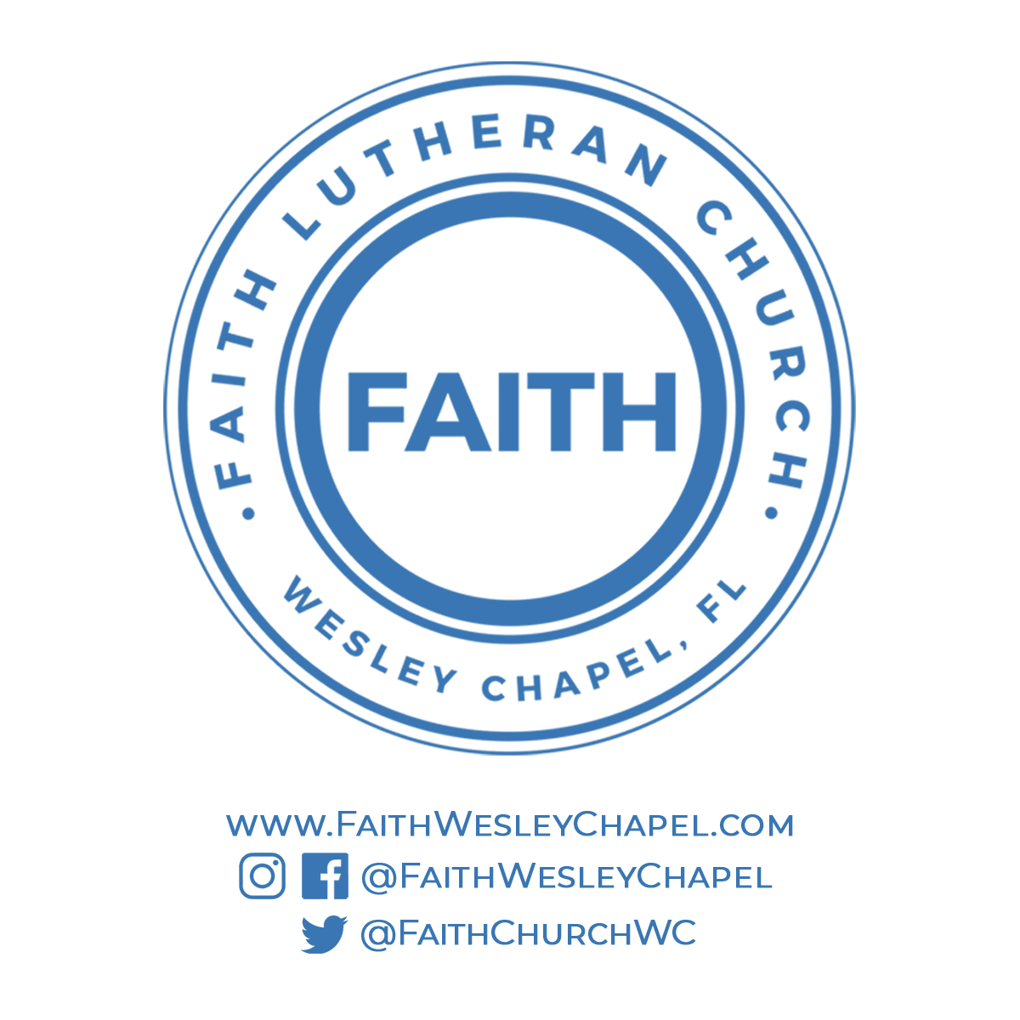**@FaithWesleyChapel**

**@FaithWesleyChapel**

**@FaithChurchWC**