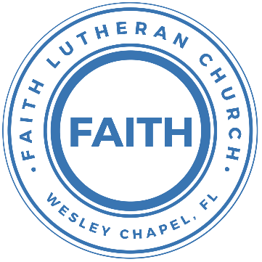

**Leading our community into a deep connection in Christ**

**___________________________________________________**

**Worship Service for August 31, 2025 at 11 AM**

**Welcome** and **Opening Song:**Praise To The Lord The Almighty  
Praise to the Lord the Almighty, the King of creation.

O my soul, praise Him for He is your health and salvation.

Let all who hear, now to His temple draw near,

Joining in glad adoration.

Praise to the Lord who o’er all things is wondrously reigning,

And as on wings of an eagle, uplifting, sustaining.

Have you not seen, all that is needful has been,

Sent by His gracious ordaining?

Praise to the Lord! O let all that is in me adore Him.

All that has life and breath come now with praises before Him.

Let the “Amen” sound from His people again.  
Gladly forever adore Him. © Public Domain

**Invocation** and **Confession and Forgiveness:**  
**P:** Come into the presence of God. It is God, Himself, who bids us to come to Him in prayer, especially when we have sinned, so that we may receive His forgiveness. So, we enter His courts with confidence that if we confess our sins, He will forgive us as He promised.

*(A time of silence to reflect and personally confess our sins)*

**C:** Heavenly Father, we confess that we have sinned against you in

thought, word, and deed. We have not loved you with our whole heart and have not loved our neighbor as ourselves. We are truly sorry and we humbly repent. For the sake of your Son Jesus Christ and His suffering and death on the cross, have mercy on us and forgive us; that we may delight in your will, and walk in your ways, to the glory of your Name. Amen

**P:** The Lord our God is merciful and gracious, longsuffering, and abounding in goodness and truth, keeping mercy for thousands, forgiving iniquity and transgression and sin. Therefore I announce unto you the grace of our Lord Jesus Christ. In His stead and by the command of my Lord Jesus Christ, I forgive you all your sins in the name of the Father and of the Son and of the Holy Spirit.  
**C:** Amen.

**Song of Praise and Thanksgiving -** God So Loved

Come all you weary. Come all you thirsty.

Come to the well that never runs dry.

Drink of the Water. Come and thirst no more.

Come all you sinners. Come find His mercy.

Come to the table. He Will satisfy.

Taste of His goodness. Find what you’re looking for.

Chorus 1:

For God so loved the World that He gave us,

His one and only Son to save us.

Whoever believes in Him, will live forever.

Bring all your failures. Bring your addictions.

Come lay them down at the Foot of the cross.

Jesus is waiting there with open arms.

*(Chorus 1)*

Chorus 2:

The power of Hell forever defeated.

Now, it is well. I’m walking in freedom.

For God so loved, God so loved the world.

Bridge:

Praise God! Praise God from whom all blessings flow.

Praise Him! Praise Him for the wonders of His love.

*(Repeat)*

His amazing love!

*(Chorus 1)*

*(Chorus 2)*

Bring all your failures. Bring your addictions.

Come lay them down at the Foot of the cross.

Jesus is waiting there with open arms. © 2019 Andrew Bergthold Designee

**Old Testament Reading -** Genesis 4:1-15

Now Adam knew Eve his wife, and she conceived and bore Cain, saying, “I have gotten a man with the help of the Lord.” And again, she bore his brother Abel. Now Abel was a keeper of sheep, and Cain a worker of the ground. In the course of time Cain brought to the Lord an offering of the fruit of the ground, and Abel also brought of the firstborn of his flock and of their fat portions. And the Lord had regard for Abel and his offering, but for Cain and his offering he had no regard. So Cain was very angry, and his face fell. The Lord said to Cain, “Why are you angry, and why has your face fallen? If you do well, will you not be accepted? And if you do not do well, sin is crouching at the door. Its desire is for you, and you must rule over it.”

Cain spoke to Abel his brother. And when they were in the field, Cain rose up against his brother Abel and killed him. Then the Lord said to Cain, “Where is Abel your brother?” He said, “I do not know; am I my brother's keeper?” And the Lord said, “What have you done? The voice of your brother's blood is crying to me from the ground. And now you are cursed from the ground, which has opened its mouth to receive your brother's blood from your hand. When you work the ground, it shall no longer yield to you its strength. You shall be a fugitive and a wanderer on the earth.” Cain said to the Lord, “My punishment is greater than I can bear. Behold, you have driven me today away from the ground, and from your face I shall be hidden. I shall be a fugitive and a wanderer on the earth, and whoever finds me will kill me.” Then the Lord said to him, “Not so! If anyone kills Cain, vengeance shall be taken on him sevenfold.” And the Lord put a mark on Cain, lest any who found him should attack him.

**Reader:** This is the Word of the Lord.  
**C:** Thanks be to God.

**Epistle Reading -** Ephesians 2:1-10

And you were dead in the trespasses and sins in which you once walked, following the course of this world, following the prince of the power of the air, the spirit that is now at work in the sons of disobedience — among whom we all once lived in the passions of our flesh, carrying out the desires of the flesh and the mind, and were by nature children of wrath, like the rest of mankind. But God, being rich in mercy, because of the great love with which he loved us, even when we were dead in our trespasses, made us alive together with Christ—by grace you have been saved — and raised us up with him and seated us with him in the heavenly places in Christ Jesus, so that in the coming ages he might show the immeasurable riches of his grace in kindness toward us in Christ Jesus. For by grace you have been saved through faith. And this is not your own doing; it is the gift of God, not a result of works, so that no one may boast. For we are his workmanship, created in Christ Jesus for good works, which God prepared beforehand, that we should walk in them.

**Reader:** This is the Word of the Lord.  
**C:** Thanks be to God.

**Gospel Reading -** Luke 18:9-14

He also told this parable to some who trusted in themselves that they were righteous, and treated others with contempt: “Two men went up into the temple to pray, one a Pharisee and the other a tax collector. The Pharisee, standing by himself, prayed thus: ‘God, I thank you that I am not like other men, extortioners, unjust, adulterers, or even like this tax collector. I fast twice a week; I give tithes of all that I get.’

But the tax collector, standing far off, would not even lift up his eyes to heaven, but beat his breast, saying, ‘God, be merciful to me, a sinner!’ I tell you, this man went down to his house justified, rather than the other. For everyone who exalts himself will be humbled, but the one who humbles himself will be exalted.”

**P:** This is the Gospel of the Lord.  
**C:** Praise be to You, O Christ.

**Children's Message** *(Children dismissed to Children's Church)*

**Sermon Hymn -** Humble Thyself In The Sight Of The Lord

Verse:  
Humble Thyself in the Sight of the Lord *(echo)*  
Humble Thyself in the Sight of the Lord *(echo)*

Chorus:  
And He shall lift you up, higher and higher.  
*(And He shall lift)*

And He shall lift you up, up into Heaven, and He shall lift you up.  
*(And He shall lift) (And He shall lift)*

(Verse 2x)

(Chorus) © 1978 Maranatha! Music and CCCM Music

**Sermon -** "Humbled and Exalted"

**Prayers:** *Text in prayer requests to (813) 326-5255‬*

**Nicene Creed** *(stand)*

I believe in one God, the Father Almighty, maker of heaven and earth and of all things visible and invisible.

And in one Lord Jesus Christ, the only-begotten Son of God, begotten of His Father before all worlds, God of God, Light of Light, very God of very God, begotten, not made, being of one substance with the Father, by whom all things were made; who for us men and for our salvation came down from heaven and was incarnate by the Holy Spirit of the virgin Mary and was made man; and was crucified also for us under Pontius Pilate. He suffered and was buried. And the third day He rose again according to the Scriptures and ascended into heaven and sits at the right hand of the Father. And He will come again with glory to judge both the living and the dead, whose kingdom will have no end.

And I believe in the Holy Spirit, the Lord and Giver of Life, who proceeds from the Father and the Son, who with the Father and the Son together is worshiped and glorified, who spoke by the prophets. And I believe in one holy Christian and apostolic Church, I acknowledge one Baptism for the remission of sins, and I look for the resurrection of the dead and the life of the world to come. Amen.

**The Lord's Prayer** *(stand)*

Our Father who art in heaven, hallowed be Thy name, Thy kingdom come, Thy will be done on earth as it is in heaven.  Give us this day our daily bread; and forgive us our trespasses as we forgive those who trespass against us; and lead us not into temptation, but deliver us from evil.  For Thine is the kingdom and the power and the glory forever and ever.  Amen

**Offering**  *Give online at:*

**Benediction** *(stand)*

**Closing Song -**This Is Our God  
Remember those walls that we called sin and shame?  
They were like prisons that we couldn't escape.  
But He came, and He died, and He rose.  
Those walls are rubble now.

Remember those giants we called death and grave?  
They were like mountains that stood in our way.  
But He came, and He died, and He rose.  
Those giants are dead now.

Chorus  
This is our God, this is who He is, He loves us.  
This is our God, this is what He does, He saves us.  
He bore the cross, beat the grave,  
let heaven and earth proclaim,  
this is our God, King Jesus.

Remember that fear that took our breath away?  
Faith so weak that we could barely pray.  
But He heard, Every word, every whisper.

Now those altars in the wilder-ness.  
Tell the story of His faithfulness.  
Never once, did He fail, and He never will.

*(Chorus)*

Bridge  
Who pulled me out of that pit? He did. He did.  
Who paid for all of our sins? Nobody but Jesus.  
*(Repeat both lines)*  
Who rescued me from that grave? Yahweh. Yahweh.  
Who gets the glory and praise? Nobody but Jesus.  
*(Repeat both lines)*

*(Chorus)* © Brandon Lake Music

|  |  |
| --- | --- |
| **Serving This Week** | |
|  | |
| **O.T. Reader:** Josh Strasheim | **Children’s Church Teacher:** |
| **Epistle Reader:** Melissa Steinbrueck | Melissa Steinbrueck |
| **Acolyte:** Lawrence Finnerty | **Children’s Church Assistant:** |
| **Com. Asst:** Larry Chmiel | Kaylee Steinbrueck |
|  | |
| **Serving Next Week** | |
|  | |
| **O.T. Reader:** Larry Chmiel | **Children’s Church Teacher:** |
| **Epistle Reader:** Melissa Steinbrueck | Ben and Halston |
| **Acolyte:** Lawrence Finnerty | **Children’s Church Assistant:** |
| **Com. Asst:** Larry Chmiel | N/A |

**Upcoming Events**

**Today, Now – In-Person Growth Group Survey**We’ve created a survey regarding our in-person Growth Group(s) to determine the best days/times to meet and topics to cover. Please complete the survey in the bulletin insert and put it in the offering plate.

**Sept. 4, 7 PM – Growth Group Bible Study**(Online)Zoom

[**www.FaithWesleyChapel.com**](http://www.FaithWesleyChapel.com)

 **Faith YouTube**

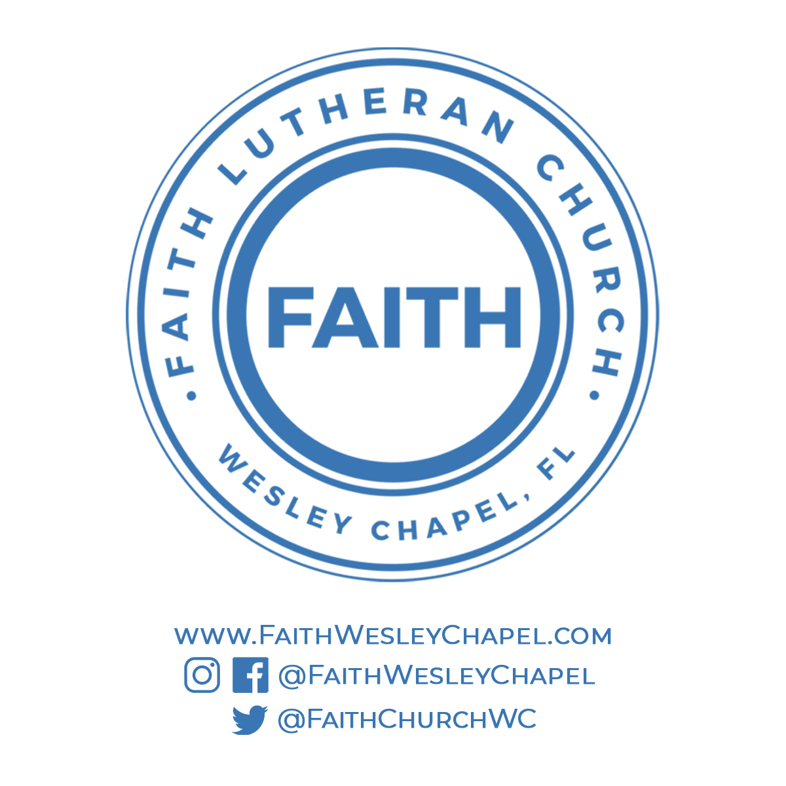**@FaithWesleyChapel**

**@FaithWesleyChapel**

**@FaithChurchWC**