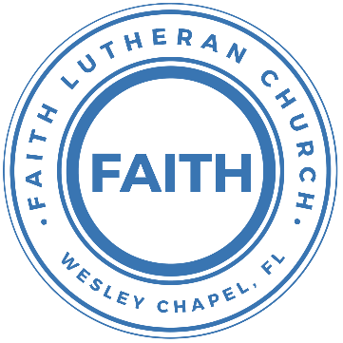

**Leading our community into a deep connection in Christ**

**___________________________________________________**

**Worship Service for September 7, 2025 at 11 AM**

**Welcome**

**Opening Song:**This Little Light of Mine

This little light of mine, I'm gonna let it shine.  
This little light of mine, I'm gonna let it shine.  
This little light of mine, I'm gonna let it shine,  
Let it shine, let it shine, let it shine.

Hide it under a bushel, NO!, I'm gonna let it shine.  
Hide it under a bushel, NO!, I'm gonna let it shine.  
Hide it under a bushel, NO!, I'm gonna let it shine,  
Let it shine, let it shine, let it shine.

Won't let Satan blow it out, I'm gonna let it shine.  
Won't let Satan blow it out, I'm gonna let it shine.  
Won't let Satan blow it out, I'm gonna let it shine,  
Let it shine, let it shine, let it shine.

Let it shine 'til Jesus comes, I'm gonna let it shine.  
Let it shine 'til Jesus comes, I'm gonna let it shine.  
Let it shine 'til Jesus comes, I'm gonna let it shine,  
Let it shine, let it shine, let it shine. © Public Domain

**Invocation**

**Confession and Forgiveness:**

**P:** We have come here today to worship the Lord.  In worship we hear the Word of God, we receive God's blessings, and respond with thanks and praise.  We begin by seeking God's blessing of forgiveness.  He has promised to remove the guilt and shame of our sin through the sacrifice of Jesus Christ on the cross.

*(a time of silence to reflect and personally confess our sins)*

**P:** Let us confess our sins to the Lord.

**P:** Heavenly Father,  
**C:** Heavenly Father,

**P:** I have done things that were wrong.  
**C:** I have done things that were wrong.  
  
**P:** I have been mean to others.  
**C:** I have been mean to others.

**P:** I have not obeyed my parents.  
**C:** I have not obeyed my parents.

**P:** I have not obeyed You, God.  
**C:** I have not obeyed You, God.

**P:** But I am very sorry.  
**C:** But I am very sorry.

**P:** Please forgive me.  
**C:** Please forgive me.

**P:** I love You very much.  
**C:** I love You very much.

**P:** And I know You love me, too.  
**C:** And I know You love me, too.

**P:** Amen.  
**C:** Amen.

**P:** God has heard your apology.  He loves you very much.  God has told us that when we believe and trust in Him, He makes us His children.  As far as the east is from the west, so far does he remove our sins from us. He has told me to tell you that you are forgiven.  So, as His servant, I forgive you in the name of the Father and of the Son and of the Holy Spirit.   
**C:** Amen.

**Song:**Jesus Loves Me

Verse 1:

Jesus loves me this I know, For the Bible tells me so.

Little ones to Him belong, They are weak, but He is strong.

Chorus:

Yes, Jesus loves me, Yes, Jesus loves me,

Yes, Jesus loves me, The Bible tells me so.

Verse 2:

Jesus loves me, He who died. Heaven's gates to open wide.

He will wash away my sin, Let His little child come in.

Chorus:

Yes, Jesus loves me, Yes, Jesus loves me,

Yes, Jesus loves me, The Bible tells me so. © Public Domain

**First Reading –**2 Corinthians 3:6

We know that these things are true. Because of what Christ has done, we trust God to help us. We know that we cannot do this work by ourselves. We never think that. But God makes us able to do it. God has made us his servants. So we are able to tell people the message of his new agreement.

**Reader:** This is the Word of the Lord.  
**C:** Thanks be to God.

**Children's Message**"We Are Ministers Because God Makes Us Able"

**Song:**I Love To Tell The Story

I love to tell the story of unseen things above,   
Of Jesus and His glory, of Jesus and his love.  
I love to tell the story because I know 'tis true.  
It satisfies my longings as nothing else can do.

Chorus:  
I love to tell the story. 'Twill be my theme in glory,  
To tell the old, old story of Jesus and his love.

I love to tell the story. 'Tis pleasant to repeat,   
What seems each time I tell it more wonderfully sweet.  
I love to tell the story for some have never heard,   
The message of salvation from God's own Holy Word.

*(Chorus)*

I love to tell the story, for those who know it best,  
Seem hungering and thirsting to hear it like the rest.  
And when in scenes of glory, I sing the new, new song,  
Twill be the old, old story that I have loved so long.

*(Chorus)* © Public Domain

**Second Reading -**2 Corinthians 3:6

This new agreement is not about rules. Rules tell people what they must do and they bring death. But God's new agreement comes from his Spirit. And the Spirit brings new life to us, not death.

**Reader:** This is the Word of the Lord.  
**C:** Thanks be to God.

**Children's Message**"The Law Kills. The Gospel Gives Life"

**Gospel Reading –**Mark 7:31-37

Then he returned from the region of Tyre and went through Sidon to the Sea of Galilee, in the region of the Decapolis. And they brought to him a man who was deaf and had a speech impediment, and they begged him to lay his hand on him. And taking him aside from the crowd privately, he put his fingers into his ears, and after spitting touched his tongue. And looking up to heaven, he sighed and said to him, “Ephphatha,” that is, “Be opened.” And his ears were opened, his tongue was released, and he spoke plainly. And Jesus charged them to tell no one. But the more he charged them, the more zealously they proclaimed it. And they were astonished beyond measure, saying, “He has done all things well. He even makes the deaf hear and the mute speak.”

**P:** This is the Gospel of the Lord.  
**C:** Praise be to You, O Christ.

**Song:**Now All The Vault Of Heaven Resounds

Now all the vault of Heav'n resounds,

In praise of love that still abound,

“Christ has triumphed! He is living!"

Sing, choirs of angels, loud and clear.

Repeat their song of glory here.

“Christ has triumphed! Christ has triumphed!

Alleluia, alleluia, alleluia.”

Eternal is the gift He brings.

Therefore, our heart with rapture sings,

“Christ has triumphed! He is living!"

Now, still, He comes to give us life,

And by His presence stills all strife.

Christ has triumphed! He is living!

Alleluia, alleluia, alleluia.

Adoring praises now we bring

And with the heavenly blessed sing,

“Christ has triumphed, Alleluia!

Be to the Father, and our Lord,

To Spirit blest, most holy God,

All the glory, never-ending!

Alleluia, alleluia, alleluia.“ © 1989,1994 Lorenz Publishing Company

**Sermon –**“It's Time for the Mute to Speak”

**What Happened at the Youth Gathering –** Kaylee Steinbrueck

**Prayers:** *Text in prayer requests to (813) 326-5255*

**The Lord's Prayer**

Our Father who art in heaven, hallowed be Thy name, Thy kingdom come, Thy will be done on earth as it is in heaven.  Give us this day our daily bread; and forgive us our trespasses as we forgive those who trespass against us; and lead us not into temptation, but deliver us from evil.  For Thine is the kingdom and the power and the glory forever and ever.  Amen

**Offering**  *Give online at:*

**Benediction** *(The online service ends. The closing song can be found as a YouTube video at FaithWesleyChapel.com/bulletin)*

**Thank you for joining Faith for worship. We hope to see you in person soon!**

**Closing Song:**We Are

Every secret, every shame, every fear, every pain,

Live inside the dark, but that’s not who we are.

We are children of the day.

Pre-Chorus:

So wake up sleeper, lift your head.

We were meant for more than this

Fight the shadows conquer death.

Make the most of the time we have left

Chorus:  
We are the light of the world. We are the city on a hill  
We are the light of the world  
We gotta, we gotta, we gotta let the light shine  
*(Repeat)*  
Let the light shine, let the light shine

We are called to the spread the news.  
Tell the world the simple truth.  
Jesus came to save. There’s freedom in His Name.  
So let it all break through

*(Pre-Chorus)*

*(Chorus)*

Bridge:  
We are the light we are the light we are the light  
So let your light shine brighter  
We the light we are the light we are the light... Jesus  
You are the light you are the light you are the light.  
We will lift you high and Shine, shine, shine

*(Chorus)* © 2011 Alletrop Music, Centricity Music Publishing

|  |  |
| --- | --- |
| **Serving This Week** | |
|  | |
| **1st Reader:** Kaylee Steinbrueck | **Children’s Church Teacher:** |
| **2nd Reader:** Thomas Horness | N/A – No Children’s Church |
| **Acolyte:** Eli Steinbrueck | **Children’s Church Assistant:** |
| **Com. Asst:** Larry Chmiel | N/A – No Children’s Church |
|  | |
| **Serving Next Week** | |
|  | |
| **O.T. Reader:** Richard Steinbrueck | **Children’s Church Teacher:** |
| **Epistle Reader:** Eli Bingaman | Melissa Steinbrueck |
| **Acolyte:** Alanna Bingaman | **Children’s Church Assistant:** |
| **Com. Asst:** Larry Chmiel | Kaylee Steinbrueck |

**Upcoming Events**

**Sept 11, 7 PM – Growth Group Bible Study** (Online)Zoom

**Sept 14, 11 AM – Faith and Food Worship Service**Faith Lutheran Church.

**Sept 14, 11 AM – Outreach Planning**Faith Lutheran Church

**Sept 14, After the Service – Prepping Mailers**Faith Lutheran Church

[**www.FaithWesleyChapel.com**](http://www.FaithWesleyChapel.com)

 **Faith YouTube**

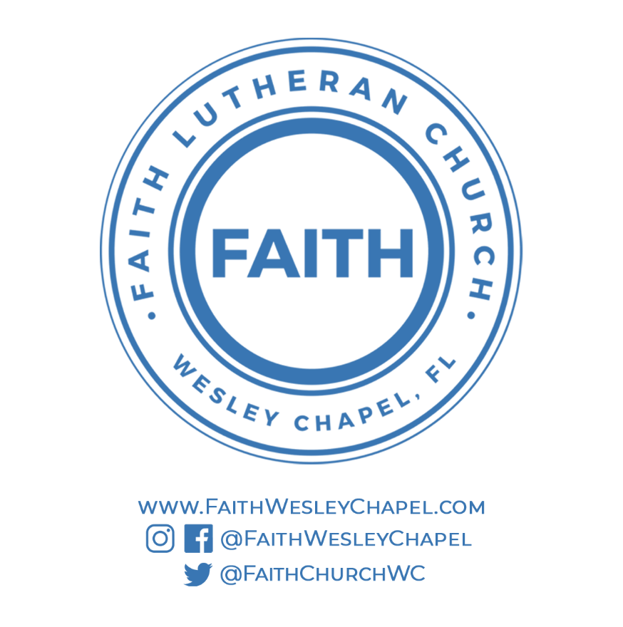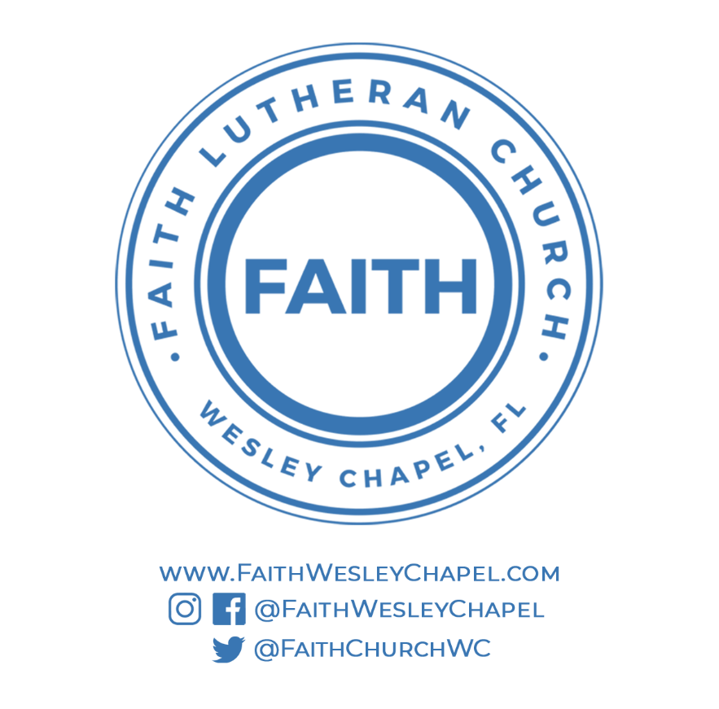**@FaithWesleyChapel**

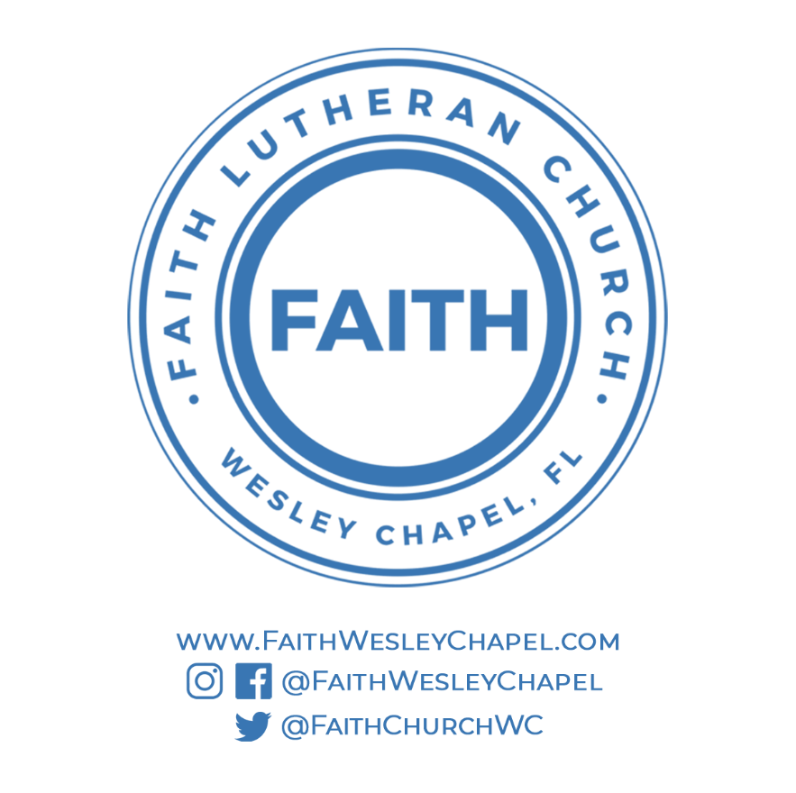**@FaithWesleyChapel**

**@FaithChurchWC**