

**Leading our community into a deep connection in Christ**

**___________________________________________________**

**Worship Service for September 21, 2025 at 11 AM**

**Welcome and Opening Song:** Let Us Ever Walk With Jesus

Let us ever walk with Jesus, follow His example pure,  
Through a world that would deceive us and to sin our spirits lure.  
Onward in His footsteps treading, pilgrims here, our home above,  
Full of faith and hope and love, let us do the Father’s bidding.  
Faithful Lord, with me abide; I shall follow where You guide.

Let us suffer here with Jesus and with patience bear our cross.  
Joy will follow all our sadness; where He is, there is no loss.  
Though today we sow no laughter, we shall reap celestial joy;  
All discomforts that annoy shall give way to mirth hereafter.  
Jesus, here I share Your woe; help me there Your joy to know.

Let us gladly die with Jesus. Since by death He conquered death,  
He will free us from destruction, give to us immortal breath.  
Let us mortify all passion that would lead us into sin;  
And the grave that shuts us in shall but prove the gate to heaven.  
Jesus, here with You I die, there to live with You on high.

Let us also live with Jesus. He has risen from the dead,  
That to life we may awaken. Jesus, You are now our head.  
We are Your own living members; where You live, there we shall be,  
In Your presence constantly, living there with You forever.  
Jesus, let me faithful be, life eternal grant to me.   
 © 1978 Lutheran Book of Worship

**Invocation**

**Confession and Forgiveness:**

**P:** Our Heavenly Father asks us to come into His presence.  
**C:** But we are sinful and unworthy.

**P:** Yes, all have sinned and fall short of the glory of God, but Jesus Christ died on the cross that we may be forgiven and washed clean of all our sins by His blood spilled on the cross.  
**C:** Lord, if You wash us, we will certainly be clean and pure.

**P:** We take a moment to bow before the His cross and silently reflect on our lives and confess our sins.

*(Time of silence for reflection and confession)*

**P:** Let us confess, together, our sins to God our Father.  
**C:** Heavenly Father, we confess that we are sinners.  We have sinned against you and our neighbors. We have not loved you with our whole heart and we have not loved our neighbors as ourselves. We have not lived out our faith in our community. We justly deserve Your punishment.  For the sake of Your Son, Jesus Christ, have mercy on us.  Forgive us, renew us, and lead us, so that we may delight in Your will and walk in Your ways to the glory of Your holy name.  Amen.

**P:** Almighty God in His mercy has given His Son to die for you and for His sake forgives you all your sins.  As a called and ordained servant of Christ, and by His authority, I, therefore, forgive you all your sins in the name of the Father and of the Son and of the Holy Spirit.  
**C:** Amen

**Song of Praise and Thanksgiving:** What a Friend

Everybody has trials and temptations.  
Everybody knows heartbreak, isolation.

Pre-Chorus:  
But we can lay our burdens down. Lay our burdens down.

Chorus:  
What a friend we have in Jesus. East to west my sins are gone.  
I see grace on every horizon.  
And forever and ever His heart is my home.

Everybody has fears, everybody got worries.  
Everybody knows sorrow, devastation.

*(Pre-Chorus)  
(Chorus)*

Bridge:  
No more betrayal, for He is faithful.  
He fills me up and my cup runneth over.  
No more betrayal, for He is faithful.  
How He has proven it over and over.  
(Repeat)

*(Chorus 2x)*

And forever and ever His heart is my home. © All Essential Music

**Old Testament Reading** - Psalm 119:9– 16How can a young man keep his way pure? By guarding it according to your word. With my whole heart I seek you; let me not wander from your commandments! I have stored up your word in my heart, that I might not sin against you. Blessed are you, O Lord; teach me your statutes! With my lips I declare all the rules of your mouth. In the way of your testimonies I delight as much as in all riches. I will meditate on your precepts and fix my eyes on your ways. I will delight in your statutes; I will not forget your word.

**Reader:** This is the Word of the Lord.  
**C:** Thanks be to God.

**Epistle Reading** - Galatians 5:16-25But I say, walk by the Spirit, and you will not gratify the desires of the flesh. For the desires of the flesh are against the Spirit, and the desires of the Spirit are against the flesh, for these are opposed to each other, to keep you from doing the things you want to do. But if you are led by the Spirit, you are not under the law. Now the works of the flesh are evident: sexual immorality, impurity, sensuality, idolatry, sorcery, enmity, strife, jealousy, fits of anger, rivalries, dissensions, divisions, envy, drunkenness, orgies, and things like these. I warn you, as I warned you before, that those who do such things will not inherit the kingdom of God. But the fruit of the Spirit is love, joy, peace, patience, kindness, goodness, faithfulness, gentleness, self-control; against such things there is no law. And those who belong to Christ Jesus have crucified the flesh with its passions and desires. If we live by the Spirit, let us also keep in step with the Spirit.

**Reader:** This is the Word of the Lord.  
**C:** Thanks be to God.

**Gospel Reading** - Luke 17:11-19On the way to Jerusalem he was passing along between Samaria and Galilee. And as he entered a village, he was met by ten lepers, who stood at a distance and lifted up their voices, saying, “Jesus, Master, have mercy on us.” When he saw them he said to them, “Go and show yourselves to the priests.” And as they went they were cleansed. Then one of them, when he saw that he was healed, turned back, praising God with a loud voice; and he fell on his face at Jesus' feet, giving him thanks. Now he was a Samaritan. Then Jesus answered, “Were not ten cleansed? Where are the nine? Was no one found to return and give praise to God except this foreigner?” And he said to him, “Rise and go your way; your faith has made you well.”

**P:** This is the Gospel of the Lord.  
**C:** Praise be to You, O Christ.

**Children's Message** *(Children dismissed to Children's Church)*

**Sermon Hymn***–*Turn Your Eyes Upon Jesus

O soul are you weary and troubled?  
No light in the darkness you see?  
There's light for a look at the Savior,  
And life more abundant and free.

Chorus:  
Turn your eyes upon Jesus,  
Look full in His wonderful face;  
And the things of earth will grow strangely dim,  
In the light of His glory and grace.

Through death into life everlasting,  
He passed, and we follow Him there.  
Over us sin no more hath dominion,  
For more than conqu'rors we are.

*(Chorus)*

His word shall not fail you. He promised.  
Believe Him and all will be well.  
Then go to a world that is dying,  
His perfect salvation to tell.

*(Chorus repeat last two lines)*

**Sermon** - "The Way of The Spirit"

**Prayers:** *Text in prayer requests to (813) 326-5255*

**Nicene Creed** *(stand)*

I believe in one God, the Father Almighty, maker of heaven and earth and of all things visible and invisible.

And in one Lord Jesus Christ, the only-begotten Son of God, begotten of His Father before all worlds, God of God, Light of Light, very God of very God, begotten, not made, being of one substance with the Father, by whom all things were made; who for us men and for our salvation came down from heaven and was incarnate by the Holy Spirit of the virgin Mary and was made man; and was crucified also for us under Pontius Pilate. He suffered and was buried. And the third day He rose again according to the Scriptures and ascended into heaven and sits at the right hand of the Father. And He will come again with glory to judge both the living and the dead, whose kingdom will have no end.

And I believe in the Holy Spirit, the Lord and Giver of Life, who proceeds from the Father and the Son, who with the Father and the Son together is worshiped and glorified, who spoke by the prophets. And I believe in one holy Christian and apostolic Church, I acknowledge one Baptism for the remission of sins, and I look for the resurrection of the dead and the life of the world to come. Amen.

**The Lord's Prayer** *(stand)*

Our Father who art in heaven, hallowed be Thy name, Thy kingdom come, Thy will be done on earth as it is in heaven.  Give us this day our daily bread; and forgive us our trespasses as we forgive those who trespass against us; and lead us not into temptation, but deliver us from evil.  For Thine is the kingdom and the power and the glory forever and ever.  Amen

**Offering**  *Give online at:*

**Benediction** *(The online service ends. The closing song can be found as a YouTube video at FaithWesleyChapel.com/bulletin)*

**Thank you for joining Faith for worship. We hope to see you in person soon!**

**Closing Song:**Holy Spirit, Breath of God

Holy Spirit living Breath of God  
Breathe new life into my willing soul  
Bring the presence of the risen Lord  
Come renew my heart and make me whole  
Cause Your Word to come alive in me  
Give me faith for what I can-not see  
Give me passion for Your purity  
Holy Spirit breathe new life in me

Holy Spirit come abide within  
May Your joy be seen in all I do  
Love enough to cover every sin  
In each thought and deed and attitude  
Kindness to the greatest and the least  
Gentleness that sows the path of peace  
Turn my striving into works of grace  
Breath of God, show Christ in all I do

Holy Spirit from creation's birth  
Giving life to all that God has made  
Show Your power once again on earth  
Cause Your church to hunger for Your ways  
Let the fragrance of our prayers arise  
Lead us on the road of sacrifice  
That in unity the face of Christ  
May be clear for all the world to see © 2006 Thankyou Music

|  |  |
| --- | --- |
| **Serving This Week** | |
|  | |
| **O.T. Reader:** Josh Strasheim | **O.T. Reader:** Josh Strasheim |
| **Epistle Reader:** Melissa Steinbrueck | **Epistle Reader:** Melissa Steinbrueck |
| **Acolyte:** Lawrence Finnerty | **Acolyte:** Lawrence Finnerty |
| **Com. Asst:** Larry Chmiel | **Com. Asst:** Larry Chmiel |
|  | |
| **Serving Next Week** | |
|  | |
| **O.T. Reader:** Darlene Mueller | **O.T. Reader:** Darlene Mueller |
| **Epistle Reader:** Ginger Dunn | **Epistle Reader:** Ginger Dunn |
| **Acolyte:** Kaylee Steinbrueck | **Acolyte:** Kaylee Steinbrueck |
| **Com. Asst:** Larry Chmiel | **Com. Asst:** Larry Chmiel |

**Upcoming Events**

**Oct 5, 11 AM Commitment Sunday**  
Faith Lutheran Church

**Oct 5, After the Service – Pizza and Games**Faith Lutheran Church

**Oct 9, 7 PM – Growth Group Bible Study**  
Renee’s Home

**Oct 12, After the Service – Growth Group Bible Study**Faith Lutheran Church

[**www.FaithWesleyChapel.com**](http://www.FaithWesleyChapel.com)

 **Faith YouTube**

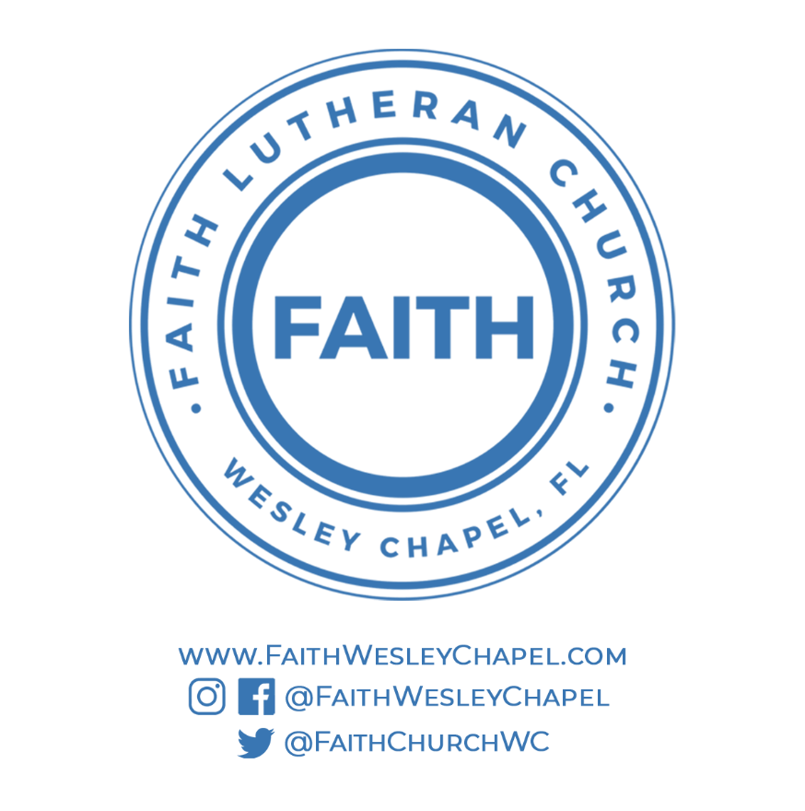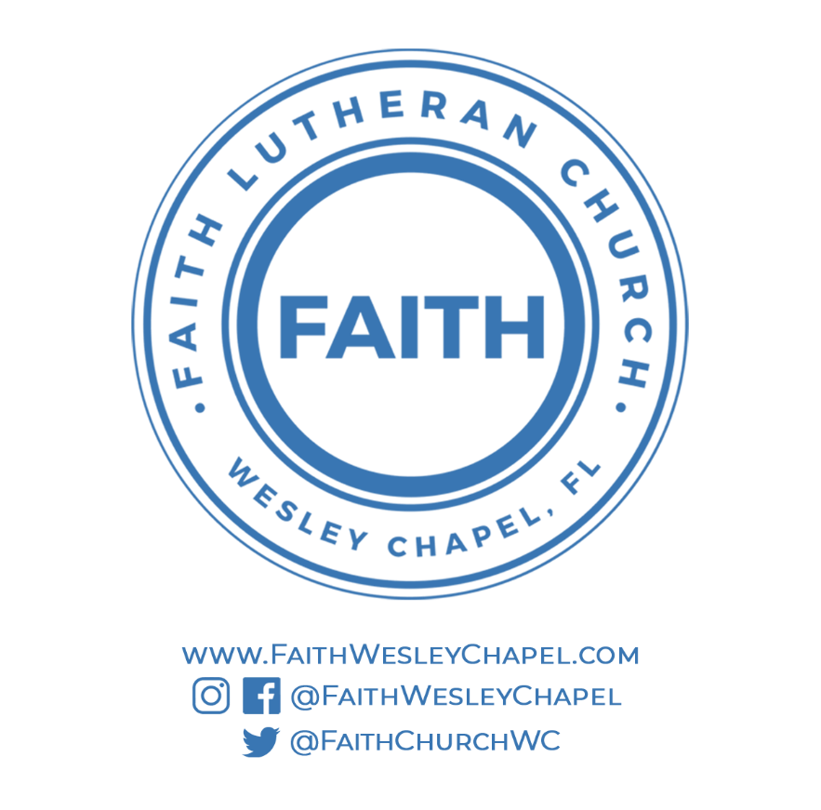**@FaithWesleyChapel**

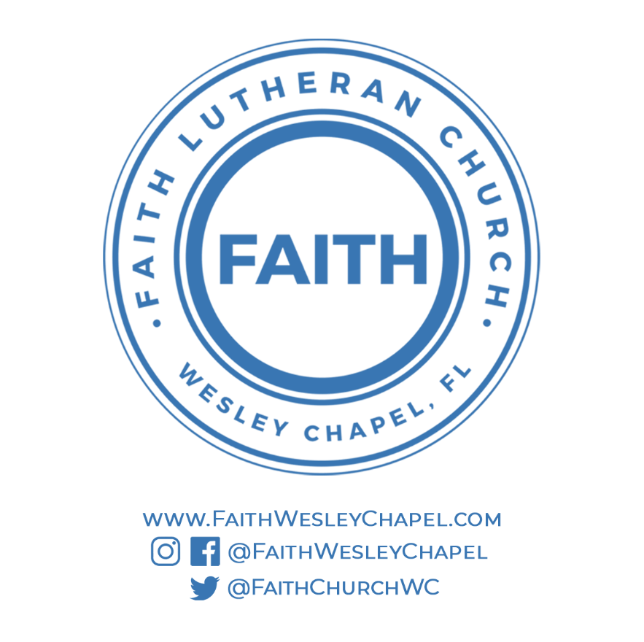**@FaithWesleyChapel**

**@FaithChurchWC**