

**Leading our community into a deep connection in Christ**

**Worship Service for October 12, 2025 at 11 AM**

**Welcome**

**Invocation** *(stand)*

**Confession and Forgiveness:** *(stand)*

**P:** As we gather, today, let us cleanse our hearts and our consciences by confessing our sin to God.

*(Time of silence for reflection and confession)*

**C:** Heavenly Father, we confess that we are sinful and unclean. We have sinned against you and against our neighbor in our thoughts, words, and actions.  We are truly sorry for our sins and sincerely repent of them. We ask for Your mercy. For the sake of Jesus Christ's bitter suffering and death, please forgive us and renew us that we may walk in Your Spirit to the glory of Your holy name. Amen.

**P:** The Lord has heard your confession. Therefore, as a called and ordained servant of the Lord, in the stead and by the command of my Lord, Jesus Christ, I forgive you all your sins in the name of the Father and of the Son and of the Holy Spirit.  
**C:** Amen

**Songs of Praise and Thanksgiving** – Holy Spirit, Breath of God*(sit)*

Holy Spirit, living Breath of God,  
Breathe new life into my willing soul.  
Bring the presence of the risen Lord.  
Come renew my heart and make me whole.  
Cause Your Word to come alive in me.  
Give me faith for what I cannot see.  
Give me passion for Your purity.  
Holy Spirit, breathe new life in me.

Holy Spirit, come abide within.  
May Your joy be seen in all I do.  
Love enough to cover every sin,  
In each thought and deed and attitude,  
Kindness to the greatest and the least,  
Gentleness that sows the path of peace.  
Turn my striving into works of grace.  
Breath of God, show Christ in all I do.

Holy Spirit, from creation's birth,  
Giving life to all that God has made,  
Show Your power once again on earth,  
Cause Your church to hunger for Your ways.  
Let the fragrance of our prayers arise.  
Lead us on the road of sacrifice,  
That in unity the face of Christ,  
May be clear for all the world to see. © 2006 Thankyou Music

**Old Testament Reading**– Proverbs 4:20-27

My son, be attentive to my words;  
 incline your ear to my sayings.  
Let them not escape from your sight;  
 keep them within your heart.  
For they are life to those who find them,  
 and healing to all their flesh.  
Keep your heart with all vigilance,  
 for from it flow the springs of life.  
Put away from you crooked speech,  
 and put devious talk far from you.  
Let your eyes look directly forward,  
 and your gaze be straight before you.  
Ponder the path of your feet;  
 then all your ways will be sure.  
Do not swerve to the right or to the left;  
 turn your foot away from evil.

**Reader:** This is the Word of the Lord.  
**C:** Thanks be to God.

**Epistle Reading** – Ephesians 4:1-6

I therefore, a prisoner for the Lord, urge you to walk in a manner worthy of the calling to which you have been called, with all humility and gentleness, with patience, bearing with one another in love, eager to maintain the unity of the Spirit in the bond of peace. There is one body and one Spirit—just as you were called to the one hope that belongs to your call—one Lord, one faith, one baptism, one God and Father of all, who is over all and through all and in all.

**Reader:** This is the Word of the Lord.  
**C:** Thanks be to God.

**Gospel Reading** – Luke 14:1-11

One Sabbath, when he went to dine at the house of a ruler of the Pharisees, they were watching him carefully. And behold, there was a man before him who had dropsy. And Jesus responded to the lawyers and Pharisees, saying, “Is it lawful to heal on the Sabbath, or not?” But they remained silent. Then he took him and healed him and sent him away. And he said to them, “Which of you, having a son or an ox that has fallen into a well on a Sabbath day, will not immediately pull him out?” And they could not reply to these things.

Now he told a parable to those who were invited, when he noticed how they chose the places of honor, saying to them, “When you are invited by someone to a wedding feast, do not sit down in a place of honor, lest someone more distinguished than you be invited by him, and he who invited you both will come and say to you, ‘Give your place to this person,’ and then you will begin with shame to take the lowest place. But when you are invited, go and sit in the lowest place, so that when your host comes he may say to you, ‘Friend, move up higher.’ Then you will be honored in the presence of all who sit at table with you. For everyone who exalts himself will be humbled, and he who humbles himself will be exalted.”

**P:** This is the Gospel of the Lord.  
**C:** Praise be to You, O Christ.

**Sermon Song –** In Christ Alone

In Christ alone my hope is found.   
He is my light, my strength, my song.  
This Cornerstone, this solid ground,  
Firm through the fiercest drought and storm.  
What heights of love, what depths of peace,  
When fears are stilled, when strivings cease.  
My Comforter, my All in All. Here in the love of Christ I stand.

In Christ alone, who took on flesh,   
Fullness of God in helpless babe.  
This gift of love and righteousness,   
Scorned by the ones He came to save.  
‘Til on that cross as Jesus died,   
The wrath of God was satisfied.  
For every sin on Him was laid, Here in the death of Christ I live.

There in the ground His body lay,   
Light of the world by darkness slain.  
Then bursting forth in glorious Day,   
Up from the grave He rose again.  
And as He stands in victory,   
Sin’s curse has lost its grip on me.  
For I am His and He is mine,   
Bought with the precious blood of Christ.

No guilt in life, no fear in death,   
This is the power of Christ in me.  
From life’s first cry to final breath,   
Jesus commands my destiny.  
No power of hell, no scheme of man,   
Can ever pluck me from His hand.  
‘Til He returns or calls me home,   
Here in the power of Christ I’ll stand.  
No power of hell, no scheme of man,   
Can ever pluck me from His hand.  
‘Til He returns or calls me home,   
Here in the power of Christ I’ll stand. © 2001 Thankyou Music

**Sermon/Discussion** – Humble Listening

**Proverbs 18:13**

To answer before listening — that is folly and shame.

**Prayers**

**Apostles' Creed** *(stand)*

I believe in God, the Father almighty, maker of heaven and earth,  
And in Jesus Christ, his only Son, our Lord,  
who was conceived by the Holy Spirit,  
born of the Virgin Mary, suffered under Pontius Pilate,  
was crucified, died and was buried. He descended into hell.  
The third day he rose again from the dead.  
He ascended into heaven and sits at the right hand of God  
the Father almighty.  
From there he will come to judge the living and the dead.  
I believe in the Holy Spirit, the holy Christian Church,  
the communion of saints, the forgiveness of sins,  
the resurrection of the body, and the life everlasting. Amen.

**The Lord's Prayer** *(stand)*

Our Father who art in heaven, hallowed be Thy name, Thy kingdom come, Thy will be done on earth as it is in heaven.  Give us this day our daily bread; and forgive us our trespasses as we forgive those who trespass against us; and lead us not into temptation, but deliver us from evil.  For Thine is the kingdom and the power and the glory forever and ever.  Amen

**Benediction** *(stand)*

**Closing Song:** Praise God From Whom All Blessings Flow *(stand)*

Praise God from Whom all blessings flow.  
Praise Him all creatures here below.  
Praise Him above, ye heavenly hosts.  
Praise Father, Son and Holy Ghost.  
Amen

**Offering** *(sit) Give online at:*

**Sermon Notes:**

**_______________________________________________**

**_______________________________________________**

**_______________________________________________**

**_______________________________________________**

**_______________________________________________**

**_______________________________________________**

**_______________________________________________**

**_______________________________________________**

**_______________________________________________**

**_______________________________________________**

**_______________________________________________**

**_______________________________________________**

**_______________________________________________**

**_______________________________________________**

|  |  |
| --- | --- |
| **Serving This Week** | |
|  | |
| **O.T. Reader:** Darlene Mueller | **Children’s Church Teacher:** |
| **Epistle Reader :** Richard Steinbrueck | Melissa Steinbrueck |
| **Acolyte:** Lawrence Finnerty | **Children’s Church Assistant:** |
| **Com. Asst:** Larry Chmiel | Kaylee Steinbrueck |
|  | |
| **Serving Next Week** | |
|  | |
| **O.T. Reader:** Ben Pike | **Children’s Church Teacher:** |
| **Epistle Reader:** Larry Chmiel | Halston and Ben |
| **Acolyte:** Kaylee Steinbrueck | **Children’s Church Assistant:** |
| **Com. Asst:** Larry Chmiel | N/A |

**Upcoming Events**

**Today, After the Service – Growth Group Bible Study**Faith Lutheran Church

**Oct 14, 7pm – Council Meeting**Ginger Dunn’s Home

**Oct 16, 7pm – Online Growth Group Bible Study**Zoom

**Oct 19, 11am – Food Drive for Your Table**Faith Lutheran Church

**www.FaithWesleyChapel.com**

**Faith YouTube**

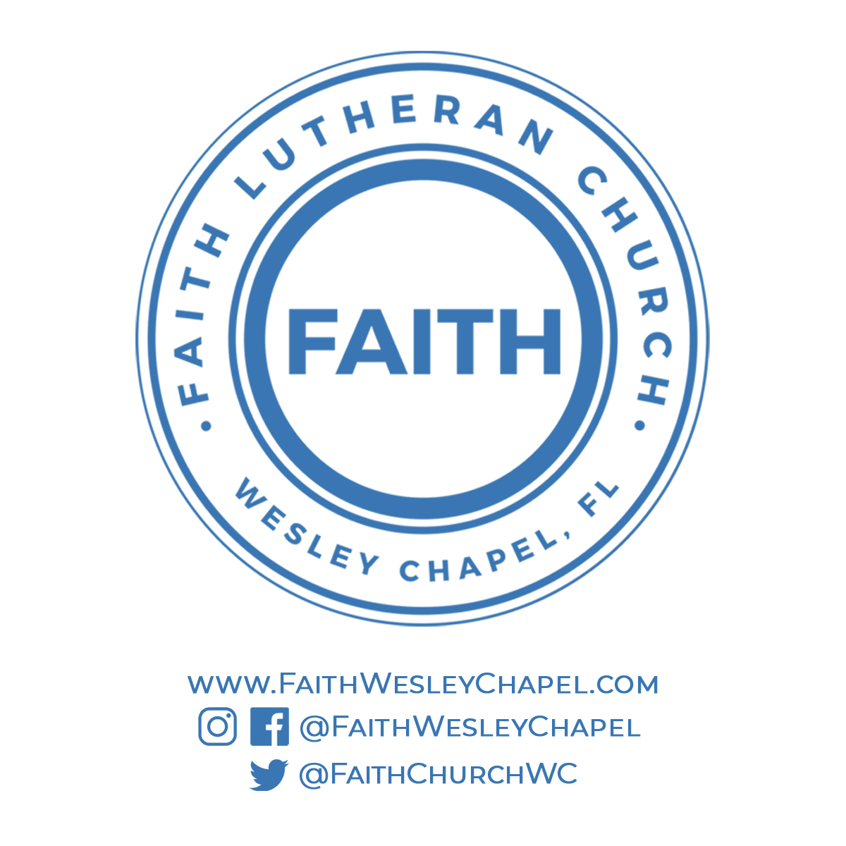**@FaithWesleyChapel**

**@FaithWesleyChapel**

**@FaithChurchWC**