

**Leading our community into a deep connection in Christ**

**___________________________________________________**

**Worship Service for October 19, 2025 at 11 AM**

**Welcome**

**Invocation**

**Confession and Forgiveness:**

**P:** As we gather, today, let us cleanse our hearts and our consciences by confessing our sin to God.

*(Time of silence for reflection and confession)*

**P:** Today, we confess our sins by singing the song, “Lord, I Need You.”

**Song of Confession:** Lord, I Need You

Lord I come, I confess. Bowing here, I find my rest.  
Without You, I fall apart. You're the one that guides my heart.

Chorus:  
Lord, I need You, oh I need You. Every hour I need You.  
My one defense, my righteousness, Oh God, how I need You.

Where sin runs deep, Your grace is more.  
Where grace is found is where You are.  
And where You are Lord I am free. Holiness is Christ in me.

Chorus:  
Lord, I need You, oh I need You. Every hour I need You.  
My one defense, my righteousness, Oh God, how I need You.

So teach my song to rise to You, when temptation comes my way.  
And when I cannot stand I'll fall on You.   
Jesus, You're my hope and stay.

Chorus:Lord, I need You, oh I need You. Every hour I need You  
My one defense, my righteousness, Oh God, how I need You  
My one defense, my righteousness, Oh God, how I need You  
My one defense, my righteousness, Oh God, how I need You

© 2011 Sweater Weather Music, Valley Of Songs Music, and Thankyou Music

**P:** The Lord has heard your confession. Therefore, as a called and ordained servant of the Lord, in the stead and by the command of my Lord, Jesus Christ, I forgive you all your sins in the name of the Father and of the Son and of the Holy Spirit.  
**C:** Amen

**Song of Praise and Thanksgiving:** 10,000 Reasons (Bless The Lord)

Chorus:

Bless the Lord, O my soul, O my soul, Worship His holy name.

Sing like never before, 0 my soul. I'll worship Your holy name.

The sun comes up, it's a new day dawning;

It's time to sing Your song again.

Whatever may pass, and whatever lies before me,

Let me be singing when the evening comes.

*(Chorus)*

You're rich in love, and You're slow to anger.

Your name is great, and Your heart is kind.

For all Your goodness, I will keep on singing;

Ten thousand reasons for my heart to find.

*(Chorus)*

And on that day when my strength is failing,

The end draws near, and my time has come;

Still my soul will sing Your praise unending:

Ten thousand years and then forevermore! Forevermore!  
*(Chorus)*

I'll worship Your holy name. Yes, I'll worship Your holy name.  
 © 2011 Thankyou Music, Said And Done Music, and SHOUT! Publishing

**Old Testament Reading** - Deuteronomy 10:12-21

“And now, Israel, what does the Lord your God require of you, but to fear the Lord your God, to walk in all his ways, to love him, to serve the Lord your God with all your heart and with all your soul, and to keep the commandments and statutes of the Lord, which I am commanding you today for your good? Behold, to the Lord your God belong heaven and the heaven of heavens, the earth with all that is in it. Yet the Lord set his heart in love on your fathers and chose their offspring after them, you above all peoples, as you are this day. Circumcise therefore the foreskin of your heart, and be no longer stubborn. For the Lord your God is God of gods and Lord of lords, the great, the mighty, and the awesome God, who is not partial and takes no bribe. He executes justice for the fatherless and the widow, and loves the sojourner, giving him food and clothing. Love the sojourner, therefore, for you were sojourners in the land of Egypt. You shall fear the Lord your God. You shall serve him and hold fast to him, and by his name you shall swear. He is your praise. He is your God, who has done for you these great and terrifying things that your eyes have seen."

**Reader:** This is the Word of the Lord.  
**C:** Thanks be to God.

**Epistle Reading** - 1 Corinthians 1:4-9

I give thanks to my God always for you because of the grace of God that was given you in Christ Jesus, that in every way you were enriched in him in all speech and all knowledge—even as the testimony about Christ was confirmed among you—so that you are not lacking in any gift, as you wait for the revealing of our Lord Jesus Christ, who will sustain you to the end, guiltless in the day of our Lord Jesus Christ. God is faithful, by whom you were called into the fellowship of his Son, Jesus Christ our Lord.

**Reader:** This is the Word of the Lord.  
**C:** Thanks be to God.

**Gospel Reading** - Matthew 22:34-46

But when the Pharisees heard that he had silenced the Sadducees, they gathered together. And one of them, a lawyer, asked him a question to test him. “Teacher, which is the great commandment in the Law?” And he said to him, “You shall love the Lord your God with all your heart and with all your soul and with all your mind. This is the great and first commandment. And a second is like it: You shall love your neighbor as yourself. On these two commandments depend all the Law and the Prophets.”

Now while the Pharisees were gathered together, Jesus asked them a question, saying, “What do you think about the Christ? Whose son is he?” They said to him, “The son of David.” He said to them, “How is it then that David, in the Spirit, calls him Lord, saying,

“‘The Lord said to my Lord,

“Sit at my right hand,

until I put your enemies under your feet”’?

If then David calls him Lord, how is he his son?” And no one was able to answer him a word, nor from that day did anyone dare to ask him any more questions.

**P:** This is the Gospel of the Lord.  
**C:** Praise be to You, O Christ.

**Children's Message** *(Children dismissed to Children's Church)*

**Sermon Hymn***–*Blessed Be the Tie That Binds

Blest be the tie that binds our hearts in Christian love;

The fellow-ship of kindred minds is like to that above.

We share our mutual woes, our mutual bur-dens bear,

And often for each other flows the sympathizing tear.

From sorrow, toil, and pain, and sin we shall be free

And perfect love and friendship reign through all eternity

© Public Domain

**Sermon** - "The Sojourner / Immigrant"

**Prayers:** *Text in prayer requests to (813) 326-5255*

**Nicene Creed** *(stand)*

I believe in one God, the Father Almighty, maker of heaven and earth and of all things visible and invisible.

And in one Lord Jesus Christ, the only-begotten Son of God, begotten of His Father before all worlds, God of God, Light of Light, very God of very God, begotten, not made, being of one substance with the Father, by whom all things were made; who for us men and for our salvation came down from heaven and was incarnate by the Holy Spirit of the virgin Mary and was made man; and was crucified also for us under Pontius Pilate. He suffered and was buried. And the third day He rose again according to the Scriptures and ascended into heaven and sits at the right hand of the Father. And He will come again with glory to judge both the living and the dead, whose kingdom will have no end.

And I believe in the Holy Spirit, the Lord and Giver of Life, who proceeds from the Father and the Son, who with the Father and the Son together is worshiped and glorified, who spoke by the prophets. And I believe in one holy Christian and apostolic Church, I acknowledge one Baptism for the remission of sins, and I look for the resurrection of the dead and the life of the world to come. Amen.

**The Lord's Prayer** *(stand)*

Our Father who art in heaven, hallowed be Thy name, Thy kingdom come, Thy will be done on earth as it is in heaven.  Give us this day our daily bread; and forgive us our trespasses as we forgive those who trespass against us; and lead us not into temptation, but deliver us from evil.  For Thine is the kingdom and the power and the glory forever and ever.  Amen

**Offering**  *Give online at:*

**Benediction** *(The online service ends. The closing song can be found as a YouTube video at FaithWesleyChapel.com/bulletin)*

**Thank you for joining Faith for worship. We hope to see you in person soon!**

**Closing Song:**Amazing Grace (My Chains Are Gone)

Amazing grace how sweet the sound That saved a wretch like me

I once was lost, but now I'm found Was blind but now I see

’Twas grace that taught my heart to fear,  
And grace my fears relieved;

How precious did that grace appear, The hour I first believed!

Chorus:

My chains are gone, I've been set free.

My God, My Savior has ransomed me.

And like a flood his mercy reigns. Unending love, amazing grace

The Lord has promised good to me, His word my hope secures;

He will my shield and portion be, As long as life endures.

*(Chorus x 2)*

The earth shall soon dissolve like snow, The sun forbear to shine;

But God, who call’d me here below, Will be forever mine...

Will be forever mine... You are forever mine. © 2006 Vamos Publishing

|  |  |
| --- | --- |
| **Serving This Week** | |
|  | |
| **O.T. Reader:** Ben Pike | **Children’s Church Teacher:** |
| **Epistle Reader:** Larry Chmiel | Halston & Ben |
| **Acolyte:** Kaylee Steinbrueck | **Children’s Church Assistant:** |
| **Com. Asst:** Larry Chmiel | N/A |
|  | |
| **Serving Next Week** | |
|  | |
| **O.T. Reader:** Josh Strasheim | **Children’s Church Teacher:** |
| **Epistle Reader:** Ginger Dunn | Melissa Steinbrueck |
| **Acolyte:** Eli Bingaman  **Offering:** Heidi Strasheim | **Children’s Church Assistant:** |
| **Com. Asst:** Larry Chmiel | Kaylee Steinbrueck |

**Upcoming Events**

**Oct 19, After the Service – Food Drive for Your Table**Faith Lutheran Church

**Oct 23, 7 PM – Growth Group Bible Study**  
Renee’s Home

**Oct 26, After the Service – Growth Group Bible Study**Faith Lutheran Church

**Nov 9, After the Service – Pies in the Park**Wesley Chapel District Park – Large Pavilion

**Dec 6, 6 PM - 10 PM – Open House Christmas Party**The Chmiel’s Home

**Dec 14, 6 PM – Christmas in the Park**Wesley Chapel District Park – Large Pavilion

[**www.FaithWesleyChapel.com**](http://www.FaithWesleyChapel.com)

 **Faith YouTube**

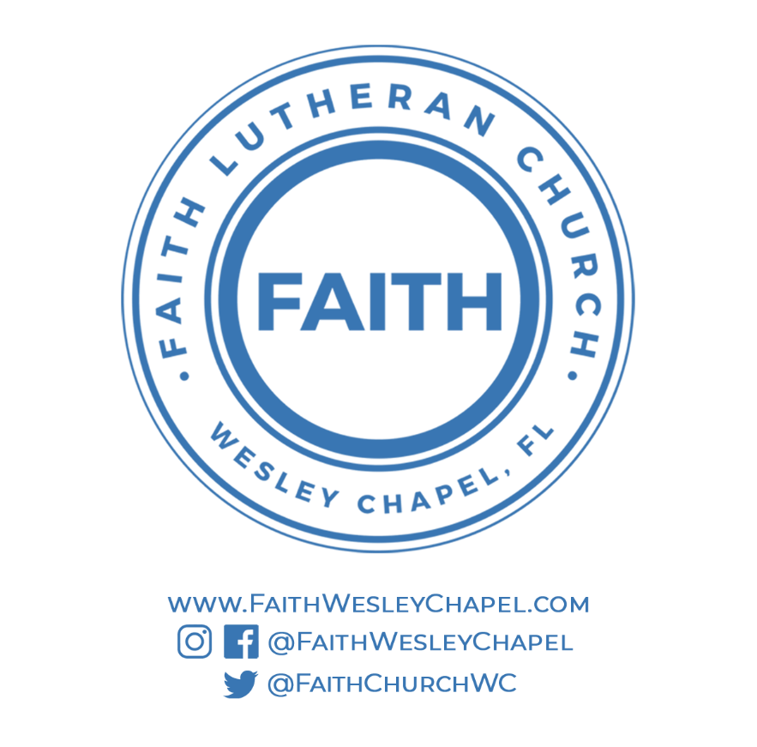**@FaithWesleyChapel**

**@FaithWesleyChapel**

**@FaithChurchWC**