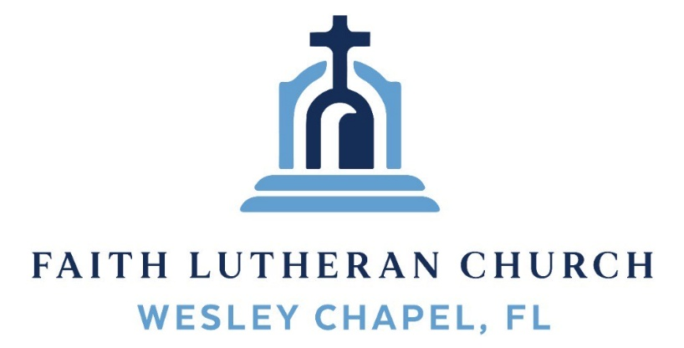
Leading our community into a deep connection in Christ
___________________________________________________
Worship Service for November 30, 2025 at 11 AM
Welcome
Opening Song: The Advent of Our King
Verse 1:
The advent of our King, our prayers must now employ;
And we must hymns of welcome sing in strains of holy joy.

Verse 2:
The everlasting Son, incarnate deigns to be;
Him-self a servant's form put on to set His servants free.

Verse 3:
O Zion's daughter rise to meet your lowly King;
Nor let you faithless heart despise the peace He comes to bring.
Verse 6
All glory to the Son, who comes to set us free;
With Father, Spirit, ever one through all eternity.
© Public Domain
Invocation
Confession and Absolution:
P: In our first lesson Isaiah writes, “Seek the LORD while he may be found; call on him while he is near. Let the wicked forsake his way and the evil man his thoughts. Let him turn to the LORD, and he will have mercy on him, and to our God, for he will freely pardon.” (Isaiah 55:6–7) Let us seek the LORD—
C: For he will have mercy on us.
P: And our God will freely pardon.
(A time of silence to reflect and personally confess our sins)
ALL: Most merciful Father, we confess that we frequently neglect the preaching and teaching of your Word and ignore its promises and power. Failing to listen to you, we listen to ourselves, our culture and the lying accusations of the enemy. We are broken because of it and are empty from it. We forsake our wicked ways and our evil thoughts.
P: God says through Isaiah, “My word that goes out from my mouth will not return to me empty, but will accomplish what I desire and achieve the purpose for which I sent it.” (Isaiah 55:11)
Hear God’s Word of forgiveness. In Christ Jesus you are fully and forever forgiven, a child of the heavenly Father and a heir of everlasting life.
ALL: He who promised is faithful and he will do it!
Song of Praise and Thanksgiving - Jesus Messiah
He became sin, who knew no sin,
That we might become His Righteousness.
He humbled Himself and carried the cross.
Love so amazing, love so amazing!
Chorus:
Jesus Messiah, Name above all names,
Blessed Redeemer, Emmanuel,
The rescue for sinners, the ransom from Heaven,
Jesus Messiah, Lord of all.
His body the bread, His blood the wine,
Broken and poured out all for love.
The whole earth trembled and the veil was torn.
Love so amazing, love so amazing!
(Chorus)
All our hope is in You. All our hope is in You.
All the glory to You, God, The light of the world.
(Chorus)
Jesus Messiah, Lord of all. He is the Lord of all! Lord of all.
© 2008 Vamos Publishing and Alletrop Music
Old Testament Reading - Isaiah 55:6–11
“Seek the Lord while he may be found;
call upon him while he is near;
let the wicked forsake his way,
and the unrighteous man his thoughts;
let him return to the Lord, that he may have compassion on him,
and to our God, for he will abundantly pardon.
For my thoughts are not your thoughts,
neither are your ways my ways, declares the Lord.
For as the heavens are higher than the earth,
so are my ways higher than your ways
and my thoughts than your thoughts.
“For as the rain and the snow come down from heaven
and do not return there but water the earth,
making it bring forth and sprout,
giving seed to the sower and bread to the eater,
so shall my word be that goes out from my mouth;
it shall not return to me empty,
but it shall accomplish that which I purpose,
Reader: This is the Word of the Lord.
C: Thanks be to God.
Epistle Reading - Hebrews 1:1–4
Long ago, at many times and in many ways, God spoke to our fathers by the prophets, but in these last days he has spoken to us by his Son, whom he appointed the heir of all things, through whom also he created the world. He is the radiance of the glory of God and the exact imprint of his nature, and he upholds the universe by the word of his power. After making purification for sins, he sat down at the right hand of the Majesty on high, having become as much superior to angels as the name he has inherited is more excellent than theirs.
Reader: This is the Word of the Lord.
C: Thanks be to God.
Gospel Reading - John 1:1–5
In the beginning was the Word, and the Word was with God, and the Word was God. He was in the beginning with God. All things were made through him, and without him was not any thing made that was made. In him was life, and the life was the light of men. The light shines in the darkness, and the darkness has not overcome it.
P: This is the Gospel of the Lord.
C: Praise be to You, O Christ.
Children's Message (Children dismissed to Children's Church)
Sermon Hymn – Speak, O Lord, Your Servant Listens
Verse 1
Speak, O Lord, Your servant listens,
Let Your Word to me come near;
Newborn life and spirit give me,
Let each promise still my fear.
Death's dread pow'r, its inward strife,
Wars against Your Word of life;
Fill me, Lord, with love's strong fervor
That I cling to You forever!
Verse 2
Oh, what blessing to be near You and to listen to Your voice;
Let me ever love and hear You, let Your Word be now my choice!
Many hardened sinners, Lord, flee in terror at Your Word;
But to all who feel sin's burden
You give words of peace and pardon.
Verse 3
Lord, Your words are waters living
When my thirsting spirit pleads.
Lord, Your words are bread life-giving;
On Your words my spirit feeds.
Lord, Your words will be my light
through death's cold and dreary night;
Yes, they are my sword prevailing and my cup of joy unfailing!
Verse 4
As I pray, dear Jesus, hear me; let Your words in me take root.
May Your Spirit e'er be near me that I bear abundant fruit.
May I daily sing Your praise, from my heart glad anthems raise,
Till my highest praise is given in the endless joy of heaven.
© Public Domain
Sermon – Series: “Something Better"
This Week: “A Better Word”
Prayers: Text in prayer requests to (813) 326-5255‬
Nicene Creed (stand)
I believe in one God, the Father Almighty, maker of heaven and earth and of all things visible and invisible.
And in one Lord Jesus Christ, the only-begotten Son of God, begotten of His Father before all worlds, God of God, Light of Light, very God of very God, begotten, not made, being of one substance with the Father, by whom all things were made; who for us men and for our salvation came down from heaven and was incarnate by the Holy Spirit of the virgin Mary and was made man; and was crucified also for us under Pontius Pilate. He suffered and was buried. And the third day He rose again according to the Scriptures and ascended into heaven and sits at the right hand of the Father. And He will come again with glory to judge both the living and the dead, whose kingdom will have no end.
And I believe in the Holy Spirit, the Lord and Giver of Life, who proceeds from the Father and the Son, who with the Father and the Son together is worshiped and glorified, who spoke by the prophets. And I believe in one holy Christian and apostolic Church, I acknowledge one Baptism for the remission of sins, and I look for the resurrection of the dead and the life of the world to come. Amen.
The Lord's Prayer (stand)
Our Father who art in heaven, hallowed be Thy name, Thy kingdom come, Thy will be done on earth as it is in heaven. Give us this day our daily bread; and forgive us our trespasses as we forgive those who trespass against us; and lead us not into temptation, but deliver us from evil. For Thine is the kingdom and the power and the glory forever and ever. Amen
Offering (sit) Give online at:
Benediction (The online service ends. The closing song can be found as a YouTube video at FaithWesleyChapel.com/bulletin)
Thank you for joining Faith for worship. We hope to see you in person soon!
Closing Song - Go Tell It On The Mountain
Chorus:
Go tell it on the mountain, over the hills and everywhere.
Go tell it on the mountain that Jesus Christ is born.
While shepherds kept their watching o'er silent flocks by night,
Behold throughout the heavens there shone a Holy Light.
(Chorus)
The shepherds feared and trembled when lo, above the earth,
Rang out the angel chorus that hailed our Savior’s birth.
Chorus:
Go tell it on the mountain, over the hills and everywhere.
Go tell it on the mountain that Jesus Christ is born.
Down in a lowly manger, the humble Christ was born,
And brought us God's salvation that blessed Christmas morn!
(Chorus) © 1945 © Galaxy Music Corporation

Serving This Week
O.T. Reader: Ben Pike | Children’s Church Teacher:
Epistle Reader: Richard Steinbrueck | Halston & Ben
Acolyte: Kaylee Steinbrueck | Children’s Church Assistant:
Com. Asst: Larry Chmiel | N/A
Serving Next Week
1st Reader: Kaylee Steinbrueck | Children’s Church Teacher:
2nd Reader: Alanna Bingaman | N/A – No Children’s Church
Acolyte: Eli Bingaman  Offering: Heidi Strasheim | Children’s Church Assistant:
Com. Asst: Larry Chmiel | N/A – No Children’s Church

Upcoming Events
Dec 4, 7 PM –Online Growth Group Bible Study (Zoom)
Dec 6, 6 PM - 10 PM – Open House Christmas Party
The Chmiel’s Home
Dec 7, 2 PM – Christmas Caroling
Baldomero Lopez State Veterans Nursing Home
Dec 14, 6 PM – Christmas in the Park
Wesley Chapel District Park – Large Pavilion
Dec. 24, 6 PM – Christmas Eve Worship
Faith Lutheran Church

www.FaithWesleyChapel.com

Faith YouTube
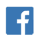
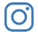
@FaithWesleyChapel
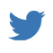
@FaithWesleyChapel
@FaithChurchWC

