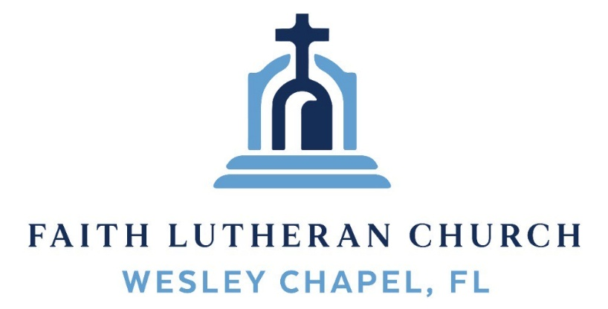
Leading our community into a deep connection in Christ
___________________________________________________
Worship Service for December 7, 2025 at 11 AM
Welcome
Opening Song: I Just Wanna Be A Sheep
Chorus:
I just wanna be a sheep, baa baa baa baa.
I just wanna be a sheep, baa baa baa baa.
I pray the Lord my soul to keep,
I just wanna be a sheep, baa baa baa baa.
Verse 1:
Don't wanna be a goat...nope! Don't wanna be a goat...nope!
Haven't got any hope...nope! Don't wanna be a goat...nope!
Verse 4:
Don't wanna be a Sadducee. Don't wanna be a Sadducee.
'Cause they're so sad you see. Don't wanna be a Sadducee.
(Chorus)
Verse 5:
Just wanna be a child of God. Just wanna be a child of God.
Walkin' the same path He trod. Just wanna be a child of God.
(Chorus) © 1974 Mission Hills Music
Invocation
Confession and Forgiveness:
P: We have come here today to worship the Lord. In worship we hear the Word of God, we receive God's blessings, and respond with thanks and praise. We begin by seeking God's blessing of forgiveness. He has promised to remove the guilt and shame of our sin through the sacrifice of Jesus Christ on the cross.
(a time of silence to reflect and personally confess our sins)
P: Let us confess our sins to the Lord.
P: Heavenly Father,
C: Heavenly Father,
P: I have done things that were wrong.
C: I have done things that were wrong.
P: I have been mean to others.
C: I have been mean to others.
P: I have not obeyed my parents.
C: I have not obeyed my parents.
P: I have not obeyed You, God.
C: I have not obeyed You, God.
P: But I am very sorry.
C: But I am very sorry.
P: Please forgive me.
C: Please forgive me.
P: I love You very much.
C: I love You very much.
P: And I know You love me, too.
C: And I know You love me, too.
P: Amen.
C: Amen.
P: God has heard your apology. He loves you very much. God has told us that when we believe and trust in Him, He makes us His children. As far as the east is from the west, so far does he remove our sins from us. He has told me to tell you that you are forgiven. So, as His servant, I forgive you in the name of the Father and of the Son and of the Holy Spirit.
C: Amen.
Song: God Is So Good
God is so good. God is so good.
God is so good. He's so good to me.
He died for me. He died for me so.
He died for me. He's so good to me.
He loves me so. He loves me so.
He loves me so. He's so good to me. © Public Domain
First Reading – Hebrews 1:3

God's Son has all the brightness of God's own glory and is like him in every way.

Reader: This is the Word of the Lord.
C: Thanks be to God.
Children's Message
Song: He Shall Reign Forevermore
In the bleak mid-winter, all creation groans,
For a world in darkness, frozen like a stone,
Light is breaking, in a stable for a throne.
Chorus:
And He shall reign forevermore, forevermore.
And He shall reign forevermore, forevermore.
Unto us a child is born, The King of kings and Lord of lords.
And He shall reign forevermore, forevermore.
If I were a wise man, I would travel far,
And if I were a shepherd, I would do my part.
But poor as I am, I will give to Him my heart.
(Chorus)
Here within a manger lies the One who made the starry skies,
This baby born for sacrifice, Christ, the Messiah.
Into our hopes, into our fears, The Savior of the world appears,
The promise of eternal years, Christ, the Messiah.
Chorus 2:
He shall reign forevermore, forevermore.
He shall reign forevermore, forevermore.
He shall reign forevermore, forevermore.
And He shall reign forevermore, forevermore.
Unto us a child is born, The King of kings and Lord of lords.
And He shall reign forevermore, forevermore.
© 2015 © S. D. G. Publishing (Admin. by Capitol CMG Publishing), Sixsteps Songs (Admin. by Capitol CMG Publishing), Worship Together Music (Admin. by Capitol CMG Publishing), Be Essential Songs (Admin. by Essential Music Publishing LLC), and I Am A Pilgrim Songs (Admin. by Essential Music Publishing LLC)

Second Reading - Hebrews 10:1
For since the law has but a shadow of the good things to come instead of the true form of these realities, it can never, by the same sacrifices that are continually offered every year, make perfect those who draw near.
Reader: This is the Word of the Lord.
C: Thanks be to God.
Children's Message
Gospel Reading – John 1:6–14
There was a man sent from God, whose name was John. He came as a witness, to bear witness about the light, that all might believe through him. He was not the light, but came to bear witness about the light.
The true light, which gives light to everyone, was coming into the world. He was in the world, and the world was made through him, yet the world did not know him. He came to his own, and his own people did not receive him. But to all who did receive him, who believed in his name, he gave the right to become children of God, who were born, not of blood nor of the will of the flesh nor of the will of man, but of God.
And the Word became flesh and dwelt among us, and we have seen his glory, glory as of the only Son from the Father, full of grace and truth.
P: This is the Gospel of the Lord.
C: Praise be to You, O Christ.
Song: Savior Of The Nations Come
Savior of the nations, come, virgin's Son, make here Thy home!
Marvel now, O heaven and earth, that the Lord chose such a birth.

Not by human flesh and blood, by the Spirit of our God,
Was the Word of God made flesh
Woman's Off-Spring, pure and fresh.

Thou, the Father's only Son, hast o'er sin the vict'ry won.
Boundless shall Thy kingdom be; when shall we its glories see?
Praise to God the Father sing. Praise to God the Son, our King.
Praise to God the Spirit be ever and eternally. © Public Domain
Sermon – Series: “Something Better”
This Week: “A Better Glory”
Prayers: Text in prayer requests to (813) 326-5255

The Lord's Prayer

Our Father who art in heaven, hallowed be Thy name, Thy kingdom come, Thy will be done on earth as it is in heaven. Give us this day our daily bread; and forgive us our trespasses as we forgive those who trespass against us; and lead us not into temptation, but deliver us from evil. For Thine is the kingdom and the power and the glory forever and ever. Amen
Offering (sit) Give online at:
Benediction (The online service ends. The closing song can be found as a YouTube video at FaithWesleyChapel.com/bulletin)
Thank you for joining Faith for worship. We hope to see you in person soon!
Closing Song: Hark the Glad Sound
Hark, the glad sound! the Savior comes,
The Savior promised long!
Let every heart prepare a throne
And every voice a song.
He comes the prisoners to release,
In Satan's bondage held;
The gates of brass before him burst,
The iron fetters yield.
He comes the broken heart to bind,
The bleeding soul to cure,
And with the treasures of his grace,
To enrich the humble poor.
Our glad hosannas, Prince of Peace,
Your welcome shall proclaim,
And Heav’n’s eternal arches ring
With your beloved name. © Public Domain

Serving This Week
O.T. Reader: Ben Pike | Children’s Church Teacher:
Epistle Reader: Richard Steinbrueck | Halston & Ben
Acolyte: Kaylee Steinbrueck | Children’s Church Assistant:
Com. Asst: Larry Chmiel | N/A
Serving Next Week
1st Reader: Kaylee Steinbrueck | Children’s Church Teacher:
2nd Reader: Alanna Bingaman | N/A – No Children’s Church
Acolyte: Eli Bingaman  Offering: Heidi Strasheim | Children’s Church Assistant:
Com. Asst: Larry Chmiel | N/A – No Children’s Church

Upcoming Events
Today, 2 PM – Christmas Caroling
Baldomero Lopez State Veterans Nursing Home
Dec 11, 7 PM –Online Growth Group Bible Study (Zoom)
Dec 11, 7 PM –In-Person Growth Group Bible Study
Renee’s Home
Dec 14, 6 PM – Christmas in the Park
Wesley Chapel District Park – Large Pavilion
Dec. 24, 6 PM – Christmas Eve Worship
Faith Lutheran Church

www.FaithWesleyChapel.com

Faith YouTube
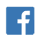
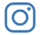
@FaithWesleyChapel
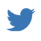
@FaithWesleyChapel
@FaithChurchWC

