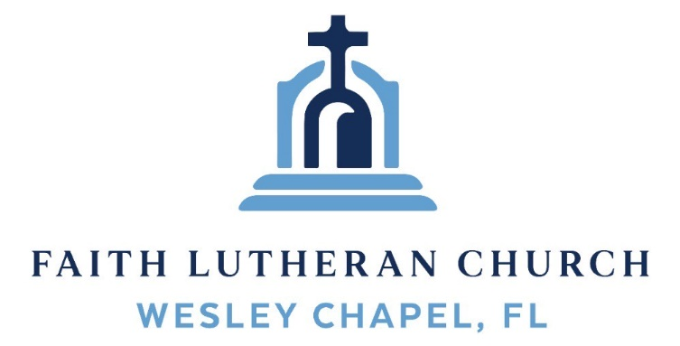
Leading our community into a deep connection in Christ

Worship Service for December 14, 2025 at 11 AM
Welcome
Invocation (stand)
Confession and Forgiveness: (stand)
P: In our first lesson, through Jeremiah, God says, “I will forgive their wickedness and will remember their sins no more.” (Jer 31:34) Forgive us, Father, for we are prone to bury our guilt in our hearts.
C: But then it comes back to hurt us and haunt us.
P: Forgive us, Father, for we are prone to blame our guilt on someone else.
C: But this burdens other people and often destroys relationships.
P: Forgive us, Father, for we are prone to beating ourselves up with guilt.
C: But this leaves us down, depressed, and despondent.
P: And stuck in a pit of despair.
ALL: Lord, have mercy! Christ, have mercy! Lord, have mercy!
P: Hear the best news you will ever hear! Christ Jesus provided purification for all your sin. In His name, you are forgiven. You are absolved. And you are free!
ALL: He who promised is faithful and He will do it!

Songs of Praise and Thanksgiving – Just As I Am (sit)
Just as I am, without one plea,
But that Thy blood was shed for me,
And that Thou bidd'st me come to Thee,
O Lamb of God, I come! I come!
Just as I am, and waiting not,
To rid my soul of one dark blot,
To Thee whose blood can cleanse each spot,
O Lamb of God, I come! I come!
Just as I am, though tossed about,
With many a conflict, many a doubt,
Fightings and fears within, without,
Lamb of God, I come! I come!
Just as I am, Thou wilt receive,
Wilt welcome, pardon, cleanse, relieve,
Because Thy promise I believe,
O Lamb of God, I come! I come! © Public Domain
Old Testament Reading – Jeremiah 31:31–34
“Behold, the days are coming, declares the Lord, when I will make a new covenant with the house of Israel and the house of Judah, not like the covenant that I made with their fathers on the day when I took them by the hand to bring them out of the land of Egypt, my covenant that they broke, though I was their husband, declares the Lord. For this is the covenant that I will make with the house of Israel after those days, declares the Lord: I will put my law within them, and I will write it on their hearts. And I will be their God, and they shall be my people. And no longer shall each one teach his neighbor and each his brother, saying, ‘Know the Lord,’ for they shall all know me, from the least of them to the greatest,

declares the Lord. For I will forgive their iniquity, and I will remember their sin no more.”
Reader: This is the Word of the Lord.
C: Thanks be to God.
Epistle Reading – Hebrews 1:1–4
Long ago, at many times and in many ways, God spoke to our fathers by the prophets, but in these last days he has spoken to us by his Son, whom he appointed the heir of all things, through whom also he created the world. He is the radiance of the glory of God and the exact imprint of his nature, and he upholds the universe by the word of his power. After making purification for sins, he sat down at the right hand of the Majesty on high, having become as much superior to angels as the name he has inherited is more excellent than theirs.
Reader: This is the Word of the Lord.
C: Thanks be to God.
Gospel Reading – Luke 1:67–79
And his father Zechariah was filled with the Holy Spirit and prophesied, saying,
“Blessed be the Lord God of Israel,
for he has visited and redeemed his people
and has raised up a horn of salvation for us
in the house of his servant David,
as he spoke by the mouth of his holy prophets from of old,
that we should be saved from our enemies
and from the hand of all who hate us;
to show the mercy promised to our fathers
and to remember his holy covenant,
the oath that he swore to our father Abraham, to grant us
that we, being delivered from the hand of our enemies,
might serve him without fear,
in holiness and righteousness before him all our days.
And you, child, will be called the prophet of the Most High;
for you will go before the Lord to prepare his ways,
to give knowledge of salvation to his people
in the forgiveness of their sins,
because of the tender mercy of our God,
whereby the sunrise shall visit us from on high
to give light to those who sit in darkness and in the shadow of death,
to guide our feet into the way of peace.”
P: This is the Gospel of the Lord.
C: Praise be to You, O Christ.
Sermon Song – O Come, O Come, Emmanuel
O come, O come, Emmanuel, and ransom captive Israel,
That mourns in lonely exile here, until the Son of God appear.
Chorus:
Rejoice! Rejoice! Emmanuel shall come to thee, O Israel.
O come, Thou Rod of Jesse free,
Thine own from Satan's tyranny.
From depths of hell Thy people save,
And give them victory o'er the grave.

(Chorus)
O come, Thou Key of David, come,
And open wide our heav’nly home.
Make safe the way that leads on high,
And close the path to misery.
(Chorus)
O come, Thou Dayspring, come and cheer,
Our spirits by Thine advent here,
And drive away the shades of night,
And pierce the clouds and bring us light.
(Chorus) © 1982 The Jubilate Group
Sermon/Discussion – Series: “Something Better”
This Week: “A Better Absolution”
Prayers
Apostles' Creed (stand)
I believe in God, the Father almighty, maker of heaven and earth,
And in Jesus Christ, his only Son, our Lord,
who was conceived by the Holy Spirit,
born of the Virgin Mary, suffered under Pontius Pilate,
was crucified, died and was buried. He descended into hell.
The third day he rose again from the dead.
He ascended into heaven and sits at the right hand of God
the Father almighty.
From there he will come to judge the living and the dead.
I believe in the Holy Spirit, the holy Christian Church,
the communion of saints, the forgiveness of sins,
the resurrection of the body, and the life everlasting. Amen.
The Lord's Prayer (stand)
Our Father who art in heaven, hallowed be Thy name, Thy kingdom come, Thy will be done on earth as it is in heaven. Give us this day our daily bread; and forgive us our trespasses as we forgive those who trespass against us; and lead us not into temptation, but deliver us from evil. For Thine is the kingdom and the power and the glory forever and ever. Amen
Benediction (stand)
Closing Song: Praise God From Whom All Blessings Flow (stand)
Praise God from Whom all blessings flow.
Praise Him all creatures here below.
Praise Him above, ye heavenly hosts.
Praise Father, Son and Holy Ghost. Amen

Offering (sit) Give online at:

Sermon Notes:
_______________________________________________
_______________________________________________
_______________________________________________
_______________________________________________
_______________________________________________
_______________________________________________
_______________________________________________
_______________________________________________
_______________________________________________
_______________________________________________
_______________________________________________
_______________________________________________
_______________________________________________
_______________________________________________
_______________________________________________
_______________________________________________
_______________________________________________
_______________________________________________
_______________________________________________
_______________________________________________
_______________________________________________
_______________________________________________
_______________________________________________
Serving This Week
O.T. Reader: Darlene Mueller | Children’s Church Teacher:
Epistle Reader : Rich Steinbrueck | Melissa Steinbrueck
Acolyte: Lawrence Finnerty | Children’s Church Assistant:
Com. Asst: Larry Chmiel | Kaylee Steinbrueck
Serving Next Week
O.T. Reader: Josh Strasheim | Children’s Church Teacher:
Epistle Reader: Ginger Dunn | Halston and Ben
Acolyte: Eli Steinbrueck | Children’s Church Assistant:
Com. Asst: Larry Chmiel | N/A

Upcoming Events
Today, 6 PM – Christmas in the Park
Wesley Chapel District Park – Large Pavilion
Dec 18, 7 PM – Online Growth Group Bible Study (Zoom)
Dec. 24, 6 PM – Christmas Eve Worship
Faith Lutheran Church

www.FaithWesleyChapel.com

Faith YouTube
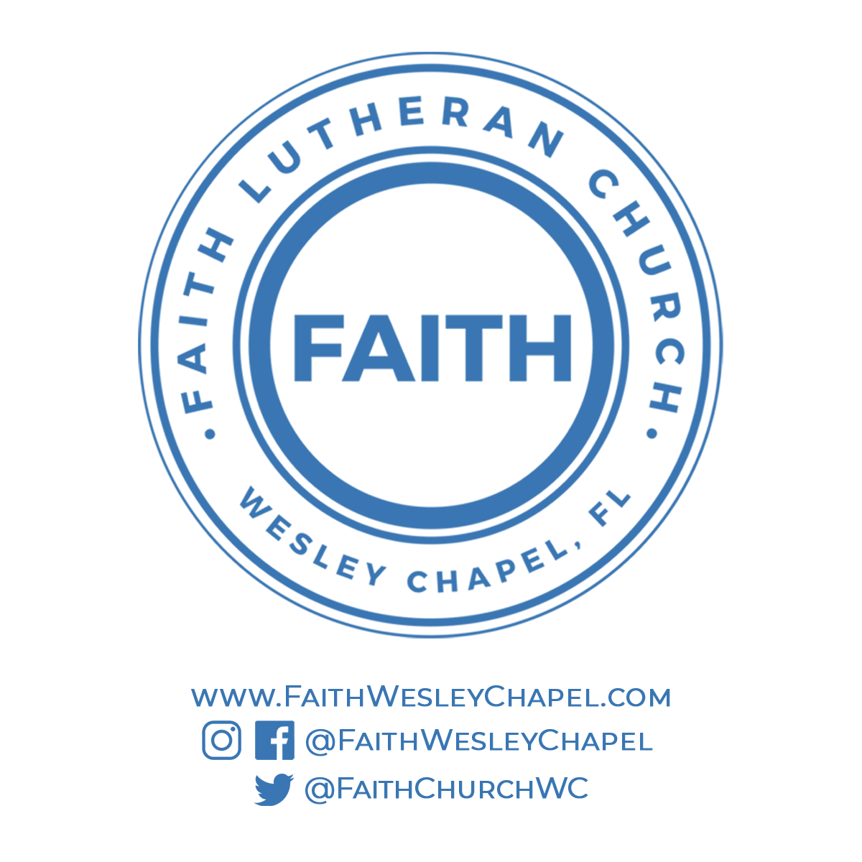
@FaithWesleyChapel
@FaithWesleyChapel
@FaithChurchWC

