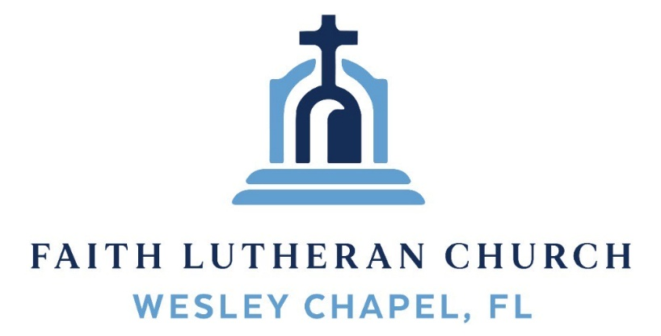
Leading our community into a deep connection in Christ

Worship Service for December 21, 2025 at 11 AM
Welcome
Opening Song: Come Thou Long Expected Jesus
Come thou long-expected Jesus, born to set thy people free,
From our fears and sins release us; let us find our rest in thee.
Israel’s strength and consolation, hope of all the earth thou art,
Dear desire of ev’ry nation, joy of every longing heart.
Come to earth to taste our sadness, He whose glories knew no end;
by His life He brings us gladness, Our Redeemer, Shepherd, Friend.
Leaving riches without number, born within a cattle stall;
This the everlasting wonder, Christ was born the Lord of all!
Born Thy people to deliver, born a child and yet a king.
Born to reign in us forever, now Thy gracious kingdom bring.
By Thine own eternal Spirit; rule in all our hearts alone.
By Thine all sufficient merit, raise us to Thy glorious throne.
© Public Domain
Invocation
Confession and Forgiveness:
P: Merciful Father, King David writes, “O LORD, our Lord, how majestic is Your name.” (Psalm 8:1) Forgive us for failing to honor Your name and neglecting to regard it as the greatest treasure and most sacred gift we have.
C: We look for life in other names, brand names and famous names.
P: Your word says, “The name of the LORD is a strong tower; the righteous run to it and are safe.” (Proverbs 18:10)
C: We run to other names we think will save us, like money and merchandise.
P: Your word says, “In him our hearts rejoice, for we trust in His holy name.” (Psalm 33:21)
C: We trust in other names, big names and business names.
P: Your word says, “I will lift up the cup of salvation and call on the name of the LORD.” (Psalm 116:13)
C: We call on other names that promise everything, only to deliver nothing.
ALL: God, be merciful to me, a poor, sinful being.
P: Hear the good news! The name of Jesus is the name that is above every name—that includes the names sin, guilt, shame, regret, and remorse. In the powerful name of Jesus, you are absolved, forgiven, cleansed, washed, and set free.
ALL: He who promised is faithful, and He will do it!
Song of Praise and Thanksgiving: Angels We Have Heard on High
Angels we have heard on high, sweetly singing o’er the plains,
And the mountains in reply, echoing their joyous strains.
Gloria, in excelsis Deo. Gloria, in excelsis Deo.
Shepherds why this jubilee? Why your joyous strains prolong?
What the gladsome tidings be which inspire your heavenly song?
Gloria, in excelsis Deo. Gloria, in excelsis Deo.
Come to Bethlehem and see Him whose birth the angels sing;
Come adore on bended knee Christ the Lord the newborn King.
Gloria, in excelsis Deo. Gloria, in excelsis Deo. © Public Domain
Old Testament Reading - Exodus 3:9–14
And now, behold, the cry of the people of Israel has come to me, and I have also seen the oppression with which the Egyptians oppress them. Come, I will send you to Pharaoh that you may bring my people, the children of Israel, out of Egypt.” But Moses said to God, “Who am I that I should go to Pharaoh and bring the children of Israel out of Egypt?” He said, “But I will be with you, and this shall be the sign for you, that I have sent you: when you have brought the people out of Egypt, you shall serve God on this mountain.”
Then Moses said to God, “If I come to the people of Israel and say to them, ‘The God of your fathers has sent me to you,’ and they ask me, ‘What is his name?’ what shall I say to them?” God said to Moses, “I am who I am.” And he said, “Say this to the people of Israel: ‘I am has sent me to you.’”
Reader: This is the Word of the Lord.
C: Thanks be to God.
Epistle Reading - Hebrews 1:4–14
having become as much superior to angels as the name he has inherited is more excellent than theirs.
For to which of the angels did God ever say,
“You are my Son, today I have begotten you”?
Or again,
“I will be to him a father, and he shall be to me a son”?
And again, when he brings the firstborn into the world, he says,
“Let all God's angels worship him.”
Of the angels he says,
“He makes his angels winds, and his ministers a flame of fire.”
But of the Son he says,
“Your throne, O God, is forever and ever, the scepter of uprightness is the scepter of your kingdom. You have loved righteousness and hated wickedness; therefore God, your God, has anointed you with the oil of gladness beyond your companions.”
And,
“You, Lord, laid the foundation of the earth in the beginning, and the heavens are the work of your hands; they will perish, but you remain; they will all wear out like a garment, like a robe you will roll them up, like a garment they will be changed. But you are the same, and your years will have no end.”
And to which of the angels has he ever said,
“Sit at my right hand until I make your enemies a footstool for your feet”?
Are they not all ministering spirits sent out to serve for the sake of those who are to inherit salvation?
Reader: This is the Word of the Lord.
C: Thanks be to God.
Gospel Reading - Matthew 1:18–25
Now the birth of Jesus Christ took place in this way. When his mother Mary had been betrothed to Joseph, before they came together she was found to be with child from the Holy Spirit. And her husband Joseph, being a just man and unwilling to put her to shame, resolved to divorce her quietly. But as he considered these things, behold, an angel of the Lord appeared to him in a dream, saying, “Joseph, son of David, do not fear to take Mary as your wife, for that which is conceived in her is from the Holy Spirit. She will bear a son, and you shall call his name Jesus, for he will save his people from their sins.” All this took place to fulfill what the Lord had spoken by the prophet:
“Behold, the virgin shall conceive and bear a son,
and they shall call his name Immanuel”
(which means, God with us). When Joseph woke from sleep, he did as the angel of the Lord commanded him: he took his wife, but knew her not until she had given birth to a son. And he called his name Jesus.
P: This is the Gospel of the Lord.
C: Praise be to You, O Christ.
Children's Message (Children dismissed to Children's Church)
Sermon Hymn – Angels From The Realms of Glory (Emmanuel)
Angels from the realms of glory wing your flight o'er all the earth.
You who sang creation's story now proclaim Messiah's birth.
Come and worship. Come and worship.
Worship Christ the newborn King.
Shepherds in the field abiding watching o'er your flocks by night.
God with man is now residing yonder shines the infant light.
Come and worship. Come and worship.
Worship Christ the newborn King.

Chorus:
Emmanuel, Emmanuel,
You are the God who saves us, worthy of all our praises.
Emmanuel, Emmanuel,
Come have Your way among us. We welcome You here, Lord Jesus.
Come have Your way among us. We welcome You here, Lord Jesus.
Come and worship, worship Christ the newborn King.
God is with us, even now His love is here.
(Repeat)

His love is here.

(Chorus) © 2015 © Thankyou Music
Sermon – Series: "Something Better"
This Week: “A Better Name”
Prayers: Text in prayer requests to (813) 326-5255
Nicene Creed (stand)
I believe in one God, the Father Almighty, maker of heaven and earth and of all things visible and invisible.
And in one Lord Jesus Christ, the only-begotten Son of God, begotten of His Father before all worlds, God of God, Light of Light, very God of very God, begotten, not made, being of one substance with the Father, by whom all things were made; who for us men and for our salvation came down from heaven and was incarnate by the Holy Spirit of the virgin Mary and was made man; and was crucified also for us under Pontius Pilate. He suffered and was buried. And the third day He rose again according to the Scriptures and ascended into heaven and sits at the right hand of the Father. And He will come again with glory to judge both the living and the dead, whose kingdom will have no end.
And I believe in the Holy Spirit, the Lord and Giver of Life, who proceeds from the Father and the Son, who with the Father and the Son together is worshiped and glorified, who spoke by the prophets. And I believe in one holy Christian and apostolic Church, I acknowledge one Baptism for the remission of sins, and I look for the resurrection of the dead and the life of the world to come. Amen.
The Lord's Prayer (stand)
Our Father who art in heaven, hallowed be Thy name, Thy kingdom come, Thy will be done on earth as it is in heaven. Give us this day our daily bread; and forgive us our trespasses as we forgive those who trespass against us; and lead us not into temptation, but deliver us from evil. For Thine is the kingdom and the power and the glory forever and ever. Amen
Offering (sit) Give online at:
Benediction (The online service ends. The closing song can be found as a YouTube video at FaithWesleyChapel.com/bulletin)
Thank you for joining Faith for worship. We hope to see you in person soon!
Closing Song: Joyful, Joyful We Adore Thee
Joyful, joyful we adore Thee, God of glory, Lord of love!
Hearts unfold like flow'rs before Thee, praising Thee, their sun above.
Melt the clouds of sin and sadness. Drive the gloom of doubt away.
Giver of immortal gladness, fill us with the light of day.
All Thy works with joy surround Thee. Earth and heav'n reflect Thy rays.
Stars and angels sing around Thee, center of unbroken praise. Field and forest, vale and mountain, flow'ry meadow, flashing sea, Chanting bird, and flowing fountain call us to rejoice in Thee.
Thou art giving and forgiving, ever blessing, ever blest,
Wellspring of the joy of living, Ocean-depth of happy rest!
Father, Son, and Holy Spirit, fountainhead of love divine:
Joyful, we Thy heav'n inherit! Joyful, we by grace are Thine.
© Public Domain
Serving This Week
O.T. Reader: Josh Strasheim | Children’s Church Teacher:
Epistle Reader: Ginger Dunn | Melissa Steinbrueck
Acolyte: Eli Steinbrueck | Children’s Church Assistant:
Com. Asst: Larry Chmiel | Kaylee Steinbrueck
Serving Next Week
1st Reader: Richard Steinbrueck | Children’s Church Teacher:
2nd Reader: Eli Bingaman  3rd Reader: Halston Quinn  4th Reader: Alanna Bingaman  5th Reader: Josh Straheim | N/A – Christmas Service
Acolyte: Alanna Bingaman | Children’s Church Assistant:
Com. Asst: Larry Chmiel | N/A – Christmas Service

Upcoming Events
Dec. 24, 6 PM – Christmas Eve Worship
Faith Lutheran Church
Dec 28, 7 PM –In-Person Growth Group Bible Study

www.FaithWesleyChapel.com

Faith YouTube
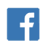
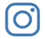
@FaithWesleyChapel
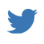
@FaithWesleyChapel
@FaithChurchWC

