
Leading our community into a deep connection in Christ
___________________________________________________
Worship Service for January 25, 2026 at 11 AM
Welcome
Confession and Forgiveness:
P: As we gather, today, let us cleanse our hearts and our consciences by confessing our sin to God.
(Time of silence for reflection and confession)
P: Today, we confess our sins by singing the song, “Lord, I Need You.”
Song of Confession: Lord, I Need You
Lord, I come, I confess. Bowing here I find my rest.
Without You, I fall apart. You're the one that guides my heart.
Chorus:
Lord, I need You, oh I need You. Every hour I need You.
My one defense, my righteousness, Oh God, how I need You.
Where sin runs deep, Your grace is more.
Where grace is found is where You are.
And where You are, Lord, I am free. Holiness is Christ in me.
(Chorus)
So, teach my song to rise to You when temptation comes my way.
And when I cannot stand, I'll fall on You. Jesus, You're my hope and stay.
(Chorus)
Lord, I need You, oh I need You. Every hour I need You.
My one defense, my righteousness, Oh God, how I need You.
My one defense, my righteousness, Oh God, how I need You.
My one defense, my righteousness, Oh God, how I need You.
P: The Lord has heard your confession. Therefore, as a called and ordained servant of the Lord, in the stead and by the command of my Lord, Jesus Christ, I forgive you all your sins in the name of the Father and of the Son and of the Holy Spirit.
C: Amen
Song of Praise and Thanksgiving – In Christ Alone
In Christ alone my hope is found. He is my light, my strength, my song.
This Cornerstone, this solid ground, firm through the fiercest drought and storm.
What heights of love, what depths of peace, when fears are stilled, when strivings cease.
My Comforter, my All in All. Here in the love of Christ I stand.
In Christ alone, who took on flesh, fullness of God in helpless babe.
This gift of love and righteousness, scorned by the ones He came to save.
‘Til on that cross as Jesus died, the wrath of God was satisfied.
For every sin on Him was laid, Here in the death of Christ I live.
There in the ground His body lay, Light of the world by darkness slain.
Then bursting forth in glorious Day, up from the grave He rose again.
And as He stands in victory, sin’s curse has lost its grip on me.
For I am His and He is mine, bought with the precious blood of Christ.
No guilt in life, no fear in death, this is the power of Christ in me.
From life’s first cry to final breath, Jesus commands my destiny.
No power of hell, no scheme of man, can ever pluck me from His hand.
‘Til He returns or calls me home, here in the power of Christ I’ll stand.
No power of hell, no scheme of man, can ever pluck me from His hand.
‘Til He returns or calls me home, here in the power of Christ I’ll stand. © 2001 Thankyou Music
Old Testament Reading – Isaiah 9:1-4
But there will be no gloom for her who was in anguish. In the former time he brought into contempt the land of Zebulun and the land of Naphtali, but in the latter time he has made glorious the way of the sea, the land beyond the Jordan, Galilee of the nations.
The people who walked in darkness have seen a great light; those who dwelt in a land of deep darkness, on them has light shone. You have multiplied the nation; you have increased its joy; they rejoice before you as with joy at the harvest, as they are glad when they divide the spoil. For the yoke of his burden, and the staff for his shoulder, the rod of his oppressor, you have broken as on the day of Midian.
Reader: This is the Word of the Lord.
C: Thanks be to God.

Epistle Reading – 1 Corinthians 1:10-18
I appeal to you, brothers, by the name of our Lord Jesus Christ, that all of you agree, and that there be no divisions among you, but that you be united in the same mind and the same judgment. For it has been reported to me by Chloe's people that there is quarreling among you, my brothers. What I mean is that each one of you says, “I follow Paul,” or “I follow Apollos,” or “I follow Cephas,” or “I follow Christ.” Is Christ divided? Was Paul crucified for you? Or were you baptized in the name of Paul? I thank God that I baptized none of you except Crispus and Gaius, so that no one may say that you were baptized in my name. (I did baptize also the household of Stephanas. Beyond that, I do not know whether I baptized anyone else.) For Christ did not send me to baptize but to preach the gospel, and not with words of eloquent wisdom, lest the cross of Christ be emptied of its power. For the word of the cross is folly to those who are perishing, but to us who are being saved it is the power of God.
Reader: This is the Word of the Lord.
C: Thanks be to God.
Gospel Reading – Matthew 4:12-25
Now when he heard that John had been arrested, he withdrew into Galilee. And leaving Nazareth he went and lived in Capernaum by the sea, in the territory of Zebulun and Naphtali, so that what was spoken by the prophet Isaiah might be fulfilled:
“The land of Zebulun and the land of Naphtali, the way of the sea, beyond the Jordan, Galilee of the Gentiles—the people dwelling in darkness have seen a great light, and for those dwelling in the region and shadow of death, on them a light has dawned.”
From that time Jesus began to preach, saying, “Repent, for the kingdom of heaven is at hand.”
While walking by the Sea of Galilee, he saw two brothers, Simon (who is called Peter) and Andrew his brother, casting a net into the sea, for they were fishermen. And he said to them, “Follow me, and I will make you fishers of men." Immediately they left their nets and followed him. And going on from there he saw two other brothers, James the son of Zebedee and John his brother, in the boat with Zebedee their father, mending their nets, and he called them. Immediately they left the boat and their father and followed him.
And he went throughout all Galilee, teaching in their synagogues and proclaiming the gospel of the kingdom and healing every disease and every affliction among the people. So his fame spread throughout all Syria, and they brought him all the sick, those afflicted with various diseases and pains, those oppressed by demons, those having seizures, and paralytics, and he healed them. And great crowds followed him from Galilee and the Decapolis, and from Jerusalem and Judea, and from beyond the Jordan.
P: This is the Gospel of the Lord.
C: Praise be to You, O Christ.
Children's Message
Sermon Hymn – King Of Kings (sit)
In the darkness we were waiting, without hope, without light,
Till from heaven You came running. There was mercy in Your eyes.
To fulfil the law and prophets, to a virgin came the Word;
From a throne of endless glory to a cradle in the dirt.

Chorus:
Praise the Father, Praise the Son, Praise the Spirit, Three in One!
God of glory, Majesty. Praise forever to the King of Kings!
To reveal the kingdom coming and to reconcile the lost,
To redeem the whole creation, You did not despise the cross.
For even in your suffering You saw to the other side.
Knowing this was our salvation, Jesus, for our sake, You died

(Chorus)
And the morning that You rose all of heaven held its breath,
Till that stone was moved for good; for the Lamb had conquered death.
And the dead rose from their tombs. And the angels stood in awe,
For the souls of all who'd come to the Father are restored.
And the church of Christ was born. Then, the Spirit lit the flame.
Now this Gospel truth of old shall not kneel, shall not faint.
By His blood and in His name, in His freedom, I am free;
For the love of Jesus Christ who has resurrected me.

(Chorus 2x) © 2018 Hillsong Music Publishing
Sermon - "The Light of the World"
Prayers: Text in prayer requests to (813) 326-5255‬
Apostles' Creed (stand)
I believe in God, the Father almighty, maker of heaven and earth,
And in Jesus Christ, his only Son, our Lord, who was conceived by the Holy Spirit,
born of the Virgin Mary, suffered under Pontius Pilate,
was crucified, died and was buried. He descended into hell.
The third day he rose again from the dead.
He ascended into heaven and sits at the right hand of God the Father almighty.
From there he will come to judge the living and the dead.
I believe in the Holy Spirit, the holy Christian Church,
the communion of saints, the forgiveness of sins,
the resurrection of the body, and the life everlasting. Amen.

The Lord's Prayer (stand)
Our Father who art in heaven, hallowed be Thy name, Thy kingdom come, Thy will be done on earth as it is in heaven. Give us this day our daily bread; and forgive us our trespasses as we forgive those who trespass against us; and lead us not into temptation, but deliver us from evil. For Thine is the kingdom and the power and the glory forever and ever. Amen

Offering (sit) Give online at:
Words of Institution (stand)
Peace (stand)
P: The peace of the Lord be with you all.
C: And also, with you.
P: We greet each other in the peace of Christ.
Distribution
Prayer (stand)
Benediction (stand)
Closing Song – The Church’s One Foundation (sit)
The church's one foundation is Jesus Christ, her Lord;
She is his new creation by water and the Word:
From heav'n he came and sought her to be his holy bride;
With his own blood he bought her, and for her life he died.
Elect from ev’ry nation, yet one o'er all the earth,
Her charter of salvation one Lord, one faith, one birth;
One holy name she blesses, partakes one holy food,
And to one hope she presses, with ev'ry grace endued.
Through toil and tribulation, and tumult of her war,
She waits the consummation of peace forevermore;
Till with the vision glorious her longing eyes are blest,
And the great church victorious shall be the church at rest.
Yet she on earth hath union with God the Three in One,
And mystic sweet communion with those whose rest is won:
O blessed heav'nly chorus! Lord, save us by Your grace,
That we, like saints before us, may see You face to face. © Public Domain

Serving This Week
O.T. Reader: Josh Strasheim | Children’s Church Teacher:
Epistle Reader: Eli Bingaman | Melissa Steinbrueck
Acolyte: Eli Bingaman | Children’s Church Assistant:
Com. Asst: Larry Chmiel | Kaylee Steinbrueck
Serving Next Week
1st Reader: Kaylee Steinbrueck | Children’s Church Teacher:
2nd Reader: Thomas Horness | N/A – Youth Sunday
Acolyte: Lawrence Finnerty  Offering: Heidi Strasheim | Children’s Church Assistant:  N/A – Youth Sunday
Com. Asst: Larry Chmiel

Upcoming Events
Today, After the Service – In-Person Growth Group Bible Study
Faith Lutheran Church
Today, 6 PM – Youth Group (Activities and Bible Study)
Grace Community Church
Jan 29, 7 PM – Online Growth Group Bible Study
Zoom
Feb 1, After the Service – Voter Meeting
Faith Lutheran Church
Feb 9, 11 AM – “Your Table” Food Drive
Faith Lutheran Church

www.FaithWesleyChapel.com

Faith YouTube
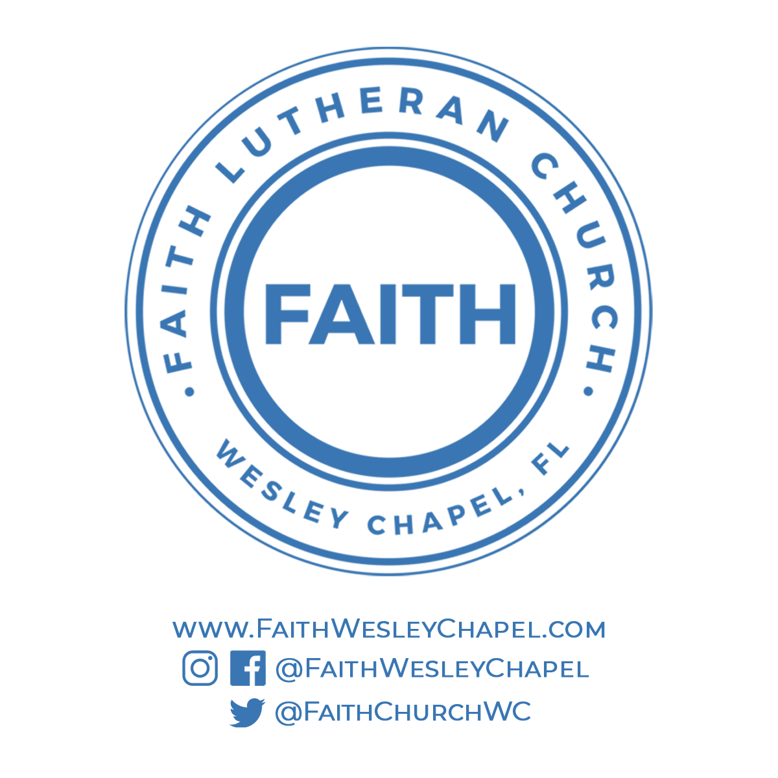
@FaithWesleyChapel
@FaithWesleyChapel
@FaithChurchWC

